Introduction

Multicluster Management with Red Hat OpenShift Platform Plus

Multicluster Management with Red Hat OpenShift Platform Plus teaches the skills required to maintain a diverse portfolio of applications running across a fleet of Red Hat OpenShift clusters. You will learn to control applications by using placement rules that are determined by capacity and criticality, ensure that cluster configurations comply with governance and security policies, and automate these capabilities according to DevOps principles.

**Course Objectives**

* Deploy Red Hat Advanced Cluster Management for Kubernetes (RHACM).
* Add managed clusters to RHACM.
* Define and apply cluster configuration policies.
* Detect and correct non-conformance to cluster configuration policies.
* Deploy applications by using RHACM
* Deploy a private Red Hat Quay registry.
* Deploy Red Hat Advanced Cluster Security for Kubernetes (RHACS).
* Integrate Red Hat Quay and RHACS security with RHACM.

**Audience**

* System Administrators, Developers, SREs, and IT Architects interested in managing and automating the management of a fleet of OpenShift clusters, possibly in different data centers and cloud providers.

**Prerequisites**

* Red Hat Certified Specialist in OpenShift Administration certification (EX280) or equivalent knowledge for the roles of Red Hat OpenShift cluster administrator or SRE.
* Red Hat Certified Systems Administrator certification (EX200) or equivalent knowledge of Linux system administration is recommended for all roles.
* Basic knowledge of Kubernetes and OpenShift administration skills are recommended.

# **Chapter 1.  Managing a Multicluster Kubernetes Architecture**

[The Kubernetes Multicluster and Hybrid Cloud Architecture Landscape](https://rol.redhat.com/rol/app/courses/do480-2.4/pages/ch01)

[Quiz: The Kubernetes Multicluster and Hybrid Cloud Architecture Landscape](https://rol.redhat.com/rol/app/courses/do480-2.4/pages/ch01s02)

[Describing Red Hat OpenShift Platform Plus](https://rol.redhat.com/rol/app/courses/do480-2.4/pages/ch01s03)

[Quiz: Describing Red Hat OpenShift Platform Plus](https://rol.redhat.com/rol/app/courses/do480-2.4/pages/ch01s04)

[Installing Red Hat Advanced Cluster Management for Kubernetes](https://rol.redhat.com/rol/app/courses/do480-2.4/pages/ch01s05)

[Guided Exercise: Installing Red Hat Advanced Cluster Management for Kubernetes](https://rol.redhat.com/rol/app/courses/do480-2.4/pages/ch01s06)

[Lab: Installing the RHACM Operator and importing clusters](https://rol.redhat.com/rol/app/courses/do480-2.4/pages/ch01s07)

[Summary](https://rol.redhat.com/rol/app/courses/do480-2.4/pages/ch01s08)

**Abstract**

|  |  |
| --- | --- |
| **Goal** | Describe multicluster architectures and use Red Hat OpenShift Platform Plus to solve their challenges. |
| **Objectives** | * Identify common use cases for multiple Kubernetes clusters and the challenges presented by multicluster architectures. * Identify the tools provided by OpenShift Platform Plus to facilitate the end-to-end management, security, and compliance of Kubernetes fleets on hybrid clouds. * Install the RHACM operator from the operator hub in a Red Hat OpenShift hub cluster. |
| **Sections** | * The Kubernetes Multicluster and Hybrid Cloud Architecture Landscape (and Quiz) * Describing Red Hat OpenShift Platform Plus (and Quiz) * Installing Red Hat Advanced Cluster Management for Kubernetes (and Guided Exercise) |
| **Lab** | * Installing the RHACM Operator and importing clusters |

## **The Kubernetes Multicluster and Hybrid Cloud Architecture Landscape**

### **Objectives**

* Identify common use cases for multiple Kubernetes clusters and the challenges presented by multicluster architectures.

### **Interpreting the Background of Kubernetes Multicluster Architectures**

Digital transformation is challenging traditional Information Technology (IT) departments and teams.

The wide adoption of the Internet brought new business models to different industries, with new technologies and ways of working. One example is the music and video streaming services that completely changed the entertainment industry. Another example is the growth of online stores that pushed traditional retailers to change how they operated their traditional stores. These disruptions affect other sectors also, such as telecommunications, the automotive business, and financial companies.

Furthermore, these new business models must frequently support operations that serve many users. An online business with one thousand customers could succeed and grow to hundreds of thousands or millions of users in a few days or weeks.

The following list enumerates some of the challenges that face IT departments:

* Modernizing systems and processes to deliver new software services quickly
* Building new services for customers to adapt to new industry trends and legislation
* Adapting new and existing services to run on a global scale
* Establishing new methodologies that support the work of modernizing, building, and adapting services

Three modern technologies and ways of working are helping IT departments to adapt to digital transformation:

* Cloud computing
* Containers technology
* Automation of processes

#### **Describing Cloud Computing: The Way to the Hybrid Cloud**

In IT, a cloud is an environment that abstracts, pools, and shares resources across a network. Cloud computing is the act of running workloads in a cloud environment. The following are some of the main features of a cloud computing IT system:

* You can access all resources in the cloud computing environment through a network.
* The cloud computing environment contains a repository of IT resources, such as applications, software services, and hardware abstractions.
* You can provision and scale the cloud computing environment quickly.

There are different types of clouds, such as public clouds, private clouds, and hybrid clouds. A public cloud provider is a company in charge of maintaining the base hardware, the network, and the software used to virtualize the servers. Cloud providers also offer service agreements and pay-per-use options for using their services.

The arrival of public cloud providers was a disruptive change in the IT market. Now, an enterprise can run all its software workloads without maintaining on premises data centers or spending on new hardware.

However, not all companies and workloads are suitable for migration to a public cloud. The following list suggests some reasons to limit the use of public clouds:

* The company already has many critical workloads running in its data centers.
* The cost of migrating to cloud-native developments is very high.
* Some legacy systems are not adapted to run on cloud environments.
* The operational cost of public cloud services can be high, especially if the enterprise grows rapidly.
* Some verticals, such as healthcare or finance, must comply with important regulatory restrictions on storing their data. The General Data Protection Regulation law of the European Union is an excellent example of a data location restriction.
* Concerns about security and losing control of the IT infrastructure are prioritized.

There are many other models of interacting with one or multiple clouds, such as between a fully externalized public provider and a private data center. One model is a fully private cloud.

A private cloud is an IT infrastructure hosted in private data centers whose services are requested and served with a model similar to public clouds:

* Self-provisioning on demand
* Autoscaling resources based on infrastructure usage
* Better resource allocation and utilization over the same physical resources

Private clouds can be isolated from the external world. Ideally, a private cloud should not communicate with a public cloud. However, in the real world, IT departments use mixed models. Private data centers, hosted data centers, data centers on public clouds, or data centers on private clouds need to share resources between them.

A Hybrid Cloud is an IT infrastructure that can communicate and share services between the following resource types:

* One or more data centers with bare metal or virtualized environments owned by the company
* One or more data centers with bare metal or virtualized environments rented to other companies
* One or more private clouds
* One or more public clouds

The boundaries between some of these infrastructures are not always clear, particularly as the technologies evolve. For example, many public cloud providers install services, and sometimes physical resources, in their customer's private data centers.

Using multiple clouds has the following benefits:

* High availability and failover capabilities: Other clouds can assume the workload if the primary cloud is down.
* Using specific services from specific clouds: Administrators can use a preferred cloud service from each cloud.
* Geographical proximity: Some services can be faster if they run close to the user, although this depends on the customer's location.
* Regulatory restrictions: In some cases, regulatory data restrictions can apply.
* Network latency: Network traffic latency is a critical concern for some industries like Telco.

The following diagram shows an example of a hybrid cloud; it displays the distribution of two software services, an online shop for global access to customers and a back-office application to manage the online shop. The shop service has the benefits of global distribution.

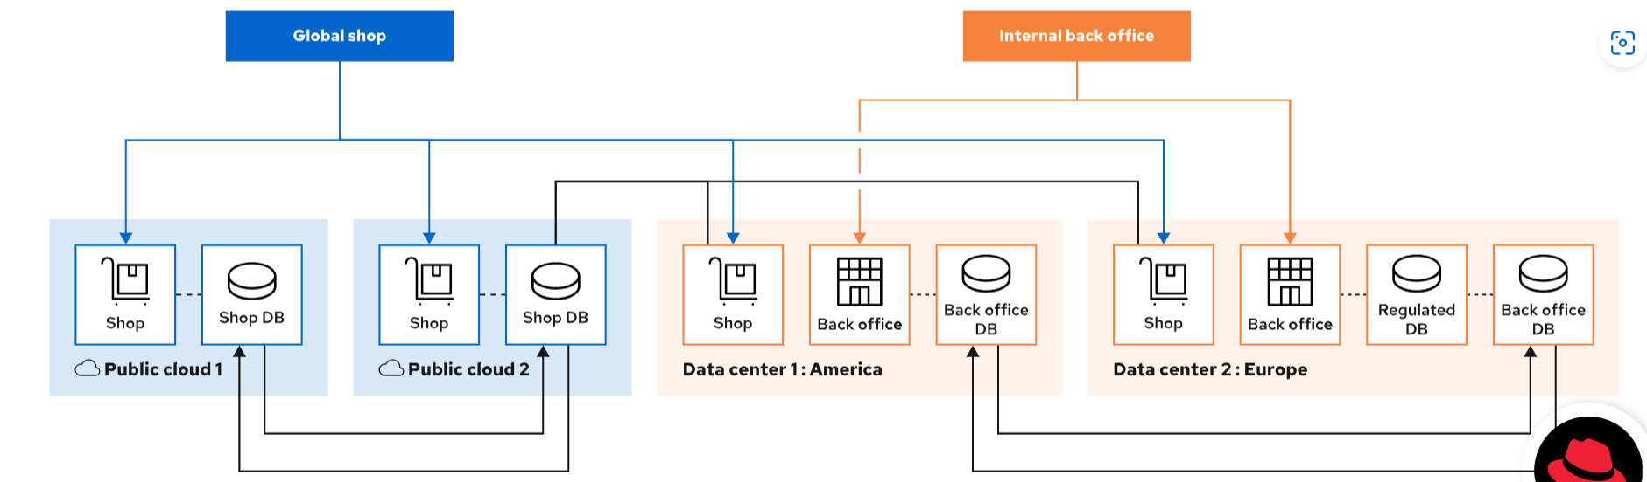

Figure 1.1: A hybrid cloud example

Customers always connect to the nearest shop location. The back-office service only runs in the private data centers, whereas the shop service runs in the private data centers and in two public clouds. However, the regulated back-office data is only present in the Europe data center.

#### **Explaining the Need for Containers and Orchestration**

As discussed elsewhere in this chapter, software development techniques are evolving quickly. Scale economies and new disruptive players in different industries push to bring new features to their applications as soon as possible. Nevertheless, user applications must still be developed with quality, stability, performance, and high availability.

Linux containers are one of the best approaches to providing the infrastructure and development framework to run both cloud-native applications and legacy workloads.

Container technologies use software packaging techniques to make applications fully portable to any hybrid cloud. The packaging and portability of containers make them suitable for every cloud-computing model and in traditional data centers.

The following list describes some of the benefits of using Linux containers:

* Security, storage, and network isolation, similar to virtual machines (VMs)
* Require fewer hardware resources and are quick to start and terminate compared to VMs
* Quick deployment because you do not need to install a complete operating system
* Portable and reusable applications by using environments

In contrast, the use of Linux containers can introduce some of the following new challenges:

* Managing communications between services provided by containers
* Managing versions of running containers and controlling their deployment
* Scaling containers up and down to respond to the real demands of the service
* Determining the location of the containers in the existing infrastructure
* Limiting and balancing available compute resources for containers

You can address these challenges by using a container orchestration system. Kubernetes is an orchestration system that simplifies the deployment, management, and scaling of containerized applications.

#### **Automation Processes**

Companies must reduce the time to market for their new services and offerings but keep the ability to scale their infrastructure up or down quickly if demands change.

By using hybrid clouds and Linux containers orchestration systems, companies can cope with changing demands. Moreover, companies must also increase agility and automate their processes at technical and organizational levels.

Modern IT teams are adapting their work to adopt agile models that automate a good part of the software development lifecycle. Methods like CI/CD, DevSecOps, and GitOps are challenging to implement but are the key to rapidly bringing new business value through software development.

### Note

To learn more about CI/CD and GitOps, see [the section called “Introducing the RHACM Application Model”](https://rol.redhat.com/rol/app/courses/do480-2.4/pages/ch05).

### **Challenges of Multicluster Architectures**

The adoption of automation, containers, and Kubernetes in Hybrid Cloud environments means that companies must find a way to create and manage Kubernetes clusters across the hybrid environment easily.

The following sections discuss the main challenges to adopting a multicluster architecture.

#### **Managing Fleets of Clusters**

As software development processes evolve, it might be necessary to use ephemeral Kubernetes clusters.

For example, if many DevOps pipelines create a whole cluster to do the quality assurance (QA) end-to-end test, then you need ephemeral Kubernetes clusters.

Sometimes, you destroy the cluster after completing the test. Other times, you must keep the cluster temporarily to perform research on it after the tests are done.

When an organization has many development and QA teams belonging to different areas or regions, or in different business units, the number of Kubernetes clusters can grow quickly. The higher the number of clusters, the more difficult it is to locate information about the performance and the status of the fleet.

Managing a high number of clusters is time-consuming and error-prone. Administrators must work with multiple consoles, distributed business applications, and sometimes inconsistent security controls across diverse clusters deployed on premises or in public clouds.

#### **Organizing Compliance and Security of Clusters**

IT departments are often under different regulatory compliance requirements. Suppose a company must ensure that one clusters complies with standard or custom policies. It is easy for a team to manually implement the policies on one cluster and ensure that they are correctly applied. On the other hand, manually applying custom policies is impossible if the company has hundreds or thousands of clusters. In such cases, companies need a mechanism to set consistent security policies across diverse environments and ensure enforcement.

Another concern of IT departments from a security viewpoint is the origin of the software that runs in the Kubernetes clusters. Container packaging techniques make it easy to package software inside a container with security problems or obsolete versions of some dependencies. The developer's freedom to choose the software used in a container has the associated risk of adding layers of defective software to the container image.

#### **Organizing Applications Between Clusters**

The placement of the workloads must be automatic and based on the capacity of the clusters, availability zones, or other policies previously defined.

Furthermore, if the applications have dependencies with services in different clusters, having visibility of the network topology is a difficult challenge.

Multicluster architectures need repositories of IT artifacts available from different clouds. This need represents another challenge that affects the applications and the deployment of infrastructure in the multicluster environment. In the containers world, many infrastructure components are packaged as container images.

To summarize, the following table relates the new technologies and processes to the challenges that those technologies and new processes present in a multicluster architecture:

| **Technology or process** | **Challenges introduced by multicluster architectures** |
| --- | --- |
| Cloud computing | - Easily provisioning clusters on all types of clouds  - Locating information about objects present in the fleet of clusters  - Managing configuration compliance and the fleet of cluster's security  - Monitoring the behavior of all clusters and their workloads for performance and scalability |
| Containers | - Managing communications between services provided by containers, even when they are in different clusters or clouds  - Requires a containers orchestration system  - Requires a controlled place to store the artifacts and images that containers use  - Requires security scanning of the artifacts and images that containers use |
| Automation processes | - An easy way for developers to implement CI/CD across a fleet of clusters  - An easy way for DevOps teams to implement GitOps across a fleet of clusters |

### References

[Understanding cloud computing](https://www.redhat.com/en/topics/cloud)

[Types of cloud computing](https://www.redhat.com/en/topics/cloud-computing/public-cloud-vs-private-cloud-and-hybrid-cloud)

[What is Hybrid Cloud?](https://www.redhat.com/en/topics/cloud-computing/what-is-hybrid-cloud)

For more information, refer to the official Documentation of Red Hat Advanced Cluster Management for Kubernetes at <https://access.redhat.com/documentation/en-us/red_hat_advanced_cluster_management_for_kubernetes/2.4>

## **Describing Red Hat OpenShift Platform Plus**

### **Objectives**

* Identify the tools provided by OpenShift Platform Plus to facilitate the end-to-end management, security, and compliance of Kubernetes fleets on hybrid clouds.

### **Describing Red Hat OpenShift Platform Plus**

Red Hat OpenShift Container Platform (RHOCP) is a certified enterprise Kubernetes distribution. It runs on a wide variety of infrastructure providers, including public and private clouds, virtualization software, and bare metal servers. OpenShift Container Platform allows administrators to build a portable, production-ready, hybrid application development container platform.

Red Hat OpenShift Platform Plus is a collection of software tools running on Red Hat OpenShift Container Platform. OpenShift Platform Plus allows administrators to manage the software lifecycle across Kubernetes and Red Hat OpenShift clusters. These tools provide end-to-end visibility and control over multiple Kubernetes clusters from a single user interface. Furthermore, OpenShift Platform Plus brings Kubernetes-native security capabilities to protect the software supply chain, infrastructure, and workloads. Finally, OpenShift Platform Plus provides a globally-distributed and scalable registry.

The capabilities mentioned previously are provided by the following Red Hat products, included in the Red Hat OpenShift Platform Plus subscription and distributed and installed as Kubernetes operators in OpenShift Container Platform.

#### **Red Hat Advanced Cluster Management for Kubernetes**

Red Hat Advanced Cluster Management for Kubernetes provides multicluster and application control along with built-in security policies.

By using Red Hat Advanced Cluster Management for Kubernetes, administrators can perform the following tasks:

* Create, update, or delete OpenShift or Kubernetes clusters across multiple private and public clouds.
* Find and modify any Kubernetes resource across the entire domain by using the built-in search engine.
* Troubleshoot and resolve issues by using the built-in search engine.
* Automate and apply tasks in the clusters through the integration with Red Hat Ansible Automation Platform.
* Enforce compliance policies across the fleet of managed clusters.
* Manage the lifecycle of applications across data centers and hybrid clouds.
* Visualize cluster metrics from a centralized monitoring stack.
* Create and manage alerts that are generated across all the managed clusters.

#### **Red Hat Advanced Cluster Security for Kubernetes**

Powered by StackRox technology, Red Hat Advanced Cluster Security for Kubernetes helps administrators to enforce DevOps and security best practices.

By using Red Hat Advanced Cluster Security for Kubernetes, administrators gain the following advantages:

**Visibility**

Centralized viewing of your deployments, traffic in all clusters, and critical system-level events in each running container.

**Vulnerability management**

Image vulnerability scanning, vulnerability correlation to running deployments, and policy enforcing at build, deploy, and run time.

**Compliance**

Assessment for CIS Benchmarks, payment card industry (PCI), Health Insurance Portability and Accountability Act (HIPAA), and NIST SP 800-190. Centralized compliance dashboard with evidence export for auditors and detailed view compliance to pinpoint specific clusters, nodes, or namespaces.

**Network segmentation**

Visualizing allowed and active traffic, simulating network policy changes, network policy recommendations, and network enforcement capabilities.

**Risk profiling**

Deployment ranking based on security risk calculation and security tracking to validate configuration changes.

**Configuration management**

Prebuilt DevOps and security policies, Kubernetes role-based access control (RBAC) analysis, audit control for access to Kubernetes secrets, and configuration policies at build time for CI/CD integration and deployments.

**Runtime detection and response**

System-level event monitoring, automatically allowing process activity, prebuilt policies to detect crypto mining, privilege escalation, and various other exploits, and system-level data collection that uses the external Berkeley Packet Finder (eBPF) or other Linux kernel modules.

**Integration**

API and prebuilt plug-ins to integrate with DevOps systems, CI/CD tools, image scanners, registries, container runtimes, security integration event management (SIEM) solutions, and notification tools.

#### **Red Hat Quay**

Red Hat Quay is a scalable container registry to serve as a single source of truth for container images. Administrators can use Red Hat Quay to automate container builds with integration with GitHub, Bitbucket, and more. Red Hat Quay also provides vulnerability scanning for the container images.

By using Red Hat Quay, administrators get the following advantages:

* Time machine, with the ability to roll back image changes to a previous state.
* Geographic replication for improved performance and availability.
* Continuous garbage collection, removing unused images automatically.
* Advanced access control management, including support for mapping teams and organizations integrating with an existing identity infrastructure.
* TLS security encryption between Red Hat Quay and your servers.
* Security scanning integration with vulnerability detectors like [Clair](https://www.redhat.com/en/topics/containers/what-is-clair).
* Notifications for alerting about detected vulnerabilities.
* Integrating with CI/CD pipelines by using build triggers, git hooks, and robot accounts.
* Auditing of CI and API actions.
* Integrated Prometheus metrics export.

#### **Red Hat OpenShift Data Foundation**

Red Hat OpenShift Data Foundation is a collection of software-defined storage for containers that runs on OpenShift. Thus, you can use and install it on public or private clouds, on virtual infrastructure, and on bare-metal environments.

OpenShift Data Foundation provides the following list of storage components for Kubernetes and OpenShift clusters:

* Block storage devices
* Shared file system
* On premises object storage
* Multicloud object storage, which abstracts the access to different cloud object stores by using a S3 API endpoint

### **Challenges Addressed by Red Hat OpenShift Platform Plus**

The challenges of multicluster architectures are discussed in [the section called “Challenges of Multicluster Architectures”](https://rol.redhat.com/rol/app/courses/do480-2.4/pages/ch01). The following table relates these challenges to the Red Hat OpenShift Platform Plus software collection.

| **Challenges of multicluster architectures** | **OpenShift Platform Plus software solution** |
| --- | --- |
| Easily provisioning clusters on all types of clouds | Red Hat Advanced Cluster Management for Kubernetes |
| Locating information about objects present in a fleet of clusters | Red Hat Advanced Cluster Management for Kubernetes search engine |
| Managing configuration compliance and the fleet of cluster's security | Red Hat Advanced Cluster Management for Kubernetes governance engines |
| Monitoring the behavior of all clusters and their workloads from performance and scalability points of view | Red Hat Advanced Cluster Management for Kubernetes observability engine |
| Requires a containers orchestration system | Red Hat OpenShift Container Platform or Kubernetes |
| Managing communications between services provided by containers, even when they are in different clusters or clouds | Red Hat Advanced Cluster Management for Kubernetes Submariner services |
| Requires a controlled place to store the artifacts and images that containers use | Red Hat Quay, Red Hat OpenShift Data Foundation |
| Security scanning of the artifacts and images that containers use | Red Hat Quay for static scanning and Red Hat Advanced Cluster Security for Kubernetes for dynamic scanning |
| Automation processes | Red Hat Advanced Cluster Management for Kubernetes and its integration with the Ansible Automation Platform Resource Operator from Red Hat OpenShift Container Platform |
| An easy way for developers to implement CI/CD across a fleet of clusters | Red Hat Advanced Cluster Management for Kubernetes applications engine |
| An easy way for DevOps teams to implement GitOps across a fleet of clusters | Red Hat Advanced Cluster Management for Kubernetes applications engine |

### References

[Red Hat OpenShift Container Platform](https://www.redhat.com/en/technologies/cloud-computing/openshift/container-platform)

[Red Hat OpenShift Platform Plus](https://www.redhat.com/en/technologies/cloud-computing/openshift/platform-plus)

[Red Hat Advanced Cluster Management for Kubernetes](https://www.redhat.com/en/technologies/management/advanced-cluster-management)

[Red Hat Advanced Cluster Security for Kubernetes](https://www.redhat.com/en/resources/advanced-cluster-security-for-kubernetes-datasheet)

[Red Hat Quay](https://www.redhat.com/en/technologies/cloud-computing/quay)

[Red Hat OpenShift Data Foundation](https://access.redhat.com/documentation/en-us/red_hat_openshift_data_foundation)

[Red Hat Quay datasheet: Private container registry](https://www.redhat.com/en/resources/quay-datasheet)

## **Installing Red Hat Advanced Cluster Management for Kubernetes**

### **Objectives**

* Install the RHACM operator from the operator hub in a Red Hat OpenShift hub cluster.

### **Introducing Red Hat Advanced Cluster Management for Kubernetes**

Red Hat Advanced Cluster Management for Kubernetes (RHACM) gives you visibility into your OpenShift and Kubernetes clusters from a single user interface. RHACM provides built-in governance, cluster lifecycle management, application lifecycle management, and observability features. RHACM is cloud-native by design. It runs on containers, does not use relational persistence, and manages Kubernetes objects directly through their APIs.

The following diagram provides a high-level overview of an RHACM deployment.

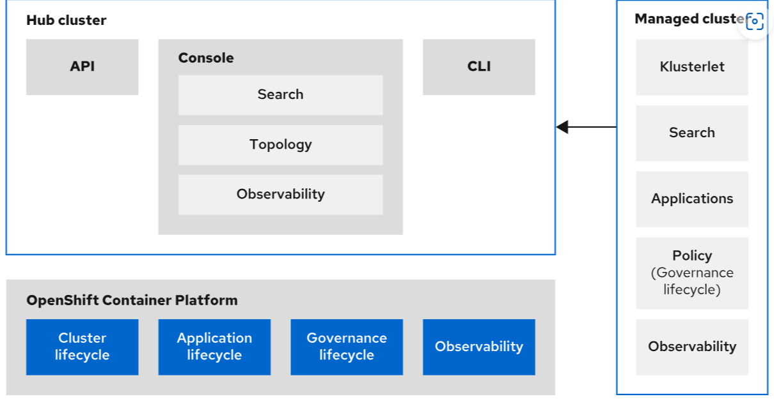

The RHACM operator creates the more than 20 necessary custom resource definitions (CRDs) for the RHACM components.

#### **RHACM Components on the Hub Cluster**

The central controller runs the core components of RHACM running in the hub cluster. The MultiClusterHub object, part of the RHACM operator installation, is responsible for managing, upgrading, and installing the components of RHACM. You can interact with RHACM by using the Kubernetes API, the RHACM web console, and the oc or kubectl commands.

In RHACM, the local cluster is the Red Hat OpenShift cluster hosting the hub cluster. The hub cluster is also a managed cluster unless you specify otherwise when creating the MultiClusterHub object.

When you install RHACM, the operator creates the following namespaces in the hub cluster:

* open-cluster-management: contains the deployments for the main features of RHACM, such as the web console, the applications for the search engine, the deployments that manage applications and their topologies, and the deployments that manage the lifecycle of the clusters.
* open-cluster-management-hub: contains the deployments that receive data from the managed clusters.
* open-cluster-management-observability: contains all the Thanos deployments that store, create and visualize the observability data. This namespace is only present if you enable the RHACM observability engine.

If you manage the hub cluster as another managed cluster, the RHACM operator creates also the namespaces present on the managed clusters. Furthermore, RHACM creates a namespace for each managed cluster.

#### **RHACM Components on the Managed Clusters**

A managed cluster is an additional Kubernetes or OpenShift cluster that reports data to, and is managed by the hub cluster. As displayed in the previous diagram, the klusterlet agent controls the connection between clusters. The hub cluster controls managed clusters by communicating with the klusterlet agent running on them. Apart from the core components running in the hub cluster, every managed cluster runs agents to communicate with the hub cluster. The following list includes these agents, also called add-ons:

* the klusterlet agent
* the search engine add-on
* the add-on for managing application deployments from RHACM
* the add-on for applying policies
* the add-on for the observability components

When you install RHACM, the operator creates the following namespaces in the managed clusters:

* open-cluster-management-agent: contains the deployments for the klusterlet agent
* open-cluster-management-agent-addon: contains the application's deployments, search engine, and policies engines
* open-cluster-management-agent-addon-observability: contains the observability engine's deployments

RHACM uses capabilities from the Red Hat OpenShift local cluster for cluster lifecycle management, application lifecycle management, applying governance, risk and compliance policies, and observability.

### **Prerequisites and Sizing for Installing RHACM**

The following list shows the basic prerequisites to install RHACM.

* An OpenShift or Kubernetes cluster listed in the [Red Hat Advanced Cluster Management for Kubernetes 2.4 Support Matrix](https://access.redhat.com/articles/6218901).
* A browser listed in the [Red Hat Advanced Cluster Management for Kubernetes 2.4 Support Matrix](https://access.redhat.com/articles/6218901).
* Network communication between the hub cluster and the managed clusters. For more specific information about network ranges and ports, refer to the Network configuration chapter in the Install guide at <https://access.redhat.com/documentation/en-us/red_hat_advanced_cluster_management_for_kubernetes/2.4/html-single/install/installing#network-configuration>.

The following list describes some of the factors that determine RHACM resource usage:

* The platform on which RHACM runs
* The number of managed clusters in the fleet
* The speed of storage or networks
* The number of applications in each cluster

Thus, it is not possible to accurately calculate the resources that a RHACM hub cluster needs.

For example sizing of an RHACM installation that creates and manages 1000 single node OpenShift clusters in different infrastructures, refer to the Sizing your cluster chapter in the Install guide at <https://access.redhat.com/documentation/en-us/red_hat_advanced_cluster_management_for_kubernetes/2.4/html-single/install/index#sizing-your-cluster>.

### **Installing RHACM**

Red Hat recommends that you install the Advanced Cluster Management for Kubernetes operator from the **OperatorHub** menu in the RHOCP web console.

### Note

A list of supported hub cluster providers is available in the [RHACM documentation](https://access.redhat.com/documentation/en-us/red_hat_advanced_cluster_management_for_kubernetes/2.4/html-single/clusters/supported-clouds#supported-hub-cluster-providers).

The installation requires selecting **Update channel**. An update channel is used to deliver streams of updates to the operators. Typically, update channels correspond to minor software versions. The installation also requires choosing between automatic and manual **Update approval** strategies. Choosing the manual update approval approach requires human intervention to update whenever a new version of the operator is available in the update stream. Alternatively, the automatic update approval will trigger an update whenever a new operator version is available.

After the operator is installed, you must create the MultiClusterHub custom resource to deploy the RHACM central services. You are required to perform these steps elsewhere in this course.

You can also install the RHACM operator by using the command line. Both installation methods can be performed in connected and disconnected environments.

### Note

For more information about all the available installation methods, check the Red Hat Advanced Cluster Management for Kubernetes Install Guide at <https://access.redhat.com/documentation/en-us/red_hat_advanced_cluster_management_for_kubernetes/2.4/html-single/install/index>.

When the MultiClusterHub finishes deploying, it creates the multicloud-console route to access the RHACM web console. You can find that route in the **Networking** → **Routes** menu by using the Red Hat OpenShift web console. Alternatively, you can use the following command:

[user@demo ~]$ oc get routes -n open-cluster-management

NAME HOST/PORT ...

multicloud-console **multicloud-console.apps.ocp4.example.com**

### **Importing Existing Clusters to Red Hat Advanced Cluster Management**

When the MultiClusterHub custom resource installation completes, the next step is to aggregate or import more Kubernetes or OpenShift clusters into RHACM.

### Note

A list of supported managed cluster providers is available in the [RHACM documentation](https://access.redhat.com/documentation/en-us/red_hat_advanced_cluster_management_for_kubernetes/2.4/html-single/clusters/supported-clouds#supported-managed-cluster-providers).

The local cluster (the OpenShift cluster where the hub cluster runs) is automatically imported into RHACM, unless otherwise specified during the creation of the MultiClusterHub object.

You can import new clusters from the web console or by using the command line.

The following prerequisites are common to both import methods:

1. Internet connectivity between the hub and the managed cluster
2. The oc or kubectl command-line tools
3. The base64 utility
4. If importing a Kubernetes cluster, then a defined multiclusterhub.spec.imagePullSecret containing the cloud.redhat.com pull secret
5. If importing a Red Hat OpenShift Dedicated cluster, then the hub cluster running in it and cluster-admin permissions to use RHACM.

#### **Importing Existing Clusters by Using the RHACM Web Console**

To import an existing cluster from the RHACM web console, administrators must follow this steps:

1. From the RHACM web console, navigate to the **Infrastructure** → **Clusters** menu.
2. Click **Add a cluster**.
3. Click **Import an existing cluster**. Give the import a name.
4. Add any desired **Additional labels** (optional).
5. Click **Save import and generate code**.
6. Click **Copy command** to copy the generated command and token to the clipboard.
7. Paste and run the copied command.
8. Return to the **Infrastructure** → **Clusters** menu.

The newly imported cluster is immediately displayed in the **Infrastructure** → **Clusters** menu. It takes several minutes to see all the cluster details. This is because RHACM is installing the add-on in the managed cluster.

### Note

For detailed steps and expanded information, review the Chapter 8. Importing a target managed cluster to the hub cluster section of the Red Hat Advanced Cluster Management for Kubernetes Clusters Guide at <https://access.redhat.com/documentation/en-us/red_hat_advanced_cluster_management_for_kubernetes/2.4/html-single/clusters/index#importing-a-target-managed-cluster-to-the-hub-cluster>.

#### **Importing Existing Clusters Using the Command Line**

The steps for importing an existing cluster using the command line are different from the ones using the web console.

The following steps are a summary of the actions that you must perform in each cluster, for a better understanding of the process.

### Note

For detailed instructions on how to import clusters into RHACM using the command line, visit <https://access.redhat.com/documentation/en-us/red_hat_advanced_cluster_management_for_kubernetes/2.4/html-single/clusters/index#importing-a-managed-cluster-with-the-cli>.

In the hub cluster:

1. Create a project with the name of the cluster to import, for instance: imported-cluster.
2. Add the label cluster.open-cluster-management.io/managedCluster=*imported-cluster* to the imported-cluster namespace.
3. Create a new ManagedCluster custom resource (CR) with the imported-cluster name.
4. Create a new KlusterletAddonConfig CR with the klusterlet configuration file.

In the hub cluster, you must extract existing secrets and generate YAML files containing the following resources:

1. The klusterlet CRD. For instance in a klusterlet-crd.yaml file.
2. The secret for importing new clusters. For instance in a import.yaml file.

Then, use the YAML files generated in the previous step to create the necessary objects in the imported managed cluster.

1. oc create -f klusterlet-crd.yaml
2. oc create -f import.yaml

In the hub cluster, validate the JOINED and AVAILABLE status of the managedcluster named imported-cluster.

In the target cluster, validate the status of the pods of all the add-ons running on the target cluster namespace open-cluster-management-agent-addon.

#### **Removing Imported Clusters from Red Hat Advanced Cluster Management**

To remove an imported cluster from the RHACM console, navigate to the **Clusters** page and click **Actions** → **Detach cluster** from the options for the cluster to remove.

To remove an imported cluster by using the command line, log in to the hub cluster, locate the correspondent managedcluster object, and use the oc command to delete it.

Because RHACM removes all the add-ons and other RHACM components from the managed cluster, the detach process takes a few minutes.

To clean up all the elements that RHACM creates in an imported cluster, remove the following elements from the cluster:

1. The klusterlet cluster role.
2. The open-cluster-management:klusterlet-admin-aggregate-clusterrole cluster role.
3. The klusterlet cluster role binding.

### References

For more general information about RHACM, refer to the About guide in the Red Hat Advanced Cluster Management for Kubernetes documentation at <https://access.redhat.com/documentation/en-us/red_hat_advanced_cluster_management_for_kubernetes/2.4/html-single/about/index>

For more information about performance and scalability, refer to the Performance and scalability chapter in the Install guide in the Red Hat Advanced Cluster Management for Kubernetes documentation at <https://access.redhat.com/documentation/en-us/red_hat_advanced_cluster_management_for_kubernetes/2.4/html-single/install/installing#performance-and-scalability>

For more information about installation, refer to the Install guide in the Red Hat Advanced Cluster Management for Kubernetes documentation at <https://access.redhat.com/documentation/en-us/red_hat_advanced_cluster_management_for_kubernetes/2.4/html-single/install/index>

For more information about managing clusters with RHACM, refer to the Clusters guide in the Red Hat Advanced Cluster Management for Kubernetes documentation at <https://access.redhat.com/documentation/en-us/red_hat_advanced_cluster_management_for_kubernetes/2.4/html-single/clusters/index>

## **Guided Exercise: Installing Red Hat Advanced Cluster Management for Kubernetes**

* Install the RHACM operator and import an existing cluster.
* Then, you will remove the imported cluster and uninstall the RHACM operator and all its components.

**Outcomes**

You should be able to:

* Install the RHACM operator from OperatorHub.
* Create the MultiClusterHub object.
* Import an existing cluster into RHACM.
* Remove an imported cluster.
* Uninstall the RHACM operator and all its components.

As the student user on the workstation machine, use the lab command to prepare your system for this exercise.

This command ensures that the RHACM operator is not already installed.

[student@workstation ~]$ **lab start multicluster-acm**

### Note

The hub cluster must be installed in the ocp4.example.com cluster.

1. Using OperatorHub, install the Advanced Cluster Management for Kubernetes operator in the ocp4.example.com cluster. The web console URL is https://console-openshift-console.apps.ocp4.example.com.
   1. From the workstation machine, navigate to the Red Hat OpenShift web console at https://console-openshift-console.apps.ocp4.example.com. When prompted, click **htpasswd_provider** and log in as the admin user with the redhat password.
   2. Install the Advanced Cluster Management for Kubernetes operator from OperatorHub.

Navigate to **Operators** → **OperatorHub** and type Advanced Cluster Management in the **Filter by keyword** field.

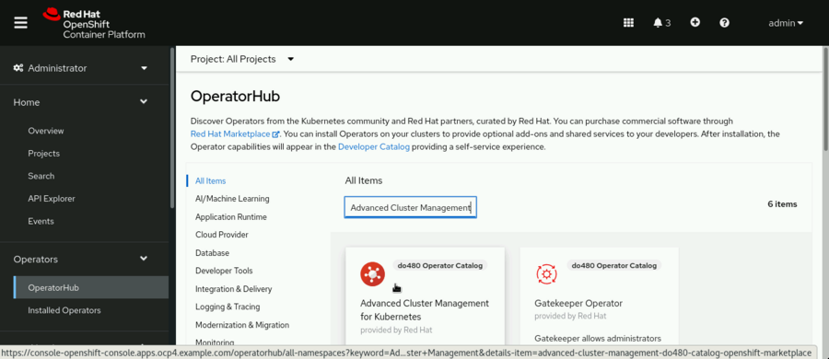

Click **Advanced Cluster Management for Kubernetes**, and then click **Install**.

In the **Update Channel**, ensure that the release-2.4 radio button is selected. In the **Update approval** section, select the **Manual** radio button to select a manual approval strategy. Then, click **Install**.

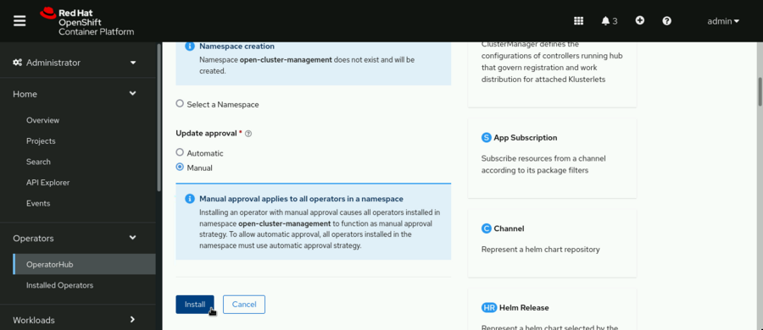

Next, you must approve the installation or updates to the RHACM operator manually.

Click **Approve** in the next step. The installation can take a few minutes to complete.

When the operator is installed, you see the following message:

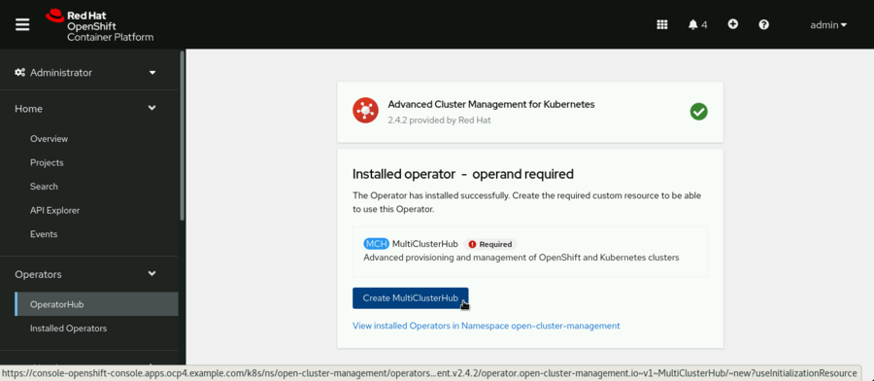

Click **Create MulticlusterHub**.

On the Create MulticlusterHub page, leave the default values and click **Create**. You are redirected to the MultiClusterHubs tab.

Initially, the multiclusterhub object has a Phase: Installing status.

After some minutes, the status Phase: Running displays in the Status column.

1. Verify the deployment of the MultiClusterHub.
   1. Open a terminal and log in to the ocp4.example.com cluster as the admin user. The API server address is https://api.ocp4.example.com:6443.

[student@workstation ~]$ **oc login -u admin -p redhat \**

**https://api.ocp4.example.com:6443**

Login successful.

...output omitted...

[student@workstation ~]$

* 1. Check the status of all the objects in the open-cluster-management namespace.

[student@workstation ~]$ **oc get all -n open-cluster-management**

...output omitted...

[student@workstation ~]$

The output is quite long. Review the status of the pods, services, deployments, replica sets, and stateful sets.

* 1. Retrieve the route to the RHACM web console, named multicloud-console.

[student@workstation ~]$ **oc get route multicloud-console \**

**-n open-cluster-management**

NAME HOST/PORT ...

multicloud-console **multicloud-console.apps.ocp4.example.com**

Copy the URL multicloud-console.apps.ocp4.example.com for the next step.

1. Test the RHACM deployment by importing the ocp4-mng.example.com cluster from the RHACM web console.
   1. From the workstation machine, navigate to the RHACM web console at https://multicloud-console.apps.ocp4.example.com. When prompted, click **htpasswd_provider** and log in as the admin user with the redhat password.
   2. Explore the **Infrastructure** → **Clusters** menu.

From the **Infrastructure** menu, click **Clusters**. Scroll down to locate the managed clusters. Notice that the local-cluster ocp4.example.com cluster, where the hub cluster runs, is automatically managed.

* 1. Generate the code to import an existing cluster.

Click **Import Cluster**.

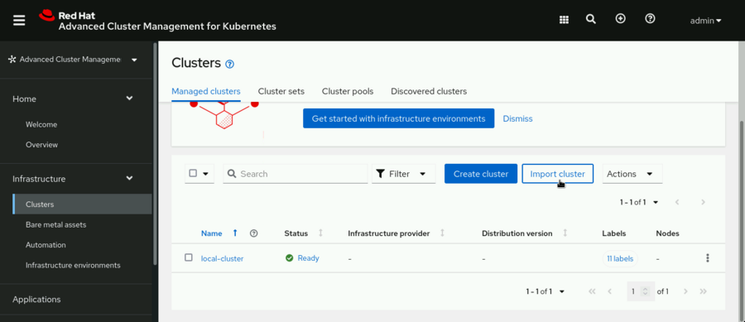

On the **Import an existing cluster** page, type the name to identify this cluster as follows:

* + - **Name**: managed-cluster

Leave the rest of the values unchanged and click **Save import and generate code**.

The **Save import and generate code** button now displays the Code generated successfully message.

Click **Copy command**.

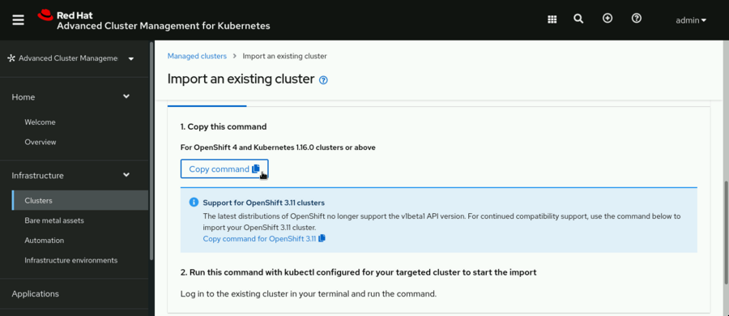

### Note

The previous steps copies a command to the clipboard to be executed in a terminal after logging in to the ocp4-mng.example.com managed cluster.

* 1. From the terminal, log in to the ocp4-mng.example.com cluster as the admin user. The API server address is <https://api.ocp4-mng.example.com:6443>.

[student@workstation ~]$ **oc login -u admin -p redhat \**

**https://api.ocp4-mng.example.com:6443**

Login successful.

...output omitted...

* 1. Paste the import code into the terminal and then press **Enter** to run it. Paste content from the clipboard by pressing **Ctrl**+**Shift**+**V** or use your preferred method. The paste command is quite long and most of it is base64 encoded.

[student@workstation ~]$ **echo "Ci0tLQph.....G9ydCBhZ2Fpbi4=" | base64 -d**

customresourcedefinition.apiextensions.k8s.io/klusterlets.operator.open-cluster-management.io created

namespace/open-cluster-management-agent created

serviceaccount/klusterlet created

secret/bootstrap-hub-kubeconfig created

clusterrole.rbac.authorization.k8s.io/klusterlet created

clusterrole.rbac.authorization.k8s.io/open-cluster-management:klusterlet-admin-aggregate-clusterrole created

clusterrolebinding.rbac.authorization.k8s.io/klusterlet created

deployment.apps/klusterlet created

klusterlet.operator.open-cluster-management.io/klusterlet created

[student@workstation ~]$

* 1. Verify the import of the managed cluster.

Return to the RHACM web console in Firefox. Navigate to **Infrastructure** → **Clusters**. The managed-cluster is now listed in the **Managed clusters** list.

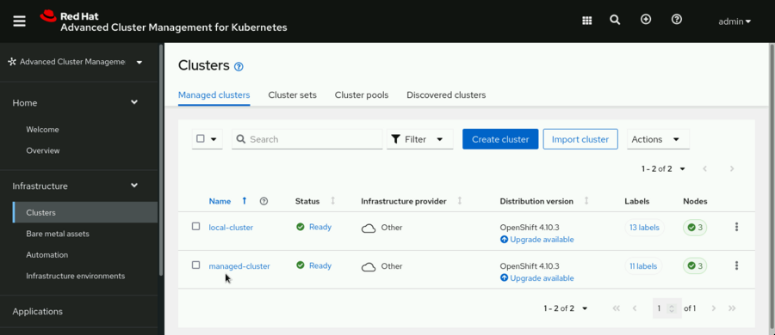

The managed-cluster is displayed in the RHACM web console almost immediately after executing the import code. Initially, you will see limited information about the cluster. After a few minutes, all the details of the cluster will become available.

1. Remove the imported cluster.
   1. From the RHACM web console, detach the imported cluster.

In the **Infrastructure** → **Clusters** pane, click the vertical ellipsis (**⋮**) menu to the right of the managed-cluster, and then click **Detach cluster**.

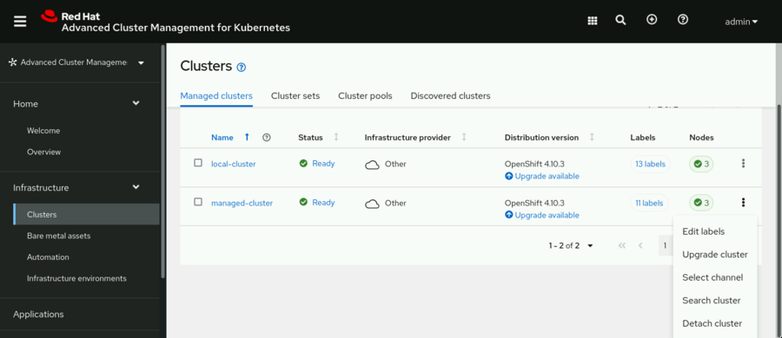

Type the managed-cluster cluster name in the confirmation window, and then click **Detach**.

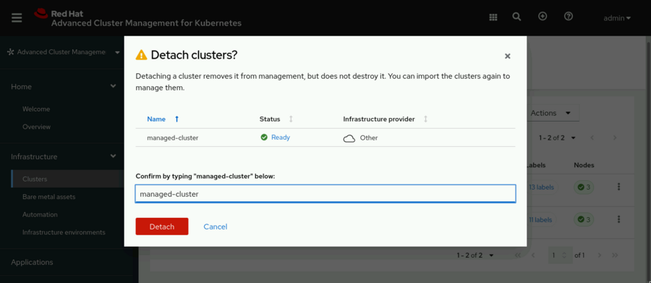

The status changes to Detaching and after a few minutes the managed-cluster is completely detached.

### Warning

Wait until the managed cluster is completely detached before continuing with the next step.

1. Uninstall the RHACM operator and all of its components.
   1. Delete the multiclusterhub object.

From the Red Hat OpenShift web console, navigate to **Operators** → **Installed Operators** and click **MultiClusterHub** in the Provided APIs column.

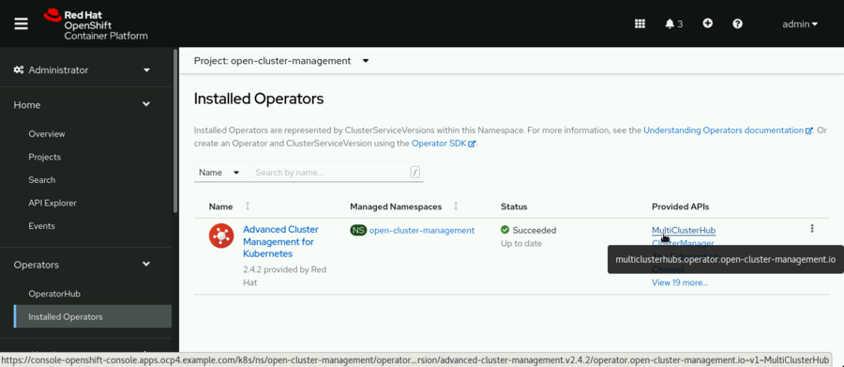

To the right of the multiclusterhub object, click the vertical ellipsis menu, and then click **Delete MultiClusterHub**.

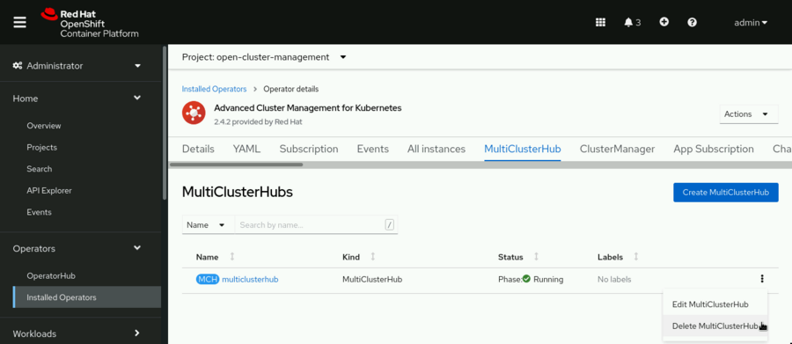

When prompted, click **Delete** to confirm. The Status column changes to Phase: Uninstalling and after a few minutes, the multiclusterhub object is completely removed. The page displays the No operands found message.

### Warning

It takes several minutes to remove the multiclusterhub object. Do not continue with the next step until the multiclusterhub object is completely removed.

* 1. Uninstall the Advanced Cluster Management for Kubernetes operator.

From the OpenShift web console, navigate to **Operators** → **Installed Operators**. Click **Options** on the right side of the Advanced Cluster Management for Kubernetes operator. Then, click **Uninstall Operator**.

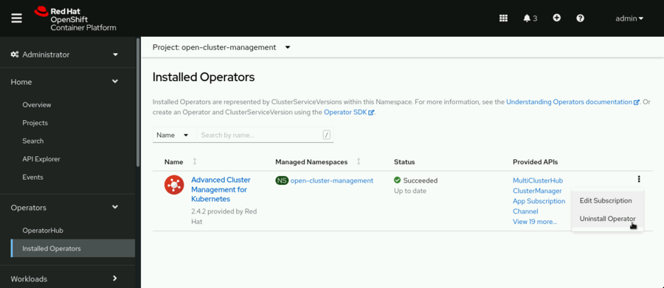

When prompted, click **Uninstall** to confirm. After a few minutes, the operator is completely uninstalled and the page displays the No Operators found message.

* 1. From the terminal, log in to the ocp4.example.com cluster as the admin user.

[student@workstation ~]$ **oc login -u admin -p \**

**redhat https://api.ocp4.example.com:6443**

Login successful.

...output omitted...

[student@workstation ~]$

* 1. Remove the open-cluster-management namespace.

From the terminal, run the following command to remove the namespace and any remaining objects in the open-cluster-management namespace:

[student@workstation ~]$ **oc delete project open-cluster-management**

project.project.openshift.io "open-cluster-management" deleted

[student@workstation ~]$

* 1. Delete the klusterlet and open-cluster-management:klusterlet-admin-aggregate-clusterrole cluster roles.

[student@workstation ~]$ **oc delete clusterrole klusterlet**

clusterrole.rbac.authorization.k8s.io "klusterlet" deleted

[student@workstation ~]$ **oc delete clusterrole \**

**open-cluster-management:klusterlet-admin-aggregate-clusterrole**

clusterrole.rbac.authorization.k8s.io "open-cluster-management:klusterlet-admin-aggregate-clusterrole" deleted

* 1. Delete the klusterlet cluster role binding.

[student@workstation ~]$ **oc delete clusterrolebinding klusterlet**

clusterrolebinding.rbac.authorization.k8s.io "klusterlet" deleted

* 1. Log in to the ocp4-mng.example.com cluster as the admin user.

[student@workstation ~]$ **oc login -u admin -p redhat \**

**https://api.ocp4-mng.example.com:6443**

Login successful.

...output omitted...

* 1. Delete the klusterlet and open-cluster-management:klusterlet-admin-aggregate-clusterrole cluster roles.

[student@workstation ~]$ **oc delete clusterrole klusterlet**

clusterrole.rbac.authorization.k8s.io "klusterlet" deleted

[student@workstation ~]$ **oc delete clusterrole \**

**open-cluster-management:klusterlet-admin-aggregate-clusterrole**

clusterrole.rbac.authorization.k8s.io "open-cluster-management:klusterlet-admin-aggregate-clusterrole" deleted

* 1. Delete the klusterlet cluster role binding.

[student@workstation ~]$ **oc delete clusterrolebinding klusterlet**

clusterrolebinding.rbac.authorization.k8s.io "klusterlet" deleted

**Finish**

On the workstation machine, change to the student user home directory and use the lab command to complete this exercise. This step is important to ensure that resources from previous exercises do not impact upcoming exercises.

[student@workstation ~]$ **lab finish multicluster-acm**

This concludes the section.

## **Lab: Installing the RHACM Operator and importing clusters**

* Install Red Hat Advanced Cluster Management for Kubernetes (RHACM) and import an existing cluster in the lab environment using the command-line interface.

**Outcomes**

You should be able to perform the following tasks by using the oc command-line tool:

* Install the RHACM operator.
* Create the MultiClusterHub object.
* Import an existing cluster into RHACM.

As the student user on the workstation machine, use the lab command to prepare your system for this exercise.

This command ensures that the RHACM operator is not already installed.

[student@workstation ~]$ **lab start multicluster-review**

### Note

The hub cluster must be installed in the ocp4.example.com cluster.

The managed-cluster URL is ocp4-mng.example.com.

1. Install the Advanced Cluster Management for Kubernetes operator on the ocp4.example.com cluster using the command line. Use the do480-catalog offline catalog. The lab script includes the DO480/labs/multicluster-review/operator-group.yaml, and the DO480/labs/multicluster-review/subscription.yaml solution files.
   1. From the workstation machine, open a terminal and log in to the ocp4 cluster as the admin user. The API server address is https://api.ocp4.example.com:6443.
   2. [student@workstation ~]$ **oc login -u admin -p redhat \**
   3. **https://api.ocp4.example.com:6443**

...output omitted...

* 1. Create a project named open-cluster-management.
  2. [student@workstation ~]$ **oc new-project open-cluster-management**
  3. Now using project "open-cluster-management" on server "https://api.ocp4.example.com:6443".

...output omitted...

* 1. Change to the ~/DO480/labs/multicluster-review directory.
  2. [student@workstation ~]$ **cd DO480/labs/multicluster-review**

[student@workstation multicluster-review]$

* 1. Create an operator group for the open-cluster-management namespace.

First, review the file named operator-group.yaml with the following contents:

apiVersion: operators.coreos.com/v1

kind: **OperatorGroup**

metadata:

name: **acm-operator-group**

spec:

targetNamespaces:

- **open-cluster-management**

Then, create the OperatorGroup object by using the oc command.

[student@workstation multicluster-review]$ **oc create -f operator-group.yaml**

operatorgroup.operators.coreos.com/acm-operator-group created

* 1. Create a subscription to the Advanced Cluster Management for Kubernetes operator.

First, review the file named subscription.yaml with the following contents:

apiVersion: operators.coreos.com/v1alpha1

kind: Subscription

metadata:

name: acm-operator-subscription

spec:

sourceNamespace: openshift-marketplace

source: do480-catalog

channel: release-2.4

installPlanApproval: Manual

name: advanced-cluster-management

Then, create the Subscription object using the oc command.

[student@workstation multicluster-review]$ **oc create -f subscription.yaml**

subscription.operators.coreos.com/acm-operator-subscription created

* 1. Approve the installation of the operator.

You must approve the installation manually because you created the subscription with the Manual approval strategy.

First, retrieve the installation plans.

[student@workstation multicluster-review]$ **oc get installplan**

NAME CSV APPROVAL APPROVED

**install-4k2q8** advanced-cluster-management.v2.4.2 Manual **false**

As you can see in the preceding output, the installation is not approved. Approve the install-4k2q8 installation plan by running the following command:

[student@workstation multicluster-review]$ **oc patch installplan *install-4k2q8* \**

**--type merge --patch '{"spec":{"approved":true}}'**

installplan.operators.coreos.com/install-4k2q8 patched

After the installation plan is approved, the cluster creates a ClusterServiceVersion object.

* 1. Watch the status of the available ClusterServiceVersion objects to verify the installation status. Wait until the PHASE column shows the Succeeded message.

[student@workstation multicluster-review]$ **watch oc get csv**

...output omitted...

NAME DISPLAY VERSION ... PHASE

advanced-cluster-management.v2.4.2 Advanced Cluster Management for Kubernetes 2.4.2 ... **Succeeded**

Exit the watch command by pressing **Ctrl**+**C**.

When the PHASE column shows the Succeeded message, the installation of the operator is complete.

1. [Hide Solution](https://rol.redhat.com/rol/app/)
2. Create the RHACM MultiClusterHub object. The lab script includes the DO480/labs/multicluster-review/mch.yaml solution file.
   1. From the terminal, review the file named mch.yaml containing the definition of the MultiClusterHub object.

apiVersion: operator.open-cluster-management.io/v1

kind: MultiClusterHub

metadata:

name: multiclusterhub

namespace: open-cluster-management

spec: {}

* 1. Use the oc command to create the MultiClusterHub object from the mch.yaml file.

[student@workstation multicluster-review]$ **oc create -f mch.yaml**

multiclusterhub.operator.open-cluster-management.io/multiclusterhub created

### Note

It takes around 5 minutes to create all the MultiClusterHub object resources.

* 1. Wait until the MultiClusterHub object creates all its components. Use the watch command to monitor the status.

[student@workstation multicluster-review]$ **watch oc get multiclusterhub**

...output omitted...

NAME STATUS AGE

multiclusterhub Installing 3m21s

When the STATUS column displays Running, exit the watch command by pressing **Ctrl**+**C**.

The creation of the MultiClusterHub object is complete.

1. [Hide Solution](https://rol.redhat.com/rol/app/)
2. Prepare RHACM to import a cluster using the name managed-cluster. The lab script includes the DO480/labs/multicluster-review/mngcluster.yaml, and the DO480/labs/multicluster-review/klusterlet.yaml solution files.
   1. In the hub cluster, create the managed-cluster namespace.

[student@workstation multicluster-review]$ **oc new-project managed-cluster**

...output omitted...

* 1. Label the namespace with the cluster name used by RHACM.

[student@workstation multicluster-review]$ **oc label namespace managed-cluster \**

**cluster.open-cluster-management.io/managedCluster=managed-cluster**

namespace/managed-cluster labeled

...output omitted...

* 1. Review the file named mngcluster.yaml with the following contents:

apiVersion: cluster.open-cluster-management.io/v1

kind: ManagedCluster

metadata:

name: **managed-cluster**

spec:

hubAcceptsClient: true

* 1. Create the ManagedCluster object using the previous file.
  2. [student@workstation multicluster-review]$ **oc create -f mngcluster.yaml**

managedcluster.cluster.open-cluster-management.io/managed-cluster created

* 1. Create a klusterlet add-on configuration using the file named klusterlet.yaml with the following contents:

apiVersion: agent.open-cluster-management.io/v1

kind: KlusterletAddonConfig

metadata:

name: managed-cluster

namespace: managed-cluster

spec:

clusterName: managed-cluster

clusterNamespace: managed-cluster

applicationManager:

enabled: true

certPolicyController:

enabled: true

clusterLabels:

cloud: auto-detect

vendor: auto-detect

iamPolicyController:

enabled: true

policyController:

enabled: true

searchCollector:

enabled: true

version: 2.4.2

* 1. Use the klusterlet.yaml file to create the klusterlet configuration in the hub cluster.

[student@workstation multicluster-review]$ **oc create -f klusterlet.yaml**

klusterletaddonconfig.agent.open-cluster-management.io/managed-cluster created

Next, the ManagedCluster-Import-Controller generates a secret named managed-cluster-import. This secret contains the import.yaml file that contains the secret used in the imported cluster.

1. [Hide Solution](https://rol.redhat.com/rol/app/)
2. Generate the files to import the managed-cluster into RHACM.
   1. Obtain the necessary files to import the managed-cluster cluster.

First, run the following command to obtain the klusterlet-crd.yaml file. This file is used to create the klusterlet in the managed-cluster.

[student@workstation multicluster-review]$ **oc get secret managed-cluster-import \**

**-n managed-cluster -o jsonpath={.data.crds\\.yaml} | base64 \**

**--decode > klusterlet-crd.yaml**

Second, obtain the import.yaml file by running the following command:

[student@workstation multicluster-review]$ **oc get secret managed-cluster-import \**

**-n managed-cluster -o jsonpath={.data.import\\.yaml} | base64 \**

**--decode > import.yaml**

This file contains the necessary secrets to import the managed-cluster into RHACM.

1. [Hide Solution](https://rol.redhat.com/rol/app/)
2. Import the RHOCP cluster available in the lab environment, ocp4-mng.example.com, into RHACM. Use managed-cluster as the name of the imported cluster.
   1. Use the terminal to log in to the ocp4-mng cluster as the admin user. The API server address is https://api.ocp4-mng.example.com:6443.

[student@workstation multicluster-review]$ **oc login -u admin -p redhat \**

**https://api.ocp4-mng.example.com:6443**

...output omitted...

* 1. Use the klusterlet-crd.yaml file to create the klusterlet custom resource definition.

[student@workstation multicluster-review]$ **oc create -f klusterlet-crd.yaml**

customresourcedefinition.apiextensions.k8s.io/klusterlets.operator.open-cluster-management.io created

* 1. Next, use the import.yaml file to create the rest of the resources necessary to import the cluster into RHACM.

[student@workstation multicluster-review]$ **oc create -f import.yaml**

namespace/open-cluster-management-agent created

serviceaccount/klusterlet created

secret/bootstrap-hub-kubeconfig created

clusterrole.rbac.authorization.k8s.io/klusterlet created

clusterrole.rbac.authorization.k8s.io/open-cluster-management:klusterlet-admin-aggregate-clusterrole created

clusterrolebinding.rbac.authorization.k8s.io/klusterlet created

deployment.apps/klusterlet created

klusterlet.operator.open-cluster-management.io/klusterlet created

* 1. Verify the status of the pods running in the open-cluster-management-agent namespace.

[student@workstation multicluster-review]$ **oc get pod -n open-cluster-management-agent**

NAME READY STATUS RESTARTS AGE

klusterlet-bfb4cd68f-j2fdt 1/1 Running 0 53s

klusterlet-registration-agent-5f749f5cf9-8xvp6 1/1 Running 0 36s

klusterlet-registration-agent-5f749f5cf9-pnkj6 1/1 Running 0 36s

klusterlet-registration-agent-5f749f5cf9-slk8j 1/1 Running 0 36s

klusterlet-work-agent-7d848f496b-7mnfw 1/1 Running 0 36s

klusterlet-work-agent-7d848f496b-bwkfv 1/1 Running 1 36s

klusterlet-work-agent-7d848f496b-wn2vd 1/1 Running 0 36s

* 1. Finally, use the watch command to validate the status of the agent pods running in the open-cluster-management-agent-addon namespace.

[student@workstation multicluster-review]$ **watch oc get pod -n open-cluster-management-agent-addon**

NAME READY STATUS RESTARTS AGE

klusterlet-addon-appmgr-7f69b84c76-kvhp7 1/1 Running 0 55s

klusterlet-addon-certpolicyctrl-7c97656db8-5s6xk 1/1 Running 0 54s

klusterlet-addon-iampolicyctrl-6f8cccf86c-lj2fg 1/1 Running 0 54s

klusterlet-addon-operator-b479bb446-kpc6t 1/1 Running 0 83s

klusterlet-addon-policyctrl-config-policy-769745c7b6-78sw2 1/1 Running 0 54s

klusterlet-addon-policyctrl-framework-6455bc9558-bz8mc 3/3 Running 0 54s

klusterlet-addon-search-7b5bb78f98-h2jlg 1/1 Running 0 53s

klusterlet-addon-workmgr-5b84cfd6dc-nxwvt 1/1 Running 0 52s

### Note

It takes around two minutes before the pods in the open-cluster-management-agent-addon start.

When all the pods are ready, press **Ctrl**+**C** to exit the watch command.

1. [Hide Solution](https://rol.redhat.com/rol/app/)
2. Log back into the hub cluster and verify the managed-cluster status.
   1. Log back into the hub cluster.

[student@workstation multicluster-review]$ **oc login -u admin -p redhat \**

**https://api.ocp4.example.com:6443**

...output omitted...

[student@workstation multicluster-review]$

* 1. Verify the managed-cluster status.

[student@workstation multicluster-review]$ **oc get managedcluster**

NAME HUB ACCEPTED ... JOINED AVAILABLE AGE

local-cluster true ... True True 4h26m

managed-cluster true ... True True 42m

The JOINED and AVAILABLE must have a True status.

* 1. Change to the /home/student directory.

[student@workstation multicluster-review]$ **cd /home/student**

[student@workstation ~]$

1. [Hide Solution](https://rol.redhat.com/rol/app/)

**Evaluation**

As the student user on the workstation machine, use the lab command to grade your work. Correct any reported failures and rerun the command until successful.

[student@workstation ~]$ **lab grade multicluster-review**

**Finish**

Do not make any other changes to the lab environment until the next guided exercise. You will continue using this environment in upcoming exercises.

As the student user on the workstation machine, use the lab command to complete this exercise.

[student@workstation ~]$ **lab finish multicluster-review**

This concludes the section

# **Chapter 2.  Inspecting Resources from Multiple Clusters Using the RHACM Web Console**

[Navigating the RHACM Web Console](https://rol.redhat.com/rol/app/courses/do480-2.4/pages/ch02)

[Guided Exercise: Navigating the RHACM Web Console](https://rol.redhat.com/rol/app/courses/do480-2.4/pages/ch02s02)

[Configuring Access Control for Multicluster Management](https://rol.redhat.com/rol/app/courses/do480-2.4/pages/ch02s03)

[Guided Exercise: Configuring Access Control for Multicluster Management](https://rol.redhat.com/rol/app/courses/do480-2.4/pages/ch02s04)

[Lab: Managing Resources from Multiple Clusters Using the RHACM Web Console](https://rol.redhat.com/rol/app/courses/do480-2.4/pages/ch02s05)

[Summary](https://rol.redhat.com/rol/app/courses/do480-2.4/pages/ch02s06)

**Abstract**

|  |  |
| --- | --- |
| **Goal** | Describe and navigate the Red Hat Advanced Cluster Management for Kubernetes (RHACM) web console. Configure role-based access control (RBAC) and search for resources across multiple clusters by using the RHACM search engine. |
| **Objectives** | * Locate objects across a fleet of managed clusters by using the search engine and enumerate Red Hat Advanced Cluster Management for Kubernetes (RHACM) features through the web console. * Create different user roles in Red Hat Advanced Cluster Management for Kubernetes (RHACM) and define an authentication model for multicluster management. |
| **Sections** | * Navigating the RHACM Web Console (and Guided Exercise) * Configuring Access Control for Multicluster Management (and Guided Exercise) |
| **Lab** | * Managing Resources from Multiple Clusters Using the RHACM Web Console |

## **Navigating the RHACM Web Console**

### **Objectives**

* Locate objects across a fleet of managed clusters by using the search engine and enumerate Red Hat Advanced Cluster Management for Kubernetes (RHACM) features through the web console.

### **RHACM Web Console Overview**

The Red Hat Advanced Cluster Management for Kubernetes (RHACM) web console provides a single access point to all the management and observation features of a fleet of Kubernetes or OpenShift clusters.

You can access the different components of the RHACM web console through the navigation panel. The following sections describe the items in the navigation panel.

#### **Home**

The **Home** page provides information about RHACM and its use cases, and links to the main product features. The **Home** page includes the following submenus:

**Welcome**

Provides information and links to access the main RHACM features.

**Overview**

Provides a summary and a high-level overview of the details and status of the managed clusters.

#### **Infrastructure**

The **Infrastructure** menu provides access to cluster lifecycle management, bare-metal asset management, Ansible automation configuration, and infrastructure environment management. This menu provides access to the following pages:

**Clusters**

The **Clusters** page provides access to the following features:

* Creating or upgrading a cluster in many different public cloud providers.
* Importing an existing cluster to the RHACM hub cluster so that you can manage it.
* Manually scaling the clusters, or enabling autoscaling. The process of resizing a cluster is different if you created the cluster by using RHACM, or if the cluster already existed and you imported it to RHACM.
* Using RHACM features such as cluster sets, cluster pools, and discovering clusters.

### Note

A list of supported hub cluster providers is available in the [RHACM documentation](https://access.redhat.com/documentation/en-us/red_hat_advanced_cluster_management_for_kubernetes/2.4/html-single/clusters/supported-clouds#supported-hub-cluster-providers).

A list of supported managed cluster providers is available in the [RHACM documentation](https://access.redhat.com/documentation/en-us/red_hat_advanced_cluster_management_for_kubernetes/2.4/html-single/clusters/index#supported-managed-cluster-providers).

**Bare metal assets**

In RHACM, a bare metal asset is a collection of physical or virtual servers that you can configure to run your OpenShift clusters. RHACM uses the Intelligent Platform Management Interface (IPMI) set of specifications to interact with the bare metal assets by using their Baseboard Management Controller (BMC) microcontrollers. The **Bare metal assets** page integrates bare metal assets into RHACM via their BMC address. RHACM uses the integration of bare metal assets to deploy and manage clusters hosted by the virtual or physical infrastructure.

**Automation**

Use the **Automation** page to create Ansible job templates and run Ansible jobs automatically during different stages of a cluster lifecycle. To create Ansible templates you need Ansible Automation Platform Resource Operator installed on the RHACM hub cluster. You also need Ansible Tower 3.7.3 or later available.

**Infrastructure environments**

In RHACM, an infrastructure environment is a pool of resources that you use to create hosts, and to create clusters on those hosts. The main component for managing infrastructure environments is the Central Infrastructure Management (CIM) service, which you need to enable. From the **Infrastructure environments** page, you can create infrastructure environments and access them to add hosts.

#### **Applications**

You can use the **Applications** page to create, deploy, and manage applications across a cluster fleet.

You can find more information in [Chapter 5, *Deploying Applications Across Multiple Clusters with RHACM*](https://rol.redhat.com/rol/app/courses/do480-2.4/pages/ch05).

#### **Governance**

You can use the **Governance** page to create and manage policies and policy controllers, and apply those to the cluster fleet.

You can find more information in [Chapter 3, *Deploying and Managing Policies for Multiple Clusters with RHACM*](https://rol.redhat.com/rol/app/courses/do480-2.4/pages/ch03).

#### **Credentials**

In RHACM, a credential stores the access information for a cloud provider. The RHACM credentials use the format of Kubernetes secrets objects. Each credential has two keys: the cloud provider access information, and a DNS name within that cloud provider. RHACM uses the following credential types:

* Cloud provider credentials: For example, Amazon Web Services, Google Cloud Platform, and Microsoft Azure.
* Data center credentials: For example, Red Hat OpenStack Platform or bare metal resources.
* Automation and other credentials: For example, for access to Red Hat Ansible Automation Platform.
* Centrally managed: A credential type for on-premise environments.

You can use the **Credentials** page to create and administer credentials for all cloud providers and systems.

### **RHACM Search Engine**

The RHACM search engine provides visibility of the Kubernetes objects across the cluster fleet from a single user interface.

The RHACM search engine is always enabled. Click the **Search** icon in the upper-right of the console to access it.

The search engine indexes and stores Kubernetes objects in the cluster fleet, and determines their relationships with other objects.

The RHACM search engine architecture is composed of the following components:

**Collector**

A collector is deployed in each of the fleet clusters. In the hub cluster, the search collector is deployed in the open-cluster-management namespace. In the other managed clusters, the collector is deployed in the open-cluster-management-agent-addon namespace, as part of the search-collector add-on. The collector indexes the Kubernetes objects information and computes relationships for objects within the managed clusters.

**Aggregator**

The aggregator is only deployed in the RHACM hub cluster, in the open-cluster-management namespace. The aggregator collects data from multiple collectors in different managed clusters, and writes that data to a Redis database in the search-redisgraph stateful set. The aggregator also computes relationships between objects of different clusters, and tracks the activity from the collectors that send data from the managed clusters.

**Search API**

The search API provides access to the data in the search index, enforcing role-based access control (RBAC). The search API uses the RBAC of each managed cluster. If you are using the RHACM web console, you can only search for objects in a managed cluster where you already have authorization.

**Search UI**

The search UI is deployed as part of the RHACM MultiClusterHub object.

#### **Using the Search Engine**

You can type free text in the **Search** field of the user interface. The search engine tries to locate that text in the Redis database of indexes, and shows results for any object that contains that string. The UI orders the results in a table by type of Kubernetes or OpenShift object, represented by the kind filter.

You can refine each search by adding more filters to the query. As you add new filters, the UI displays the values that are stored for that index.

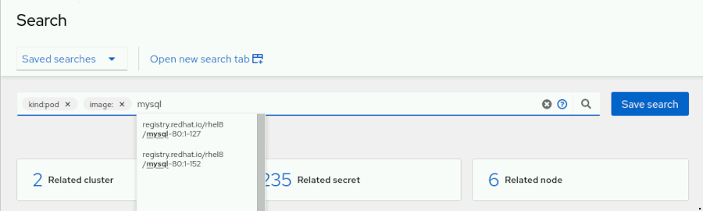

Figure 2.1: Example of search auto-completion

Some filters allow arithmetic comparators for fields of numeric nature, such as the cpu, replicas, capacity, and memory filters.

You can also use the search UI to edit objects. If you click an object displayed in a result, you can see the YAML definition of the object and the **Edit** button.

#### **What Is Indexed**

The RHACM search engine uses many different filters to classify the objects in the cluster fleet. Those filters are the keys of the indexing process. The **Search** UI provides access to all the available filters.

|  |
| --- |
|  |

You can use any of the filters to search, and you can also make free text searches. You cannot make a search refining by all the fields of the Kubernetes object: if the field is not part of a filter, it is not indexed for search.

For example, the Deployment Kubernetes object has desired and replicas fields defined in its specification. The RHACM search engine only indexes the desired field, however, and you cannot search with the strategy filter, which does not exist in the index.

### Note

The RHACM search engine always uses the label filter to index every Kubernetes object. It is a good practice to set labels on objects during the different phases of the CI/CD process, to make more accurate and faster searches.

### References

For more information, refer to the Red Hat Advanced Cluster Management for Kubernetes Web Console guide at <https://access.redhat.com/documentation/en-us/red_hat_advanced_cluster_management_for_kubernetes/2.4/html-single/web_console/index>

For more information about cluster management, refer to the Red Hat Advanced Cluster Management for Kubernetes Clusters guide at <https://access.redhat.com/documentation/en-us/red_hat_advanced_cluster_management_for_kubernetes/2.4/html-single/clusters/index>

For more information about configuring and tuning the search engine, refer to the Red Hat Advanced Cluster Management for Kubernetes Web Console guide at <https://access.redhat.com/documentation/en-us/red_hat_advanced_cluster_management_for_kubernetes/2.4/html-single/web_console/index#search-customization>

For more information about credentials, refer to the Red Hat Advanced Cluster Management for Kubernetes Credentials guide at <https://access.redhat.com/documentation/en-us/red_hat_advanced_cluster_management_for_kubernetes/2.4/html-single/credentials/index>

Guided Exercise: Navigating the RHACM Web Console

* Use the Red Hat Advanced Cluster Management for Kubernetes (RHACM) console to list the failed deployments, diagnose the cause of a failed MySQL deployment, and fix it. You also identify which database server is most used by developers for their relational persistence layer in the applications. You also ensure that there are no running containers in any cluster that are using a specific MySQL image with known vulnerabilities.

**Outcomes**

* Use saved searches in the RHACM web console to quickly identify the failing deployments across a cluster fleet.
* Use the RHACM web console to locate Kubernetes and OpenShift objects across a cluster fleet.
* Use the RHACM web console to edit Kubernetes objects across a cluster fleet.

As the student user on the workstation machine, use the lab command to prepare your system for this exercise. This command creates 15 namespaces in each managed cluster and populates them with nine different applications using three different database servers.

**Note**

The preparation of this lab changes the screen resolution to 1920x1080 for better viewing of the RHACM console. The resolution is reverted at the end of the lab.

[student@workstation ~]$ **lab start features-console**

1. Use the RHACM web console Saved searches feature to identify any failed database server deployments across the cluster fleet.
   1. From the workstation machine, navigate to the RHACM web console at https://multicloud-console.apps.ocp4.example.com. When prompted, click **htpasswd_provider** and log in as the admin user with the redhat password.
   2. Click the **Search** icon in the upper-right corner of the window to open the RHACM search web interface.
   3. Click the **Unhealthy pods** tile in the list of suggested search templates. Notice that the syntax of the search is based on the status of the pods.



Figure 2.3: Unhealthy pods search syntax

**Note**

The search results can show pods unrelated to MySQL deployments. Ignore those results and use the results related to the MySQL deployments.

Notice the two failing pods with names mysql-*POD_ID*. The two failing pods are in the company-applications-5 namespace. Each managed cluster contains a company-applications-5 namespace.

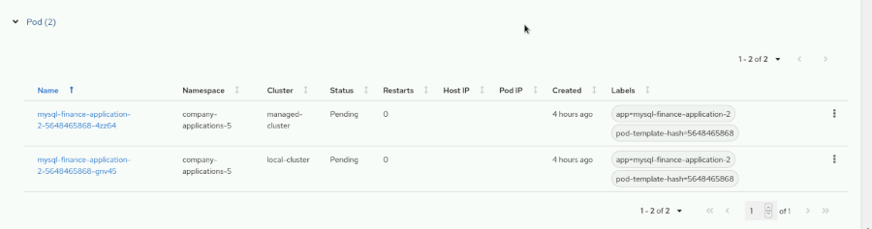

Figure 2.4: Unhealthy pods search results

* 1. Click the name of one of the MySQL pods in the Pending status. Scroll down to the status: section of the YAML file to identify the cause of the failure. This section is near the end of the YAML file.

Notice that the pods are pending because there is a reference to a Persistent Volume Claim (PVC) that does not exist.

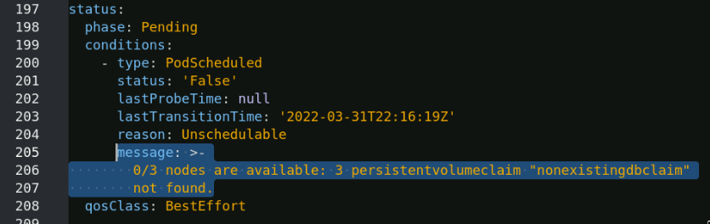

Figure 2.5: Message indicating the reason for the pod failure

* 1. Navigate back to **Unhealthy pods** in the list of suggested search templates and then click **Related deployment**. The deployment that contains the pods is mysql-finance-application-2. The deployment is present in all the managed clusters.
  2. Click the **Search** icon again to search for the correct name of the existing PVCs.

Type namespace:company-applications-5 kind:persistentvolumeclaim in the search field. The name of the existing PVC is dbclaim.

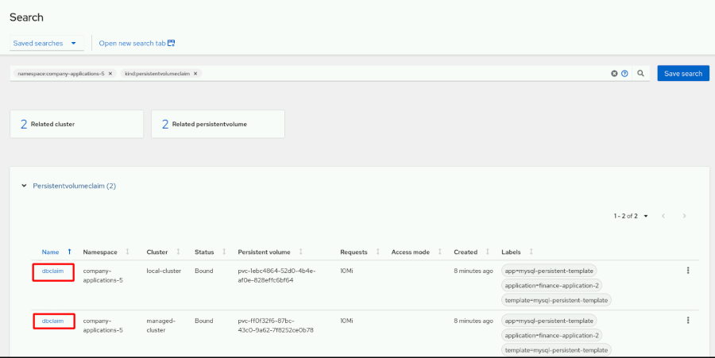

Figure 2.6: Results of the search for the existing persistent volume claims

* 1. Click the **Search** icon again to start a new search.

Type namespace:company-applications-5 kind:deployment in the search field.

* 1. Click the name of the first deployment in the **Deployment** results to display the YAML file. In the upper-right corner of the window, click **Edit**, and set claimName: to dbclaim as the PVC name.

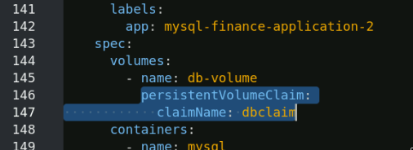

Figure 2.7: Correcting the PVC name in the YAML file for a pod

Click **Save** to trigger a redeployment automatically using the correct PVC name.

* 1. Repeat the operation to fix the failing deployment in the other cluster.
  2. Navigate to the saved searches page and run the **Unhealthy pods** saved search to verify that there are no more MySQL pods failing.

1. Search for any database software deployed across the fleet of managed clusters.
   1. In the search field, type namespace: and look at the different namespaces across the cluster fleet offered by the search engine. Notice that the company application deployment namespaces always use the company-applications- prefix.
   2. Clear the search field and type kind:deployment. Add kind:deploymentconfig to the search. Notice that the RHACM console merges the filters using the kind:deployment,deploymentconfig syntax.

Finally, add the free text mysql to the search.

Notice that the MySQL instances are deployed as Kubernetes Deployment objects. The application label indicates the name of the application. Two different applications are using MySQL containers: globalshop-application and finance-application-2.

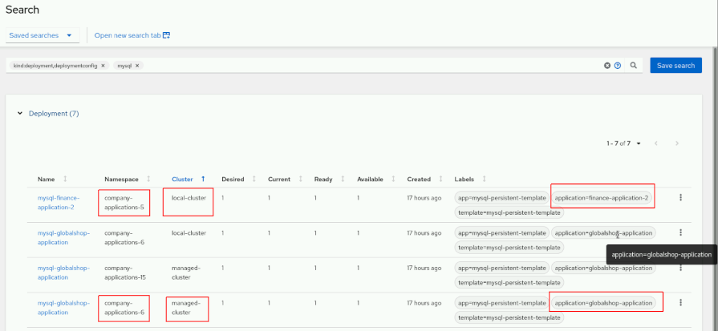

Figure 2.8: The results of search for deployments with the "mysql" free text, with the "application" label

* 1. In the search field, remove the free text mysql and replace it with mariadb. Do not remove the kind:deployment,deploymentconfig filter.

Notice that the MariaDB instances are deployed as OpenShift DeploymentConfig objects. Use the application label to locate the name. Two different applications are using MariaDB containers: humanresources-application-1 and marketing-application-2.

* 1. In the search field, remove the free text mariadb and replace it with postgresql. Do not remove the kind:deployment,deploymentconfig filter. Notice that PostgreSQL is deployed as OpenShift DeploymentConfig objects. Use the application label to locate the name.

Five different applications are using PostgreSQL containers: finance-application-1, finance-application-3 finance-application-4,humanresources-application-2, and marketing-application-1.

The most used database server is PostgreSQL, which is used in five of the nine applications.

1. Use the RHACM web console to locate any running containers that are using a MySQL image with known vulnerabilities.

Red Hat Container Catalog states that the image in use for MySQL 8 must be registry.redhat.io/rhel8/mysql-80:1, because that tag always point to the latest stable version available. For example, the MySQL image with the registry.redhat.io/rhel8/mysql-80:1-127 tag contains important vulnerabilities and must not be used. See the [Red Hat Container Catalog](https://catalog.redhat.com/software/containers/rhel8/mysql-80/5ba0ad4cdd19c70b45cbf48c) website for more information about this image.

Find the applications using the container image mysql-80 with the 1-127 tag.

* 1. Type registry.redhat.io/rhel8/mysql-80 in the search field.

Notice that the results only contain objects of type Pod.

* 1. Click one of the pod names to see the reference to the container image in use in its YAML definition. Most of the MySQL running pods are using registry.redhat.io/rhel8/mysql-80 with the 1-152 tag.
  2. Click **Search** in the upper-left of the pane to return to the initial search page, keeping the results. Do not remove the filter registry.redhat.io/rhel8/mysql-80, and add "1-127" in the search field.
  3. Inspect the results; notice two pods running in namespaces with the same name, but in different clusters.
  4. Click one of the pods to see the image in use in its YAML definition.
  5. Click the **Logs** tab and verify the running version of MySQL. The 1-152 tag corresponds to the 8.0.26 version, and the 1-127 tag is the earlier one, 8.0.21. This information is stated in the Red Hat Container Catalog.

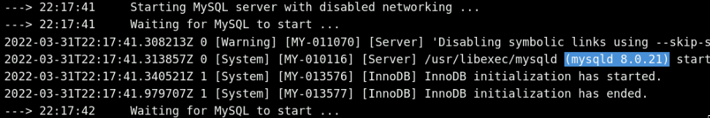

Figure 2.9: Verifying the version of MySQL

With this information, you can inform the developers which namespaces contain running pods using a vulnerable MySQL container image.

**Finish**

On the workstation machine, change to the student user home directory and use the lab command to complete this exercise. This step is important to ensure that resources from previous exercises do not impact upcoming exercises.

[student@workstation ~]$ **lab finish features-console**

This concludes the section

## **Configuring Access Control for Multicluster Management**

### **Objectives**

* Create different user roles in Red Hat Advanced Cluster Management for Kubernetes (RHACM) and define an authentication model for multicluster management.

### **Role-based Access Control in RHACM**

Red Hat Advanced Cluster Management for Kubernetes (RHACM) access control uses the Red Hat OpenShift Container Platform (RHOCP) authentication layer and roles. Administrators can design a multicluster authentication model to define access for different tenants to different groups of clusters, with fine-grained control.

#### **RHACM Cluster Sets**

To create different groups of clusters, RHACM defines the concept of cluster sets, represented by the ClusterSet object. A cluster set labels all the clusters that belong to it with the cluster.open-cluster-management.io/clusterset=*managed_clusterset_name* label. RHACM uses this label to identify the clusters that belong to the cluster set, enabling you to take action on all the member clusters at once.

| **Role** | **Definition** |
| --- | --- |
| open-cluster-management:​cluster-manager-admin | RHACM super user, with full access. Can create a ManagedCluster resource. |
| open-cluster-management:​admin:*managed_cluster_name* | RHACM administrator access to the ManagedCluster resource named *managed_cluster_name*. |
| open-cluster-management:​view:*managed_cluster_name* | RHACM view access to the ManagedCluster resource named *managed_cluster_name*. |
| open-cluster-management:​managedclusterset:admin:​*managed_clusterset_name* | RHACM administrator access to the ManagedClusterSet resource named *managed_clusterset_name*. |
| open-cluster-management:​managedclusterset:view:​*managed_clusterset_name* | RHACM view access to the ManagedClusterSet resource named *managed_clusterset_name*. |
| open-cluster-management:​subscription-admin | Can create Git subscriptions that deploy Kubernetes resources YAML files to multiple namespaces. |

RHACM also supports the following default RHOCP roles:

| **Role** | **Definition** |
| --- | --- |
| cluster-admin | RHOCP super user, with full access. |
| admin  edit  view | RHOCP default roles. A user with a namespace-scoped binding to these roles has access to open-cluster-management resources in a specific namespace.  Cluster-wide binding to the same roles gives access to all of the open-cluster-management resources. |

RHACM roles are especially useful for assigning user or group permissions to a cluster set. You can assign the admin and view cluster set roles by using the oc adm command or by navigating to the **Access management** tab within the **Cluster sets** details pane in the RHACM web console.

#### **Cluster Selectors and Cluster Sets**

A cluster cannot belong to more than one cluster set simultaneously. If you need to define overlapping groups of clusters, you can use cluster labels, acting as selectors.

By combining cluster sets and cluster selectors, you can use other tools outside of RHACM to act on a subset of clusters belonging to the same or different cluster sets.

#### **Placement Resources**

You can use placement resources to define a subset of clusters that belong to different cluster sets for placing Kubernetes resources.

Placement resources can use labelSelector, claimSelector, clusterSet, and numberOfClusters parameters to determine the clusters on which to deploy the applications.

For example, the following placement resource uses the claimSelector parameter to specify that resources should deploy on clusters from the us-west-1 region.

apiVersion: cluster.open-cluster-management.io/v1alpha1

kind: Placement

metadata:

name: placement2

namespace: ns1

spec:

predicates:

- requiredClusterSelector:

**claimSelector:**

matchExpressions:

- key: region.open-cluster-management.io

operator: In

values:

**- us-west-1**

### Note

For more information, refer to the Using ManagedClusterSets with Placement section at <https://access.redhat.com/documentation/en-us/red_hat_advanced_cluster_management_for_kubernetes/2.3/html-single/clusters/index#placement-managed>

### **Benefits of a Centralized Identity Management Service**

One important challenge in multicluster environments is managing the authentication and authorization mechanisms in a fully controlled manner across different Kubernetes and OpenShift clusters.

As noted previously, RHACM uses the Red Hat OpenShift Container Platform authentication and authorization layers. The OpenShift authentication layer uses the OAuth open standard as an authorization framework. By default, OpenShift uses an internal OAuth server. Neither Kubernetes nor OpenShift currently provides a way to federate all the internal OAuth servers of each cluster.

To solve this problem, you can use an external identity manager for central management of the users who access your clusters.

### Note

You can find the list of supported OAuth providers in the Supported identity providers section of the Red Hat OpenShift Container Platform Authorization and Authentication guide at <https://access.redhat.com/documentation/en-us/openshift_container_platform/4.9/html-single/authentication_and_authorization/index#supported-identity-providers>

### References

For more information, refer to the Red Hat Advanced Cluster Management for Kubernetes Access Control guide at <https://access.redhat.com/documentation/en-us/red_hat_advanced_cluster_management_for_kubernetes/2.3/html-single/access_control/index>

## **Guided Exercise: Configuring Access Control for Multicluster Management**

* Create cluster sets using existing Red Hat OpenShift clusters, and then configure existing users in Red Hat OpenShift Container Platform (RHOCP) to manage those cluster sets.

**Outcomes**

* Create a cluster set.
* Assign a managed cluster to a cluster set.
* Assign predefined RHACM roles to different users.
* Remove a cluster set.

As the student user on the workstation machine, use the lab command to prepare your system for this exercise.

The lab environment includes one server for Identity Management in Red Hat Enterprise Linux (IdM). This command ensures that the necessary users and roles exist in the IdM server. It also configures an additional LDAP identity provider in the hub cluster.

The following table summarizes the users and groups available in the IdM server for this exercise.

| **User** | **Group** |
| --- | --- |
| prod-admin | production-administrators |
| stage-admin | stage-administrators |

[student@workstation ~]$ **lab start features-users**

1. From the RHACM web console, create a cluster set named production and add the cluster named local-cluster.
   1. From the workstation machine, navigate to the RHACM web console at https://multicloud-console.apps.ocp4.example.com. When prompted, click **htpasswd_provider** and log in as the admin user with the redhat password.
   2. Navigate to **Infrastructure** → **Clusters** and click **Cluster sets**.

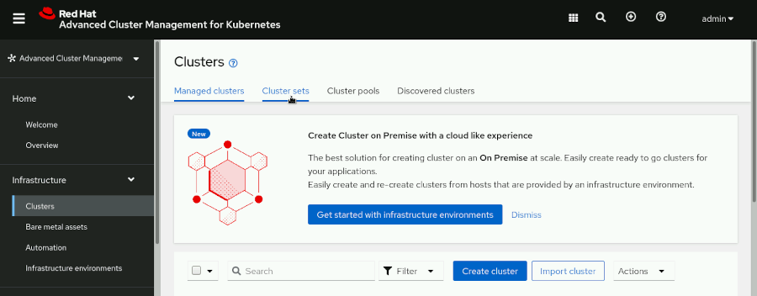

Figure 2.10: Location of the cluster sets button in the RHACM console

Scroll down and click **Create cluster set** to open the **Create cluster set** dialog box.

* 1. Type production in the **Cluster set name** field and then click **Create**.
  2. In the confirmation dialog box, click **Manage resource assignments**. Select the cluster named local-cluster and then click **Review**.

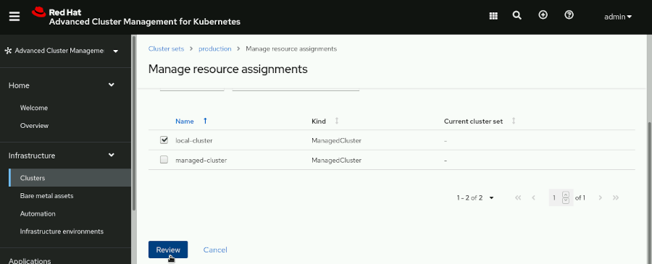

* 1. On the confirmation page, click **Save** to display the **Overview** tab of the production cluster set.

1. Verify the labels corresponding to the production cluster set.
   1. On the **Managed clusters** page of the production cluster set, click **Managed clusters**.
   2. Click **14 labels** to expand the list of labels assigned to this cluster. Notice the cluster.open-cluster-management.io/clusterset=production label. RHACM uses this label to identify clusters pertaining to a cluster set.

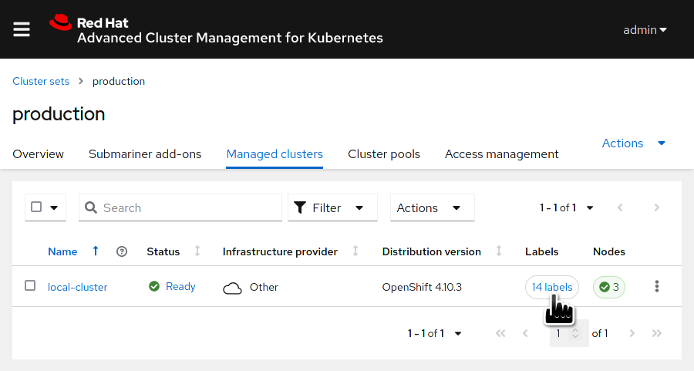

Figure 2.12: The managed clusters page of the production cluster set and the labels button

### Note

The number of labels might vary.

1. From the RHACM web console, create a cluster set named stage and add the cluster named managed-cluster.
   1. Navigate to **Infrastructure** → **Clusters** and click **Cluster sets**.

Scroll down and click **Create cluster set** to open the **Create cluster set** dialog box.

* 1. Type stage in the **Cluster set name** field and then click **Create**.
  2. In the confirmation dialog box, click **Manage resource assignments**. Select the cluster named managed-cluster and then click **Review**.
  3. On the confirmation page, click **Save** to display the **Overview** tab of the stage cluster set.
  4. On the **Managed clusters** page of the stage cluster set, click **11 labels** to verify that RHACM adds the label cluster.open-cluster-management.io/clusterset=stage to the managed-cluster cluster.

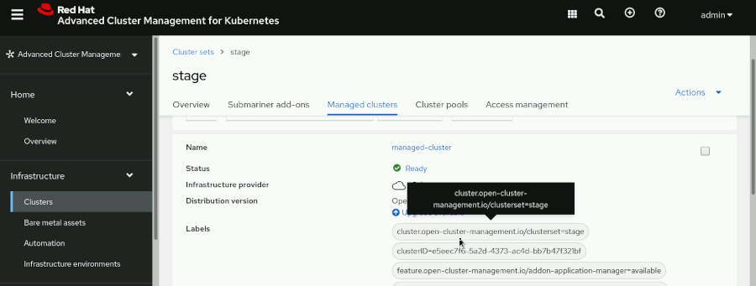

### Note

The number of labels might vary.

1. From the terminal, assign administrator permissions to the production-administrators group in the production cluster set. Assign view permissions to the production-administrators group in the stage cluster set.

### Note

RHACM automatically creates default admin and view cluster roles in the hub cluster for each new cluster set. For example, to grant administrator permissions to the production cluster set, use the open-cluster-management:managedclusterset:admin:*clusterset_name* role.

To grant view permissions to the production cluster set, use the open-cluster-management:managedclusterset:view:*clusterset_name* role.

* 1. Open a terminal and log in to the ocp4 cluster as the admin user. The API Server URL is https://api.ocp4.example.com:6443.
  2. [student@workstation ~]$ **oc login -u admin -p redhat https://api.ocp4.example.com:6443**
  3. Login successful.
  4. ...output omitted...

[student@workstation ~]$

* 1. Use the oc adm command to assign the open-cluster-management:managedclusterset:admin:production cluster role to the production-administrators group.

### Note

The production-administrators group already exists in the Red Hat Identity Management server in the lab environment. The lab start command triggers a group synchronization between the hub cluster and the Red Hat Identity Management server.

[student@workstation ~]$ **oc adm policy add-cluster-role-to-group \**

**open-cluster-management:managedclusterset:admin:production \**

**production-administrators**

clusterrole.rbac.authorization.k8s.io/open-cluster-management:managedclusterset:admin:production added: "production-administrators"

* 1. Use the oc adm command to assign the open-cluster-management:managedclusterset:view:stage cluster role to the production-administrators group.
  2. [student@workstation ~]$ **oc adm policy add-cluster-role-to-group \**
  3. **open-cluster-management:managedclusterset:view:stage \**
  4. **production-administrators**

clusterrole.rbac.authorization.k8s.io/open-cluster-management:managedclusterset:view:stage added: "production-administrators"

1. From the terminal, assign administrator permissions to the stage-administrators group in the stage cluster set. Do not assign any permissions to the stage-administrators group for the production cluster set.
   1. Use the oc adm command to assign the open-cluster-management:managedclusterset:admin:stage cluster role to the stage-administrators group.
   2. [student@workstation ~]$ **oc adm policy add-cluster-role-to-group \**
   3. **open-cluster-management:managedclusterset:admin:stage stage-administrators**

clusterrole.rbac.authorization.k8s.io/open-cluster-management:managedclusterset:admin:stage added: "stage-administrators"

The following table summarizes the users, groups, and roles at this point.

| **User** | **Group** | **Roles** |
| --- | --- | --- |
| prod-admin | production-administrators | open-cluster-management:managedclusterset:admin:production  open-cluster-management:managedclusterset:view:stage |
| stage-admin | stage-administrators | open-cluster-management:managedclusterset:admin:stage |

1. Log out of RHACM and close Firefox to remove any cached credentials in the browser. Open Firefox again and log in to the RHACM web console as the prod-admin user from the Red Hat Identity Management provider. Verify that the prod-admin user has administrator permissions on the production cluster set, comprised of the cluster named local-cluster. Also, verify that the prod-admin user only has view permissions on the stage cluster set.

### Note

The prod-admin user is member of the production-administrators group.

* 1. Log out of RHACM.

From the RHACM web console, click **admin** in the upper-right corner, and click **Logout**.

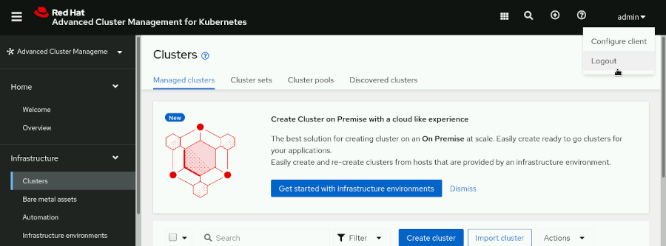

* 1. Close all windows of Firefox. Open a new Firefox window and log in to the RHACM web console as the prod-admin user from the Red Hat Identity Management provider.

When prompted, click **Red Hat Identity Management** and log in as the prod-admin user with the redhat password.

* 1. Navigate to **Infrastructure** → **Clusters**. Note the differences between the two clusters.

The **Upgrade available** link is active for local-cluster, but inactive for managed-cluster. This is because the prod-admin user has administrator privileges in the production cluster set, but only view permissions in the stage cluster set.

* 1. Click the vertical ellipsis (**⋮**) menu to the right of the local-cluster row.

Note that as an administrator, all options are enabled.

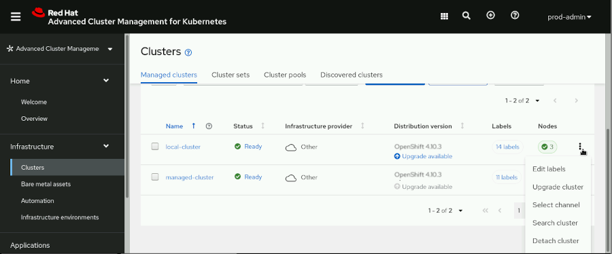

A cluster set administrator can perform various actions on clusters, such as editing labels, upgrading the version of the cluster set, selecting the channel for updates, searching for cluster resources, and detaching a cluster from RHACM management.

* 1. Click the vertical ellipsis menu to the right of the managed-cluster row.

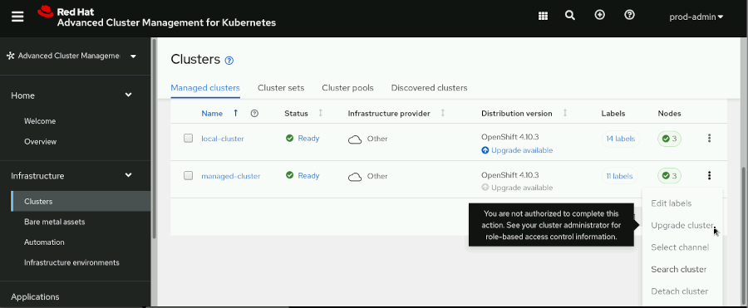

Note that as a viewer, only the **Search cluster** option is enabled.

1. Log out of RHACM and close Firefox to remove any cached credentials in the browser. Open Firefox again and log in to the RHACM web console as the stage-admin user from the Red Hat Identity Management provider. Verify that the stage-admin user has administrator permissions on the stage cluster set, comprised of the cluster named managed-cluster. Also, verify that the stage-admin user does not have any permissions on the production cluster set.

### Note

The stage-admin user is member of the stage-administrators group.

* 1. Log out of RHACM.

In the RHACM web console, click **prod-admin** at the upper-right corner, and click **Logout**.

* 1. Close all windows of Firefox. Open a new Firefox window and log in to the RHACM web console as the stage-admin user from the Red Hat Identity Management provider.

When prompted, click **Red Hat Identity Management** and log in as the stage-admin user with the redhat password.

* 1. Navigate to **Infrastructure** → **Clusters**. Note that the stage-admin user can only see clusters belonging to the stage cluster set.

The **Upgrade available** link is also active. Click the vertical ellipsis menu and notice that all options are enabled. This is because the stage-admin user has administrator permissions on the stage cluster set.

The cluster local-cluster, pertaining to the production cluster set, does not appear in the **Managed clusters** list.

1. Log out of the RHACM web console and close all Firefox windows to remove any cached credentials.
   1. From the RHACM web console, click **stage-admin** at the upper-right corner, and then click **Logout**.

Close the Firefox window.

**Finish**

On the workstation machine, change to the student user home directory and use the lab command to complete this exercise. This step is important to ensure that resources from previous exercises do not impact upcoming exercises.

[student@workstation ~]$ **lab finish features-users**

This concludes the section

## **Lab: Managing Resources from Multiple Clusters Using the RHACM Web Console**

* Assign the cluster-wide view role to a group of users so that they can perform searches across the cluster fleet. Then, you log in as a user from that group and search for a deployment with a number of replicas less than three. Finally, you log in to Red Hat Advanced Cluster Management for Kubernetes (RHACM) as a user with administrative permissions in the managed cluster set, and scale the deployment to three replicas.

**Outcomes**

* Manage RHACM roles and groups to allow searches across a cluster fleet.
* Locate Kubernetes and OpenShift objects across a cluster fleet by using the correct group of users.
* Edit Kubernetes objects across a cluster fleet using the correct group of users.

As the student user on the workstation machine, use the lab command to prepare your system for this exercise. This command ensures that RHACM is installed and running and the managed clusters are present. It also ensures that the necessary users and roles exist in the Red Hat Identity Management (IdM) server. Finally, it creates all the deployments across the cluster fleet.

[student@workstation ~]$ **lab start features-review**

1. Log in to the ocp4 cluster as the admin user with the redhat password. The API server address is https://api.ocp4.example.com:6443.

Assign the cluster-wide view role to the fleet-searchers group to allow searches across all the objects in the cluster fleet.

* 1. From the workstation machine, open a terminal and log in to the ocp4 cluster as the admin user with the redhat password. The API Server URL is https://api.ocp4.example.com:6443.
  2. [student@workstation ~]$ **oc login -u admin -p redhat \**
  3. **https://api.ocp4.example.com:6443**
  4. ...output omitted...

[student@workstation ~]$

* 1. Verify the roles assigned to the apac-operators group.
  2. [student@workstation ~]$ **oc get clusterrolebindings.authorization \**
  3. **-ocustom-columns=role:.roleRef.name,groups:.groupNames.* | grep apac-operators**
  4. open-cluster-management:managedclusterset:admin:apac apac-operators
  5. open-cluster-management:admin:local-cluster system:masters,system:cluster-admins,apac-operators
  6. open-cluster-management:view:local-cluster system:cluster-readers,system:cluster-admins,system:masters,apac-operators

[student@workstation ~]$

* 1. Verify the roles assigned to the fleet-searchers group.
  2. [student@workstation ~]$ **oc get clusterrolebindings.authorization \**
  3. **-ocustom-columns=role:.roleRef.name,groups:.groupNames.* | grep fleet-searchers**

[student@workstation ~]$

This group is not assigned any role.

* 1. Use the oc adm command to assign the view cluster role to the fleet-searchers group.
  2. [student@workstation ~]$ **oc adm policy add-cluster-role-to-group \**
  3. **view fleet-searchers**

clusterrole.rbac.authorization.k8s.io/view added: "fleet-searchers"

* 1. Reverify the fleet-searchers group roles to identify the additional roles that have been assigned.
  2. [student@workstation ~]$ **oc get clusterrolebindings.authorization \**
  3. **-ocustom-columns=role:.roleRef.name,groups:.groupNames.* | grep fleet-searchers**
  4. open-cluster-management:view:local-cluster system:cluster-readers,system:cluster-admins,system:masters,apac-operators,fleet-searchers
  5. open-cluster-management:view:managed-cluster system:cluster-readers,system:cluster-admins,system:masters,emea-operators,fleet-searchers
  6. view fleet-searchers

[student@workstation ~]$

[Hide Solution](https://rol.redhat.com/rol/app/)

1. Locate all Kubernetes objects from the applications that have the app=finance-application label and contain fewer than three replicas.

The RHACM web console is at https://multicloud-console.apps.ocp4.example.com. Log in as the fleet-searcher user with the redhat password.

* 1. From the workstation machine, navigate to the RHACM web console at https://multicloud-console.apps.ocp4.example.com. When prompted, click **Red Hat Identity Management** and log in as the fleet-searcher user with the redhat password.
  2. Click the **Search** icon to navigate to the RHACM search web interface.

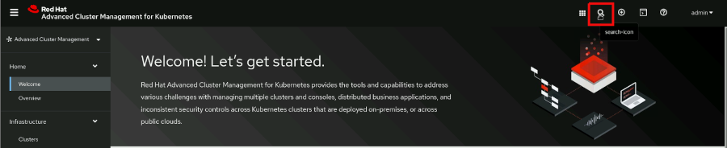

Type label:app=finance-application current:<3 in the search field. The results show two different Deployment objects. Both deployments are in the managed-cluster cluster, but one is in the company-applications-5 namespace, and the other in the company-applications-7 namespace.

The fleet-searcher user cannot modify these two deployments.

* 1. Click **Related cluster** in the related objects of the results. Expand the related cluster to see all the information about the cluster named managed-cluster.

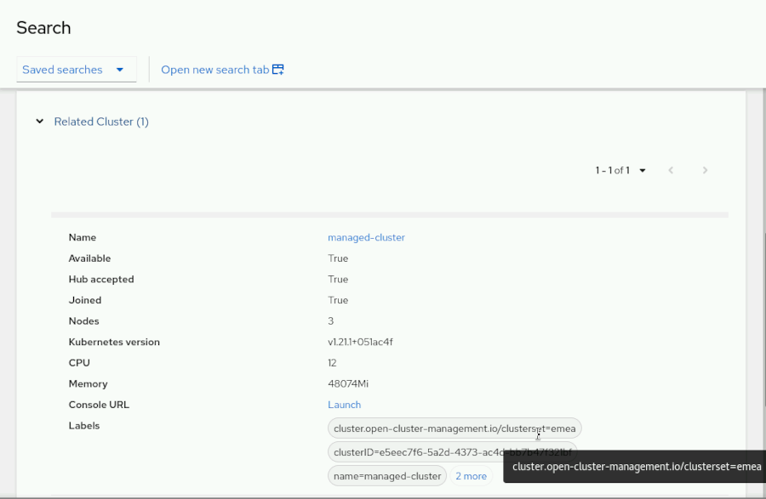

* 1. Locate the cluster set that contains the managed-cluster by finding the value of the cluster.open-cluster-management.io/clusterset= label.

The managed-cluster cluster belongs to the emea cluster set. The emea-operators group can modify the number of replicas.

[Hide Solution](https://rol.redhat.com/rol/app/)

1. Change the number of replicas of the two deployments by logging in as a user belonging to the emea-operators group. Log in as the emea-operator user with the redhat password.
   1. Log out from RHACM and close Firefox to remove any cached credentials in the browser. Open Firefox again and log in to the RHACM web console.

When prompted, click **Red Hat Identity Management** and log in as the emea-operator user with the redhat password.

* 1. Click the **Search** icon to display the **Search** page.

Repeat the previous search by typing label:app=finance-application current:<3 in the search field. The same two deployments display as when you searched as a member of the fleet-searchers group, but now the members of the emea-operators group can edit the objects.

* 1. Click the name of the deployment in the company-applications-5 namespace, and then click **Edit**.
  2. Find the text replicas: 1 in the spec: section of the deployment. You can use **Ctrl**+**F** to search inside the YAML file.
  3. Change the value to replicas: 3 and then click **Save**.
  4. Repeat the preceding operation in the deployment present in the company-applications-7 namespace.
  5. Ensure that the previous search has no more results by clicking the **Search** link.

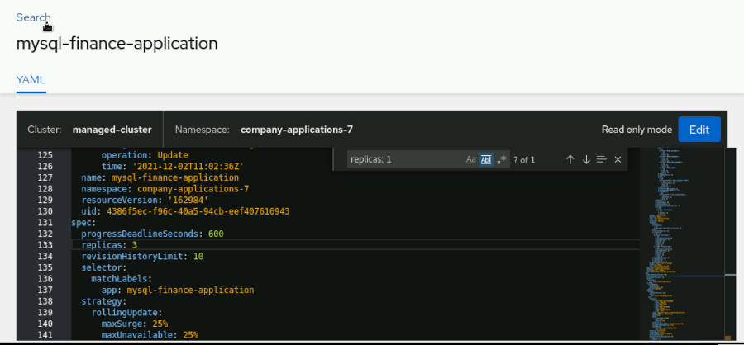

1. [Hide Solution](https://rol.redhat.com/rol/app/)

**Evaluation**

On the workstation machine, change to the student user home directory and use the lab command to grade your work. Correct any reported failures and rerun the command until successful.

[student@workstation ~]$ **lab grade features-review**

**Finish**

On the workstation machine, change to the student user home directory and use the lab command to complete this exercise. This step is important to ensure that resources from previous exercises do not impact upcoming exercises.

[student@workstation ~]$ **lab finish features-review**

This concludes the section

# **Chapter 3.  Deploying and Managing Policies for Multiple Clusters with RHACM**

[Deploying and Managing Policies with RHACM](https://rol.redhat.com/rol/app/courses/do480-2.4/pages/ch03)

[Guided Exercise: Deploying and Managing Policies with RHACM](https://rol.redhat.com/rol/app/courses/do480-2.4/pages/ch03s02)

[Deploying and Configuring the Compliance Operator for Multiple Clusters Using RHACM](https://rol.redhat.com/rol/app/courses/do480-2.4/pages/ch03s03)

[Guided Exercise: Deploying and Configuring the Compliance Operator for Multiple Clusters Using RHACM](https://rol.redhat.com/rol/app/courses/do480-2.4/pages/ch03s04)

[Integration of Other Policy Engines with RHACM](https://rol.redhat.com/rol/app/courses/do480-2.4/pages/ch03s05)

[Guided Exercise: Integration of Other Policy Engines with RHACM](https://rol.redhat.com/rol/app/courses/do480-2.4/pages/ch03s06)

[Lab: Deploying and Managing Policies with RHACM](https://rol.redhat.com/rol/app/courses/do480-2.4/pages/ch03s07)

[Summary](https://rol.redhat.com/rol/app/courses/do480-2.4/pages/ch03s08)

**Abstract**

|  |  |
| --- | --- |
| **Goal** | Deploy and manage policies in a multicluster environment by using Red Hat Advanced Cluster Management for Kubernetes (RHACM) governance. |
| **Objectives** | * Deploy policies on multiple clusters by using the command line and the Red Hat Advanced Cluster Management for Kubernetes (RHACM) governance dashboard. * Deploy the compliance operator policy and view compliance reports from multiple clusters by using the command line and the Red Hat Advanced Cluster Management for Kubernetes (RHACM) governance dashboard. * Deploy the gatekeeper policy and gatekeeper constraints to multiple clusters by using the command line and the Red Hat Advanced Cluster Management for Kubernetes (RHACM) governance dashboard. |
| **Sections** | * Deploying and Managing Policies with RHACM (and Guided Exercise) * Deploying and Configuring the Compliance Operator for Multiple Clusters Using RHACM (and Guided Exercise) * Integration of Other Policy Engines with RHACM (and Guided Exercise) |
| **Lab** | * Deploying and Managing Policies with RHACM |

## **Deploying and Managing Policies with RHACM**

### **Objectives**

* Deploy policies on multiple clusters by using the command line and the Red Hat Advanced Cluster Management for Kubernetes (RHACM) governance dashboard.

### **Red Hat Advanced Cluster Management for Kubernetes Governance Overview**

The increasing complexity of modern business systems demands that companies can quickly adapt company policies to uphold legal requirements and ensure compliance. The multicluster cloud infrastructure must support these legal and regulatory requirements by ensuring that security standards are upheld.

Governance refers specifically to the set of rules, controls, policies, and resolutions put in place to dictate behavior. Red Hat Advanced Cluster Management for Kubernetes governance provides a policy-based approach for companies to monitor these standards automatically.

#### **The Governance Architecture**

RHACM governance provides a complete graphical and command-line interface within the policy-based framework. The governance architecture includes the following components:

**RHACM governance dashboard**

The RHACM governance dashboard displays a list of policies, cluster violations, and policy violations.

**Governance framework**

The governance framework supports policy creation and deployment to the managed clusters based on placement rules.

**Policy controller**

The policy controller monitors policies and generates Kubernetes events for violation.

**Open source community**

RHACM governance supports community contribution. The stolostron/policy-collection repository has stable and community policy examples.

The following diagram shows an overview of the RHACM governance architecture.

|  |
| --- |
|  |

The Policy Propagator Controller monitors policies and updates policy status. This controller also watches PlacementRules and PlacementBindings and handles replicated policies in the cluster namespace.

The Spec Sync Controller operates on the managed cluster. This controller synchronizes local policy spec with the cluster namespace policies and updates the local policy spec if required.

The Status Sync Controller also operates on the managed cluster. This controller monitors events and changes in the managed cluster and updates the status policies for both local and hub clusters.

The Template Sync Controller operates on the managed cluster. This controller monitors policies in the cluster namespace and updates defined objects in the policies templates for any policy change.

#### **Governance Dashboard**

The governance dashboard provides an option to create, deploy, and edit policies with a graphical user interface and a YAML editor.

After the first policy creation, the governance dashboard displays a list of policies and policy violations. Use the filter list to further narrow the list of policies by Violations, Source, Remediation, and Status.

You can also change the status and remediation of selected policies from the **Actions** button. Every policy has a vertical ellipsis (**⋮**) menu to perform similar tasks and the policy deletion.

|  |
| --- |
|  |

When you click a policy from the policy list, it redirects you to the following tabs:

**Details**

This tab shows policy details and placement details.

**Clusters**

This tab shows the list of all the clusters associated with the policy placement. The **View details** link shows template details, and the **View history** link shows compliance status, message, and the last report time.

**Templates**

This tab shows the template-wise list of all the clusters associated with the policy placement. The **View details** link shows template details, and the **View history** link shows compliance status, message, and the last report time.

### **RHACM Policy Overview**

RHACM governance uses a policy-based framework. Every policy requires the policy-template , PlacmentRule and PlacementBinding templates. A policy can have one or more policy-templates, but a minimum of one policy-template is needed. The PlacementRule template specifies one cluster or set of groups for deploying the policy. As the name implies, the PlacementBinding template binds the policy to the PlacementRules.

### Note

There is no restriction for the namespace in the policy creation. However, you cannot create a policy in cluster namespace.

For example, if the managed cluster is named managed-cluster in RHACM, the reserved namespace will be managed-cluster. If you create a policy in the managed-cluster namespace, it is deleted by RHACM.

#### **Describing the Policy YAML File**

A policy YAML file has some required and some optional parameters. The optional fields and parameters depend on the policy controller.

apiVersion: policy.open-cluster-management.io/v1

kind: Policy

metadata:

name: policy-namespace

annotations:

policy.open-cluster-management.io/standards: NIST SP 800-53

policy.open-cluster-management.io/categories: CM Configuration Management

policy.open-cluster-management.io/controls: CM-2 Baseline Configuration

spec:

remediationAction: inform

disabled: false

policy-templates:

- objectDefinition:

apiVersion: policy.open-cluster-management.io/v1

kind: ConfigurationPolicy

metadata:

name: policy-namespace-example

spec:

remediationAction: inform _# the policy-template spec.remediationAction is overridden by the preceding parameter value for spec.remediationAction._

severity: low

namespaceSelector:

exclude: ["kube-*"]

include: ["default"]

object-templates:

- complianceType: musthave

objectDefinition:

kind: Namespace _# must have namespace 'prod'_

apiVersion: v1

metadata:

name: prod

---

apiVersion: policy.open-cluster-management.io/v1

kind: PlacementBinding

metadata:

name: binding-policy-namespace

placementRef:

name: placement-policy-namespace

kind: PlacementRule

apiGroup: apps.open-cluster-management.io

subjects:

- name: policy-namespace

kind: Policy

apiGroup: policy.open-cluster-management.io

---

apiVersion: apps.open-cluster-management.io/v1

kind: PlacementRule

metadata:

name: placement-policy-namespace

spec:

clusterConditions:

- status: "True"

type: ManagedClusterConditionAvailable

clusterSelector:

matchExpressions:

- {key: environment, operator: In, values: ["dev"]}

|  |  |
| --- | --- |
|  | apiVersion: Required. The value for this parameter is policy.open-cluster-management.io/v1. |
|  | kind: Required. The value for this parameter is Policy. |
|  | metadata.name: Required. The parameter sets name of the policy. |
|  | metadata.annotations: Optional. This parameter defines standards for policy to validate. |
|  | annotations.policy.open-cluster-management.io/standards: This parameter defines the name of the security standard. |
|  | annotations.policy.open-cluster-management.io/categories: This parameter defines the name of the security control category. |
|  | annotations.policy.open-cluster-management.io/controls: This parameter defines the name of the security control. |
|  | spec.remediationAction: Optional. The values for this parameter are enforce and inform. |
|  | spec.disabled: Required. The values for this parameter are true and false. |
|  | spec.policy-templates: This parameter is used for policy creation. |
|  | clusterSelector: This parameter specifies a cluster or set of clusters for policy placement. |

#### **Stable and Community Policies**

RHACM can use stable policies, supported by Red Hat, and also policies from the community. You can see most of the built-in stable policies in the RHACM governance dashboard. Examples of all policies are available in the policy-collection repository at <https://github.com/stolostron/policy-collection>.

#### **Deploying Policies on a Multicluster Architecture with RHACM**

The RHACM governance supports both dashboard and command-line methods to deploy policies.

**Deploying policy from the governance dashboard**

RHACM ships with some policy templates. You can access these templates from the governance dashboard. You can use the governance dashboard to create policies.

The policy creation page provides a graphical interface to define the policy name, namespace, policy template, cluster selector, and remediation selection space to create the policy. The governance dashboard also provides a YAML editor to customize further.

|  |
| --- |
|  |

**Deploying policy from the command line**

You can also create and edit policies from the command line. First, log in to the hub cluster and deploy the policy from the YAML file.

[user@demo ]$ **oc login -u user -p password \**

**https://api.ocp4.example.com:6443**

Login successful.

...output omitted...

[user@demo ]$ **oc create -f policy-example.yaml**

policy.policy.open-cluster-management.io/policy-example created

placementbinding.policy.open-cluster-management.io/binding-policy-example created

placementrule.apps.open-cluster-management.io/placement-policy-example created

### **RHACM Policy Controllers Overview**

The policy controllers monitor whether your cluster is compliant with a policy. The policy controller also reports the policy status, which you can see on the RHACM governance dashboard.

The supported policy controllers are described in the following sections.

#### **Kubernetes Configuration Policy Controller**

This policy controller manages, configures, and monitors Kubernetes resources. The configuration policy controller monitors policy violations and remediates them by using the enforce feature. The configuration policy controller can also install, configure, and retrieve reports from other operators, such as a compliance operator.

#### **Certificate Policy Controller**

This policy controller monitors certificates for the selected namespaces. The certificate policy detects when a certificate is about to expire in the default namespace. You can customize the certificate policy by adding or changing additional parameters, as described in the following table.

| **Parameter** | **Description** |
| --- | --- |
| minimumDuration | The minimum duration for the certificate expiration. For example, if the parameter value is set to 300h, and there are one or more certificates with an expiration age of less than 300 hours, then policy displays a Not-compliant status. |
| minimumCADuration | The minimum duration for the signing certificate expiration. |
| maximumDuration | The maximum duration for the certificate expiration. For example, if the parameter value is set to 300h, and there are one or more certificates with an expiration age of more than 300 hours, then the policy displays a Not-compliant status. |
| maximumCADuration | The maximum duration for the signing certificate expiration. |
| allowedSANPattern | You can specify an expression with this parameter. That expression must be present in every SAN entry in the certificates. It compares patterns against DNS names. |
| disallowedSANPattern | You can specify an expression with this parameter. That expression must not be present in any SAN entry in the certificates. It compares patterns against DNS names. |

The certificate policy also has a namespace selector to exclude and include namespaces. The sample certificate policy template shows that the included namespace is default, and the excluded namespace is kube-*. This policy template checks the certificate expiration age against the minimumDuration parameter value.

policy-templates:

- objectDefinition:

apiVersion: policy.open-cluster-management.io/v1

kind: CertificatePolicy

metadata:

name: policy-certificate-example

spec:

**namespaceSelector:**

**include:**

**- default**

**exclude:**

**- kube-\***

remediationAction: inform

severity: low

**minimumDuration: 300h**

#### **IAM Policy Controller**

This policy controller sends notifications about IAM policy violations. The IAM policy checks for the number of users with cluster role bindings for the cluster-admin role. IAM policy also has a namespace selector to further customize IAM policy to exclude or include namespaces.

policy-templates:

- objectDefinition:

apiVersion: policy.open-cluster-management.io/v1

kind: IamPolicy

metadata:

name: policy-example-limitclusteradmin

spec:

severity: medium

**namespaceSelector:**

**include:**

**- '*'**

**exclude:**

**- kube-\***

**- openshift-\***

remediationAction: inform

**maxClusterRoleBindingUsers: 5**

The sample IAM policy template shows that the kube-* and openshift-* namespaces are excluded, and the maximum number of ClusterRoleBinding users is set to five.

#### **Integrating Third-party Policy Controllers**

RHACM governance supports third-party policy controllers such as gatekeeper policy controllers. You can install a gatekeeper operator with a Kubernetes configuration policy controller, and then use a gatekeeper policy controller.

### Note

A sample of the gatekeeper policy is available at <https://github.com/stolostron/policy-collection/blob/main/community/CM-Configuration-Management/policy-gatekeeper-sample.yaml>

#### **Custom Policy Controller**

You can create a custom policy controller with the help of a governance-policy-framework repository. The governance-policy-framework is available at <https://github.com/stolostron/governance-policy-framework>.

### References

[Governance Policy Framework](https://github.com/stolostron/governance-policy-framework)

For more information about the policy YAML structure, refer to the The Policy YAML Structure section in the Clusters guide in the Red Hat Advanced Cluster Management for Kubernetes documentation at <https://access.redhat.com/documentation/en-us/red_hat_advanced_cluster_management_for_kubernetes/2.4/html-single/governance/index#policy-yaml-structure>

## **Deploying and Configuring the Compliance Operator for Multiple Clusters Using RHACM**

### **Objectives**

* Deploy the compliance operator policy and view compliance reports from multiple clusters by using the command line and the Red Hat Advanced Cluster Management for Kubernetes (RHACM) governance dashboard.

### **Definition of Compliance**

Compliance management is a continuous process to ensure that IT systems are compliant with the organization's policies and procedures. Through the entire lifecycle of IT infrastructure management, policy and standards continuously evolve to best suit the needs of the business. It is crucial to identify any systems that are non-compliant with the latest standards for any reason. Failure to recognize non-compliant systems can result in the following issues:

* Loss of the client's trust in the IT company, leading clients to leave the company
* Legal ramifications such as fines or being blocked from working in specific geographical locations
* Loss of IT systems certifications

Compliance management must be agile in its approach to managing security, regulatory, and configuration changes. As security threats evolve technically and strategically, compliance management aims to secure or harden cloud environments such as those comprised of multiple Kubernetes clusters.

### **Describing the RHOCP Compliance Operator**

The compliance operator is an OpenShift operator that employs OpenSCAP and enables an administrator to run compliance scans and provide remediation for the issues found. The compliance operator inspects Kubernetes objects and the nodes running the cluster to detect any gaps in compliance. The operator scans specific profiles and then produces a summary report to assist you in discovering non-compliant systems. The recommended remediation can be applied by hand, step by step, or automatically. The following is a summary of steps involved in the process:

1. Select a compliance profile for scanning.
2. Specify the scan settings.
3. Initiate the scan.
4. Generate the reports.
5. Apply remediation.

OpenSCAP performs a compliance assessment based on the policy rules defined by the content.

|  |
| --- |
|  |

### **Describing OpenSCAP**

OpenSCAP is a Security Content Automation Protocol (SCAP) compliant scanner that performs compliance and vulnerability scanning. The compliance operator uses OpenSCAP to scan the OpenShift clusters and nodes. OpenSCAP employs community-based compliance content that was developed as part of the ComplianceAsCode/content project. The content is distributed as a container image and decoupled from the operator for rapid content updates.

The compliance operator consumes the compliance content from the container image and exposes it in a custom resource.

### Note

The Security Content Automation Protocol (SCAP) is a set of specific standards supporting automated vulnerability and patch monitoring, security measurement, and technical control compliance activities.

### **Policies**

The Red Hat Advanced Cluster Management for Kubernetes policies use custom resource definitions. Policies contain one or more policy templates.

All policies require the following two custom resources definitions (CRDs):

**PlacementRule**

Defines the targeted clusters to receive the policy.

**PlacementBinding**

Binds the policy to the placement rule.

### Note

You can create a policy in any namespace on the hub cluster except the cluster namespace. If you create a policy in the cluster namespace, it is deleted by RHACM.

### **Compliance Operator Policy**

RHACM leverages the compliance operator policy to deploy the compliance operator across a fleet of clusters. The RHACM console enables administrators to create a policy that will deploy the compliance operator to all the managed clusters.

Creating a compliance operator policy results in the creation of a namespace, OperatorGroup and subscription.

**Namespace**

The compliance operator openshift-compliance namespace is created for the operator installation.

apiVersion: policy.open-cluster-management.io/v1

kind: ConfigurationPolicy

metadata:

name: comp-operator-ns

spec:

remediationAction: inform

severity: high

object-templates:

- complianceType: musthave

objectDefinition:

apiVersion: v1

kind: Namespace

metadata:

name: **openshift-compliance**

**OperatorGroup**

The compliance-operator operator group is used to specify the target namespace.

apiVersion: policy.open-cluster-management.io/v1

kind: ConfigurationPolicy

metadata:

name: comp-operator-operator-group

spec:

remediationAction: inform ***# will be overridden by remediationAction in parent policy***

severity: high

object-templates:

- complianceType: musthave

objectDefinition:

apiVersion: operators.coreos.com/v1

kind: OperatorGroup

metadata:

name: **compliance-operator**

namespace: openshift-compliance

spec:

targetNamespaces:

- **openshift-compliance**

**Subscription**

A subscription comp-operator-subscription to reference the name and channel. The subscription pulls the profile, as a container, that it supports.

apiVersion: policy.open-cluster-management.io/v1

kind: ConfigurationPolicy

metadata:

name: comp-operator-subscription

spec:

remediationAction: inform

severity: high

object-templates:

- complianceType: musthave

objectDefinition:

apiVersion: operators.coreos.com/v1alpha1

kind: Subscription

metadata:

name: **compliance-operator**

namespace: openshift-compliance

spec:

installPlanApproval: Automatic

name: compliance-operator

source: redhat-operators

sourceNamespace: openshift-marketplace

#### **Deploying the Compliance Operator Policy**

RHACM governance provides a compliance policy to deploy across the cluster fleet. To deploy the compliance policy, perform the following steps:

1. Log in to the RHACM console.
2. From the navigation menu in the left pane, select **Governance**.
3. Click **Create policy** to create the policy.
4. Select ComplianceOperator from the Specifications field and complete the YAML form.

### **Compliance Operator Policy CRDs**

A Custom Resource Definition (CRD) defines a unique object Kind to create the Custom Resource (CR) objects, and the API Server manages the entire lifecycle of CRD.

The compliance operator uses custom resource definitions that represent security policy content, configuration or result, and its scanning processes.

The following diagram provides an overview of the custom resource definitions.

|  |
| --- |
|  |

**ScanSetting**

The ScanSetting custom resource defines the scan setting such as:

* The nodes that should be scanned.
* The amount of storage allocated for the results collection.
* What time and frequency should be used for the scan.
* The retention policy.

The compliance operator creates a ScanSetting object named default.

**ScanSettingBinding**

The ScanSettingBinding object binds the ScanSetting object with the profiles.

The following example of a ScanSettingBinding object references two profiles: ocp4-e8 and rhcos4-e8. The settingsRef value is a reference to the ScanSetting object. The remediationAction is defined with inform so that RHACM will verify that the object exists but will not create the object if the object does not exist.

apiVersion: policy.open-cluster-management.io/v1

kind: ConfigurationPolicy

metadata:

name: compliance-e8-scan

spec:

remediationAction: inform

severity: high

object-templates:

- complianceType: musthave ***# this template creates ScanSettingBinding:e8***

objectDefinition:

apiVersion: compliance.openshift.io/v1alpha1

**kind: ScanSettingBinding**

metadata:

name: e8

namespace: openshift-compliance

profiles:

- apiGroup: compliance.openshift.io/v1alpha1

kind: Profile

**name: ocp4-e8**

- apiGroup: compliance.openshift.io/v1alpha1

kind: Profile

**name: rhcos4-e8**

settingsRef:

apiGroup: compliance.openshift.io/v1alpha1

**kind: ScanSetting**

name: default

The ScanSetting and ScanSettingBinding objects generate the following ComplianceSuite object.

**ComplianceScan**

The ComplianceScan represents a single scan and is represented by the ComplianceSuite object.

**ComplianceSuite**

The ComplianceSuite object is a bundle of ComplianceScan objects and maintains a record of each scan. Although the ComplianceSuite objects are automatically created when the ScanSetting and ScanSettingBinding objects are created, you can create them directly in specific use cases.

#### **Compliance Profiles**

Compliance profiles define and package a list of compliance benchmarks, scans, and remediation steps. The compliance profiles included in the compliance operator can be viewed with the oc get profile.compliance command.

[user@host ~]$ **oc get profile.compliance -n openshift-compliance \**

**-l compliance.openshift.io/profile-bundle=rhcos4**

NAME AGE

rhcos4-e8 127m

rhcos4-moderate 127m

rhcos4-nerc-cip 127m

By default, when the compliance operator is deployed, it creates two ProfileBundle objects, one for OCP and one for Red Hat CoreOS (RHCOS). The OCP and RHCOS objects are created for the cluster level scan and node level scan respectively. You can find the profiles from the ProfileBundle that contain a reference to the container image. The operator creates profile objects that represent or define the compliance benchmarks. Profiles are a set of rules that are used to confirm or validate that a system is in compliance. Red Hat provides ready to use profiles. To view the ProfileBundle objects, use the oc get profilebundle.compliance command:

[user@host ~]$ **oc get profilebundle.compliance -n openshift-compliance**

NAME ... CONTENTFILE STATUS

ocp4 ... ssg-ocp4-ds.xml VALID

rhcos4 ... ssg-rhcos4-ds.xml VALID

To view the objects in each bundle, use the oc get profile.compliance command:

[user@host ~]$ **oc get profile.compliance -n openshift-compliance \**

**-l compliance.openshift.io/profile-bundle=rhcos4**

NAME AGE

rhcos4-e8 127m

rhcos4-moderate 127m

rhcos4-nerc-cip 127m

To view the profile rules, use the oc get profile.compliance command as well:

[user@host ~]$ **oc get profile.compliance -n openshift-compliance rhcos4-e8 \**

**-o yaml**

apiVersion: compliance.openshift.io/v1alpha1

description: 'This profile contains configuration checks for Red Hat Enterprise Linux

CoreOS that align to the Australian Cyber Security Centre (ACSC) Essential Eight.

id: xccdf_org.ssgproject.content_profile_e8

kind: Profile

...output omitted...

rules:

- rhcos4-accounts-no-uid-except-zero

- rhcos4-audit-rules-dac-modification-chmod

- rhcos4-audit-rules-dac-modification-chown

- rhcos4-audit-rules-execution-chcon

- rhcos4-audit-rules-execution-restorecon

- rhcos4-audit-rules-execution-semanage

...output omitted...

The compliance operator enables auditing by exposing the Rule object as an API object.

### Note

Starting in RHACM 2.4 you need to be the Subscription-Admin user before you deploy policies with the script. One option is to execute: community/CM-Configuration-Management/policy-configure-subscription-admin-hub from the command line and set it to enforce.

### **Essential 8 (E8) Policy Scan**

This policy assumes that the compliance operator is installed and running on the managed clusters. It deploys a scan that will check the compute and worker nodes, and verifies for compliance with the Essential 8 (E8) security profile.

apiVersion: policy.open-cluster-management.io/v1

kind: Policy

metadata:

name: policy-e8-scan

annotations:

policy.open-cluster-management.io/standards: NIST SP 800-53

policy.open-cluster-management.io/categories: CM Configuration Management

policy.open-cluster-management.io/controls: CM-6 Configuration Settings

spec:

remediationAction: inform

disabled: false

policy-templates:

- objectDefinition:

apiVersion: policy.open-cluster-management.io/v1

kind: ConfigurationPolicy

metadata:

name: compliance-e8-scan

spec:

remediationAction: inform

severity: high

object-templates:

- complianceType: musthave ***# this template creates ScanSettingBinding:e8***

objectDefinition:

apiVersion: compliance.openshift.io/v1alpha1

kind: ScanSettingBinding

metadata:

name: e8

namespace: openshift-compliance

profiles:

- apiGroup: compliance.openshift.io/v1alpha1

kind: Profile

name: ocp4-e8

- apiGroup: compliance.openshift.io/v1alpha1

kind: Profile

name: rhcos4-e8

settingsRef:

apiGroup: compliance.openshift.io/v1alpha1

kind: ScanSetting

name: default

|  |  |
| --- | --- |
|  | The Policy object defines the type of policy. |
|  | The ConfigurationPolicy object checks the existence of the ScanSettingBinding. |
|  | The remediationAction parameter is defined as inform so if the ScanSettingBinding does not exist, it will be reported but not automatically enforced. |
|  | The profiles spec defines the profiles,ocp4-e8 and rhcos4-e8, that are deployed to comply with the E8 benchmarks. |

- objectDefinition:

apiVersion: policy.open-cluster-management.io/v1

kind: ConfigurationPolicy

metadata:

name: compliance-suite-e8

spec:

remediationAction: inform

severity: high

object-templates:

- complianceType: musthave ***# this template checks if scan has completed by checking the status field***

objectDefinition:

apiVersion: compliance.openshift.io/v1alpha1

kind: ComplianceSuite

metadata:

name: e8

namespace: openshift-compliance

status:

phase: DONE

|  |  |
| --- | --- |
|  | The ComplianceSuite object tracks scans and outputs reports of the scanning process. |
|  | The remediationAction parameter is defined as inform so if the ScanSettingBinding does not exist, it will be reported but not automatically enforced. |
|  | The ComplianceSuite object must be created and reach the DONE phase. |

- objectDefinition:

apiVersion: policy.open-cluster-management.io/v1

kind: ConfigurationPolicy

metadata:

name: compliance-suite-e8-results

spec:

remediationAction: inform

severity: high

object-templates:

- complianceType: mustnothave ***# this template reports the results for scan suite: e8 by looking at ComplianceCheckResult CRs***

objectDefinition:

apiVersion: compliance.openshift.io/v1alpha1

kind: ComplianceCheckResult

metadata:

namespace: openshift-compliance

labels:

compliance.openshift.io/check-status: FAIL

compliance.openshift.io/suite: e8

|  |  |
| --- | --- |
|  | The compliance operator scan results are defined as ComplianceCheckResults objects. |
|  | Verifies that no rules have failed. |
|  | The applied rules originate from an E8 scan. |

apiVersion: policy.open-cluster-management.io/v1

kind: PlacementBinding

metadata:

name: binding-policy-e8-scan

placementRef:

name: placement-policy-e8-scan

kind: PlacementRule

apiGroup: apps.open-cluster-management.io

subjects:

- name: policy-e8-scan

kind: Policy

apiGroup: policy.open-cluster-management.io

---

apiVersion: apps.open-cluster-management.io/v1

kind: PlacementRule

metadata:

name: placement-policy-e8-scan

spec:

clusterConditions:

- status: "True"

type: ManagedClusterConditionAvailable

clusterSelector:

matchExpressions:

- {key: vendor, operator: In, values: ["OpenShift"]}

|  |  |
| --- | --- |
|  | The PlacementBinding object binds the rules to the policy. |
|  | The PlacementRule object defines the schedule conditions and the target cluster for the policy. |
|  | The clusterSelector field specifies a cluster or set of clusters for policy placement. |

#### **Deploying the E8 Policy Scan from the Console**

RHACM enables administrators to create and deploy the E8 policy across a fleet of clusters. To deploy the compliance policy, perform the following steps:

1. Clone the policy collection repository. The policy-collection repository has policy examples for Open Cluster Management.
2. Edit the policy-compliance-operator-e8-scan.yaml YAML file.
3. Deploy the E8-scan policy using the following command:

[user@host]$ **oc create -f policy-compliance-operator-e8-scan.yaml**

policy.policy.open-cluster-management.io/policy-e8-scan created

placementbinding.policy.open-cluster-management.io/binding-policy-e8-scan created

placementrule.apps.open-cluster-management.io/placement-policy-e8-scan created

#### **View the Details of an E8 Policy Scan from the Console**

1. On the left pane, click **Governance**. The dashboard displays the policy-e8-scan policy.
2. Click **policy-e8-scan** and then select the **Clusters** tab to check the status.
3. Click **View details** and review the details.

### References

[What is compliance management?](https://www.redhat.com/en/topics/management/what-is-compliance-management)

[ComplianceAsCode/content project](https://github.com/ComplianceAsCode/content)

[OpenScap](https://github.com/OpenSCAP/openscap)

For more information about the compliance operator, refer to the Understanding the Compliance Operator section in the Red Hat OpenShift documentation at <https://docs.openshift.com/container-platform/4.6/security/compliance_operator/compliance-operator-understanding.html>

For more information about Compliance operator policy, refer to the Compliance operator policy chapter in the Red Hat Advanced Cluster Management for Kubernetes Governance Guide at <https://access.redhat.com/documentation/en-us/red_hat_advanced_cluster_management_for_kubernetes/2.4/html-single/governance/index#compliance-operator-policy>

For more information about E8 scan policy, refer to the E8 scan policy section in the Red Hat Advanced Cluster Management for Kubernetes Governance Guide at <https://access.redhat.com/documentation/en-us/red_hat_advanced_cluster_management_for_kubernetes/2.4/html-single/governance/governance#e8-scan-policy>

## **Guided Exercise: Deploying and Configuring the Compliance Operator for Multiple Clusters Using RHACM**

* Deploy the compliance operator on all the clusters in the Asia-Pacific (APAC) location to verify conformance to the Essential 8 (E8) standard. You will also review the compliance report on the RHACM web console.

**Outcomes**

* Install the compliance operator from the RHACM governance dashboard.
* Deploy the E8-scan policy.
* Check the compliant scan result from E8 scan.

As the student user on the workstation machine, use the lab command to prepare your system for this exercise.

[student@workstation ~]$ **lab start policy-compliance**

1. Log in to the Hub OpenShift cluster and create the policy-compliance project.
   1. Open the terminal application on the workstation machine. Log in to the Hub OpenShift cluster as the admin user.
   2. [student@workstation ~]$ **oc login -u admin -p redhat \**
   3. **https://api.ocp4.example.com:6443**
   4. Login successful.

...output omitted...

* 1. Create the policy-compliance project.
  2. [student@workstation ~]$ **oc new-project policy-compliance**
  3. Now using project "policy-compliance" on server "https://api.ocp4.example.com:6443".

...output omitted...

1. Log in to the RHACM web console and install the compliance operator.
   1. From the workstation machine, open Firefox and access https://multicloud-console.apps.ocp4.example.com.
   2. Click **htpasswd_provider** and log in as the admin user with the redhat password.
2. Create the compliance operator policy with the following parameters:

| **Field name** | **Value** |
| --- | --- |
| Name | policy-complianceoperator |
| Namespace | policy-compliance |
| Specifications | **ComplianceOperator - Install the Compliance operator** |
| Cluster selector | location: "APAC" |
| Remediation | **Inform** |

* 1. In the left pane, click **Governance** to display the governance dashboard, and then click **Create policy** to create the policy. The Create policy page is displayed.

|  |
| --- |
|  |

* 1. Complete the page with the following details, leaving the other fields unchanged. Do **not** click **Create** yet.

| **Field name** | **Value** |
| --- | --- |
| Name | policy-complianceoperator |
| Namespace | policy-compliance |
| Specifications | **ComplianceOperator - Install the Compliance operator** |
| Cluster selector | location: "APAC" |
| Remediation | **Inform** |
|  | |

* 1. Use the YAML editor on the right of the **Create policy** page to make the following edits to the YAML file:
  2. object-templates:
  3. - complianceType: musthave
  4. objectDefinition:
  5. apiVersion: operators.coreos.com/v1alpha1
  6. kind: Subscription
  7. metadata:
  8. name: compliance-operator
  9. namespace: openshift-compliance
  10. spec:
  11. installPlanApproval: Automatic
  12. name: compliance-operator
  13. source: **do480-catalog**

sourceNamespace: openshift-marketplace

Click **Create**.

### Note

The source change is required only for the DO480 lab environment because the lab environment uses an offline operator catalog named do480-catalog.

* 1. Click the policy-complianceoperator policy name from the list of policies to check the policy details from the governance dashboard.

|  |
| --- |
|  |

* 1. The policy status shows Not compliant for the cluster named managed-cluster. The Not compliant policy status indicates that the compliance operator is not installed on the managed-cluster.
  2. On the left pane, click **Governance**. The dashboard shows the policy-complianceoperator policy. Click the vertical ellipsis (**⋮**) menu to the right of the policy field, and then click **Enforce**. Click **Enforce** again in the confirmation window to change policy mode from Inform to Enforce.

Enforce mode installs the compliance operator to the managed-cluster, and the policy-complianceoperator changes to a Compliant status.

|  |
| --- |
|  |

1. As the admin user, verify the compliance operator installation by using the RHACM web console.
   1. Click the search icon at the upper-right corner of the RHACM web console.

|  |
| --- |
|  |

* 1. Type the following parameters in the search bar to search for the compliance-operator subscription.

| **Field name** | **Value** |
| --- | --- |
| kind | subscription |
| name | compliance-operator |

* 1. The search result shows the compliance-operator subscription present in the managed cluster.

|  |
| --- |
|  |

### Note

* 1. The APAC location has one cluster, named managed-cluster.

1. Clone the do480-policy-collection repository. The do480-policy-collection repository has policy examples for Open Cluster Management.
   1. Open a terminal on the workstation machine. Run the following command to clone the do480-policy-collection repository:
   2. [student@workstation ~]$ **git clone \**
   3. **https://github.com/RedHatTraining/do480-policy-collection.git**
   4. Cloning into 'do480-policy-collection'...

...output omitted...

* 1. Change to the directory where you cloned the Git repository.

[student@workstation ~]$ **cd do480-policy-collection**

1. Deploy the Essential 8 (E8) scan policy to the APAC location.
   1. Edit the policy-compliance-operator-e8-scan.yaml YAML file to change the following parameters:

| **Field name** | **Value** |
| --- | --- |
| remediationAction | enforce |
| key | location |
| values | APAC |

### Note

* 1. The policy-collection repository has both stable and community policy examples. This course uses the E8 scan policy that is available under the **stable** → **CM-Configuration-Management** directory.
  2. For more information, please visit <https://github.com/stolostron/policy-collection/blob/main/README.md>.
  3. [student@workstation do480-policy-collection]$ **cd \**
  4. **stable/CM-Configuration-Management**
  5. [student@workstation CM-Configuration-Management]$ **vim \**
  6. **policy-compliance-operator-e8-scan.yaml**
  7. apiVersion: policy.open-cluster-management.io/v1
  8. kind: Policy
  9. metadata:
  10. name: policy-e8-scan
  11. annotations:
  12. policy.open-cluster-management.io/standards: NIST SP 800-53
  13. policy.open-cluster-management.io/categories: CM Configuration Management
  14. policy.open-cluster-management.io/controls: CM-6 Configuration Settings
  15. spec:
  16. **remediationAction: enforce**
  17. disabled: false
  18. ...output omitted...
  19. ...output omitted...
  20. spec:
  21. clusterConditions:
  22. - status: "True"
  23. type: ManagedClusterConditionAvailable
  24. clusterSelector:
  25. matchExpressions:
  26. - {**key: location**, operator: In, **values: ["APAC"]**}
  27. Log in to Hub OpenShift cluster as the admin user, and then switch to the policy-compliance project.
  28. [student@workstation CM-Configuration-Management]$ **oc login -u admin -p redhat \**
  29. **https://api.ocp4.example.com:6443**
  30. Login successful.
  31. ...output omitted...
  32. [student@workstation CM-Configuration-Management]$ **oc project policy-compliance**

...output omitted...

* 1. Deploy the E8-scan policy.
  2. [student@workstation CM-Configuration-Management]$ **oc create -f \**
  3. **policy-compliance-operator-e8-scan.yaml**
  4. policy.policy.open-cluster-management.io/policy-e8-scan created
  5. placementbinding.policy.open-cluster-management.io/binding-policy-e8-scan created

placementrule.apps.open-cluster-management.io/placement-policy-e8-scan created

* 1. Change to the home directory.
  2. [student@workstation CM-Configuration-Management]$ **cd ~**

[student@workstation ~]$

1. Check the compliance operator E8 scan results.
   1. In the left pane, click **Governance**. The dashboard shows the policy-e8-scan policy. Click **policy-e8-scan** and then click **Clusters** to check the status.
   2. The clusters tab shows three resources: compliance-e8-scan, compliance-suite-e8, and compliance-suite-e8-result. Compliance-suite-e8-result shows Not compliant.

|  |
| --- |
|  |

### Note

* 1. It takes 2-3 minutes for Compliance-suite-e8-result to show the Not compliant status.
  2. The compliance-suit-e8-result object is non-compliant because the policy applies the mustnothave condition to thecompliancecheckresult object.
  3. Click **View details** and review the details. On the details page, you can see the name of non-compliant objects.

|  |
| --- |
|  |

* 1. To list the compliance check results, click the **search** icon on the upper-right corner of the RHACM web console and type kind:configurationpolicy, and then click **search**.
  2. Click compliance-suite-e8-results and check the status. It shows a list of NonCompliant objects.

|  |
| --- |
|  |

**Finish**

On the workstation machine, change to the student user home directory and use the lab command to complete this exercise. This step is important to ensure that resources from previous exercises do not impact upcoming exercises.

[student@workstation ~]$ **lab finish policy-compliance**

This concludes the section

## **Integration of Other Policy Engines with RHACM**

### **Objectives**

* Deploy the gatekeeper policy and gatekeeper constraints to multiple clusters by using the command line and the Red Hat Advanced Cluster Management for Kubernetes (RHACM) governance dashboard.

### **Open Policy Agent Versus Open Policy Agent Gatekeeper**

Implementing policies is a challenging task. It usually requires a policy management software to implement the policies, a policy language for writing the rules, and a policy engine to evaluate the policies.

**Open Policy Agent (OPA)**

OPA is an open source policy engine that unifies policy enforcement across the stack. OPA uses a high-level declarative language named Rego to write the policies, taking the policy decision-making load away from the application. OPA is a general-purpose policy engine, which can be used to enforce policies in microservices, Kubernetes, CI/CD pipelines, API gateways, and more.

**OPA gatekeeper**

The OPA gatekeeper is a use case of OPA for Kubernetes environments. It is built to work as a Kubernetes admission controller webhook. In Kubernetes, when an API request is authenticated and authorized, the Kubernetes admission controllers process and validate the API request. If the request is not compliant with the defined policies, an admission controller can block it.

### **OPA Gatekeeper Integration with RHACM**

Red Hat Advanced Cluster Management for Kubernetes (RHACM) provides a built-in policy to deploy the OPA gatekeeper operator. This way, RHACM can use OPA gatekeeper as a policy controller and you can use constraints and constraint templates to define admission and audit templates for multiple clusters.

OPA gatekeeper integration with RHACM is a two-step process.

The first step is to deploy the gatekeeper operator and create the gatekeeper custom resource. After that, you can create constraint, audit, and admission templates. The Kubernetes configuration policy controller creates all the policy templates.

The following diagram provides an overview of how the gatekeeper policy engine integrates with the RHACM configuration policy controller.

|  |
| --- |
|  |

#### **Installing the Gatekeeper Operator Using RHACM Governance**

RHACM governance provides a policy to install the gatekeeper operator to a single cluster or set of clusters based on a PlacementRule.

The following YAML code can be used as a policy to install the gatekeeper operator in the openshift-operators namespace. It installs the gatekeeper operator in the targeted cluster or set of clusters based on a PlacementRule and creates a Gatekeeper custom resource.

object-templates:

- complianceType: musthave

objectDefinition:

apiVersion: operators.coreos.com/v1alpha1

kind: **Subscription**

metadata:

name: gatekeeper-operator-product

namespace: openshift-operators

spec:

channel: stable

installPlanApproval: Automatic

name: gatekeeper-operator-product

source: redhat-operators

sourceNamespace: openshift-marketplace

object-templates:

- complianceType: musthave

objectDefinition:

apiVersion: operator.gatekeeper.sh/v1alpha1

kind: **Gatekeeper**

metadata:

name: gatekeeper

spec:

audit:

logLevel: INFO

replicas: 1

validatingWebhook: Enabled

mutatingWebhook: Disabled

webhook:

emitAdmissionEvents: Enabled

logLevel: INFO

replicas: 2

#### **Deploy Constraints Using Gatekeeper Policies**

You can deploy gatekeeper policies when the gatekeeper operator is deployed to the targeted clusters. The components of gatekeeper policies are:

**ConstraintTemplate and Constraint**

A ConstraintTemplate defines the schema for the Constraint object. It also contains the Rego code to evaluate the policy violation. A Constraint provides the value of the parameters defined in ConstraintTemplate.

The following YAML code creates a ConfigurationPolicy object named policy-gatekeeper-k8srequiredlabels and checks the existence of a ConstraintTemplate named k8srequiredlabels and a Constraint named ns-must-have-gk in the targeted cluster. If these resources are available, the policy template shows the Compliant status. Otherwise, the status is Not-compliant.

However, if the policy is in enforce mode, the policy controller creates these resources in the targeted clusters.

You can define another parameter in the Constraint named enforcementAction. The value of an enforcementAction is either dryrun or deny. In the following example, this constraint verifies if the testfail namespace has the gatekeeper label.

- objectDefinition:

apiVersion: policy.open-cluster-management.io/v1

kind: ConfigurationPolicy

metadata:

name: policy-gatekeeper-k8srequiredlabels

spec:

remediationAction: enforce ***# will be overridden by remediationAction in parent policy***

severity: low

object-templates:

- complianceType: musthave

objectDefinition:

apiVersion: templates.gatekeeper.sh/v1beta1

kind: **ConstraintTemplate**

metadata:

name: **k8srequiredlabels**

spec:

crd:

spec:

names:

kind: K8sRequiredLabels

validation:

***# Schema for the parameters field***

**openAPIV3Schema:**

**properties:**

**labels:**

**type: array**

**items: string**

targets:

- target: admission.k8s.gatekeeper.sh

**rego: |**

**package k8srequiredlabels**

**violation[{"msg": msg, "details": {"missing_labels": missing}}] {**

**provided := {label | input.review.object.metadata.labels[label]}**

**required := {label | label := input.parameters.labels[_]}**

**missing := required - provided**

**count(missing) > 0**

**msg := sprintf("you must provide labels: %v", [missing])**

}

- complianceType: musthave

objectDefinition:

apiVersion: constraints.gatekeeper.sh/v1beta1

kind: **K8sRequiredLabels**

metadata:

name: ns-must-have-gk

spec:

**enforcementAction: dryrun**

match:

kinds:

- apiGroups: [""]

kinds: ["Namespace"]

namespaces:

- testfail

**parameters:**

**labels: ["gatekeeper"]**

[user@demo ]$ **oc get configurationpolicy -n local-cluster**

NAME AGE

policy-gatekeeper-k8srequiredlabels 15h

...output omitted...

[user@demo ]$ **oc get constrainttemplate**

NAME AGE

k8srequiredlabels 15h

[user@demo ]$ **oc get constraint**

NAME AGE

k8srequiredlabels 15h

### Note

The gatekeeper policy YAML code is available at <https://github.com/stolostron/policy-collection/blob/main/community/CM-Configuration-Management/policy-gatekeeper-sample.yaml>

**Audit template**

An audit template compares the existing resources against deployed constraints, and if the resource fails to satisfy the constraints, then the template returns the Not-compliant status.

The following YAML code creates a ConfigurationPolicy object named policy-gatekeeper-audit. For example, this template returns a Not-compliant status if the testfail namespace is available in the targeted cluster, and it does not contain the gatekeeper label.

- objectDefinition:

apiVersion: policy.open-cluster-management.io/v1

kind: ConfigurationPolicy

metadata:

name: **policy-gatekeeper-audit**

spec:

remediationAction: inform ***# will be overridden by remediationAction in parent policy***

severity: low

object-templates:

- complianceType: musthave

objectDefinition:

apiVersion: constraints.gatekeeper.sh/v1beta1

kind: K8sRequiredLabels

metadata:

name: ns-must-have-gk

status:

totalViolations: 0

**Admission template**

An admission template defines parameters such as event_type, constraint_name, constraint_kind, and constraint_action and watches for the specific events in the targeted clusters. This template has the complianceType set to mustnothave. If any event matches the parameters specified in the YAML code, this template returns a Not-compliant status.

The following YAML code creates a ConfigurationPolicy object named policy-gatekeeper-admission. In this example, if you create a testfail namespace without the gatekeeper label, the admission webhook will deny the request and trigger a violation event. In this case, the template would return a Not-compliant status.

- objectDefinition:

apiVersion: policy.open-cluster-management.io/v1

kind: ConfigurationPolicy

metadata:

name: policy-gatekeeper-admission

spec:

remediationAction: inform ***# will be overridden by remediationAction in parent policy***

severity: low

object-templates:

- complianceType: **mustnothave**

objectDefinition:

apiVersion: v1

kind: Event

metadata:

namespace: openshift-gatekeeper-system ***# set it to the actual namespace where gatekeeper is running if different***

annotations:

constraint_action: deny

constraint_kind: K8sRequiredLabels

constraint_name: ns-must-have-gk

event_type: violation

You can create separate policy files for these templates or use a single policy file to deploy the constraint, audit, and admission templates.

[user@demo ]$ **oc create -f policy-gatekeeper-sample.yaml**

policy.policy.open-cluster-management.io/policy-gatekeeper created

placementbinding.policy.open-cluster-management.io/binding-policy-gatekeeper created

placementrule.apps.open-cluster-management.io/placement-policy-gatekeeper created

### References

[Open Policy Agent (OPA)](https://www.openpolicyagent.org/docs/latest/)

For more information about the policy YAML structure, refer to the The Policy YAML Structure section in the Clusters guide in the Red Hat Advanced Cluster Management for Kubernetes documentation at <https://access.redhat.com/documentation/en-us/red_hat_advanced_cluster_management_for_kubernetes/2.4/html-single/governance/index#policy-yaml-structure>

For more information, refer to the Managing Gatekeeper operator policies section in the Governance guide in the Red Hat Advanced Cluster Management for Kubernetes documentation at <https://access.redhat.com/documentation/en-us/red_hat_advanced_cluster_management_for_kubernetes/2.4/html-single/governance/index#managing-gatekeeper-operator-policies>

## **Guided Exercise: Integration of Other Policy Engines with RHACM**

* Install the gatekeeper operator in all clusters and enforce containers running in the production cluster not to use the latest tag.

**Outcomes**

* Deploy a gatekeeper policy from the Red Hat Advanced Cluster Management for Kubernetes (RHACM) governance dashboard.
* Deploy a gatekeeper policy to exclude given namespace for all constraints.
* Deploy a gatekeeper policy to enforce containers not to use images with the latest tag.

As the student user on the workstation machine, use the lab command to prepare your system for this exercise.

[student@workstation ~]$ **lab start policy-gatekeeper**

1. Log in to the Hub OpenShift cluster and create a policy-gatekeeper project.
   1. Open the terminal application on the workstation machine. Log in to the Hub OpenShift cluster as the admin user.

[student@workstation ~]$ **oc login -u admin -p redhat \**

**https://api.ocp4.example.com:6443**

Login successful.

...output omitted...

* 1. Create the policy-gatekeeper project.

[student@workstation ~]$ **oc new-project policy-gatekeeper**

Now using project "policy-gatekeeper" on server "https://api.ocp4.example.com:6443".

...output omitted...

1. Log in to the RHACM web console and install the gatekeeper operator.
   1. From the workstation machine, open Firefox and access https://multicloud-console.apps.ocp4.example.com.
   2. Click **htpasswd_provider** and log in as the admin user with the redhat password.
2. Create the gatekeeper operator policy with the following parameters:

| **Field name** | **Value** |
| --- | --- |
| Name | policy-gatekeeperoperator |
| Namespace | policy-gatekeeper |
| Specifications | **GatekeeperOperator - Install the Gatekeeper operator** |
| Remediation | **Enforce** |

* 1. In the left pane, click **Governance** to display the governance dashboard, and then click **Create policy** to create the policy. The **Create policy** page is displayed.
  2. Complete the page with the following details, leaving the other fields unchanged. Do **not** click **Create** yet.

| **Field name** | **Value** |
| --- | --- |
| Name | policy-gatekeeperoperator |
| Namespace | policy-gatekeeper |
| Specifications | **GatekeeperOperator - Install the Gatekeeper operator** |
| Remediation | **Enforce** |
|  | |

* 1. Use the YAML editor on the right of the **Create policy** page to make the following edits to the YAML file:

object-templates:

- complianceType: musthave

objectDefinition:

apiVersion: operators.coreos.com/v1alpha1

kind: Subscription

metadata:

name: gatekeeper-operator-product

namespace: openshift-operators

spec:

channel: stable

installPlanApproval: Automatic

name: gatekeeper-operator-product

source: **do480-catalog**

sourceNamespace: openshift-marketplace

* 1. Click **Create** to create the policy-gatekeeperoperator policy.

### Note

The source change is required for the DO480 lab environment because the lab environment uses an offline operator catalog named do480-catalog.

* 1. On the **Governance** page, scroll down and click the policy-gatekeeperoperator policy name from the list of policies. Click **Clusters** to review the policy details.

|  |
| --- |
|  |

* 1. The policy status is Compliant for all the clusters.

### Note

* 1. It takes 2-3 minutes to install the gatekeeper operator. The policy status changes from Not compliant to Compliant after gatekeeper installation.

1. Deploy a gatekeeper policy in the policy-gatekeeper namespace to exclude app-stage namespace for all constraints in the stage environment.
   1. Open a terminal on the workstation machine and change to the ~/DO480/labs/policy-gatekeeper/ directory.

[student@workstation ~]$ **cd ~/DO480/labs/policy-gatekeeper/**

* 1. Edit the policy-gatekeeper-config-exclude-namespaces.yaml file to change the following parameters:

| **Field name** | **Value** |
| --- | --- |
| excludedNamespaces | app-stage |
| key | environment |
| values | stage |

[student@workstation policy-gatekeeper]$ **vim \**

**policy-gatekeeper-config-exclude-namespaces.yaml**

...output omitted...

apiVersion: config.gatekeeper.sh/v1alpha1

kind: Config

metadata:

name: config

namespace: openshift-gatekeeper-system

spec:

match:

- excludedNamespaces:

- hive

- kube-node-lease

- kube-public

...output omitted...

...output omitted...

- openshift-user-workload-monitoring

- openshift-vsphere-infra

**- app-stage**

processes:

- '*'

---

apiVersion: policy.open-cluster-management.io/v1

kind: PlacementBinding

...output omitted...

...output omitted...

clusterSelector:

matchExpressions:

- {**key: environment**, operator: In, **values: ["stage"]**}

* 1. Deploy the gatekeeper policy to exclude app-stage namespace for all constraints in the stage environment.

[student@workstation policy-gatekeeper]$ **oc create -f \**

**policy-gatekeeper-config-exclude-namespaces.yaml**

policy.policy.open-cluster-management.io/policy-gatekeeper-config-exclude-namespaces created

placementbinding.policy.open-cluster-management.io/binding-policy-gatekeeper-config-exclude-namespaces created

placementrule.apps.open-cluster-management.io/placement-policy-gatekeeper-config-exclude-namespaces created

* 1. On the **Governance** page, scroll down and click the policy-gatekeeper-config-exclude-namespaces policy name from the list of policies.

|  |
| --- |
|  |

* 1. The policy status is Compliant for the stage environment.

### Note

* 1. The stage environment has one cluster, named local-cluster. The production environment has one cluster, named managed-cluster.

1. Deploy a gatekeeper policy in the policy-gatekeeper namespace to force containers not to use images with the latest tag for both stage and production environments.
   1. Edit the policy-gatekeeper-container-image-latest.yaml file to remove clusterSelector values.

[student@workstation policy-gatekeeper]$ **vim \**

**policy-gatekeeper-container-image-latest.yaml**

...output omitted...

spec:

clusterConditions:

- status: "True"

type: ManagedClusterConditionAvailable

clusterSelector:

**matchExpressions: []**

* 1. Deploy the gatekeeper policy to force containers not to use images with the latest tag for both stage and production environment.

[student@workstation policy-gatekeeper]$ **oc create -f \**

**policy-gatekeeper-container-image-latest.yaml**

policy.policy.open-cluster-management.io/policy-gatekeeper-containerimagelatest created

placementbinding.policy.open-cluster-management.io/binding-policy-gatekeeper-containerimagelatest created

placementrule.apps.open-cluster-management.io/placement-policy-gatekeeper-containerimagelatest created

* 1. On the **Governance** page, scroll down and click the policy-gatekeeper-containerimagelatest policy name from the list of policies.

|  |
| --- |
|  |

* 1. The policy status is Compliant for both the stage and production environments.

### Note

* 1. It takes 2-3 minutes to for policy to check all object templates. The policy status changes from Not compliant to Compliant after 2-3 minutes.

1. Deploy the stage-hello application to the stage environment by using the ~/DO480/labs/policy-gatekeeper/stage-hello.yaml file.
   1. Log in to the local-cluster as the admin user.

[student@workstation policy-gatekeeper]$ **oc login -u admin -p redhat \**

**https://api.ocp4.example.com:6443**

Login successful.

...output omitted...

* 1. A stage-hello application file is provided to create the namespace, deployment, service, and route. Review the stage-hello.yaml file. This application uses an image with the latest tag.

[student@workstation policy-gatekeeper]$ **cat stage-hello.yaml**

apiVersion: project.openshift.io/v1

kind: Project

metadata:

name: app-stage

spec: {}

---

apiVersion: apps/v1

kind: Deployment

metadata:

name: stage-hello

labels:

app: stage-hello

name: stage-hello

namespace: app-stage

spec:

replicas: 1

selector:

matchLabels:

app: stage-hello

name: stage-hello

template:

metadata:

labels:

app: stage-hello

name: stage-hello

spec:

containers:

- name: stage-hello

image: **quay.io/redhattraining/do480-hello-app:latest**

---

apiVersion: v1

kind: Service

metadata:

labels:

app: stage-hello

name: stage-hello

name: stage-hello

namespace: app-stage

spec:

ports:

- port: 8080

selector:

name: stage-hello

---

kind: Route

apiVersion: route.openshift.io/v1

metadata:

name: stage-hello

labels:

app: stage-hello

name: stage-hello

namespace: app-stage

spec:

host: **stage-hello.apps.ocp4.example.com**

subdomain: ''

to:

kind: Service

name: stage-hello

weight: 100

port:

targetPort: 8080

wildcardPolicy: None

* 1. Deploy the stage-hello application.

[student@workstation policy-gatekeeper]$ **oc create -f stage-hello.yaml**

project.project.openshift.io/app-stage created

deployment.apps/stage-hello created

service/stage-hello created

route.route.openshift.io/stage-hello created

* 1. Test the stage-hello application deployment.

[student@workstation policy-gatekeeper]$ **curl stage-hello.apps.ocp4.example.com**

Hello Application!

Image version : latest

1. Review the policy-gatekeeper-containerimagelatest policy status.
   1. On the **Governance** page, scroll down and click the policy-gatekeeper-containerimagelatest policy name from the list of policies. Click **Clusters** to review the policy details.

The policy status is Compliant for all the clusters.

### Note

The policy-gatekeeper-containerimagelatest policy status is Compliant despite using the latest tag because the policy-gatekeeper-config-exclude-namespaces policy excludes the app-stage namespace for all constraints in the stage environment.

1. Deploy the prod-hello application to the production environment by using the ~/DO480/labs/policy-gatekeeper/prod-hello.yaml file.
   1. Log in to the managed-cluster as the admin user.

[student@workstation policy-gatekeeper]$ **oc login -u admin -p redhat \**

**https://api.ocp4-mng.example.com:6443**

Login successful.

...output omitted...

* 1. A prod-hello application file is provided to create the namespace, deployment, service, and route. Review the prod-hello.yaml file. This application uses an image with the latest tag.

[student@workstation policy-gatekeeper]$ **cat prod-hello.yaml**

apiVersion: project.openshift.io/v1

kind: Project

metadata:

name: app-prod

spec: {}

---

apiVersion: apps/v1

kind: Deployment

metadata:

name: prod-hello

labels:

app: prod-hello

name: prod-hello

namespace: app-prod

spec:

replicas: 1

selector:

matchLabels:

app: prod-hello

name: prod-hello

template:

metadata:

labels:

app: prod-hello

name: prod-hello

spec:

containers:

- name: prod-hello

image: **quay.io/redhattraining/do480-hello-app:latest**

---

apiVersion: v1

kind: Service

metadata:

labels:

app: prod-hello

name: prod-hello

name: prod-hello

namespace: app-prod

spec:

ports:

- port: 8080

selector:

name: prod-hello

---

kind: Route

apiVersion: route.openshift.io/v1

metadata:

name: prod-hello

labels:

app: prod-hello

name: prod-hello

namespace: app-prod

spec:

host: **prod-hello.apps.ocp4-mng.example.com**

subdomain: ''

to:

kind: Service

name: prod-hello

weight: 100

port:

targetPort: 8080

wildcardPolicy: None

* 1. Deploy the prod-hello application.

[student@workstation policy-gatekeeper]$ **oc create -f prod-hello.yaml**

project.project.openshift.io/app-prod created

service/prod-hello created

route.route.openshift.io/prod-hello created

Error from server ([containerimagelatest] Deployment/prod-hello: container 'prod-hello' is using the latest tag for its image (quay.io/redhattraining/do480-hello-app:latest), which is an anti-pattern.

[containerimagelatest] **Deployment/prod-hello: container 'prod-hello' is using the latest tag for its image (quay.io/redhattraining/do480-hello-app:latest), which is an anti-pattern.)**: error when creating "prod-hello.yaml": admission webhook "validation.gatekeeper.sh" denied the request: [containerimagelatest] Deployment/prod-hello: container 'prod-hello' is using the latest tag for its image (quay.io/redhattraining/do480-hello-app:latest), which is an anti-pattern.

[containerimagelatest] Deployment/prod-hello: container 'prod-hello' is using the latest tag for its image (quay.io/redhattraining/do480-hello-app:latest), which is an anti-pattern.

You are unable to deploy the application because the deployment is using the latest image tag.

1. Review the policy-gatekeeper-containerimagelatest policy status.
   1. On the **Governance** page, scroll down and click the policy-gatekeeper-containerimagelatest policy name from the list of policies. Click **Clusters** to review the policy details.

|  |
| --- |
|  |

* 1. The status of the policy-gatekeeper-admission-latest template is Not compliant for managed-cluster.
  2. Click **View details** and review the policy-gatekeeper-admission-latest template details. On the details page, scroll down and click **View yaml** for event objects.

|  |
| --- |
|  |

* 1. The YAML file displays an error message. The error message indicates that Deployment/prod-hello is using the latest tag.

|  |
| --- |
|  |

1. Replace the latest image tag with the v1.0 version. Deploy and test the hello-prod application.
   1. Log in to the managed-cluster as the admin user, and then remove the app-prod project.

[student@workstation policy-gatekeeper]$ **oc login -u admin -p redhat \**

**https://api.ocp4-mng.example.com:6443**

Login successful.

...output omitted...

[student@workstation policy-gatekeeper]$ **oc delete project app-prod**

project.project.openshift.io "app-prod" deleted

* 1. Edit the prod-hello YAML file to use the v1.0 image tag.

[student@workstation policy-gatekeeper]$ **vim prod-hello.yaml**

...output omitted...

spec:

containers:

- name: prod-hello

image: **quay.io/redhattraining/do480-hello-app:v1.0**

...output omitted...

* 1. Deploy the prod-hello application.

[student@workstation policy-gatekeeper]$ **oc create -f prod-hello.yaml**

project.project.openshift.io/app-prod created

deployment.apps/prod-hello created

service/prod-hello created

route.route.openshift.io/prod-hello created

* 1. Test the prod-hello application deployment.

[student@workstation policy-gatekeeper]$ **curl prod-hello.apps.ocp4-mng.example.com**

Hello Application!

Image version : v1.0

* 1. Change to the home directory.

[student@workstation policy-gatekeeper]$ **cd ~**

[student@workstation ~]$

**Finish**

On the workstation machine, use the lab command to complete this exercise. This step is important to ensure that resources from previous exercises do not impact upcoming exercises.

[student@workstation ~]$ **lab finish policy-gatekeeper**

This concludes the section

## **Lab: Deploying and Managing Policies with RHACM**

* Create a policy to ensure that the test namespace does not exist in the production environment. You also create an Identity and Access Management (IAM) policy to limit the number of cluster administrators to two for all clusters.

**Outcomes**

* Deploy a namespace policy from the Red Hat Advanced Cluster Management for Kubernetes (RHACM) governance dashboard.
* Deploy an IAM policy from the RHACM governance dashboard.

As the student user on the workstation machine, use the lab command to prepare your system for this exercise.

[student@workstation ~]$ **lab start policy-review**

1. Log in to the Hub OpenShift cluster as the admin user with the redhat password and create the policy-review project.

The API server address is https://api.ocp4.example.com:6443.

* 1. Open a terminal on the workstation machine. Log in to the Hub OpenShift cluster as the admin user.
  2. [student@workstation ~]$ **oc login -u admin -p redhat \**
  3. **https://api.ocp4.example.com:6443**
  4. Login successful.

...output omitted...

* 1. Create the policy-review project.
  2. [student@workstation ~]$ **oc new-project policy-review**
  3. Now using project "policy-review" on server "https://api.ocp4.example.com:6443".

...output omitted...

[Hide Solution](https://rol.redhat.com/rol/app/)

1. Log in to the RHACM web console as the admin user with the redhat password and the **htpasswd_provider** option. Deploy a namespace policy in the policy-review namespace to enforce that the test namespace does not exist in the production environment.
   1. From the workstation machine, open Firefox and access https://multicloud-console.apps.ocp4.example.com.
   2. Click **htpasswd_provider** and log in as the admin user with the redhat password.
   3. In the left pane, click **Governance** to display the **Governance** dashboard, and then click **Create policy** to create the policy. The **Create policy** page is displayed.
   4. Complete the page with the following details, leaving the other fields unchanged. Do **not** click **Create** yet.

| **Field name** | **Value** |
| --- | --- |
| Name | policy-namespace |
| Namespace | policy-review |
| Specifications | **Namespace - Must have namespace 'prod'** |
| Cluster selector | **environment: "production"** |
| Remediation | **Enforce** |
|  | |

* 1. Use the YAML editor on the right of the **Create policy** page to make the following edits to the YAML file:

spec:

remediationAction: **enforce**

disabled: false

policy-templates:

- objectDefinition:

apiVersion: policy.open-cluster-management.io/v1

kind: ConfigurationPolicy

metadata:

name: policy-namespace-prod-ns

spec:

remediationAction: inform

severity: low

namespaceSelector:

exclude:

- kube-*

include:

- default

object-templates:

- complianceType: **mustnothave**

objectDefinition:

kind: Namespace

apiVersion: v1

metadata:

name: **test**

Click **Create**.

* 1. On the Governance page, scroll down and click the policy-namespace policy name from the list of policies. Click **Clusters** to review the policy details.

|  |
| --- |
|  |

* 1. The policy status is Compliant for the managed-cluster.

1. [Hide Solution](https://rol.redhat.com/rol/app/)
2. Deploy an IAM policy in the policy-review namespace to enforce the number of cluster administrators limits to two for all clusters.
   1. In the left pane, click **Governance** to display the **Governance** dashboard, and then click **Create policy** to create the policy. The **Create policy** page is displayed.
   2. Complete the page with the following details, leaving the other fields unchanged. Do **not** click **Create** yet.

| **Field name** | **Value** |
| --- | --- |
| Name | policy-iampolicy |
| Namespace | policy-review |
| Specifications | **IamPolicy - Limit clusteradmin roles** |
|  | |

* 1. Use the YAML editor on the right of the **Create policy** page to make the following edit to the YAML file:

spec:

remediationAction: inform

disabled: false

policy-templates:

- objectDefinition:

apiVersion: policy.open-cluster-management.io/v1

kind: IamPolicy

metadata:

name: policy-iampolicy-limit-clusteradmin

spec:

severity: medium

namespaceSelector:

include:

- '*'

exclude:

- kube-*

- openshift-*

remediationAction: inform

maxClusterRoleBindingUsers: **2**

Click **Create**.

* 1. On the Governance page, scroll down and click the policy-iampolicy policy name from the list of policies. Click **Clusters** to review the policy details.

|  |
| --- |
|  |

* 1. The status of the policy-iampolicy-limit-clusteradmin template is Not compliant for local-cluster and Compliant for managed-cluster.

1. [Hide Solution](https://rol.redhat.com/rol/app/)

**Evaluation**

As the student user on the workstation machine, use the lab command to grade your work. Correct any reported failures and rerun the command until successful.

[student@workstation ~]$ **lab grade policy-review**

**Finish**

On the workstation machine, use the lab command to complete this exercise. This step is important to ensure that resources from previous exercises do not impact upcoming exercises.

[student@workstation ~]$ **lab finish policy-review**

This concludes the section.

# **Chapter 4.  Installing and Customizing the RHACM Observability Stack**

[Installing the RHACM Observability Stack](https://rol.redhat.com/rol/app/courses/do480-2.4/pages/ch04)

[Guided Exercise: Installing the RHACM Observability Stack](https://rol.redhat.com/rol/app/courses/do480-2.4/pages/ch04s02)

[Customizing the RHACM Observability Stack](https://rol.redhat.com/rol/app/courses/do480-2.4/pages/ch04s03)

[Guided Exercise: Customizing the RHACM Observability Stack](https://rol.redhat.com/rol/app/courses/do480-2.4/pages/ch04s04)

[Lab: Installing and Customizing the RHACM Observability Stack](https://rol.redhat.com/rol/app/courses/do480-2.4/pages/ch04s05)

[Summary](https://rol.redhat.com/rol/app/courses/do480-2.4/pages/ch04s06)

**Abstract**

|  |  |
| --- | --- |
| **Goal** | Gain insight into the fleet of managed clusters by using Red Hat Advanced Cluster Management for Kubernetes (RHACM) observability components. |
| **Objectives** | * Enable the Red Hat Advanced Cluster Management for Kubernetes (RHACM) observability stack and describe the architecture and the benefits of observability in a multicluster environment. * Customize the Red Hat Advanced Cluster Management for Kubernetes (RHACM) observability stack. |
| **Sections** | * Installing the RHACM Observability Stack (and Guided Exercise) * Customizing the RHACM Observability Stack (and Guided Exercise) |
| **Lab** | * Installing and Customizing the RHACM Observability Stack |

## **Installing the RHACM Observability Stack**

### **Objectives**

* Enable the Red Hat Advanced Cluster Management for Kubernetes (RHACM) observability stack and describe the architecture and the benefits of observability in a multicluster environment.

### **Multicluster Observability in RHACM**

The observability service in RHACM provides a unified display of metrics across the fleet of clusters.

This service is based on the Thanos project from the Cloud Native Computing Foundation (CNCF). Thanos can gather data from multiple Prometheus endpoints running on different Red Hat OpenShift clusters. Thanos deploys a sidecar container to the Kubernetes Prometheus pods, which sends metrics and responds to queries, providing high availability to the observability environment. Furthermore, Thanos uses the storage format created by Prometheus to be very efficient at retaining and querying the data. Prometheus was created to inform about live data; Thanos adds long-term storage to multiple Prometheus instances.

In production environments, monitoring, processing, and storing metrics from the fleet of clusters is crucial to anticipating issues, improving the performance of the clusters, and conducting postmortem analysis.

The following diagram provides an architecture overview of the observability components in RHACM.

When you enable the observability service, the multicluster observability operator defines and instantiates a MultiClusterObservability custom resource. Then, the MultiClusterObservability custom resource deploys Grafana and Alertmanager instances in the hub cluster. If not specified otherwise, it also deploys the observability add-on and on-demand log components in each managed cluster.

The Grafana and Alertmanager instances deployed in the hub cluster receive, process, and display alerts and metrics from all the managed clusters with the observability add-on activated.

Grafana ships with many predefined dashboards, and you can also create your own custom dashboards. As explained elsewhere in this chapter, you can also create custom recording rules and alerting rules. The Alertmanager instance manages alert forwarding to third-party applications.

#### **Differences Between the RHOCP Monitoring Stack and the RHACM Observability Service**

The Grafana and Alertmanager instances provided by RHACM complement the Red Hat OpenShift cluster-level metrics.

The Red Hat OpenShift Container Platform (RHOCP) monitoring stack provides preconfigured monitoring for core platform components. Starting with RHOCP version 4.6, you can also monitor your own projects.

The RHACM observability service is designed to provide cluster-level metrics, which it receives from the fleet of clusters. You can use the Grafana instance of the RHACM observability service to monitor cluster-level metrics across the fleet of clusters.

You can configure the RHACM observability service for extended data retention, as discussed in the [the section called “Configuring a Multicluster Observability Custom Resource”](https://rol.redhat.com/rol/app/courses/do480-2.4/pages/ch04s03) section.

### **Enabling the RHACM Observability Service**

The RHACM observability service is always installed in the hub cluster, although due to the requirements for persistent storage, CPU, and memory, it is not enabled by default.

If the RHACM observability service is enabled, the observability service add-on is deployed in each managed cluster, in the open-cluster-management-addon-observability namespace. In the hub cluster, the central components of the observability service run in the open-cluster-management-observability namespace.

#### **Prerequisites for the Observability Service in RHACM**

To enable the RHACM observability service, create the open-cluster-management-observability namespace.

Create a secret named multiclusterhub-operator-pull-secret in the open-cluster-management-observability namespace. You can extract the secret named multiclusterhub-operator-pull-secret from the open-cluster-management namespace, or the secret named pull-secret from the openshift-config namespace.

The following commands are an example for storing the secret in a variable and creating the multiclusterhub-operator-pull-secret secret in the open-cluster-management-observability namespace.

[user@demo ~]$ **DOCKER_CONFIG_JSON=$(oc extract secret/pull-secret \**

**-n openshift-config --to=-)**

# .dockerconfigjson

[user@demo ~]$ **oc create secret generic \**

**multiclusterhub-operator-pull-secret \**

**-n open-cluster-management-observability \**

**--from-literal=.dockerconfigjson="$DOCKER_CONFIG_JSON" \**

**--type=kubernetes.io/dockerconfigjson**

secret/multiclusterhub-operator-pull-secret created

[user@demo ~]$

The RHACM observability service needs a persistent object store, and supports the following S3 compatible stores:

* Amazon S3
* Red Hat Ceph
* Google Cloud Storage
* Azure Storage
* Red Hat OpenShift Container Storage
* Red Hat OpenShift on IBM Cloud

The persistent volume used by the thanos-receive StatefulSet object uses the most storage resources. The Thanos receiver accepts incoming Prometheus remote-write requests and stores the data in a local instance of the Prometheus time-series database. The amount of storage required depends on several factors, including the time period over which data is retained.

The following is an example YAML file to create an object bucket claim named thanos-bc using the ocs-external-storagecluster-ceph-rgw storage class.

apiVersion: objectbucket.io/v1alpha1

kind: ObjectBucketClaim

metadata:

name: thanos-bc

namespace: open-cluster-management-observability

spec:

storageClassName: ocs-external-storagecluster-ceph-rgw

generateBucketName: observability-bucket

### Note

The ObjectBucketClaim custom resource is available because the Red Hat OpenShift Data Foundation operator is installed in the hub cluster.

After creating the object bucket claim, extract the configuration map using the following command:

[user@demo ~]$ **oc extract configmap/thanos-bc \**

**-n open-cluster-management-observability --to=-**

# BUCKET_REGION

us-east-1

# BUCKET_SUBREGION

# BUCKET_HOST

rook-ceph-rgw-ocs-external-storagecluster-cephobjectstore.openshift-storage.svc

# BUCKET_NAME

observability-bucket-4702d056-1e1b-435d-8b53-e65bc87d8717

# BUCKET_PORT

8080

Extract the credentials to the bucket using the following command:

[user@demo ~]$ **oc extract secret/thanos-bc \**

**-n open-cluster-management-observability --to=-**

# AWS_ACCESS_KEY_ID

1B7I9PL0C5J2BECSVCP6

# AWS_SECRET_ACCESS_KEY

CPBnRVW8O75NoIKqhLvg2rpZ0EdXFpb2ppEOqWbD

Use the information from the configuration map and the secret to create the thanos-object-storage secret. The following is an example YAML file to create the thanos-object-storage secret:

apiVersion: v1

kind: Secret

metadata:

name: thanos-object-storage

namespace: open-cluster-management-observability

type: Opaque

stringData:

thanos.yaml: |

type: s3

config:

bucket: observability-bucket-bucket-4702d056-1e1b-435d-8b53-e65bc87d8717

endpoint: rook-ceph-rgw-ocs-external-storageclustercephobjectstore.openshift-storage.svc:8080

insecure: true

access_key: 1B7I9PL0C5J2BECSVCP6

secret_key: CPBnRVW8O75NoIKqhLvg2rpZ0EdXFpb2ppEOqWbD

Regarding CPU and memory, the observability service requires a minimum of 2701 mCPU and a minimum of 11.9 Gi. In the managed clusters, the observability service add-on requests a minimum of 12 mCPU and 150 Mi of memory.

#### **Creation of a Multicluster Observability Custom Resource**

You must create a MultiClusterObservability custom resource in the open-cluster-management-observability namespace to enable the observability service. The MultiClusterObservability object requires a secret containing the credentials of the S3 bucket storage.

To deploy the observability components on dedicated infrastructure nodes, you can define a set a label to the infra machine set by using the nodeSelector field in the MultiClusterObservability custom resource YAML file. The following is an example MultiClusterObservability custom resource YAML file using the nodeSelector field to deploy on the infra machine set:

apiVersion: observability.open-cluster-management.io/v1beta2

kind: MultiClusterObservability

metadata:

name: observability

spec:

observabilityAddonSpec: {}

storageConfig:

metricObjectStorage:

name: thanos-object-storage

key: thanos.yaml

nodeSelector:

node-role.kubernetes.io/infra:

### References

For more general information, refer to the Red Hat Advanced Cluster Management for Kubernetes Observability Guide at <https://access.redhat.com/documentation/en-us/red_hat_advanced_cluster_management_for_kubernetes/2.4/html-single/observability/index>

For detailed instructions about enabling the observability service, refer to the Enable Observability Service section at <https://access.redhat.com/documentation/en-us/red_hat_advanced_cluster_management_for_kubernetes/2.4/html-single/observability/index#enable-observability>

For more information about the scaling of the observability service, refer to the Scaling for Observability section at <https://access.redhat.com/documentation/en-us/red_hat_advanced_cluster_management_for_kubernetes/2.4/html-single/install/index#scaling-for-observability>

For more information about the community project Prometheus used by the observability service in RHACM and RHOCP, visit the Prometheus web site at <https://prometheus.io/>

For more information about the community project Thanos used by the observability service in RHACM, visit the Thanos web site at [https://thanos.io](https://thanos.io/)

## **Guided Exercise: Installing the RHACM Observability Stack**

* Deploy the observability stack in all the managed clusters in Red Hat Advanced Cluster Management for Kubernetes (RHACM) and verify the installation in the hub cluster and the managed clusters. Then, you explore the Grafana dashboard provided by the RHACM observability stack. Finally, you disable the metrics collection in a cluster used for the stage environment.

**Outcomes**

* Install the observability stack in RHACM.
* Verify the installation in all the managed clusters.
* Access the RHACM Grafana dashboard.
* Disable the observability agent in the managed-cluster.

### Note

You can find YAML files to complete this guided exercise in the ~/DO480/labs/observability-install directory.

As the student user on the workstation machine, use the lab command to prepare your system for this exercise.

This command ensures that RHACM is deployed in the hub cluster, and that the cluster called managed-cluster exists in RHACM.

[student@workstation ~]$ **lab start observability-install**

1. Enable the observability service from the terminal.
   1. Open a terminal and log in to the ocp4 cluster as the admin user with the redhat password. The API server address is https://api.ocp4.example.com:6443.
   2. [student@workstation ~]$ **oc login -u admin -p redhat \**
   3. **https://api.ocp4.example.com:6443**
   4. Login successful.
   5. ...output omitted...

[student@workstation ~]$

* 1. Create the open-cluster-management-observability namespace.

[student@workstation ~]$ **oc create namespace open-cluster-management-observability**

namespace/open-cluster-management-observability created

* 1. Extract the pull secret from the openshift-config namespace and store it in a variable.

[student@workstation ~]$ **DOCKER_CONFIG_JSON=$(oc extract secret/pull-secret \**

**-n openshift-config --to=-)**

# .dockerconfigjson

[student@workstation ~]$

* 1. Create the pull secret in the open-cluster-management-observability namespace.

[student@workstation ~]$ **oc create secret generic \**

**multiclusterhub-operator-pull-secret \**

**-n open-cluster-management-observability \**

**--from-literal=.dockerconfigjson="$DOCKER_CONFIG_JSON" \**

**--type=kubernetes.io/dockerconfigjson**

secret/multiclusterhub-operator-pull-secret created

[student@workstation ~]$

* 1. Change to the ~/DO480/labs/observability-install folder.

[student@workstation ~]$ **cd DO480/labs/observability-install**

[student@workstation observability-install]$

* 1. Review the file named obc.yaml with the definition of a new object bucket claim (OBC):
  + [student@workstation observability-install]$ **cat obc.yaml**
  + apiVersion: objectbucket.io/v1alpha1
  + kind: ObjectBucketClaim
  + metadata:
  + name: thanos-bc
  + namespace: open-cluster-management-observability
  + spec:
  + storageClassName: ocs-external-storagecluster-ceph-rgw

generateBucketName: observability-bucket

* 1. Use the oc command to create the ObjectBucketClaim resource.

[student@workstation observability-install]$ **oc create -f obc.yaml**

objectbucketclaim.objectbucket.io/thanos-bc created

* 1. Extract the storage configuration details.

[student@workstation observability-install]$ **oc extract configmap/thanos-bc \**

**-n open-cluster-management-observability --to=-**

# BUCKET_REGION

us-east-1

# BUCKET_SUBREGION

# BUCKET_HOST

**rook-ceph-rgw-ocs-external-storagecluster-cephobjectstore.openshift-storage.svc**

# BUCKET_NAME

**observability-bucket-4702d056-1e1b-435d-8b53-e65bc87d8717**

# BUCKET_PORT

**8080**

* 1. Extract the secret.

[student@workstation observability-install]$ **oc extract secret/thanos-bc \**

**-n open-cluster-management-observability --to=-**

# AWS_ACCESS_KEY_ID

**1B7I9PL0C5J2BECSVCP6**

# AWS_SECRET_ACCESS_KEY

**CPBnRVW8O75NoIKqhLvg2rpZ0EdXFpb2ppEOqWbD**

* 1. Create a YAML configuration file for the thanos-object-storage secret with the information from the previous steps and the template file named secret.yaml. The resulting file should look as follows:

[student@workstation observability-install]$ **vi secret.yaml**

apiVersion: v1

kind: Secret

metadata:

name: thanos-object-storage

namespace: open-cluster-management-observability

type: Opaque

stringData:

thanos.yaml: |

type: s3

config:

bucket: ***observability-bucket-bucket-4702d056-1e1b-435d-8b53-e65bc87d8717***

endpoint: ***rook-ceph-rgw-ocs-external-storagecluster-cephobjectstore.openshift-storage.svc:8080***

insecure: true

access_key: ***1B7I9PL0C5J2BECSVCP6***

secret_key: ***CPBnRVW8O75NoIKqhLvg2rpZ0EdXFpb2ppEOqWbD***

### Note

Note that the endpoint value is compound by the BUCKET_HOST and the BUCKET_PORT extracted from the thanos-bc configuration map.

* 1. Use the oc command to create the secret in RHOCP.

[student@workstation observability-install]$ **oc create -f secret.yaml**

secret/thanos-object-storage created

* 1. Review the YAML file named mcobs.yaml defining the multicluster observability custom resource.

[student@workstation observability-install]$ **cat mcobs.yaml**

apiVersion: observability.open-cluster-management.io/v1beta2

kind: MultiClusterObservability

metadata:

name: observability

spec:

enableDownsampling: true

observabilityAddonSpec:

enableMetrics: true

interval: 30

storageConfig:

alertmanagerStorageSize: 1Gi

compactStorageSize: 20Gi

metricObjectStorage:

key: thanos.yaml

name: thanos-object-storage

receiveStorageSize: 20Gi

ruleStorageSize: 1Gi

storageClass: ocs-external-storagecluster-ceph-rbd

storeStorageSize: 10Gi

### Note

The provided mcobs.yaml file contains custom parameters for the observability persistent storage.

* 1. Use the oc command to create the multicluster observability instance in RHOCP.

[student@workstation observability-install]$ **oc create -f mcobs.yaml**

multiclusterobservability.observability.open-cluster-management.io/observability created

This initiates the deployment of the observability components.

* 1. Monitor the progress of the installation using the following command:

[student@workstation observability-install]$ **watch 'oc describe mco \**

**observability | grep -A 6 Status'**

...output omitted...

Status:

Conditions:

Last Transition Time: 2022-04-08T10:23:37Z

Message: Installation is in progress

Reason: Installing

Status: True

Type: Installing

Last Transition Time: 2022-04-08T10:24:58Z

Message: **Observability components are deployed and running**

Reason: **Ready**

Status: **True**

Type: **Ready**

Events: <none>

...output omitted...

It takes around one minute to deploy the observability components. When the message Observability components are deployed and running is displayed, exit the watch command by pressing **Ctrl**+**C** and continue with the next step.

* 1. Change to the /home/student folder.

[student@workstation observability-install]$ **cd /home/student**

[student@workstation ~]$

1. Verify the deployment of the observability components in the managed cluster.
   1. Log in to the ocp4-mng cluster.

[student@workstation ~]$ **oc login -u admin -p redhat \**

**https://api.ocp4-mng.example.com:6443**

...output omitted...

* 1. Verify the status of the components of the observability add-on in the cluster named managed-cluster in RHACM. These components are installed in the open-cluster-management-addon-observability namespace.

[student@workstation ~]$ **oc get all -n open-cluster-management-addon-observability**

NAME READY STATUS RESTARTS AGE

pod/endpoint-observability-operator-7dd7595ff8-hn8qc 1/1 Running 0 13m

pod/metrics-collector-deployment-7c5cf96599-cfh5s 1/1 Running 0 12m

NAME READY UP-TO-DATE AVAILABLE AGE

deployment.apps/endpoint-observability-operator 1/1 1 1 13m

deployment.apps/metrics-collector-deployment 1/1 1 1 12m

NAME DESIRED CURRENT READY AGE

replicaset.apps/endpoint-observability-operator-7dd7595ff8 1 1 1 13m

replicaset.apps/metrics-collector-deployment-7c5cf96599 1 1 1 12m

### Note

If the pods are not ready, look for error messages in the pod logs, or the events in the namespace.

[student@workstation ~]$ oc logs pod/metrics-collector-deployment-***7c5cf96599-cfh5s*** -n open-cluster-management-addon-observability

[student@workstation ~]$ oc get events -n open-cluster-management-addon-observability

1. Navigate to **Home** → **Overview** in the RHACM console to display the Grafana dashboard. Analyze the capacity and utilization data provided about CPU and memory of the clusters.

### Note

After enabling the observability components, RHACM shows direct access to the Grafana dashboard from within the RHACM console.

* 1. From the workstation machine, navigate to the RHACM web console at https://multicloud-console.apps.ocp4.example.com. When prompted, click **htpasswd_provider** and log in as the admin user with the redhat password.
  2. Navigate to **Home** → **Overview** and then click **Grafana** to display the Grafana dashboard..

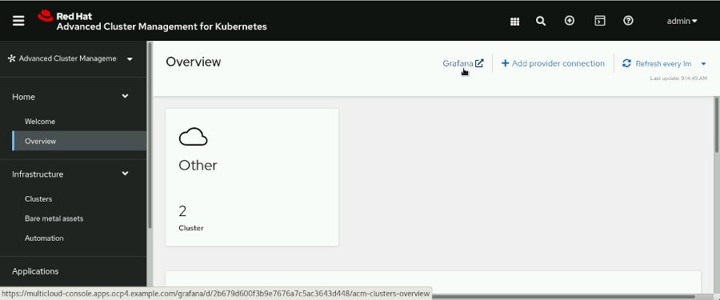

### Note

Reload the Grafana dashboard if the panels show any error messages.

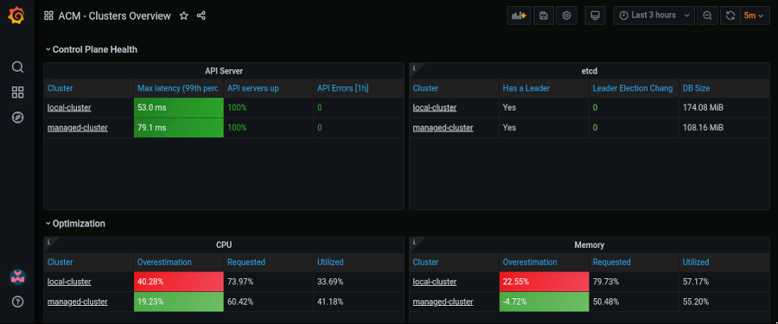

The RHACM Grafana dashboard contains information about all the clusters in the fleet. The observability add-on, deployed in all the managed clusters, sends information to the central Grafana instance deployed in the hub cluster.

* 1. In the Grafana dashboard, scroll down to the Capacity / Utilization table.

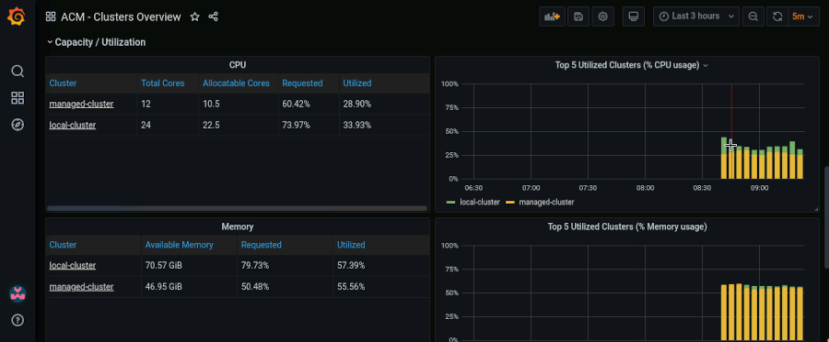

Grafana gathers information about CPU and memory utilization across all the clusters in the fleet. This way, a system administrator can monitor all the clusters from the same dashboard.

### Note

In some tables, data can take a few minutes to appear after the observability service is installed.

1. Disable metrics collection from the managed-cluster. This is useful to avoid overloading the observability service with metrics from clusters used for stage environments.
   1. Open a terminal and log in to the ocp4 cluster as the admin user. The API server address is https://api.ocp4.example.com:6443.

[student@workstation ~]$ **oc login -u admin -p redhat \**

**https://api.ocp4.example.com:6443**

Login successful.

...output omitted...

[student@workstation ~]$

* 1. Add the observability=disabled label to the managedcluster custom resource named managed-cluster.

[student@workstation ~]$ **oc label managedcluster managed-cluster \**

**observability=disabled -n open-cluster-management**

managedcluster.cluster.open-cluster-management.io/managed-cluster labeled

After applying this label, RHACM removes the objects in the open-cluster-management-addon-observability namespace.

* 1. Verify that the changes in the managed-cluster are applied. Log in to the ocp4-mng cluster as the admin user. The API server address is https://api.ocp4-mng.example.com:6443.

[student@workstation ~]$ **oc login -u admin -p redhat \**

**https://api.ocp4-mng.example.com:6443**

Login successful.

...output omitted...

[student@workstation ~]$

* 1. Retrieve the objects in the open-cluster-management-addon-observability namespace.

[student@workstation ~]$ **oc get all \**

**-n open-cluster-management-addon-observability**

No resources found in open-cluster-management-addon-observability namespace.

The expected result is that no resources are found in the open-cluster-management-addon-observability namespace.

### Note

The Grafana dashboard can show cached information about the managed-cluster after disabling the observability add-on. All the information about the managed-cluster cluster eventually disappears.

**Finish**

On the workstation machine, change to the student user home directory and use the lab command to complete this exercise. This step is important to ensure that resources from previous exercises do not impact upcoming exercises.

[student@workstation ~]$ **lab finish observability-install**

This concludes the section

## **Customizing the RHACM Observability Stack**

### **Objectives**

* Customize the Red Hat Advanced Cluster Management for Kubernetes (RHACM) observability stack.

### **Observability Service Customizations in RHACM**

In production environments, you might need to adapt the observability service to the workloads and processes of your fleet of clusters.

This customization usually involves creating custom Prometheus metrics, and adding or modifying existing dashboards in Grafana. You can also create Prometheus recording rules to precalculate time-consuming expressions, and configure custom alerting rules to detect any potential issue in their environments.

With the RHACM observability service, you can also configure Prometheus to forward metrics to an external or centralized alerting engine.

#### **Prometheus RHACM Default Metrics**

The RHACM observability service receives metrics from Prometheus. Prometheus defines a custom functional query language named Prometheus Query Language (PromQL). The Prometheus metrics are aggregated in time series and defined using expressions written in PromQL.

The RHACM metrics are defined by the MultiClusterObservability custom resource. All the current metrics for the observability-metrics-allowlist ConfigMap object exist in the open-cluster-management-observability namespace in the hub cluster

You can remove default metrics by deleting them from the observability-metrics-allowlist ConfigMap object.

#### **Grafana RHACM Default Dashboards**

When you enable the observability service in RHACM, the MultiClusterObservability custom resource creates a Grafana console with more than 15 dashboards. Navigate to the **Overview** page in the RHACM web console and then click the **Grafana** link to access these dashboards.

The RHACM Grafana dashboards display the status of the cluster fleet, always classifying the data by managed clusters. You can hover over the **i** icon in the upper-left of each panel for more information about that panel.

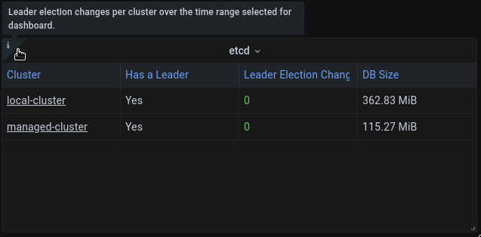

Some of the Grafana dashboards come from the Red Hat OpenShift Container Platform (RHOCP) monitoring stack, but include a cluster filter, which refers to each managed cluster in the fleet. Other dashboards are new for RHACM, and show data based on longer ranges of time, such as those dashboards with Service-level Overview in their name.

Review the ConfigMap objects in the open-cluster-management-observability namespace to learn how each dashboard is defined. ConfigMap names use the grafana-dashboard- prefix.

#### **RHACM Default Alerts**

When you enable the observability service in RHACM, the MultiClusterObservability custom resource creates an instance of Alertmanager, which is a component of Prometheus, along with several default alerting rules.

Review the thanos-ruler-default-rules ConfigMap object in the open-cluster-management-observability namespace, to learn how each alert is defined.

You can customize the default components of the RHACM observability service discussed previously.

#### **Creating Custom Recording and Alerting Rules**

To benefit from the RHACM observability stack, you can add customizations to the Grafana and Alertmanager instances.

**Prometheus recording rules**

You can use recording rules to precalculate expensive expressions. The resulting metric is saved as a new set of time series, which are used to create custom Grafana dashboards.

Remember that you can study the default existing recording rules in the observability-metrics-allowlist ConfigMap object in the open-cluster-management-observability namespace in the hub cluster. To add custom metrics, you need to create a new observability-metrics-custom-allowlist ConfigMap object in the open-cluster-management-observability namespace.

**Prometheus alerting rules**

You can use alerting rules to receive alerts based on determined conditions. Review the thanos-ruler-default-rules ConfigMap object in the open-cluster-management-observability namespace to learn how each alert is defined. To add custom alerts, create a new thanos-ruler-custom-rules ConfigMap object in the open-cluster-management-observability namespace.

### **Configuring a Multicluster Observability Custom Resource**

The MultiClusterObservability custom resource contains all the parameters required to configure the observability service. Use this custom resource to specify the service behavior in the following areas:

* Persistent storage configuration
* Alertmanager configuration
* Metrics retention policy
* Number of replicas of different components of the observability service
* Configuration of the observability add-on deployed on the managed clusters

The following is a MultiClusterObservability custom resource YAML file with customized values for the storage class and storage size:

apiVersion: observability.open-cluster-management.io/v1beta2

kind: MultiClusterObservability

metadata:

name: observability

spec:

enableDownsampling: true

observabilityAddonSpec:

enableMetrics: true

interval: 300

storageConfig:

alertmanagerStorageSize: 1Gi

compactStorageSize: 20Gi

metricObjectStorage:

key: thanos.yaml

name: thanos-object-storage

receiveStorageSize: 20Gi

ruleStorageSize: 1Gi

storageClass: ocs-external-storagecluster-ceph-rbd

storeStorageSize: 10Gi

See the documentation listed in the References section to learn the complete definition of the MultiClusterObservability custom resource.

### **Forwarding Metrics to External Services**

Typically, organizations have a centralized alerting engine to receive alerts from different systems.

To facilitate this centralized alerting, you can configure extra alert receivers as explained in the Prometheus Alertmanager documentation at <https://prometheus.io/docs/alerting/latest/configuration/>.

### References

For more information, refer to the Red Hat Advanced Cluster Management for Kubernetes Observability Guide at <https://access.redhat.com/documentation/en-us/red_hat_advanced_cluster_management_for_kubernetes/2.4/html-single/observability/index>

For more information about designing custom Grafana dashboards, refer to the Designing your Grafana Dashboard section of the RHACM Observability Guide at <https://access.redhat.com/documentation/en-us/red_hat_advanced_cluster_management_for_kubernetes/2.4/html-single/observability/index#designing-your-grafana-dashboard>

For more information about PromQL, visit the Prometheus documentation at <https://prometheus.io/docs/prometheus/latest/querying/basics/>

For more information about recording rules, visit the Prometheus documentation at <https://prometheus.io/docs/prometheus/latest/configuration/recording_rules/>

For more information about alerting rules, visit the Prometheus documentation at <https://prometheus.io/docs/prometheus/latest/configuration/alerting_rules/>

For more information about all the fields of the MultiClusterObservability custom resource, refer to the MultiClusterObservability section of the APIS Guide at <https://access.redhat.com/documentation/en-us/red_hat_advanced_cluster_management_for_kubernetes/2.4/html-single/apis/index#rhacm-docs_apis_multiclusterobservability_jsonmulticlusterobservability>

## **Guided Exercise: Customizing the RHACM Observability Stack**

* Configure an existing Red Hat Advanced Cluster Management for Kubernetes (RHACM) observability service to handle a higher load of monitoring data from the managed clusters. Then, you create a custom alerting rule that triggers when the CPU requests of a cluster are above 60% of the total allocatable CPU. Finally, you disable the RHACM observability service.

**Outcomes**

* Increase the number of replicas of the observability metrics receiver pods
* Verify that the number of pods increases
* Create a Prometheus custom alerting rule
* Verify that the alerts are triggering
* Remove the observability components from RHACM

### Note

You can find YAML files to complete this guided exercise in the ~/DO480/labs/observability-customize directory.

As the student user on the workstation machine, use the lab command to prepare your system for this exercise.

This command ensures that RHACM is deployed in the hub cluster, that the managed-cluster cluster exists in RHACM, and that the observability service is enabled.

[student@workstation ~]$ **lab start observability-customize**

1. From the terminal, log in to the ocp4 cluster and increase the the observability metrics receiver pod replicas to six.
   1. Open a terminal and log in to the ocp4 cluster as the admin user with the redhat password. The API server address is https://api.ocp4.example.com:6443.

[student@workstation ~]$ **oc login -u admin -p redhat \**

**https://api.ocp4.example.com:6443**

Login successful.

...output omitted...

[student@workstation ~]$

* 1. Use the oc command to edit the multiclusterobservability object in the openshift-multicluster-observability namespace. Update the spec section so that it contains the following highlighted information:

[student@workstation ~]$ **oc edit multiclusterobservability \**

**-n openshift-multicluster-observability**

...output omitted...

spec:

**advanced:**

**receive:**

**replicas: 6**

enableDownsampling: true

Save the file and close the editor.

### Note

After exiting the editor, the following message is displayed:

multiclusterobservability.observability.open-cluster-management.io/observability edited

* 1. Use the watch command to verify that the observability-thanos-receive-default stateful set now contains six pods.

[student@workstation ~]$ **watch oc get pods \**

**-n open-cluster-management-observability**

...output omitted...

NAME READY STATUS RESTARTS AGE

...output omitted...

observability-thanos-receive-default-0 1/1 Running 0 55m

observability-thanos-receive-default-1 1/1 Running 0 54m

observability-thanos-receive-default-2 1/1 Running 0 54m

observability-thanos-receive-default-3 1/1 Running 0 2m56s

observability-thanos-receive-default-4 1/1 Running 0 2m51s

observability-thanos-receive-default-5 1/1 Running 0 2m46s

...output omitted...

Notice that three of the pods were created recently, and the other three were already running.

Press **Ctrl**+**C** to exit the watch command.

### Note

Increasing the replicas of the receiver pods is necessary in production environments when the number of managed clusters increases.

1. Create a Prometheus alerting rule so that cluster administrators receive alerts when the CPU requests of any cluster are above 60% of the available compute capacity.
   1. Change to the ~/DO480/labs/observability-customize folder.

[student@workstation ~]$ **cd DO480/labs/observability-customize**

[student@workstation observability-customize]$

* 1. From the terminal, review the file named custom_rule.yaml containing the instructions in PromQL.

[student@workstation observability-customize]$ **cat custom-rules.yaml**

kind: ConfigMap

apiVersion: v1

metadata:

name: thanos-ruler-custom-rules

data:

custom_rules.yaml: |

groups:

- name: cluster-health

rules:

- alert: ClusterCPUReq-60

annotations:

summary: Notify when CPU requests on a cluster are greater than the defined utilization limit

description: "The cluster {{ $labels.cluster }} has an elevated percentage of CPU requests: {{ $labels.clusterID }}."

expr: |

sum(namespace_cpu:kube_pod_container_resource_requests:sum) by (clusterID, cluster) / sum(kube_node_status_allocatable{resource="cpu"}) by (clusterID, cluster) > 0.6

for: 5s

labels:

cluster: "{{ $labels.cluster }}"

severity: critical

* 1. Create the thanos-ruler-custom-rules ConfigMap in the open-cluster-management-observability namespace.

[student@workstation observability-customize]$ **oc apply -f custom-rules.yaml \**

**-n open-cluster-management-observability**

configmap/thanos-ruler-custom-rules created

The creation of the ConfigMap triggers a restart of the observability-thanos-rule-*X* pods in the open-cluster-management-observability namespace.

* 1. Verify that the new configuration applies. You can monitor the restart of the pods in the open-cluster-management-observability namespace with the watch command.

[student@workstation observability-customize]$ **watch oc get pods \**

**-n open-cluster-management-observability**

...output omitted...

NAME READY STATUS RESTARTS AGE

...output omitted...

observability-thanos-rule-0 2/2 Running 0 **1m**

observability-thanos-rule-1 2/2 Running 0 **1m**

observability-thanos-rule-2 2/2 Running 0 **2m**

...output omitted...

Press **Ctrl**+**C** to exit the watch command.

After the observability-thanos-rule-*X* pods restart, the alerting rule is visible from the RHACM Grafana dashboard.

1. Verify that the custom alert triggers for the cluster named managed-cluster.
   1. From the workstation machine, navigate to the RHACM web console at https://multicloud-console.apps.ocp4.example.com. When prompted, click **htpasswd_provider** and log in as the admin user with the redhat password.
   2. Navigate to **Home** → **Overview** and click **Grafana** to display a new tab showing the Grafana dashboard.

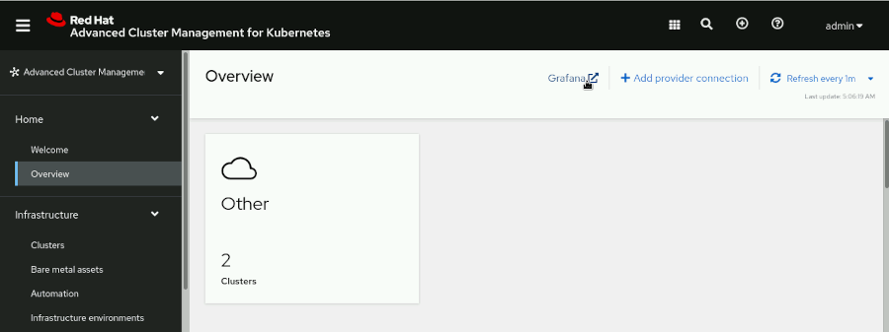

* 1. On the left menu of the Grafana dashboard, click **Explore**.

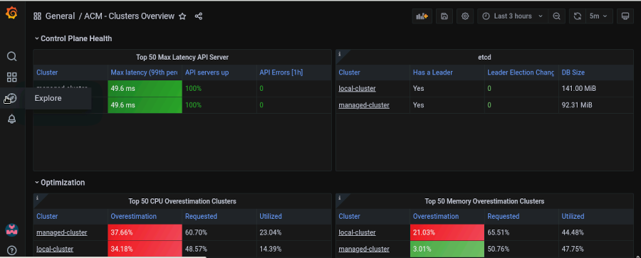

* 1. In the Metrics text field, type ALERTS{alertname="ClusterCPUReq-60",alertstate="firing"}. Click **Instant** to select the correct query type, and then click **Run Query**.

Verify that the Table field contains a row with the ClusterCPUReq-60 custom alert. Also, verify that the ClusterCPUReq-60 alert is firing in the managed-cluster cluster.

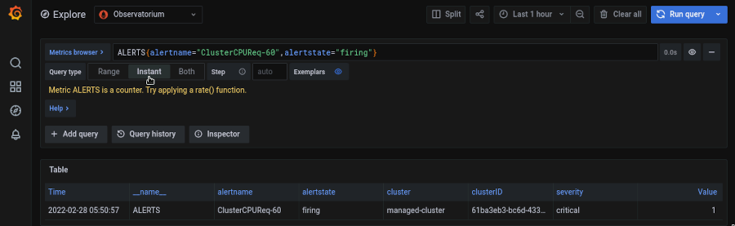

* 1. Change to the /home/student folder.

[student@workstation observability-customize]$ **cd /home/student**

[student@workstation ~]$

1. Disable the RHACM observability service.
   1. Open a terminal and log in to the ocp4 cluster as the admin user. The API server address is https://api.ocp4.example.com:6443.

[student@workstation ~]$ **oc login -u admin -p redhat \**

**https://api.ocp4.example.com:6443**

Login successful.

...output omitted...

[student@workstation ~]$

* 1. Use the oc command to remove the MultiClusterObservability object named observability.

[student@workstation ~]$ **oc delete multiclusterobservability \**

**observability**

multiclusterobservability.observability.open-cluster-management.io "observability" deleted

* 1. Remove the open-cluster-management-observability namespace.

[student@workstation ~]$ **oc delete namespace \**

**open-cluster-management-observability**

namespace "open-cluster-management-observability" deleted

### Note

Deleting the open-cluster-management-observability namespace typically takes less than five minutes.

**Finish**

On the workstation machine, change to the student user home directory and use the lab command to complete this exercise. This step is important to ensure that resources from previous exercises do not impact upcoming exercises.

[student@workstation ~]$ **lab finish observability-customize**

This concludes the section

## **Lab: Installing and Customizing the RHACM Observability Stack**

* Enable the Red Hat Advanced Cluster Management for Kubernetes (RHACM) observability service in all the managed clusters. Then, you create a custom alerting rule that triggers a warning when the memory requested in any cluster of the fleet exceeds 45%. Finally, you verify that the alert triggers for every cluster that meets the condition.

**Outcomes**

* Enable the observability service in RHACM.
* Create a Prometheus custom alerting rule.
* Verify that the alertstate is firing in the Grafana dashboard.

### Note

You can find YAML files to complete this guided exercise in the ~/DO480/labs/observability-review directory.

As the student user on the workstation machine, use the lab command to prepare your system for this exercise.

This command ensures that RHACM is deployed in the hub cluster, that the cluster named managed-cluster exists in RHACM, and that the observability service is not enabled.

[student@workstation ~]$ **lab start observability-review**

1. Enable the observability service from the terminal.
   1. Open a terminal and log in to the ocp4 cluster as the admin user with the redhat password. The API server address is https://api.ocp4.example.com:6443.

[student@workstation ~]$ **oc login -u admin -p redhat \**

**https://api.ocp4.example.com:6443**

Login successful.

...output omitted...

[student@workstation ~]$

* 1. Create the open-cluster-management-observability namespace.

[student@workstation ~]$ **oc create namespace open-cluster-management-observability**

namespace/open-cluster-management-observability created

* 1. Extract the pull secret from the openshift-config namespace and store it in a variable.

[student@workstation ~]$ **DOCKER_CONFIG_JSON=$(oc extract secret/pull-secret \**

**-n openshift-config --to=-)**

# .dockerconfigjson

[student@workstation ~]$

* 1. Create the pull secret in the open-cluster-management-observability namespace.

[student@workstation ~]$ **oc create secret generic \**

**multiclusterhub-operator-pull-secret \**

**-n open-cluster-management-observability \**

**--from-literal=.dockerconfigjson="$DOCKER_CONFIG_JSON" \**

**--type=kubernetes.io/dockerconfigjson**

secret/multiclusterhub-operator-pull-secret created

[student@workstation ~]$

* 1. Change to the ~/DO480/labs/observability-review folder.

[student@workstation ~]$ **cd DO480/labs/observability-review**

[student@workstation observability-review]$

* 1. Review the file named obc.yaml with the definition of a new object bucket claim (OBC):

[student@workstation observability-review]$ **cat obc.yaml**

apiVersion: objectbucket.io/v1alpha1

kind: ObjectBucketClaim

metadata:

name: thanos-bc

namespace: open-cluster-management-observability

spec:

storageClassName: ocs-external-storagecluster-ceph-rgw

generateBucketName: observability-bucket

* 1. Create the ObjectBucketClaim object by using the oc command.
  2. [student@workstation observability-review]$ **oc create -f obc.yaml**

objectbucketclaim.objectbucket.io/thanos-bc created

* 1. Extract the storage configuration information.

[student@workstation observability-review]$ **oc extract configmap/thanos-bc \**

**-n open-cluster-management-observability --to=-**

# BUCKET_REGION

us-east-1

# BUCKET_SUBREGION

# BUCKET_HOST

**rook-ceph-rgw-ocs-external-storagecluster-cephobjectstore.openshift-storage.svc**

# BUCKET_NAME

**observability-bucket-4702d056-1e1b-435d-8b53-e65bc87d8717**

# BUCKET_PORT

**8080**

* 1. Extract the thanos-bc secret.

[student@workstation observability-review]$ **oc extract secret/thanos-bc \**

**-n open-cluster-management-observability --to=-**

# AWS_ACCESS_KEY_ID

**1B7I9PL0C5J2BECSVCP6**

# AWS_SECRET_ACCESS_KEY

**CPBnRVW8O75NoIKqhLvg2rpZ0EdXFpb2ppEOqWbD**

* 1. Create a YAML configuration file for the thanos-object-storage secret with the information from the previous steps and the template file named secret.yaml. The resulting file should look as follows:

[student@workstation observability-review]$ **vi secret.yaml**

apiVersion: v1

kind: Secret

metadata:

name: thanos-object-storage

namespace: open-cluster-management-observability

type: Opaque

stringData:

thanos.yaml: |

type: s3

config:

bucket: ***observability-bucket-bucket-4702d056-1e1b-435d-8b53-e65bc87d8717***

endpoint: ***rook-ceph-rgw-ocs-external-storagecluster-cephobjectstore.openshift-storage.svc:8080***

insecure: true

access_key: ***1B7I9PL0C5J2BECSVCP6***

secret_key: ***CPBnRVW8O75NoIKqhLvg2rpZ0EdXFpb2ppEOqWbD***

* 1. Use the oc command to create the secret in RHOCP.

[student@workstation observability-review]$ **oc create -f secret.yaml**

secret/thanos-object-storage created

* 1. Review the YAML file named mcobs.yaml defining the multicluster observability custom resource.

[student@workstation observability-review]$ **cat mcobs.yaml**

apiVersion: observability.open-cluster-management.io/v1beta2

kind: MultiClusterObservability

metadata:

name: observability

spec:

enableDownsampling: true

observabilityAddonSpec:

enableMetrics: true

interval: 30

storageConfig:

alertmanagerStorageSize: 1Gi

compactStorageSize: 20Gi

metricObjectStorage:

key: thanos.yaml

name: thanos-object-storage

receiveStorageSize: 20Gi

ruleStorageSize: 1Gi

storageClass: ocs-external-storagecluster-ceph-rbd

storeStorageSize: 10Gi

### Note

The provided mcobs.yaml file contains custom parameters for the observability persistent storage.

* 1. Use the oc command to create the multicluster observability instance in Red Hat OpenShift Container Platform (RHOCP).

This initiates the deployment of the observability components.

[student@workstation observability-review]$ **oc create -f mcobs.yaml**

multiclusterobservability.observability.open-cluster-management.io/observability created

* 1. Monitor the progress of the installation using the following command:

[student@workstation observability-install]$ **watch 'oc describe mco \**

**observability | grep -A 6 Status'**

...output omitted...

Status:

Conditions:

Last Transition Time: 2022-04-08T10:23:37Z

Message: Installation is in progress

Reason: Installing

Status: True

Type: Installing

Last Transition Time: 2022-04-08T10:24:58Z

Message: **Observability components are deployed and running**

Reason: **Ready**

Status: **True**

Type: **Ready**

Events: <none>

...output omitted...

It takes around one minute to deploy the observability components. When the message Observability components are deployed and running is displayed, exit the watch command by pressing **Ctrl**+**C** and continue with the next step.

1. [Hide Solution](https://rol.redhat.com/rol/app/)
2. Create a Prometheus alerting rule so that cluster administrators receive alerts when the memory usage of a cluster exceeds 45%.
   1. From the terminal, review the file named custom_rules.yaml containing the ConfigMap object with the instructions in Prometheus Querying Language (PromQL).

[student@workstation observability-review]$ **cat custom-rules.yaml**

kind: ConfigMap

apiVersion: v1

metadata:

name: thanos-ruler-custom-rules

data:

custom_rules.yaml: |

groups:

- name: cluster-health

rules:

- alert: MemoryRequested-45

annotations:

summary: Notify when the total memory requested in the clusters is greater than 45%.

description: "The cluster {{ $labels.cluster }} has more than 45% of the memory requested."

expr: |

cluster:memory_requested:ratio > 0.45

for: 5s

labels:

cluster: "{{ $labels.cluster }}"

severity: warning

* 1. Create the thanos-ruler-custom-rules ConfigMap object in the open-cluster-management-observability namespace.

[student@workstation observability-review]$ **oc apply -f custom-rules.yaml \**

**-n open-cluster-management-observability**

configmap/thanos-ruler-custom-rules created

Creating the ConfigMap object triggers a restart of the observability-thanos-rule-*X* pods in the open-cluster-management-observability namespace.

* 1. Verify that the new configuration applies. Use the watch command to monitor the restart of the pods in the open-cluster-management-observability namespace.

[student@workstation observability-review]$ **watch oc get pods \**

**-n open-cluster-management-observability**

...output omitted...

NAME READY STATUS RESTARTS AGE

...output omitted...

observability-thanos-rule-0 2/2 Running 0 **1m**

observability-thanos-rule-1 2/2 Running 0 **1m**

observability-thanos-rule-2 2/2 Running 0 **2m**

...output omitted...

Press **Ctrl**+**C** to exit the watch command.

After the observability-thanos-rule-*X* pods restart, the alerting rule is visible from the RHACM Grafana dashboard.

1. [Hide Solution](https://rol.redhat.com/rol/app/)
2. From Grafana, verify that the custom alert triggers for the local-cluster and managed-cluster clusters.
   1. From the workstation machine, navigate to the RHACM web console at https://multicloud-console.apps.ocp4.example.com. When prompted, click **htpasswd_provider** and log in as the admin user with the redhat password.
   2. Navigate to **Home** → **Overview** and click **Grafana** to display the Grafana dashboard, and then click **Explore**.
   3. In the Metrics text field, type ALERTS{alertname="MemoryRequested-45", alertstate="firing"}.
   4. Click **Instant** to select the correct query type, and then click **Run Query**.
   5. Verify that the Table field contains a row with the MemoryRequested-45 custom alert, and that the alertstate is firing in both clusters.

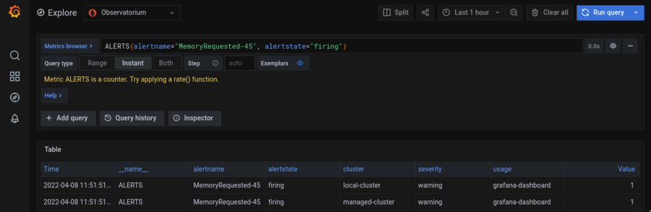

* 1. Change to the /home/student folder.

[student@workstation observability-review]$ **cd /home/student**

[student@workstation ~]$

1. [Hide Solution](https://rol.redhat.com/rol/app/)

**Evaluation**

As the student user on the workstation machine, use the lab command to grade your work. Correct any reported failures and rerun the command until successful.

[student@workstation ~]$ **lab grade observability-review**

**Finish**

On the workstation machine, use the lab command to complete this exercise. This step is important to ensure that resources from previous exercises do not impact upcoming exercises.

[student@workstation ~]$ **lab finish observability-review**

This concludes the section

# **Chapter 5.  Deploying Applications Across Multiple Clusters with RHACM**

[Introducing RHACM GitOps and the Application Model](https://rol.redhat.com/rol/app/courses/do480-2.4/pages/ch05)

[Quiz: Introducing RHACM GitOps and the Application Model](https://rol.redhat.com/rol/app/courses/do480-2.4/pages/ch05s02)

[Managing Multicluster Application Resources with RHACM](https://rol.redhat.com/rol/app/courses/do480-2.4/pages/ch05s03)

[Guided Exercise: Managing Multicluster Application Resources with RHACM](https://rol.redhat.com/rol/app/courses/do480-2.4/pages/ch05s04)

[Customizing Resources with Kustomize for RHACM](https://rol.redhat.com/rol/app/courses/do480-2.4/pages/ch05s05)

[Guided Exercise: Customizing Resources with Kustomize for RHACM](https://rol.redhat.com/rol/app/courses/do480-2.4/pages/ch05s06)

[Lab: Managing Applications Across Multiple Clusters with RHACM](https://rol.redhat.com/rol/app/courses/do480-2.4/pages/ch05s07)

[Summary](https://rol.redhat.com/rol/app/courses/do480-2.4/pages/ch05s08)

**Abstract**

|  |  |
| --- | --- |
| **Goal** | Deploy and manage applications in a multicluster environment with Red Hat Advanced Cluster Management for Kubernetes GitOps. |
| **Objectives** | * Describe and define GitOps concepts and the resources of the Red Hat Advanced Cluster Management for Kubernetes (RHACM) application model. * Deliver applications into multiple clusters by using Red Hat Advanced Cluster Management for Kubernetes (RHACM) GitOps. * Describe Kustomize concepts and features, and deploy new customizations with the Kustomize command-line tool. |
| **Sections** | * Introducing RHACM GitOps and the Application Model (and Quiz) * Managing Multicluster Application Resources with RHACM (and Guided Exercise) * Customizing Resources with Kustomize for RHACM (and Guided Exercise) |
| **Lab** | * Managing Applications Across Multiple Clusters with RHACM |

## **Introducing RHACM GitOps and the Application Model**

### **Objectives**

* Describe and define GitOps concepts and the resources of the Red Hat Advanced Cluster Management for Kubernetes (RHACM) application model.

### **Introducing GitOps Concepts**

GitOps is a framework that consists of procuring the very best practices from DevOps and applying them to infrastructure as code (IaC). DevOps organizations can efficiently deploy code to production clusters 24 hours a day.

Implementing GitOps includes introducing practices to automate the process of managing and provisioning infrastructure, such as version control, code review, and CI/CD. GitOps requires storage of resource files in a repository, such as Git. The resource files in the Git repository are referred to as the source of truth because they generate the same infrastructure every time you deploy them, much like using source code to build binaries.

GitOps practices enable you to manage the resources required for continuous deployments and integration of rapidly growing infrastructures.

### **GitOps Principles**

Adopting GitOps principles and then implementing and maintaining GitOps practices is essential to your multicluster environment.

**Declarative desired state**

This state is the final result that the user desires. The declarative description code, or configuration, is centralized and secured within a Git repository as a single source of truth for the entire system.

Systems must use declarative data to export the desired system state. The data must be readable and writable by both machines and humans.

**Immutable desired state**

This state refers to versioned IaC files that you cannot modify after the deployment. All declarative states are stored in Git. In Git, system infrastructure changes are available chronologically to help with troubleshooting, auditing, and rollbacks.

**Infrastructure as code**

IaC includes storing all configurations for managing and provisioning infrastructure in a repository. This practice ensures that the same environment is provisioned every time. Similar to the mechanics of software source code, all files under version control can be modified and then deployed. IaC automates infrastructure provisioning of storage and operating systems so that manual provisioning is no longer needed.

**Merge requests**

In the Git Ops workflow, merge requests are used effectively as a catalyst for infrastructure updates. Merging the updated source code after a review triggers an automatic deployment of the updated resources to the targeted clusters. Merge requests enable project developers to collaborate and review IaC before deploying to production systems.

**Continuous integration (CI)**

This practice describes the discipline of integrating changes in the main branch as often as possible. Developers use short-lived branches or small change sets and integrate them frequently, ideally several times a day. This speeds up the integration, makes code review easier, and reduces potential problems.

Continuous integration normally includes the validation of integrated changes by using automated integration tests. After the changes are integrated and validated, the team can decide when to deploy a new release. However, continuous integration by itself does not involve automating the release process.

### **Continuous Integration Tools**

At a high level, implementing CI requires two essential tools, a version control system and a CI service. A version control system is a system that assists in managing and tracking your source code in a repository. The repository uses a main or trunk branch to track the main development line. Feature development occurs in separate branches that are integrated into the main branch after review and validation. Git is one popular version control system. A continuous integration automation service is a server or a daemon that monitors the repository for changes. If the repository changes, the CI automation service checks out the new code and verifies that everything is valid. Red Hat Advanced Cluster Management for Kubernetes (RHACM) deploys the subscription operator to monitor Git for repository changes.

### **GitOps Workflow**

GitOps workflows use Git as the version control system that contains the configurations for managing and provisioning infrastructures. GitOps and IaC use a declarative approach to configuration management, instead of an imperative approach. A declarative model in programming focuses on how the application should accomplish the desired state; an imperative model focus on how it should do it.

A typical GitOps workflow includes the following steps:

* Store all IaC files in Git.
* Create a branch from the main repository to contain the updated IaC file.
* Update the branch, push the change to Git, and create a pull request.
* Request a peer review of the code to ensure proper configuration.
* Approve and merge the updated code.
* The RHACM subscription operator deploys the new code.

#### **Introducing the RHACM Application Model**

The ability to subscribe to channel repositories that contain the resources for managing deployments is the foundation of the application model. Application resource definitions are created, managed, and updated in the YAML resource files spec section.

This section enumerates resources available for the application model.

**Subscriptions**

The subscription (subscription.apps.open-cluster-management.io) enables clusters to subscribe to a source repository, also known as a channel.

The subscription type can be a Git repository, Helm release registry, or object storage repository.

Both the hub and managed cluster can use subscriptions. Subscriptions are associated with the channel and identify new or updated resource templates.

The subscription operator pulls from the source repository and deploys to the targeted managed clusters without checking the hub cluster first. The subscription operator can then monitor for new or updated resources.

The following example displays a typical subscription YAML file.

apiVersion: apps.open-cluster-management.io/v1

kind: Subscription

metadata:

name: web-app-cluster1

namespace: web-app

labels:

deployment: hello

annotations:

apps.open-cluster-management.io/github-branch: main

apps.open-cluster-management.io/github-path: mysql

|  |  |
| --- | --- |
|  | The optional github-branch annotation specifies that the branch, main, contains the deployment IaC files. |
|  | The optional github-path annotation specifies that the application is deployed from the mysql directory from the source repository. |

**Channels**

The application channels (channel.apps.open-cluster-management.io) are source definitions of repositories that the cluster can access. The channels can be GitHub repositories, Helm charts, object stores, and deployable resource namespaces on the hub cluster.

Except for GitHub, all channels require individual namespaces. The following example illustrates a typical channel configuration YAML file:

apiVersion: apps.open-cluster-management.io/v1 #API name of the object.

kind: Channel

metadata:

name: web-app-channel

namespace: web-app

spec:

pathname: 'https://github.com/redhattraining/do480-apps'

type: GitHub

|  |  |
| --- | --- |
|  | The value for pathname is required and specifies the URL of the repository that contains the IaC resource files. |
|  | The value for type is required and specifies the type of repository selected to contain the IaC resource files. |

**Placement Rules**

Placement rules (placementrule.apps.open-cluster-management.io) ensure that the application subscription runs on the correct cluster in your infrastructure. Placement rules assist in managing a multicluster deployment and can be shared across multiple subscriptions. The following example illustrates a typical placement rule YAML file:

apiVersion: apps.open-cluster-management.io/v1 #API name of the object

kind: PlacementRule

metadata:

name: cluster1

namespace: web-app

spec:

clusterSelector:

matchLabels:

clusterid: cluster1

|  |  |
| --- | --- |
|  | The value of name is required and identifies the placement rule as cluster1. |
|  | The value of namespace is required and specifies the namespace resource web-app for the placement rule. |

**Applications**

Applications (application.app.k8s.io) in RHACM are used for grouping Kubernetes resources that build an application. The following example illustrates a typical application YAML file:

apiVersion: app.k8s.io/v1 #API name of the object

kind: Application

metadata:

name: web-app

namespace: web-app

spec:

selector:

matchLabels:

app: web-app

|  |  |
| --- | --- |
|  | The value of namespace is required and specifies the namespace resource web-app. |
|  | The value of matchLabel is required and specifies that the key and value pair, app:wep-app, are contained in the subscription resource. |

### References

For more information, refer to the Red Hat Advanced Cluster Management for Kubernetes Applications guide at <https://access.redhat.com/documentation/en-us/red_hat_advanced_cluster_management_for_kubernetes/2.4>

[Previous](https://rol.redhat.com/rol/app/courses/do480-2.4/pages/do480-2.4)[Next](https://rol.redhat.com/rol/app/courses/do480-2.4/pages/ch05s02)

## **Managing Multicluster Application Resources with RHACM**

### **Objectives**

* Deliver applications into multiple clusters by using Red Hat Advanced Cluster Management for Kubernetes (RHACM) GitOps.

### **Introducing Red Hat Advanced Cluster Management GitOps**

Red Hat Advanced Cluster Management for Kubernetes (RHACM) provides GitOps capabilities as part of the application deployment lifecycle. RHACM implements GitOps components and adhere to GitOps principles. RHACM combines infrastructure as code (IaC), merge requests, and continuous integration (CI) and continuous deployment (CD) with the GitOps push pattern or method.

The GitOps push pattern uses a CI/CD pipeline to push changes to multicluster applications. A merge commit in Git triggers the CI/CD pipeline. The subscription operator monitors the channel for new or updated resources. After a merge commit, the subscription operator downloads the updated resources directly from the storage location and deploys them to the targeted managed clusters. This GitOps pattern does not require running agents in each infrastructure component.

This GitOps pattern uses documented CI/CD tooling that is familiar to a large segment of administrators. This familiarity enables a quick start to collaboration on projects with a large pool of contributors. The deployments are standardized and use the same deployment methodology.

### **Organizing a Git Repository for RHACM GitOps**

The RHACM application lifecycle can use multiple types of directory structures. A directory structure provides the logical implementation and deployment of the resource YAML files for one or multiple directories.

For example, the mysql application contains a mysql-app directory and a subscriptions directory containing a mysql-sub directory.

In the following tree output, the subscription directory targets the mysql-sub subdirectory containing a single subscription. The subscription operator applies the subscriptions to the hub cluster.

From the mysql-sub directory, the subscription operator applies subscriptions and policies to the managed cluster based on the placement rule. Placement rules determine which managed clusters are affected by each subscription.

├── mysql-app

└── subscriptions

└── mysql-sub

Subscriptions content from the mysql-sub directory is applied to all managed clusters, common applications, and common configurations that match the placement rule.

### **Managing Git Repository Applications**

RHACM provides application management functions with options for building and deploying applications and updates. You can manage applications across multicluster environments by implementing subscription and channel automation. In this course, all the application resources are located in the Git repository. RHACM also supports Helm repositories and object storage repositories.

### **Application Console**

The application console dashboard manages the application lifecycle. The dashboard includes capabilities to create, manage, and view the application status.

#### **Resource Topology**

RHACM provides a resource topology page that visually represents the application and related resources. This visualization of resources assists in troubleshooting and confirming application issues.

|  |
| --- |
|  |

#### **Advanced Configuration**

The **Advanced configuration** tab provides access to application tables and terminology. You can also access filters for subscriptions, placement rules, and channel resources.

|  |
| --- |
|  |

### **Deploying an Application from RHACM Using a Git Repository**

To prepare for application deployment from RHACM by using a Git repository, you must define Kubernetes resources for the application in advance and add them to a Git repository. The RHACM hub uses these resources to create the desired application architecture in the managed clusters.

To deploy and manage an application with RHACM, you must create custom resources. For example, you can create a subscription, namespace, service, channel, placement rule, and a route custom resource to deploy a MySQL application. After creating the resource YAML file, you can use the kubectl command to verify that the resource definition is created without an error. The following sections describe the custom resource files.

#### **Namespaces**

Each deployed application requires a namespace resource. The following example namespace definition displays the namespace resource created for a MySQL application.

apiVersion: v1

kind: Namespace

metadata:

name: mysql

#### **Creating Subscriptions**

The following example shows a subscription resource created for a MySQL application. You must specify the API version and full group name in the resource YAML file.

You can subscribe to the main branch or any branch within the repository by specifying the branch name annotation in the subscription. You can also specify the mysql path directory that is used to access the custom resources for deployment.

apiVersion: apps.open-cluster-management.io/v1

kind: Subscription

metadata:

name: mysql-development-subscription

labels:

app: mysql

annotations:

apps.open-cluster-management.io/github-path: mysql

apps.open-cluster-management.io/github-branch: main

#### **Channels**

Channels define the source repositories to which a cluster can subscribe by using a subscription. The following channel definition is an example of a Git channel for the mysql application. Within the hub cluster, the channel uses the mysql namespace. The channel also specifies the <https://github.com/redhattraining/do480-apps> path name that points to the storage location of resources used in the deployment.

apiVersion: apps.open-cluster-management.io/v1

kind: Channel

metadata:

name: mysql-channel

namespace: mysql

spec:

pathname: 'https://github.com/redhattraining/do480-apps'

type: GitHub

#### **Placement Rules**

Placement rules describe and specify the target clusters where subscriptions are deployed. The following example placement rule definition specifies the mysql namespace, and that the application can occupy only the hub or local-cluster cluster.

apiVersion: apps.open-cluster-management.io/v1

kind: PlacementRule

metadata:

labels:

app: mysql

name: mysql-placement-1

namespace: mysql

spec:

clusterSelector:

matchLabels:

'local-cluster': 'true'

### **Deploying an Application from the RHACM Console by Using a Git Repository**

After creating the required resource YAML files for the application and pushing them to a Git repository, you can deploy the application by using RHACM.

* Log in to the RHACM web console.
* Navigate to **Applications** → **Create application**. Use the built-in YAML editor to configure, update, and preview the resources in the YAML file.
* Enter a valid Kubernetes name and namespace for the application. A namespace list shows current namespaces based on your access role. You can choose a namespace from the list or create a new one, if you have the correct access role.
* The **Location for repository resources** menu contains three repository types: Git, Helm, and object storage. Selecting the Git repository displays the following fields:

| **Field** | **Value** |
| --- | --- |
| URL | The location of the Git repository. |
| Branch | The branch that contains the applicable resource files. |
| Path | The directory path that contains the applicable resource files. |
| Commit hash | The commit hash of the specific Git commit. |
| Tag | The tag annotation of the specific Git branch. |
| Reconcile | The reconcile option to override the default behavior that reconciles on a commit merge. The other option, replace, replaces the existing resource with the Git resource. |
| Pre/Post deployment task | The pre- and post-development tasks for Ansible jobs that run before or after the subscription deploys the application resources. |

* Use the **Select clusters to deploy** field to define and update the placement rule allocated for the application. You can deploy the placement rule to the local hub cluster, to the online managed clusters and the local cluster, or only deploy to clusters that match a specified label. You can also choose **Select existing placement configuration** to use a previously defined placement rule for an application in an existing namespace.
* From the **Settings** list, you can specify the application behavior for the **Deployment window** and **Time window**. The **Time window** allows resource subscriptions to begin deployments only during specific days and hours. You can define the subscription **Deployment window** type as always active, active within a specified interval, or blocked within a specified interval for the specified **Time window**.

For example, you could define an active **Time window** for web application updates between 3:00 PM and 3:30 PM every Monday. This **Time window** allows application deployments to occur between 3:00 PM and 3:30 PM every Monday. If a deployment begins during a defined time window and is still running when the time window closes, the deployment continues until it completes.

In the previous example, if you were to define the type as blocked instead of active, application deployments could not begin between 3:00 PM and 3:30 PM, but could start at any other time. The subscription operator continues monitory regardless of the defined deployment windows. The following example shows a **Time window** YAML definition that defines an active time zone window between 10:00 PM and 12:00 AM. Notice the time zone is set to US Eastern time.

apiVersion: apps.open-cluster-management.io/v1

kind: Subscription

...***output omitted***...

spec:

channel:

placement:

placementRef:

kind: PlacementRule

name: mysql-placement-1

timewindow:

windowtype: active

location: "America/New_York"

daysofweek: ["Monday"]

hours:

- start: "10:00PM"

end: "12:00AM"

### References

For more information, refer to the Red Hat Advanced Cluster Management for Kubernetes Applications guide at <https://access.redhat.com/documentation/en-us/red_hat_advanced_cluster_management_for_kubernetes/2.4>

## **Guided Exercise: Managing Multicluster Application Resources with RHACM**

* Use an RHACM GitOps workflow to deploy a MySQL task list application to the local cluster based on an active time window interval.

**Outcomes**

* Deliver applications into multiple clusters by using RHACM GitOps.
* Implement application placement rules.
* Define an active time interval for application deployments.

A GitHub account is required to complete this exercise.

As the student user on the workstation machine, use the lab command to prepare your system for this exercise. This command ensures that Red Hat Advanced Cluster Management for Kubernetes is installed and that the local cluster is ready and available.

[student@workstation ~]$ **lab start applications-resources**

1. Fork the do480-apps course GitHub repository at <https://github.com/redhattraining/do480-apps/>. This repository contains the YAML files required to build the application.
   1. From the workstation machine, navigate to the do480-apps repository at <https://github.com/redhattraining/do480-apps/>.
   2. In the upper-right corner of the GitHub repository page, click **Fork** to create a fork.
   3. Ensure that the **Copy the main branch only** option is disabled. You cannot perform this exercise if you copy only the main branch of the repository.

### Note

If you have already performed this exercise or made other changes to the fork, then you must delete your fork to avoid problems during this exercise.

To delete the fork, navigate to https://github.com/your-fork-name/DO480-apps/. Click **Settings**. Click **Delete this repository** and enter the name of the repository to confirm the deletion.

1. Access the RHACM web console at https://multicloud-console.apps.ocp4.example.com.
   1. From the workstation machine, navigate to https://multicloud-console.apps.ocp4.example.com.
   2. Click **htpasswd_provider** and log in as the admin user with the redhat password.
2. Use RHACM GitOps to create a new MySQL application based on the following criteria.

**Table 5.1. MySQL for Local Cluster**

| **Field** | **Value** |
| --- | --- |
| Name | mysql |
| Namespace | mysql |
| Repository types | Git |
| URL | https://github.com/*your-fork-name*/do480-apps/ |
| Branch | main |
| Path | mysql |

* 1. On the left navigation bar, navigate to **Applications**, click **Create application** in the middle of the page and then click **Subscription**.
  2. On the **Applications** page, set **YAML: On** to view the YAML in the console as you create the application.
  3. In both the **Name** and **Namespace** fields, type mysql. Applications from the local hub cluster require a namespace for every application to contain application resources on the managed clusters..
  4. Click **Repository location for resources** and choose **Git** as the repository type for your deployable resources.

For the channel source, enter the URL of your forked do480-apps repository in the **URL** field.

|  |
| --- |
|  |

* 1. Type main and mysql for the **Branch** and **Path** fields, respectively.

View the subscription and channel configuration in **Application YAML** pane.

|  |
| --- |
|  |

* 1. Scroll down to configure a placement rule for the application. Select **Deploy on local cluster** to create a placement rule that deploys the application only on the local cluster.
  2. Click **Save**.

1. Verify that you can access the MySQL application front end for the local cluster.
   1. On the **Topology** page, click the **Route** pod, and then click the **Location** URL to view the application front end on the local cluster.
   2. On the subsequent web page, append /todo/ to the URL to display the application.
2. Define an active time window to deploy updated versions of the application resources.
   1. Click the **Applications** link in the upper-left of the page.
   2. To update the application resources, click the vertical ellipsis (**⋮**) menu to the right of the mysql application row and click **Edit application**.

|  |
| --- |
|  |

* 1. Scroll down and click **Settings: Specify application behavior**. Click **Active with specified interval** to display the **Time window configuration** pane.

|  |
| --- |
|  |

* 1. Specify the day of the week and the start and end times for the time interval. Select the appropriate day of the week, time zone, and start and end times, based on your current day of the week, time zone, and local time. For example, if today is Thursday and the current time is 05:30 AM, the active time window is defined for Thursday between 05:30 AM and 05:45 AM in the US Eastern time zone.

|  |
| --- |
|  |

* 1. Click **Update**.

|  |
| --- |
|  |

1. Navigate to your forked do480-apps repository in the main branch and edit the do480-apps/mysql/deployment.yaml file. Update the container image to mysql-80:156.
   1. In your GitHub fork, ensure that you are in the main branch. Click **mysql**, and then click the **deployment.yaml** file link to access the file. Click the pencil icon to edit the YAML file.
   2. In the YAML editor, update the current image tag to mysql-80:1-156. Scroll to the end of the page and click **Commit changes** to update the main branch.

### Note

Committing the changes in GitHub triggers the application update and should take approximately 5 seconds.

spec:

containers:

- image: registry.redhat.io/rhel8/mysql-80:1-156

name: mysql

env:

1. Return to the RHACM web console and view the application **Topology** page to verify that the new pod is created.
   1. On the **Topology** page, click the **ReplicaSet** pod. View the created time for the pod as the resource updates and creates a new pod. After a couple minutes, you see the newly created mysql ReplicaSet pod.

|  |
| --- |
|  |

1. Verify that resource updates cannot occur outside the active time window. For example, the current time is 5:30 AM, the time zone is US Eastern time, and the time window interval is defined to end at 5:45 AM.
   1. After the time window interval expires, return to your GitHub fork, ensuring that you are in the main branch. Click **mysql** and then click the **deployment.yaml** file link to access the file. Click the pencil icon to edit the YAML file.
   2. In the GitHub YAML editor, update the current image tag to mysql-80:latest. Scroll to the end of the page and click **Commit changes** to update the main branch.

spec:

containers:

- image: registry.redhat.io/rhel8/mysql-80:latest

name: mysql

env:

* 1. Return to the RHACM web console and view the application **Topology** page to verify that the new pod is created.
  2. On the **Topology** page, click the **ReplicaSet** pod. The pod has not been recreated because the active time window is now closed.

**Finish**

On the workstation machine, use the lab command to complete this exercise. This step is important to ensure that resources from previous exercises do not impact upcoming exercises.

[student@workstation ~]$ **lab finish applications-resources**

This concludes the section

## **Customizing Resources with Kustomize for RHACM**

### **Objectives**

* Describe Kustomize concepts and features, and deploy new customizations with the Kustomize command-line tool.

### **Introducing Kustomize**

Kustomize is a configuration management tool that you can use to make declarative changes to application configurations and components while preserving the original base YAML files. Kustomize overlays declarative YAML artifacts, or patches, that override the general settings without modifying the original files. For example, you could have a multiphase application for multiple departments. The application configuration is predominately identical across different departments, but some settings are specific to each department and require customization.

### **Kustomize Benefits**

Kustomize implements the kustomization.yaml file, which contains specific settings that override those in the original base configuration. The GitOps team can use Kustomize to consume base YAML file updates while maintaining customized settings.

Kustomize implements the concepts of bases and overlays. Bases are the minimal YAML files that contain the settings shared between the application target environments. Managing Kubernetes configurations with Kustomize provides the following benefits.

**Reusability**

Kustomize lets you reuse base YAML files across multiple environments. If the deployment is successful with the base settings, but not when using the overlays, you can troubleshoot by comparing the behavior of the overlays to the behavior of the base.

**Templateless**

Kustomize uses standard YAML syntax that is the same as Kubernetes. It does not have a templating language.

### **Kustomize Files**

Kustomize breaks down configuration deployment manifests into base YAML files and overlay YAML files for environment specific settings. After the customization parameters are defined, Kustomize rebuilds and deploys a new manifest with the kubectl kustomize and kubectl apply commands, respectively.

Kustomize consists of the following file types:

**Base YAML files**

The base YAML files contain the application settings that are identical or common to multiple environments.

**Overlay YAML files**

The overlay YAML files contains the application settings that are unique and override the base file parameters.

**Kustomization files**

The kustomization.yaml files define how the settings in the overlay YAML files should interact with the base YAML files to build the new manifest. The new manifest builds are called variants and consist of the base YAML files and their overlays. Generally, in a multicluster infrastructure, each environment has a corresponding kustomization.yaml file that contains specific settings for different environments, such as production and development.

### **Kustomize Transformers**

Kustomize provides a wide range of default transformers that focus on simplifying application deployments in multicluster environments. Transformers are responsible for modifying the resource and the build process. Kustomize creates new resources by applying a series of transformations to the original set of resources.

For example, you might have production, development, and quality assurance environments running an application that requires different image versions for each environment. Kustomize provides the images transformer that can update image names and tags using the newName and newTag directives. The images transformer eliminates the requirement to update all the applicable manifests for each environment individually.

There are many more transformers available depending on your needs. This section discusses several of the most commonly used Kustomize transformers in more detail, and provides example kustomization.yaml files to help you implement them.

#### **Adding Prefixes to Resource Names**

Use the namePrefix transformer to prepend a specific prefix to resource names.

The following kustomization.yaml examples apply the prefix prod- to all resource names for the production environment and the prefix dev- to all resource names in the development environment.

#Production

kind: Kustomization

#path to base directory

bases:

- ../../base

#Add name prefix "prod"

namePrefix: prod-

#Development

kind: Kustomization

#path to base directory

bases:

- ../../base

#Add name prefix "dev"

namePrefix: dev-

#### **Replacing Label Values**

Use the commonLabels transformer to replace label values for a specific keyword.

For example, the production and development cluster sets require a label for the application that references the cluster set environment. The following kustomization.yaml file defines the prod-todolist.js and dev-todolist.js labels for the keyword app on the production and development cluster sets respectively.

#Production

commonLabels:

app: prod-todolist.js

#Development

commonLabels:

app: dev-todolist.js

Note that the commonLabels transformer does not append or prepend characters but directly replaces the values.

#### **Replacing Images**

Use the images transformer to replace the image with a customized image name.

For example, the production and development cluster sets require an image that references a specific cluster set environment. The images transformer replaces the mysql-image placeholder in the deployment.yaml file. The images for the production and development cluster sets are defined in their respective kustomization.yaml files with the newName and newTag keys.

The following kustomization.yaml files define the newName value as quay.io/example/todo-single for both the production and development cluster sets. The production cluster set uses the stable v1.1 tag that has been tested and secured. However, the development cluster set uses the latest open source release of the image, with the v2.0-beta tag.

#Production

images:

- name: mysql-db-image

newName: quay.io/example/todo-single

newTag: v1.1

#Development

images:

- name: mysql-db-image

newName: quay.io/example/todo-single

newTag: v2.0-beta

#### **Merging Patches**

Use the patchesStrategicMerge transformer to merge specific configuration segments into to the common base configuration.

For example, the development cluster set uses the default emptyDir setting with ephemeral storage. However, the production environment requires persistent volumes and persistent volume claims (PVCs) for storage. Define the PVCs in a separate pvc.yaml file. Then, edit the kustomization.yaml file for the production environment to include pvc.yaml in the resources section. Finally, use the patchesStrategicMerge transformer to apply the volumes defined in the pvc.yaml file, as shown in the following example:

#Production

patchesStrategicMerge:

- pvc.yaml

### **Directory Structure**

Kustomize does not enforce a strict directory structure. The use case determines the directory structure. A typical use case for Kustomize is an application deployment that contains a base configuration and multiple variants of that configuration.

Consider the following example use case and the proposed directory structure. Your organization has a base set of files to deploy a PostgreSQL database, and an overlay that patches the base manifest to use a specific type of storage. The infrastructure consists of two environments, development and production; both environments run MySQL applications on their respective clusters. Although the configuration settings are mostly the same, there are some differences between the storage requirements that you customize by using a patch overlay.

The following is an example of the directory structure:

── base

│ ├── deployment.yaml

│ ├── kustomization.yaml

│ └── service.yaml

└── overlays

├── development

│ └── kustomization.yaml

├── production

│ ├── kustomization.yaml

│ ├── pvc.yaml

The base directory must contain a kustomization.yaml file that specifies the resources required to build a new application manifest.

kind: Kustomization

resources:

- deployment.yaml

- service.yaml

The base directory contains the resource files for the application. You must build this directory by using the kubectl kustomize command.

[student@workstation base]$ **kubectl kustomize .**

This command takes the YAML source (from a path or URL) and creates a new YAML file that can be piped into the kubectl create command.

### References

For more information, refer to the Red Hat Advanced Cluster Management for Kubernetes Applications guide at <https://access.redhat.com/documentation/en-us/red_hat_advanced_cluster_management_for_kubernetes/2.4>

## **Guided Exercise: Customizing Resources with Kustomize for RHACM**

* Use Kustomize to maintain a common set of deployment resources and build overlays. The overlays modify the base deployment resources for specific environments. You also build deployment overlays that modify available storage and replicas on the local and managed clusters.

**Outcomes**

* Build a base deployment for Kustomize.
* Build overlays to modify the base deployment.
* Configure the kustomization.yaml file to add resources.
* Deploy an application modified and managed with Kustomize.

As the student user on the workstation machine, use the lab command to prepare your system for this exercise.

This command ensures that Red Hat Advanced Cluster Management (RHACM) is installed and that clusters are ready and available.

[student@workstation ~]$ **lab start applications-kustomize**

1. Fork the DO480-apps course GitHub repository at <https://github.com/redhattraining/DO480-apps/>. This repository contains the YAML files required to build the application.
   1. From the workstation machine, navigate to the DO480-apps repository at <https://github.com/redhattraining/DO480-apps/>.
   2. In the upper-right corner of the GitHub repository page, click **Fork** to create a fork for your repository.
   3. Ensure that the **Copy the main branch only** option is disabled. You cannot perform this exercise if you copy only the main branch of the repository.

### Note

If you have already performed this exercise or made other changes to the fork, then you must delete your fork to avoid problems during this exercise.

To delete the fork, navigate to https://github.com/your-fork-name/DO480-apps/. Click **Settings**. Click **Delete this repository** and enter the name of the repository to confirm the deletion.

1. Access the RHACM web console at https://multicloud-console.apps.ocp4.example.com.
   1. From the workstation machine, navigate to https://multicloud-console.apps.ocp4.example.com.
   2. Click **htpasswd_provider** and log in as the admin user with the redhat password.
2. Use RHACM GitOps to create a new MySQL application based on the following criteria.

**Table 5.2. MySQL for Development Clusters**

| **Field** | **Value** |
| --- | --- |
| Name | mysql |
| Namespace | mysql |
| Repository types | Git |
| URL | https://github.com/*your-fork-name*/DO480-apps/ |
| Branch | main |
| Path | mysql |

* 1. On the left navigation bar, navigate to **Applications**, click **Create application**, and then click **Subscription**.
  2. On the **Applications** page, set **YAML: On** to view the YAML in the console as you create the application.
  3. In both the **Name** and **Namespace** fields, type mysql. Applications from the local hub cluster require a namespace for every application to contain application resources on the managed clusters.
  4. Click **Repository location for resources** and select **Git** for the repository type for your deployable resources.

For the channel source, enter the URL of your forked DO480-apps repository in the **URL** field.

|  |
| --- |
|  |

* 1. Type main and mysql for the **Branch** and **Path** fields, respectively.
  2. Scroll down and click **Select clusters to deploy to** to configure a placement rule for the application. Select **Deploy on local cluster** to create a placement rule that deploys the application only on the local cluster.
  3. Click **Save**.

1. Verify that you can access the MySQL application front end for the local cluster.
   1. On the **Topology** page, click the **Route** pod, and then click the **Location** URL to view the application front end on the local cluster.
   2. On the subsequent web page, append /todo/ to the URL to display the application.
2. Use the RHACM web console to add the env=development and env=production labels to the local-cluster and managed-cluster clusters respectively. The web console URL is https://multicloud-console.apps.ocp4.example.com.
   1. Navigate to the RHACM web console at https://multicloud-console.apps.ocp4.example.com. When prompted, click **htpasswd_provider** and log in as the admin user with the redhat password.
   2. On the left navigation menu, click **Clusters** to add new labels to the local-cluster and managed-cluster clusters.
   3. Click the vertical ellipsis (**⋮**) menu to the right of the local-cluster row, and then click **Edit labels**.
   4. Type env=development for the new label and then click **Save**.
   5. Click the vertical ellipsis menu to the right of the managed-cluster row, and then click **Edit labels**.
   6. Type env=production for the new label and then click **Save**.
3. Use the kubectl kustomize command to build the base directory and corresponding kustomization.yaml file in the ~/DO480/labs/applications-kustomize directory. The base directory contents are located at http://github.com/*your_fork*/DO480-apps in the main-kustomize branch.
   1. From the RHACM console, navigate to **Applications**, click the vertical ellipsis menu on the right side of the mysql application row, and then click **Delete application**.
   2. Select **Remove application related resources** and click **Delete** to delete the application.
   3. From the workstation machine, open a terminal and login to the ocp4 cluster as the admin user. The API Server URL is https://api.ocp4.example.com:6443.

[student@workstation ~]$ **oc login -u admin -p redhat \**

**https://api.ocp4.example.com:6443**

Login successful.

...output omitted...

* 1. Navigate to the DO480/labs/applications-kustomize/ directory.

[student@workstation ~]$ **cd DO480/labs/applications-kustomize**

* 1. Use Git to clone your forked DO480-apps repository to access the common set of YAML resource files.

[student@workstation applications-kustomize]$ **git clone \**

**https://github.com/*your-fork-name*/DO480-apps**

Cloning into 'DO480-apps'...

remote: Enumerating objects: 144, done.

remote: Counting objects: 100% (144/144), done.

remote: Compressing objects: 100% (103/103), done.

remote: Total 144 (delta 56), reused 104 (delta 36), pack-reused 0

Receiving objects: 100% (144/144), 18.03 KiB | 18.03 MiB/s, done.

Resolving deltas: 100% (56/56), done.

* 1. Navigate to the DO480-apps directory and checkout the main-kustomize branch, which contains the MySQL deployment YAML files.

[student@workstation applications-kustomize]$ **cd DO480-apps**

[student@workstation DO480-apps]$ **git checkout main-kustomize**

Branch 'kustomize' set up to track remote branch 'main-kustomize' from 'origin'.

Switched to a new branch 'main-kustomize'

* 1. Create the ~/DO480/labs/applications-kustomize/DO480-apps/base/kustomization.yaml file to contain the resources and associated customizations.

The kustomization.yaml file should consist of the following content:

kind: Kustomization

resources:

- deployment-frontend.yaml

- deployment.yaml

- service.yaml

- service-frontend.yaml

* 1. Save the changes and close the editor.
  2. Verify that the kustomization.yaml file builds the deployment without errors with the kubectl kustomize command.

[student@workstation DO480-apps]$ **kubectl kustomize base/**

...output omitted...

You now have a base set of deployment resources that you can share with both the development and production clusters.

1. Examine the deployment.yaml file in the base directory and note that it currently configures ephemeral storage. The development clusters require that the MySQL applications use 5 MiB persistent volume claims for storage. Build an overlay for the development clusters that uses persistent storage.
   1. Create the overlays directory and the corresponding development subdirectory.

[student@workstation DO480-apps]$ **mkdir -p overlays/{development,production}**

* 1. Ensure that the overlays directory is at the same directory level as the base directory

[student@workstation DO480-apps]$ **tree -d**

base

overlays/

├── development

└── production

* 1. Create the dbclaim-pvc.yaml file resource, which contains the persistent volume claim, in the ~/DO480/labs/applications-kustomize/DO480-apps/overlays/development/ subdirectory. The dbclaim-pvc.yaml file should consist of the following content:

apiVersion: v1

kind: PersistentVolumeClaim

metadata:

name: mysql-pv-claim

spec:

accessModes:

- ReadWriteOnce

resources:

requests:

storage: 5Mi

storageClassName: nfs-storage

* 1. Save the changes and close the editor.
  2. Create the corresponding kustomization.yaml file in the ~/DO480/labs/applications-kustomize/DO480-apps/overlays/development/ subdirectory to add the new resource. The kustomization.yaml file should consist of the following content:

kind: Kustomization

bases:

- ../../base

resources:

- dbclaim-pvc.yaml

* 1. Save the changes and close the editor.
  2. Update the storage setting in the ~/DO480/labs/applications-kustomize/DO480-apps/base/deployment.yaml file to reference the PVC mysql-pv-claim. The deployment.yaml file should consist of the following content:

...output omitted...

ports:

- containerPort: 3306

name: mysql

volumeMounts:

- mountPath: /var/lib/mysql

name: db-volume

volumes:

- name: db-volume

**persistentVolumeClaim:**

**claimName: mysql-pv-claim**

- name: db-init

emptyDir: {}

To expand storage in the future, you need only modify the overlay kustomization.yaml file.

* 1. Use the kubectl kustomize command to test the settings for the development clusters with the new storage resource. Verify that the new resource is added to the deployment.

[student@workstation DO480-apps]$ **kubectl kustomize overlays/development/**

...output omitted...

1. The development clusters require that the MySQL application pods are identifiable by the prefix dev-. Build an overlay for the development clusters that uses the namePrefix transformer to set dev- as the name prefix.
   1. Add the namePrefix transformer with the prefix dev- to the ~/DO480/labs/applications-kustomize/DO480-apps/overlays/development/kustomization.yaml file. The kustomization.yaml file should consist of the following content:

kind: Kustomization

bases:

- ../../base

resources:

- dbclaim-pvc.yaml

**namePrefix:** **dev-**

* 1. Use the kubectl kustomize command to test the settings for the development clusters with the namePrefix transformer.
  2. [student@workstation DO480-apps]$ **kubectl kustomize overlays/development/**

...output omitted...

1. The development clusters require that a route for the MySQL application.
   1. Create the route.yaml file resource in the ~/DO480/labs/applications-kustomize/DO480-apps/overlays/development/ subdirectory. The route.yaml file should consist of the following content:

apiVersion: route.openshift.io/v1

kind: Route

metadata:

labels:

app: todonodejs

name: frontend

name: frontend

spec:

host: todo.apps.ocp4.example.com

path: "/todo"

to:

kind: Service

name: dev-frontend

weight: 100

wildcardPolicy: None

* 1. Save the changes and close the editor.
  2. Update the corresponding kustomization.yaml file in the ~/DO480/labs/applications-kustomize/DO480-apps/overlays/development/ subdirectory to add the new resource. The kustomization.yaml file should consist of the following content:

kind: Kustomization

bases:

- ../../base

resources:

- dbclaim-pvc.yaml

**- route.yaml**

namePrefix: dev-

1. Commit the newly created development Kustomize files to your Git repository.
   1. Add the newly created Kustomize files.
   2. [student@workstation DO480-apps]$ **git add .**

...output omitted...

* 1. Commit the newly created Kustomize files.
  2. [student@workstation DO480-apps]$ **git commit -m "kustomize storage"**

...output omitted...

* 1. Push the changes to your Git repository.
  2. [student@workstation DO480-apps]$ **git push --set-upstream origin main-kustomize**

...output omitted...

1. From the RHACM console, deploy the development customized MySQL application.
   1. On the left navigation bar, navigate to **Applications**, click **Create application**, and then click **Subscription**.
   2. On the **Applications** page, set **YAML: On** to view the YAML in the console as you create the application.
   3. In both the **Name** and **Namespace** fields, type mysql.
   4. Click **Repository location for resources** and choose **Git** for the repository type for your deployable resources.

For the channel source, enter the URL of your forked DO480-apps repository in the **URL** field.

* 1. Type main-kustomize in the **Branch** field and overlays/development in the **Path** field to reference the customized configuration.
  2. Scroll down, click **Select clusters to deploy to**, then select **Deploy application resources only on clusters matching specified labels** to configure a placement rule for the application. Type env in the **Label** field and development in the **Value** field, and then click **Save**.
  3. On the **Topology** page, navigate to **Subscription** → **mysql-subscription-1** and click the **Route** pod. Click **todo.apps.ocp4.example.com/**, located under **Location**, to view the application. On the next page, append /todo/ to the URL to display the application.

1. The production clusters require that the MySQL applications use a 50 MiB persistent volume for storage.

Build an overlay for the production clusters that uses persistent storage.

* 1. Return to the terminal and create a new prod-kustomize branch.

[student@workstation DO480-apps]$ **git checkout -b prod-kustomize**

Branch 'kustomize' set up to track remote branch 'prod-kustomize' from 'origin'.

Switched to a new branch 'prod-kustomize'

* 1. Create the dbclaim-pvc.yaml file resource that contains the 10 MiB persistent volume, in the ~/DO480/labs/applications-kustomize/DO480-apps/overlays/production/ subdirectory. The dbclaim-pvc.yaml file should consist of the following content:

apiVersion: v1

kind: PersistentVolumeClaim

metadata:

name: mysql-pv-claim

spec:

accessModes:

- ReadWriteOnce

resources:

requests:

storage: 50Mi

storageClassName: nfs-storage

* 1. Save the changes and close the editor.
  2. Create the corresponding kustomization.yaml file in the ~/DO480/labs/applications-kustomize/DO480-apps/overlays/production/ subdirectory to add the new resource. The kustomization.yaml file should consist of the following content:

kind: Kustomization

bases:

- ../../base

resources:

- dbclaim-pvc.yaml

* 1. Save the changes and close the editor.

To expand storage in the future, you need only modify the overlay kustomization.yaml file.

* 1. Use the kubectl kustomize command to test the deployment for the production clusters with the new storage resource. Verify that the new resource has been added to the deployment.

[student@workstation DO480-apps]$ **kubectl kustomize overlays/production**

...output omitted...

1. The production clusters require that the MySQL application pods are identifiable by the prefix prod-. Build an overlay for the production clusters that uses the namePrefix transformer to set prod- as the name prefix.
   1. Add the namePrefix transformer with the prefix prod- to the ~/DO480/labs/applications-kustomize/DO480-apps/overlays/production/kustomization.yaml file. The kustomization.yaml file should consist of the following content:

kind: Kustomization

bases:

- ../../base

resources:

- dbclaim-pvc.yaml

**namePrefix:** **prod-**

* 1. Use the kubectl kustomize command to test the settings for the production clusters with the namePrefix transformer.

[student@workstation DO480-apps]$ **kubectl kustomize overlays/production/**

...output omitted...

1. The production clusters require a route for the MySQL application.
   1. Create the route-mng.yaml file resource in the ~/DO480/labs/applications-kustomize/DO480-apps/overlays/production/ subdirectory. The route-mng.yaml file should consist of the following content:

apiVersion: route.openshift.io/v1

kind: Route

metadata:

labels:

app: todonodejs

name: frontend

name: frontend

spec:

host: todo.apps.ocp4-mng.example.com

path: "/todo"

to:

kind: Service

name: prod-frontend

weight: 100

wildcardPolicy: None

* 1. Save the changes and close the editor.

Update the corresponding kustomization.yaml file in the ~/DO480/labs/applications-kustomize/DO480-apps/overlays/production/ subdirectory to add the new resource. The kustomization.yaml file should consist of the following content:

kind: Kustomization

bases:

- ../../base

resources:

- dbclaim-pvc.yaml

**- route-mng.yaml**

namePrefix: prod-

* 1. Save the changes and close the editor.
  2. Use the kubectl kustomize command to test the settings for the production clusters with the namePrefix transformer.
  3. [student@workstation DO480-apps]$ **kubectl kustomize overlays/production/**

...output omitted...

1. Add and push the newly created production Kustomize files to the Git repository.
   1. Add the newly created Kustomize files.
   2. [student@workstation DO480-apps]$ **git add .**

...output omitted...

* 1. Commit the newly created Kustomize files.
  2. [student@workstation DO480-apps]$ **git commit -m "prod kustomize storage"**

...output omitted...

* 1. Push the newly created Kustomize files to your Git repository.
  2. [student@workstation DO480-apps]$ **git push --set-upstream origin prod-kustomize**

...output omitted...

1. From the RHACM web console, update the MySQL application to use the Kustomize storage configuration.
   1. On the left navigation bar, navigate to **Applications** and click **mysql**.
   2. Click **Editor** to modify the MySQL application.
   3. Add an additional repository to the MySQL application for the production clusters, based on the following settings.

**Table 5.3. MySQL for Production Clusters**

| **Field** | **Value** |
| --- | --- |
| Repository types | Git |
| URL | https://github.com/*your fork*/DO480-apps/ |
| Branch | prod-kustomize |
| Path | overlays/production |
| Label name | env |
| Label value | production |

* 1. Click **Update**.
  2. On the **Topology** page, navigate to **Subscription** → **mysql-subscription-2** and click the **Route** pod. Click **todo.apps.ocp4-mng.example.com/** under **Location** to view the application. On the next page, append /todo/ to the URL to display the application.

**Finish**

On the workstation machine, change to the student user home directory and use the lab command to complete this exercise. This step is important to ensure that resources from previous exercises do not impact upcoming exercises.

[student@workstation DO480-apps]$ **cd ~**

[student@workstation ~]$ **lab finish applications-kustomize**

This concludes the section.

## **Guided Exercise: Customizing Resources with Kustomize for RHACM**

* Use Kustomize to maintain a common set of deployment resources and build overlays. The overlays modify the base deployment resources for specific environments. You also build deployment overlays that modify available storage and replicas on the local and managed clusters.

**Outcomes**

* Build a base deployment for Kustomize.
* Build overlays to modify the base deployment.
* Configure the kustomization.yaml file to add resources.
* Deploy an application modified and managed with Kustomize.

As the student user on the workstation machine, use the lab command to prepare your system for this exercise.

This command ensures that Red Hat Advanced Cluster Management (RHACM) is installed and that clusters are ready and available.

[student@workstation ~]$ **lab start applications-kustomize**

1. Fork the DO480-apps course GitHub repository at <https://github.com/redhattraining/DO480-apps/>. This repository contains the YAML files required to build the application.
   1. From the workstation machine, navigate to the DO480-apps repository at <https://github.com/redhattraining/DO480-apps/>.
   2. In the upper-right corner of the GitHub repository page, click **Fork** to create a fork for your repository.
   3. Ensure that the **Copy the main branch only** option is disabled. You cannot perform this exercise if you copy only the main branch of the repository.

### Note

If you have already performed this exercise or made other changes to the fork, then you must delete your fork to avoid problems during this exercise.

To delete the fork, navigate to https://github.com/your-fork-name/DO480-apps/. Click **Settings**. Click **Delete this repository** and enter the name of the repository to confirm the deletion.

1. Access the RHACM web console at https://multicloud-console.apps.ocp4.example.com.
   1. From the workstation machine, navigate to https://multicloud-console.apps.ocp4.example.com.
   2. Click **htpasswd_provider** and log in as the admin user with the redhat password.
2. Use RHACM GitOps to create a new MySQL application based on the following criteria.

**Table 5.2. MySQL for Development Clusters**

| **Field** | **Value** |
| --- | --- |
| Name | mysql |
| Namespace | mysql |
| Repository types | Git |
| URL | https://github.com/*your-fork-name*/DO480-apps/ |
| Branch | main |
| Path | mysql |

* 1. On the left navigation bar, navigate to **Applications**, click **Create application**, and then click **Subscription**.
  2. On the **Applications** page, set **YAML: On** to view the YAML in the console as you create the application.
  3. In both the **Name** and **Namespace** fields, type mysql. Applications from the local hub cluster require a namespace for every application to contain application resources on the managed clusters.
  4. Click **Repository location for resources** and select **Git** for the repository type for your deployable resources.

For the channel source, enter the URL of your forked DO480-apps repository in the **URL** field.

|  |
| --- |
|  |

* 1. Type main and mysql for the **Branch** and **Path** fields, respectively.
  2. Scroll down and click **Select clusters to deploy to** to configure a placement rule for the application. Select **Deploy on local cluster** to create a placement rule that deploys the application only on the local cluster.
  3. Click **Save**.

1. Verify that you can access the MySQL application front end for the local cluster.
   1. On the **Topology** page, click the **Route** pod, and then click the **Location** URL to view the application front end on the local cluster.
   2. On the subsequent web page, append /todo/ to the URL to display the application.
2. Use the RHACM web console to add the env=development and env=production labels to the local-cluster and managed-cluster clusters respectively. The web console URL is https://multicloud-console.apps.ocp4.example.com.
   1. Navigate to the RHACM web console at https://multicloud-console.apps.ocp4.example.com. When prompted, click **htpasswd_provider** and log in as the admin user with the redhat password.
   2. On the left navigation menu, click **Clusters** to add new labels to the local-cluster and managed-cluster clusters.
   3. Click the vertical ellipsis (**⋮**) menu to the right of the local-cluster row, and then click **Edit labels**.
   4. Type env=development for the new label and then click **Save**.
   5. Click the vertical ellipsis menu to the right of the managed-cluster row, and then click **Edit labels**.
   6. Type env=production for the new label and then click **Save**.
3. Use the kubectl kustomize command to build the base directory and corresponding kustomization.yaml file in the ~/DO480/labs/applications-kustomize directory. The base directory contents are located at http://github.com/*your_fork*/DO480-apps in the main-kustomize branch.
   1. From the RHACM console, navigate to **Applications**, click the vertical ellipsis menu on the right side of the mysql application row, and then click **Delete application**.
   2. Select **Remove application related resources** and click **Delete** to delete the application.
   3. From the workstation machine, open a terminal and login to the ocp4 cluster as the admin user. The API Server URL is https://api.ocp4.example.com:6443.

[student@workstation ~]$ **oc login -u admin -p redhat \**

**https://api.ocp4.example.com:6443**

Login successful.

...output omitted...

* 1. Navigate to the DO480/labs/applications-kustomize/ directory.

[student@workstation ~]$ **cd DO480/labs/applications-kustomize**

* 1. Use Git to clone your forked DO480-apps repository to access the common set of YAML resource files.

[student@workstation applications-kustomize]$ **git clone \**

**https://github.com/*your-fork-name*/DO480-apps**

Cloning into 'DO480-apps'...

remote: Enumerating objects: 144, done.

remote: Counting objects: 100% (144/144), done.

remote: Compressing objects: 100% (103/103), done.

remote: Total 144 (delta 56), reused 104 (delta 36), pack-reused 0

Receiving objects: 100% (144/144), 18.03 KiB | 18.03 MiB/s, done.

Resolving deltas: 100% (56/56), done.

* 1. Navigate to the DO480-apps directory and checkout the main-kustomize branch, which contains the MySQL deployment YAML files.

[student@workstation applications-kustomize]$ **cd DO480-apps**

[student@workstation DO480-apps]$ **git checkout main-kustomize**

Branch 'kustomize' set up to track remote branch 'main-kustomize' from 'origin'.

Switched to a new branch 'main-kustomize'

* 1. Create the ~/DO480/labs/applications-kustomize/DO480-apps/base/kustomization.yaml file to contain the resources and associated customizations.

The kustomization.yaml file should consist of the following content:

kind: Kustomization

resources:

- deployment-frontend.yaml

- deployment.yaml

- service.yaml

- service-frontend.yaml

* 1. Save the changes and close the editor.
  2. Verify that the kustomization.yaml file builds the deployment without errors with the kubectl kustomize command.
  3. [student@workstation DO480-apps]$ **kubectl kustomize base/**

...output omitted...

You now have a base set of deployment resources that you can share with both the development and production clusters.

1. Examine the deployment.yaml file in the base directory and note that it currently configures ephemeral storage. The development clusters require that the MySQL applications use 5 MiB persistent volume claims for storage. Build an overlay for the development clusters that uses persistent storage.
   1. Create the overlays directory and the corresponding development subdirectory.

[student@workstation DO480-apps]$ **mkdir -p overlays/{development,production}**

* 1. Ensure that the overlays directory is at the same directory level as the base directory

[student@workstation DO480-apps]$ **tree -d**

base

overlays/

├── development

└── production

* 1. Create the dbclaim-pvc.yaml file resource, which contains the persistent volume claim, in the ~/DO480/labs/applications-kustomize/DO480-apps/overlays/development/ subdirectory. The dbclaim-pvc.yaml file should consist of the following content:

apiVersion: v1

kind: PersistentVolumeClaim

metadata:

name: mysql-pv-claim

spec:

accessModes:

- ReadWriteOnce

resources:

requests:

storage: 5Mi

storageClassName: nfs-storage

* 1. Save the changes and close the editor.
  2. Create the corresponding kustomization.yaml file in the ~/DO480/labs/applications-kustomize/DO480-apps/overlays/development/ subdirectory to add the new resource. The kustomization.yaml file should consist of the following content:

kind: Kustomization

bases:

- ../../base

resources:

- dbclaim-pvc.yaml

* 1. Save the changes and close the editor.
  2. Update the storage setting in the ~/DO480/labs/applications-kustomize/DO480-apps/base/deployment.yaml file to reference the PVC mysql-pv-claim. The deployment.yaml file should consist of the following content:

...output omitted...

ports:

- containerPort: 3306

name: mysql

volumeMounts:

- mountPath: /var/lib/mysql

name: db-volume

volumes:

- name: db-volume

**persistentVolumeClaim:**

**claimName: mysql-pv-claim**

- name: db-init

emptyDir: {}

To expand storage in the future, you need only modify the overlay kustomization.yaml file.

* 1. Use the kubectl kustomize command to test the settings for the development clusters with the new storage resource. Verify that the new resource is added to the deployment.
  2. [student@workstation DO480-apps]$ **kubectl kustomize overlays/development/**

...output omitted...

1. The development clusters require that the MySQL application pods are identifiable by the prefix dev-. Build an overlay for the development clusters that uses the namePrefix transformer to set dev- as the name prefix.
   1. Add the namePrefix transformer with the prefix dev- to the ~/DO480/labs/applications-kustomize/DO480-apps/overlays/development/kustomization.yaml file. The kustomization.yaml file should consist of the following content:

kind: Kustomization

bases:

- ../../base

resources:

- dbclaim-pvc.yaml

**namePrefix:** **dev-**

* 1. Use the kubectl kustomize command to test the settings for the development clusters with the namePrefix transformer.
  2. [student@workstation DO480-apps]$ **kubectl kustomize overlays/development/**

...output omitted...

1. The development clusters require that a route for the MySQL application.
   1. Create the route.yaml file resource in the ~/DO480/labs/applications-kustomize/DO480-apps/overlays/development/ subdirectory. The route.yaml file should consist of the following content:

apiVersion: route.openshift.io/v1

kind: Route

metadata:

labels:

app: todonodejs

name: frontend

name: frontend

spec:

host: todo.apps.ocp4.example.com

path: "/todo"

to:

kind: Service

name: dev-frontend

weight: 100

wildcardPolicy: None

* 1. Save the changes and close the editor.
  2. Update the corresponding kustomization.yaml file in the ~/DO480/labs/applications-kustomize/DO480-apps/overlays/development/ subdirectory to add the new resource. The kustomization.yaml file should consist of the following content:

kind: Kustomization

bases:

- ../../base

resources:

- dbclaim-pvc.yaml

**- route.yaml**

namePrefix: dev-

1. Commit the newly created development Kustomize files to your Git repository.
   1. Add the newly created Kustomize files.
   2. [student@workstation DO480-apps]$ **git add .**

...output omitted...

* 1. Commit the newly created Kustomize files.
  2. [student@workstation DO480-apps]$ **git commit -m "kustomize storage"**

...output omitted...

* 1. Push the changes to your Git repository.
  2. [student@workstation DO480-apps]$ **git push --set-upstream origin main-kustomize**

...output omitted...

1. From the RHACM console, deploy the development customized MySQL application.
   1. On the left navigation bar, navigate to **Applications**, click **Create application**, and then click **Subscription**.
   2. On the **Applications** page, set **YAML: On** to view the YAML in the console as you create the application.
   3. In both the **Name** and **Namespace** fields, type mysql.
   4. Click **Repository location for resources** and choose **Git** for the repository type for your deployable resources.

For the channel source, enter the URL of your forked DO480-apps repository in the **URL** field.

* 1. Type main-kustomize in the **Branch** field and overlays/development in the **Path** field to reference the customized configuration.
  2. Scroll down, click **Select clusters to deploy to**, then select **Deploy application resources only on clusters matching specified labels** to configure a placement rule for the application. Type env in the **Label** field and development in the **Value** field, and then click **Save**.
  3. On the **Topology** page, navigate to **Subscription** → **mysql-subscription-1** and click the **Route** pod. Click **todo.apps.ocp4.example.com/**, located under **Location**, to view the application. On the next page, append /todo/ to the URL to display the application.

1. The production clusters require that the MySQL applications use a 50 MiB persistent volume for storage.

Build an overlay for the production clusters that uses persistent storage.

* 1. Return to the terminal and create a new prod-kustomize branch.
  2. [student@workstation DO480-apps]$ **git checkout -b prod-kustomize**
  3. Branch 'kustomize' set up to track remote branch 'prod-kustomize' from 'origin'.

Switched to a new branch 'prod-kustomize'

* 1. Create the dbclaim-pvc.yaml file resource that contains the 10 MiB persistent volume, in the ~/DO480/labs/applications-kustomize/DO480-apps/overlays/production/ subdirectory. The dbclaim-pvc.yaml file should consist of the following content:

apiVersion: v1

kind: PersistentVolumeClaim

metadata:

name: mysql-pv-claim

spec:

accessModes:

- ReadWriteOnce

resources:

requests:

storage: 50Mi

storageClassName: nfs-storage

* 1. Save the changes and close the editor.
  2. Create the corresponding kustomization.yaml file in the ~/DO480/labs/applications-kustomize/DO480-apps/overlays/production/ subdirectory to add the new resource. The kustomization.yaml file should consist of the following content:

kind: Kustomization

bases:

- ../../base

resources:

- dbclaim-pvc.yaml

* 1. Save the changes and close the editor.

To expand storage in the future, you need only modify the overlay kustomization.yaml file.

* 1. Use the kubectl kustomize command to test the deployment for the production clusters with the new storage resource. Verify that the new resource has been added to the deployment.

[student@workstation DO480-apps]$ **kubectl kustomize overlays/production**

...output omitted...

1. The production clusters require that the MySQL application pods are identifiable by the prefix prod-. Build an overlay for the production clusters that uses the namePrefix transformer to set prod- as the name prefix.
   1. Add the namePrefix transformer with the prefix prod- to the ~/DO480/labs/applications-kustomize/DO480-apps/overlays/production/kustomization.yaml file. The kustomization.yaml file should consist of the following content:

kind: Kustomization

bases:

- ../../base

resources:

- dbclaim-pvc.yaml

**namePrefix:** **prod-**

* 1. Use the kubectl kustomize command to test the settings for the production clusters with the namePrefix transformer.

[student@workstation DO480-apps]$ **kubectl kustomize overlays/production/**

...output omitted...

1. The production clusters require a route for the MySQL application.
   1. Create the route-mng.yaml file resource in the ~/DO480/labs/applications-kustomize/DO480-apps/overlays/production/ subdirectory. The route-mng.yaml file should consist of the following content:

apiVersion: route.openshift.io/v1

kind: Route

metadata:

labels:

app: todonodejs

name: frontend

name: frontend

spec:

host: todo.apps.ocp4-mng.example.com

path: "/todo"

to:

kind: Service

name: prod-frontend

weight: 100

wildcardPolicy: None

* 1. Save the changes and close the editor.

Update the corresponding kustomization.yaml file in the ~/DO480/labs/applications-kustomize/DO480-apps/overlays/production/ subdirectory to add the new resource. The kustomization.yaml file should consist of the following content:

kind: Kustomization

bases:

- ../../base

resources:

- dbclaim-pvc.yaml

**- route-mng.yaml**

namePrefix: prod-

* 1. Save the changes and close the editor.
  2. Use the kubectl kustomize command to test the settings for the production clusters with the namePrefix transformer.
  3. [student@workstation DO480-apps]$ **kubectl kustomize overlays/production/**

...output omitted...

1. Add and push the newly created production Kustomize files to the Git repository.
   1. Add the newly created Kustomize files.

[student@workstation DO480-apps]$ **git add .**

...output omitted...

* 1. Commit the newly created Kustomize files.

[student@workstation DO480-apps]$ **git commit -m "prod kustomize storage"**

...output omitted...

* 1. Push the newly created Kustomize files to your Git repository.

[student@workstation DO480-apps]$ **git push --set-upstream origin prod-kustomize**

...output omitted...

1. From the RHACM web console, update the MySQL application to use the Kustomize storage configuration.
   1. On the left navigation bar, navigate to **Applications** and click **mysql**.
   2. Click **Editor** to modify the MySQL application.
   3. Add an additional repository to the MySQL application for the production clusters, based on the following settings.

**Table 5.3. MySQL for Production Clusters**

| **Field** | **Value** |
| --- | --- |
| Repository types | Git |
| URL | https://github.com/*your fork*/DO480-apps/ |
| Branch | prod-kustomize |
| Path | overlays/production |
| Label name | env |
| Label value | production |

* 1. Click **Update**.
  2. On the **Topology** page, navigate to **Subscription** → **mysql-subscription-2** and click the **Route** pod. Click **todo.apps.ocp4-mng.example.com/** under **Location** to view the application. On the next page, append /todo/ to the URL to display the application.

**Finish**

On the workstation machine, change to the student user home directory and use the lab command to complete this exercise. This step is important to ensure that resources from previous exercises do not impact upcoming exercises.

[student@workstation DO480-apps]$ **cd ~**

[student@workstation ~]$ **lab finish applications-kustomize**

This concludes the section.

# **Chapter 6.  Installing and Configuring Red Hat Quay**

[Identifying the Components and Features of Red Hat Quay](https://rol.redhat.com/rol/app/courses/do480-2.4/pages/ch06)

[Quiz: Identifying the Components and Features of Red Hat Quay](https://rol.redhat.com/rol/app/courses/do480-2.4/pages/ch06s02)

[Deploying and Configuring Red Hat Quay](https://rol.redhat.com/rol/app/courses/do480-2.4/pages/ch06s03)

[Guided Exercise: Deploying and Configuring Red Hat Quay](https://rol.redhat.com/rol/app/courses/do480-2.4/pages/ch06s04)

[Describing the Red Hat Quay Repository Model and RBAC](https://rol.redhat.com/rol/app/courses/do480-2.4/pages/ch06s05)

[Guided Exercise: Describing the Red Hat Quay Repository Model and RBAC](https://rol.redhat.com/rol/app/courses/do480-2.4/pages/ch06s06)

[Lab: Installing and Configuring Red Hat Quay](https://rol.redhat.com/rol/app/courses/do480-2.4/pages/ch06s07)

[Summary](https://rol.redhat.com/rol/app/courses/do480-2.4/pages/ch06s08)

**Abstract**

|  |  |
| --- | --- |
| **Goal** | Install and configure Red Hat Quay on Red Hat OpenShift Container Platform (RHOCP). |
| **Objectives** | * Describe the architecture and identify the main benefits of Red Hat Quay. * Install the Quay operator and deploy and configure a Quay registry using the command line. * Describe the Red Hat Quay concepts for image registry organization, and manage role-based access control (RBAC) by using LDAP |
| **Sections** | * Identifying the Components and Features of Red Hat Quay (and Quiz) * Deploying and Configuring Red Hat Quay (and Guided Exercise) * Describing the Red Hat Quay Repository Model and RBAC (and Guided Exercise) |
| **Lab** | * Installing and Configuring Red Hat Quay |

## **Identifying the Components and Features of Red Hat Quay**

### **Objectives**

* Describe the architecture and identify the main benefits of Red Hat Quay.

### **Benefits of an Enterprise Registry**

Red Hat Quay is a registry with enterprise-grade support that provides solutions to common challenges of managing a multicluster and multicloud containerized architecture.

The following list describes some of these solutions.

**Platform scalability**

The registry scales both storage and compute resources to manage large numbers of Kubernetes and OpenShift clusters pulling and pushing container images.

**Access control**

A well-defined RBAC model helps you manage teams who access different image repositories on different clusters, or who authenticate against different providers.

**Content distribution of the images**

The registry supports widely-distributed image registry clients by identifying the locations of the stored images and serving each image from the location nearest the client.

**Maintenance of the list of images**

Because registry clients can store many different versions of the same image, the registry provides a mechanism to delete images that are not used.

**Secure source of truth**

The registry helps maintain security by providing access control to images, an auditing registry, and an alerting mechanism.

You can use Red Hat Quay.io, which is the Software-as-a-Service version of Red Hat Quay, or run Quay on one of the many supported platforms.

### Note

To see the full list of tested Quay integrations and platforms, refer to <https://access.redhat.com/articles/4067991>

### **Quay Features**

Red Hat Quay is an integrated enterprise registry that is both highly-available and highly-scalable. The following list describes the main features of Quay. See the references section for more information about each feature.

**Repository Mirroring**

You can configure Quay to mirror external registries. You can copy entire registries, or define filters based on tags to decide which images to copy to the internal Quay registry.

When Quay mirrors an external registry, it copies the images to its own back-end storage and stores the metadata information in its database.

**Geo-replication**

By using the Geo-replication feature, Quay allows you to store registry images in a geographically distributed storage engine. After writing an image to the preferred storage engine, Quay replicates the image to other storage engines across many synchronized local storage instances. This approach provides users a single point of access to the registry and associated database.

Whenever a client pulls a image, Quay serves it directly from the nearest local storage. This feature reduces bandwidth usage and costs and improves performance for users.

The Quay operator supports geo-replication in version 3.7 and later.

You can use the repository mirroring and the geo-replication features simultaneously.

**Enterprise Authentication**

Quay supports the following identity providers:

* LDAP
* OpenID Connect
* Keystone, the OpenStack identity provider
* GitHub
* Google

**Tags Management and Time Machine**

Quay identifies images by mapping the tag with the full SHA256 identifier of the stored image. You can add, modify, create, or delete tags for each repository.

For each image tag, you can configure an expiration period. When a tag expires, or is deleted, the Quay time machine feature keeps the tag for an additional configurable period. Note that when an image tag reaches its expiration, or is deleted, the underlying image is deleted only if there are no more tags pointing to its full SHA256 identifier.

Tag management and time machine features address the challenge of maintaining reasonable storage sizes when the number of stored images grows. Furthermore, with these features you can recover deleted tags.

**Image Scanning**

Quay has an image vulnerability scanner based on the Clair open source project.

You can use the Quay operator to install and configure the Quay vulnerability scanner when Quay is running on OpenShift.

When Quay receives a push, it sends the image to Clair. Clair unpacks the image and indexes its layers. Then, Clair compares the indexed content with the information from the vulnerabilities databases. Finally, Clair generates the results for Quay.

The indexing mechanism helps save compute resources and reduces the number of scans.

The Red Hat OpenShift Platform Plus subscription includes Quay and Red Hat Advanced Cluster Security for Kubernetes (RHACS). RHACS also includes image scanning. However, in addition to scanning images in a registry like Quay, the RHACS scanner can also scan running containers.

The Quay image scanning feature analyzes stored images by consulting the following list of vulnerabilities databases:

* Alpine SecDB
* AWS UpdateInfo
* Debian Oval
* Oracle Oval
* RHEL Oval
* SUSE Oval
* Ubuntu Oval
* Pyup.io (Python libraries)

**Builds**

You can configure Quay to watch source code repositories and build images when a change is detected.

When Quay is running on OpenShift, Quay builds images using the buildah command in a Kubernetes job that uses a containerized virtual machine.

**Notifications**

Quay can send notifications for repository events. The following list shows the event types.

* An image push
* The start, stop, fail, cancellation, or queue of a build
* A vulnerability detection

The following list shows the notification actions.

* Quay notification in the Quay web console
* Email
* Webhook POST request
* Flowdock chat system
* Hipchat chat system
* Slack chat system

**Prometheus and Grafana Metrics**

Quay provides an endpoint that exports Prometheus data.

The Quay operator adds a new Grafana dashboard with Quay metrics to the OpenShift console. This dashboard shows the following statistics, among others.

* Number of users, organizations, repositories, and robot accounts
* Compute resources consumption
* Image pulls and pushes
* Authentication requests

### **Overview of the Red Hat Quay.io Hosted Service**

Quay provides a Software-as-a-Service (SaaS) solution, Red Hat Quay.io. Quay.io has the same benefits as running an enterprise-grade registry but without the maintenance and administration costs of the Quay software and its components. The pricing of Quay.io is based on the number of private repositories.

The features of Red Hat Quay.io and Red Hat Quay are the same, but the responsibilities for repository administrators are not. The following table shows differences in responsibilities between Quay.io and Red Hat Quay features, from a system administrator point of view.

| **Administrator's responsibility** | **Red Hat Quay** | **Quay.io** |
| --- | --- | --- |
| Configure Security Scanning | Yes | No |
| Configure Authorization providers | Yes | No |
| Configure geo-replication | Yes | No |
| Configure monitoring and alerts | Yes | No |
| Configure RBAC | Yes | Limited |
| Configure logging | Yes | Limited |
| Configure mirroring | Yes | No |
| Ownership of storage back end | Yes | No |

### **Overview of the Quay Architecture**

The following image describes the components that all Quay registries include.

The components in dark blue are stateful components. Thus, if you need high availability, the components in dark blue must support it.

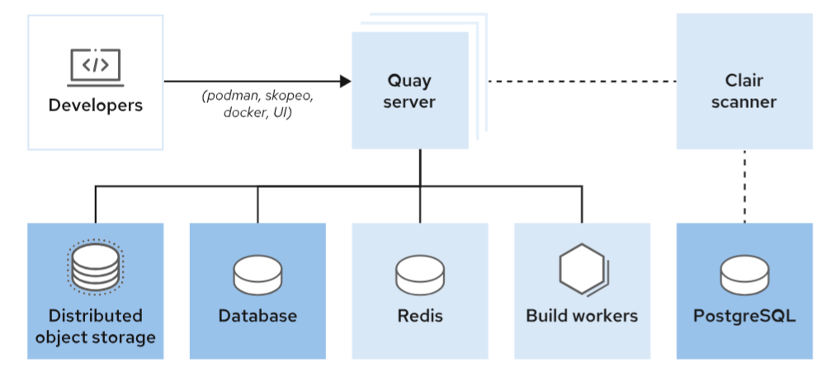

Figure 6.1: Quay Components

**Quay server**

This application manages the images and their metadata; the server is the main way that users interact with the enterprise registry.

**Clair scanner**

This application scans the images, searching for known vulnerabilities.

**Build workers**

These containers can start builds by reacting to source code repositories changes.

**Redis**

The Redis server stores build logs.

**Databases**

The Quay database can be PostgreSQL, MariaDB, or MySQL, provided by Red Hat or by a public cloud provider. Red Hat recommends PostgreSQL because all other database engines are scheduled for deprecation in the near future.

The database for Clair can be PostgreSQL only.

**Distributed object storage**

This storage contains the image's binary content.

For a highly-available storage engine, you can subscribe to Red Hat OpenShift Data Foundation. For more information about the distributed object storage, see [the section called “ Deploying and Configuring Red Hat Quay ”](https://rol.redhat.com/rol/app/courses/do480-2.4/pages/ch06s03).

The following diagram depicts a deployment of a central Quay registry installed in two different cloud regions. The Quay deployment uses shared databases for the multiple Quay, Clair, and Redis instances. There is an image object storage attached to each region. The Quay instances read and write from their nearest location. The images are replicated in the background to the other storage location.

|  |
| --- |
|  |

Figure 6.2: Example of Central Quay Running in Two Cloud Regions using Geo-replication

The previous diagram shows the Quay instances running on OpenShift. You can use the same architecture running the Quay instances on other servers in the cloud provider.

#### **Quay on OpenShift**

Red Hat provides three different operators to deploy and manage enterprise Quay registries on OpenShift.

The following diagram relates the regular Quay components to the Quay operators:

|  |
| --- |
|  |

Figure 6.3: Quay Components on OpenShift

**The Quay operator**

The operator manages the lifecycle of one or more Quay registries running in an OpenShift cluster. This operator provides the QuayRegistry custom resource definition (CRD) and allows you to choose which components the operator controls.

The Quay operator can manage the following components.

* postgres: If managed, the operator creates the needed pods for the Quay metadata database.
* clair: If managed, the operator creates the needed pods for the scanner database and application.
* redis: If managed, the operator creates the Redis pods needed for build logs storage.
* objectstorage: If managed, the operator uses the ObjectBucketClaim API to provide storage for image data.
* route: If managed, the operator creates an OpenShift route to access the registry.
* monitoring: If managed, the operator configure OpenShift and Quay to gather metrics from the Quay registries.
* tls: If managed, the operator uses the default wildcard certificate for the OpenShift route to access Quay.
* horizontalpodautoscaler: If managed, the operator defines resources for autoscaling Quay, Clair, and the pods used for mirroring.
* mirror: If managed, the operator enables the mirror workers.

More information about the Quay operator is provided elsewhere in this chapter.

**The Quay container security operator**

The operator integrates image vulnerability information within the OpenShift console.

**The Quay bridge operator**

This operator provides deeper integration between Quay and OpenShift. More information about the Quay bridge operator is available elsewhere in this course.

### **Benefits of Using Quay on OpenShift**

As stated elsewhere in this lecture, Quay can be used from a standalone installation or from an OpenShift installation.

The following list enumerates the main benefits of using Quay installed on OpenShift.

* The Quay installation on OpenShift is customizable and repeatable.
* The Quay operator can manage one or more Quay registries.
* The operator can manage Quay and all of its dependent components.
* Quay resources scale automatically when usage grows.
* Updating Quay on OpenShift is easier than updating a standalone installation.
* The Quay monitoring, alerting, and logging engines integrate with OpenShift engines.

### References

For more information about Quay repository mirroring, refer to the Repository Mirroring chapter in the Manage Red Quay guide at <https://access.redhat.com/documentation/en-us/red_hat_quay/3.6/html-single/manage_red_hat_quay/index#repo-mirroring-in-red-hat-quay>

For more information about Quay geo-replication, refer to the Geo-Replication chapter in the Manage Red Quay guide at <https://access.redhat.com/documentation/en-us/red_hat_quay/3.6/html-single/manage_red_hat_quay/index#georepl-intro>

For more information about Quay tag expiration, refer to the Tag expiration options chapter in the Configure Red Hat Quay guide at <https://access.redhat.com/documentation/en-us/red_hat_quay/3.6/html-single/configure_red_hat_quay/config-fields-intro#config-fields-tag-expiration>

For more information about Quay image scanning, refer to the Clair Security Scanning chapter in the Manage Red Quay guide at <https://access.redhat.com/documentation/en-us/red_hat_quay/3.6/html-single/manage_red_hat_quay/index#clair-intro2>

For more information about Quay builds, refer to the Automatically building Dockerfiles with Build workers chapter in the Use Red Quay guide at <https://access.redhat.com/documentation/en-us/red_hat_quay/3.6/html-single/use_red_hat_quay/index#build-support>

For more information about Quay notifications, refer to the Repository Notifications chapter in the Use Red Quay guide at <https://access.redhat.com/documentation/en-us/red_hat_quay/3.6/html-single/use_red_hat_quay/index#repository_notifications>

For more information about Quay monitoring on OpenShift, refer to the Console monitoring and alerting chapter in the Deploy Red Hat Quay on OpenShift with the Quay Operator at <https://access.redhat.com/documentation/en-us/red_hat_quay/3.6/html-single/deploy_red_hat_quay_on_openshift_with_the_quay_operator/quay_operator_features#operator-console-monitoring-alerting>

## **Deploying and Configuring Red Hat Quay**

### **Objectives**

* Install the Quay operator and deploy and configure a Quay registry using the command line.

### **Requirements for Installing Red Hat Quay on OpenShift**

Red Hat Quay requires the following resources.

#### **OpenShift Cluster**

Quay requires a Red Hat OpenShift cluster, version 4.5 or later, and an account with permissions to install operators and create namespaces at the cluster scope.

#### **Compute Resource Requirements**

Each Red Hat Quay application pod has identical resource requirements for requests and limits, which are defined in the quay-app deployment object.

By default, the Quay operator scales the Quay application to 2 replicas. Thus, you need at least 4 CPUs and 16 GiB of RAM to install and deploy a single Quay registry. If you deploy more than one registry for your multicluster environment, then multiply these values for each registry.

The Quay operator activates the horizontal pod autoscaler (HPA) by default. The HPA can start more pods when the Quay load grows. Additional resources are required for the pods that the HPA creates.

#### **Object Storage**

Quay uses object storage to save container images. The Quay operator uses the ObjectBucketClaim Kubernetes API to obtain storage when running on OpenShift. The use of the ObjectBucketClaim Kubernetes API allows Quay to access a vendor neutral storage solution.

The following list shows the supported object storage on different clouds:

* Amazon S3
* Azure Blob Storage
* Google Cloud Storage
* Ceph Object Gateway (RADOS)
* OpenStack Swift
* CloudFront + S3

When you choose managed object storage, the Quay operator uses the Red Hat OpenShift Data Foundation operator to provide the ObjectBucketClaim Kubernetes API. Thus, if the storage for your clusters is managed by the Quay operator, then you must install the OpenShift Data Foundation operator.

There are two supported methods for the Quay operator to access to the object buckets from OpenShift Data Foundation:

**Multicloud object gateway**

The multicloud object gateway uses a Kubernetes PersistentVolume object to provision the ObjectBucketClaim API. The multicloud object gateway is included in the Red Hat OpenShift Plus subscription and with Red Hat Advanced Cluster Management for Kubernetes, Red Hat Advanced Cluster Security for Kubernetes, Red Hat Quay, and Red Hat OpenShift Data Foundation Essentials. The multicloud object gateway is a stand-alone deployment provided by Red Hat OpenShift Data Foundation Essentials, and does not provide high availability of the persistent bucket.

**Highly-available storage infrastructure**

If you have a full Red Hat OpenShift Data Foundation subscription, then you can use a production deployment of OpenShift Data Foundation. When using this option, image storage is highly available.

When the Quay operator manages the object storage, it creates storage buckets with a default size of 50 GiB. See the references section for a guide to resizing the default bucket claims.

### **The Red Hat Quay Operator**

Red Hat recommends installing Red Hat Quay on OpenShift by using the Quay operator. The Quay operator automates the deployment of Quay registries, including mandatory Quay components, certificate management, and OpenShift resource configuration. If some of the components of Quay are already present in your infrastructure, for example, a highly available and redundant PostgreSQL database, then you can instruct the operator to use the external component instead of the managed one.

By default, the Quay operator creates and manages instances of all components to simplify operation. The following list shows those Quay components that can be excluded from operator management as part of a pre-existing infrastructure:

* Redis
* PostgreSQL database
* Object storage

The following list of components can be disabled to save resources, use alternative implementations, or to manage the component manually.

* Clair scanner
* Horizontal Pod Autoscaler
* OpenShift Monitoring
* Routes for access outside OpenShift
* TLS certificate management

The Quay operator version always matches the Quay version. Quay operator 3.6.4 installs Red Hat Quay 3.6.4.

The Quay operator provides the QuayRegistry custom resource definition (CRD).

The QuayRegistry object defines which components will be managed by the operator, and the configuration bundle that contains the resources needed for the installation and configuration of a registry. The following YAML file is a complete example of a QuayRegistry object:

apiVersion: quay.redhat.com/v1

kind: QuayRegistry

metadata:

name: central

namespace: registry

spec:

components:

- kind: clair

managed: true

- kind: horizontalpodautoscaler

managed: true

- kind: mirror

managed: true

- kind: postgres

managed: true

- kind: redis

managed: true

- kind: objectstorage

managed: true

- kind: route

managed: true

- kind: monitoring

managed: true

- kind: tls

managed: true

configBundleSecret: init-config-bundle-secret

|  |  |
| --- | --- |
|  | name: Required. The name of the registry. |
|  | namespace: Required. The namespace containing the registry. The name and the namespace fields form the default DNS name of the Quay registry. |
|  | components: Required. Defines which components the Quay operator manages. By default, the operator manages all components. Refer to [the section called “ Identifying the Components and Features of Red Hat Quay ”](https://rol.redhat.com/rol/app/courses/do480-2.4/pages/ch06) for further details this components. |
|  | configBundleSecret: Optional. Define the Secret object in the same namespace that the registry. This secret can contain a config.yaml file to configure the Quay registry. |

### **Quay Configuration Lifecycle on OpenShift**

A Quay registry configuration is stored in a config.yaml file. In OpenShift, the config.yaml file is stored in a Secret object in the same namespace as the Quay registry.

#### **The Quay Registry Configuration File**

The config.yaml file contains all the configuration fields needed to run a Quay registry.

There are some configuration fields that are always required, although the Quay operator can start a Quay registry on OpenShift with an initial basic configuration for all the configuration fields. See the references section for the full reference about the config.yaml fields.

The following config.yaml example file shows options that are suggested for automation.

FEATURE_USER_INITIALIZE: true

BROWSER_API_CALLS_XHR_ONLY: false

SUPER_USERS:

- quayadmin

FEATURE_USER_CREATION: false

|  |  |
| --- | --- |
|  | Enables the /api/v1/user/initialize Quay API endpoint to create the first user |
|  | Allows access to the Quay registry API without using an X-Requested-With header. Thus, command-line and automation tools can use the API without a browser. |
|  | List of users that become super users after first log in. |
|  | Restrict the creation of users to super users. By default, users can register by themselves. |

The following config.yaml example file shows a complete configuration with authentication and authorization from an LDAP server:

FEATURE_USER_INITIALIZE: true

BROWSER_API_CALLS_XHR_ONLY: false

SUPER_USERS:

- quayadmin

FEATURE_USER_CREATION: true

AUTHENTICATION_TYPE: LDAP

LDAP_ADMIN_DN: uid=admin,cn=users,cn=accounts,dc=ocp4,dc=example,dc=com

LDAP_ADMIN_PASSWD: Q@&fh3eR5

LDAP_ALLOW_INSECURE_FALLBACK: false

LDAP_BASE_DN:

- cn=accounts

- dc=ocp4

- dc=example

- dc=com

LDAP_EMAIL_ATTR: mail

LDAP_UID_ATTR: uid

LDAP_URI: ldap://myldap.ocp4.example.com

FEATURE_TEAM_SYNCING: true

|  |  |
| --- | --- |
|  | First four options, suggested for automation. |
|  | Required field to set the authentication type to LDAP. The field can be the default, Database, or LDAP, JWT, Keystone, or OIDC. |
|  | Seven fields to set the configuration of the LDAP directory containing users and groups. See the references section for more information about the Quay LDAP configuration fields. |
|  | Field that allows the mapping between Quay team members and groups in the authorization provider, LDAP, or Keystone. |

To find the full list of fields, refer to the references.

#### **The Configuration Bundle Secret**

The configuration bundle secret is a Kubernetes Secret that must be present in the namespace where the QuayRegistry object resides. The QuayRegistry object references this secret in the configBundleSecret field.

The configuration bundle secret contains the config.yaml file and other resources, such as custom certificates for different secure connections.

### **Installing a Quay Registry on OpenShift**

To run a Quay registry on OpenShift you must install the Quay operator. Then, use the configuration secret to create a QuayRegistry object.

#### **Installing the Quay Operator from the Command Line**

See the references section for a step-by-step guide to installing the Quay operator from the OpenShift web console.

You must create a Subscription object, which subscribes the Quay operator to one or all of the cluster namespaces. The subscription searches and uses the required software in the Red Hat OperatorHub.

The following YAML file defines a subscription to the Quay operator. Because the namespace is openshift-operators, this subscription installs the Quay operator cluster-wide.

apiVersion: operators.coreos.com/v1alpha1

kind: Subscription

metadata:

name: quay-operator

namespace: openshift-operators

spec:

sourceNamespace: openshift-marketplace

source: redhat-operators

channel: stable-3.6

installPlanApproval: Automatic

name: quay-operator

Red Hat recommends installing the operator cluster-wide, making it available in all namespaces. If you install the Quay operator in a specific namespace, then the OpenShift monitoring integration is disabled by default.

See the references section for a full explanation of the generic fields of a Subscription object.

#### **Creating the Quay Registry on OpenShift**

You can create the Quay registry on OpenShift by using the config.yaml file inside a configuration bundle secret and a quay-registry.yaml file like the one shown elsewhere in this lecture.

The following steps describe how to create the Quay registry on OpenShift:

* Create a namespace to deploy the registry

[user@demo ~]$ oc create namespace registry

* Create the initial configuration bundle secret using a config.yaml file.

[user@demo ~]$ oc create secret generic \

--from-file config.yaml=./config.yaml \

init-config-bundle-secret \

-n registry

* Create the registry

[user@demo ~]$ cat <<EOF | oc apply -f -

apiVersion: quay.redhat.com/v1

kind: QuayRegistry

metadata:

name: central

namespace: registry

spec:

configBundleSecret: init-config-bundle-secret

EOF

After creating the QuayRegistry object, the Quay operator creates all managed resources and starts a new Quay application to serve a full enterprise container images registry.

#### **Modifying the Configuration of a Quay Registry on OpenShift**

These are the two methods for modifying the configuration of a Quay registry deployed on OpenShift.

* Changing the config.yaml file referenced by the configuration bundle secret. This is the only method that allows you to change all the configuration fields of a Quay registry.
* Using the Config Editor application. Refer to the application's official documentation at <https://access.redhat.com/documentation/en-us/red_hat_quay/3.6/html-single/deploy_red_hat_quay_on_openshift_with_the_quay_operator/index#operator-config-ui>

To change the config.yaml file, note that the Quay operator does not watch the configuration bundle secret to roll out a new deployment when it changes. Thus, to make a change you must create a new secret containing the new config.yaml file and all other resources. Then, modify the QuayRegistry object to point to the new configuration bundle secret. When you modify the QuayRegistry object, the Quay operator rolls out the new version of the Quay application with the new configuration.

### References

For a step-by-step guide to installing the Quay operator from the OpenShift web console, refer to the Installing the Quay Operator from OperatorHub chapter in the Deploy Red Hat Quay on OpenShift with the Quay Operator guide at <https://access.redhat.com/documentation/en-us/red_hat_quay/3.6/html-single/deploy_red_hat_quay_on_openshift_with_the_quay_operator/index#installing_the_quay_operator_from_operatorhub>

For more information about the generic fields of a Subscription object, refer to the Adding Operators to a cluster chapter in the OpenShift official documentation at <https://docs.openshift.com/container-platform/4.10/operators/admin/olm-adding-operators-to-cluster.html>

For more information about configuration of unmanaged storage, refer to the Image Storage chapter in the Configure Red Hat Quay guide at <https://access.redhat.com/documentation/en-us/red_hat_quay/3.6/html-single/configure_red_hat_quay/index#config-fields-storage>

For more information on how to resize the default bucket claims, refer to the Resizing Managed Storage in the Deploy Red Hat Quay on OpenShift with the Quay Operator guide at <https://access.redhat.com/documentation/en-us/red_hat_quay/3.6/html-single/deploy_red_hat_quay_on_openshift_with_the_quay_operator/index#operator-resize-storage>

For more information about the LDAP configuration fields for Quay, refer to the LDAP configuration fields in the Configure Red Hat Quay guide at <https://access.redhat.com/documentation/en-us/red_hat_quay/3.6/html-single/configure_red_hat_quay/index#config-fields-ldap>.

For more information about all the configuration fields in the config.yaml file, refer to the Configuration fields chapter in the Configure Red Hat Quay guide at <https://access.redhat.com/documentation/en-us/red_hat_quay/3.6/html-single/configure_red_hat_quay/index#config-fields-intro>

## **Guided Exercise: Deploying and Configuring Red Hat Quay**

* Install the Red Hat Quay operator in the hub cluster. Then, you deploy and configure a Red Hat Quay registry by using the command line and preconfiguration files.

**Outcomes**

* Install the Red Hat Quay operator from OperatorHub.
* Configure a Quay registry before the deployment by using a preconfiguration file.
* Create a QuayRegistry object.
* Push an image to test the registry.

As the student user on the workstation machine, use the lab command to prepare your system for this exercise.

This command ensures that Quay is not installed, creates the cloudadmin IdM user, and gives administrator privileges to that user in all consoles.

[student@workstation ~]$ **lab start quay-deploy**

1. Using OperatorHub, install the Quay operator in the ocp4.example.com cluster.
   1. From the workstation machine, navigate to the Red Hat OpenShift web console at https://console-openshift-console.apps.ocp4.example.com. When prompted, click **Red Hat Identity Management** and log in as the cloudadmin user with the redhat password.
   2. Install the Quay operator from OperatorHub.

Navigate to **Operators** → **OperatorHub** and type quay in the **Filter by keyword** field.

Click **Red Hat Quay**, and then click **Install**.

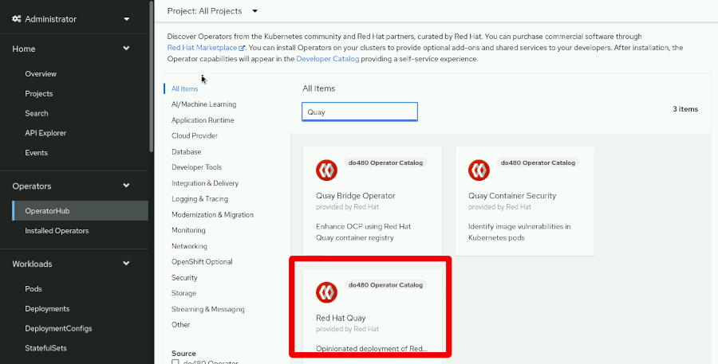

Figure 6.4: The three Red Hat Quay operators in OperatorHub

* 1. In the **Update Channel** section, ensure that the **stable-3.6** radio button is selected. In the **Update approval** section, ensure that the **Automatic** radio button is selected. Then, click **Install**.

When the operator is installed, you see the following message:

|  |
| --- |
|  |

1. Create the preconfiguration file and the initial secret for the Quay registry configuration.
   1. Open a terminal and log in to the ocp4 hub cluster as the cloudadmin user with the redhat password. The API server address is https://api.ocp4.example.com:6443.

[student@workstation ~]$ **oc login -u cloudadmin -p redhat \**

**https://api.ocp4.example.com:6443**

Login successful.

* 1. ...output omitted...

[student@workstation ~]$

* 1. From the terminal, change to the ~/DO480/labs/quay-deploy folder.

[student@workstation ~]$ **cd DO480/labs/quay-deploy**

[student@workstation quay-deploy]$

* 1. Review the config.yaml file, which contains the preconfiguration of the Quay registry. The Quay operator uses this information when creating the QuayRegistry object to define the features of the registry.

AUTHENTICATION_TYPE: LDAP

FEATURE_USER_INITIALIZE: true

BROWSER_API_CALLS_XHR_ONLY: false

SUPER_USERS:

- cloudadmin

FEATURE_USER_CREATION: true

LDAP_ADMIN_DN: uid=admin,cn=users,cn=accounts,dc=ocp4,dc=example,dc=com

LDAP_ADMIN_PASSWD: Redhat123@!

LDAP_ALLOW_INSECURE_FALLBACK: false

LDAP_BASE_DN:

- cn=accounts

- dc=ocp4

- dc=example

- dc=com

LDAP_EMAIL_ATTR: mail

LDAP_UID_ATTR: uid

LDAP_URI: ldaps://idm.ocp4.example.com

LDAP_USER_RDN:

- cn=users

FEATURE_TEAM_SYNCING: true

TEAM_RESYNC_STALE_TIME: 60m

FEATURE_NONSUPERUSER_TEAM_SYNCING_SETUP: true

This file configures a Quay registry for the Quay operator that uses the following features:

* + - Authentication against the LDAP provider in the classroom
    - The recommended configuration for automation of Quay on OpenShift
    - The cloudadmin superuser for Quay
  1. Create the registry namespace.
  2. [student@workstation quay-deploy]$ **oc create namespace registry**

namespace/registry created

* 1. Create the init-config-bundle-secret object using the configuration files that you created in a previous step. You need a secret containing the config.yaml Quay configuration file and the ldap.crt file to connect to the LDAP server through a secure channel.

[student@workstation quay-deploy]$ **oc create secret generic \**

**--from-file config.yaml=./config.yaml \**

**--from-file ldap.crt=./ldap.crt init-config-bundle-secret \**

**-n registry**

secret/init-config-bundle-secret created

1. Create the QuayRegistry object.
   1. Review the quay-registry.yaml file, which contains the configuration of the QuayRegistry object.

apiVersion: quay.redhat.com/v1

kind: QuayRegistry

metadata:

name: central

namespace: registry

spec:

configBundleSecret: init-config-bundle-secret

components:

- kind: clair

managed: false

- kind: horizontalpodautoscaler

managed: false

- kind: mirror

managed: false

This file configures the QuayRegistry object to deploy on OpenShift with the central name in the registry namespace. Thus, the Quay operator generates the https://central-quay-registry.apps.ocp4.example.com OpenShift route to access the registry. To save compute resources, the components key in the YAML file disables the Clair scanner, horizontal pod autoscaler, and registry mirror.

* 1. Create the Quay registry using the quay-registry.yaml file.

[student@workstation quay-deploy]$ **oc apply -f quay-registry.yaml**

quayregistry.quay.redhat.com/central created

* 1. Wait until the Quay registry application pods are in the Running state.

[student@workstation quay-deploy]$ **oc get pods -n registry| grep central-quay-app | grep Running**

central-quay-app-555844bbbd-77gzr 1/1 Running 0 44m

central-quay-app-555844bbbd-g7chz 1/1 Running 0 44m

1. Test the new registry by pushing an image to a private user repository.
   1. Create a Containerfile file containing a minimal image definition.

[student@workstation quay-deploy]$ **vi Containerfile**

FROM quay.io/podman/hello

* 1. Build the image using the podman build command.

[student@workstation quay-deploy]$ **podman build . -t hello-to-quay:dev**

...output omitted...

Successfully tagged localhost/hello-to-quay:dev

...output omitted...

* 1. Log in as the cloudadmin user with the redhat password.

### Warning

This exercise uses a plain text password for brevity. Commands such as podman store passwords in the file system unencrypted. If a malicious actor obtains access to the file system, then the actor can impersonate your account.

In real-world situations, always use encrypted passwords as described elsewhere in this course.

[student@workstation quay-deploy]$ **podman login -u=cloudadmin -p=redhat \**

**central-quay-registry.apps.ocp4.example.com**

Login Succeeded!

...output omitted...

* 1. Push the image to the cloudadmin user's private repository.

[student@workstation quay-deploy]$ **podman push localhost/hello-to-quay:dev \**

**central-quay-registry.apps.ocp4.example.com/cloudadmin/hello-to-quay:dev**

...output omitted...

Storing signatures

* 1. From the workstation machine, navigate to the Red Hat Quay console at https://central-quay-registry.apps.ocp4.example.com.

Log in as the cloudadmin user with the redhat password.

If prompted, click **Confirm Username**.

The Quay console shows the cloudadmin/hello-to-quay private repository, which contains the image that you pushed in the previous step.

The Quay registry is fully operative in the OpenShift hub cluster.

**Finish**

On the workstation machine, change to the student user home directory and use the lab command to complete this exercise. This step is important to ensure that resources from previous exercises do not impact upcoming exercises.

[student@workstation ~]$ **lab finish quay-deploy**

This concludes the section

## **Describing the Red Hat Quay Repository Model and RBAC**

### **Objectives**

* Describe the Red Hat Quay concepts for image registry organization, and manage role-based access control (RBAC) by using LDAP

### **The Red Hat Quay Tenancy Model**

Companies often need to control the origin of software running their workloads. If malicious actors can modify the code running a workload, then they can cause significant damage.

Using an image registry can help control the code when running containerized workloads. If deployments only use container images from a registry, then registry access permissions control who can deploy workloads.

Red Hat Quay has a tenancy model for managing access to container images in the registry. The Quay model uses the following concepts:

**Image repository**

An image repository contains tagged container images.

For example, the quay repository in the Red Hat Quay.io public registry contains container images for each release of the upstream Project Quay. Each image has a tag to identify its release.

Image repositories usually contain tags for different versions of the same software.

By default, new image repositories are private.

**Organization**

An organization contains image repositories and teams.

For example, the projectquay organization in the Quay.io public registry contains image repositories related to Quay.

Organizations are closely related to users. Many organization features are available to users. For example, both organizations and users can own image repositories. Organizations and users share the same namespace, so you cannot create an organization and a user with the same name.

**Team**

Organization administrators can assign roles to groups of users by using teams. Quay teams are similar to Kubernetes groups, but by default, there is no correspondence between Quay teams and Kubernetes groups.

Administrators can grant permissions over image repositories and general roles to the team.

Teams with the member role only have the permissions granted by administrators over repositories. Teams with the creator role can create repositories. Teams with the administrator role have full access to the organization.

For example, an organization has the following teams and permissions:

* The development team has write permissions to the development image repositories.
* The administrators team has administrator permissions to the production image repositories.

With these permissions, developers can deploy changes to development environments, but only administrators can deploy changes to production environments.

**User**

Quay users are similar to Kubernetes users, but Quay has its own authentication back end.

Quay users also have a home organization. Users can create image repositories in their home organizations.

The Quay configuration can designate some users as super users. Super users can access some administrative features by using a separate part of the web console and some protected API calls. Administrative features include viewing usage logs, managing ownership of organizations, and managing service keys to authenticate external services.

The Quay tenancy model is a form of role-based access control (RBAC). A user's group membership determines their roles in an organization and roles control permissions.

### **Managing Organizations Using the Web Console**

Quay users can create and manage organizations by using the web console.

Create an organization by clicking **Create New Organization** on the **Repositories** page.

|  |
| --- |
|  |

Figure 6.6: Creating organizations using the web console

Organizations automatically contain an owners group. This group contains the organization creator and has administrator permissions over the organization.

On the organization page, you can find tabs to access different features.

|  |
| --- |
|  |

Accessing different organization features.

|  |  |
| --- | --- |
|  | Click **Repositories** to create repositories and manage repository permissions. |
|  | Click **Teams and Membership** to manage team membership and permissions, and to create teams. |
|  | Click **Robot Accounts** to manage robot accounts. |
|  | Click **Default Permissions** to manage default permissions. |
|  | Click **Usage Logs** to review actions performed by users, tokens, and applications. |
|  | Click **Applications** to create applications and generate API tokens. |

After clicking **Repositories**, click **Settings** to manage repository permissions.

|  |
| --- |
|  |

Managing repository settings.

|  |  |
| --- | --- |
|  | Use the **User and Robot Permissions** section to view and change permissions for teams. |
|  | Use the **Repository Visibility** section to toggle visibility of the repository. |

From the organization page, click **Teams and Membership** to manage teams.

|  |
| --- |
|  |

Managing teams.

|  |  |
| --- | --- |
|  | Click **Create New Team** to create a new team. |
|  | Click the team name under the **TEAM NAME** column, the member number under the **MEMBERS** column, or the **Manage Team Members** option in the **Options** gear box icon to manage team membership. |
|  | Select a role from the list in the **TEAM ROLE** column to assign an organization role to the team. |
|  | Click **Set Repository Permissions** from the **Options** gear box icon to manage repository permissions. Click **Delete Team** from the **Options** gear box icon to delete a team. |

### **Managing Organizations via the API**

Organization administrators can also use the Quay API to manage organizations.

Administrators can create OAuth applications and generate tokens to access the API. HTTP requests to the Quay API that use a token act on behalf of the token creator.

To create a token, click **Applications** on the organization page, then click **Create New Application** and type a name for the application.

On the application page, click **Generate Token** to generate a token.

|  |
| --- |
|  |

Figure 6.7: Creating an application token.

After clicking **Generate Token**, a page listing available permissions is displayed. Choose the permissions you need and click **Generate Access Token**.

If you chose permissions that are potentially dangerous, a confirmation page shows additional warnings. Click **Authorize Application**. A page displays the token. After this page is closed, you cannot access the token. Save the token to use with the API.

### Warning

If a malicious actor obtains access to the token, they can act on your behalf.

Only grant the minimum permissions you require. Store the token as confidential information. Review usage logs to detect unusual activity.

To revoke a token, remove the application. You can also recreate applications periodically to reduce the period a leaked token is usable.

Note that by default, the Quay API is public. Many API calls work without providing a token or when you use a token incorrectly, but the data returned is incomplete public data. Ensure that you log in correctly to see protected data.

To authenticate a call to the Quay API, make an HTTP request with an Authentication header. The value of the authentication header is Bearer *token*.

The following command shows how to execute an API call by using the curl command.

[user@demo ]$ **$ curl -k -H 'Authorization: Bearer *token*' \**

**https://quay.example.com/api/v1/users/*user***

{"anonymous": false, "username": "alice", "avatar": {"name": "alice", "hash": "9d...2e", "color": "#ad494a", "kind": "user"}}

Only use the -k option if the Quay certificate is not trusted by your workstation.

#### **Creating Organizations Using the API**

To create an organization by using the API, you need a token with administer user permissions.

Use the POST method and provide a payload in JSON format for API calls that require data, such as creating an organization. Specify the Content-Type header with the application/json value.

Use the following command to create an organization.

[user@demo ]$ **curl -k -X POST -H 'Authorization: Bearer *token*' \**

**-H 'Content-Type: application/json' \**

**-d @- <<EOF \**

**https://quay.example.com/api/v1/organization/**

**{**

**"name": "*name*",**

**"email": "*email*"**

**}**

**EOF**

"Created"

When creating organizations by using the API, you must provide a unique organization email.

The previous command uses the -d @- option to read the payload from standard input and a here document to provide the payload in standard input. This change allows the JSON payload to contain new lines for readability. You can modify the command to provide the payload without using a here document.

[user@demo ]$ **curl ... -d {"name":...} \**

**https://quay.example.com/api/v1/organization/**

"Created"

#### **Creating an Image Repository Using the API**

To create an image repository by using the API, you need a token with the create repositories permission.

To create repositories, post a payload with the following structure to the /api/v1/repository endpoint.

{

"namespace": "***namespace***",

"repository": "***repository_name***",

"description": "***description***",

"visibility": "***visibility***"

}

|  |  |
| --- | --- |
|  | The namespace value is the name of the organization or user that contains the repository. |
|  | The visibility value is either public or private. |

#### **Managing Teams Using the API**

To manage teams by using the API, you need a token with the administer organization permission.

To create teams, make an HTTP PUT request with a payload with the following structure to the /api/v1/organization/*organization*/team/*team_name* endpoint.

{

"name": "***name***",

"role": "***role***",

"description": "***description***"

}

|  |  |
| --- | --- |
|  | The role has a member, creator, or admin value. |

To grant teams permissions over repositories, make an HTTP PUT request with a payload with the following structure to the https://quay.example.com/api/v1/repository/*organization*/*repository*/permissions/*team*/ endpoint.

{"role": "***role***"}

The role has a read, write, or admin value.

#### **Creating Users Using the API**

To manage users by using the API, you need a token with the super user access permission.

To create users, make an HTTP POST request with a payload with the following structure to the /api/v1/user/initialize endpoint.

{

"username": "***username***",

"password":"***password***",

"email": "***email***",

"access_token": true

}

|  |  |
| --- | --- |
|  | The password must be at least 8 characters and contain no white space. |
|  | If true, then the response contains a token for the user. |

### **Synchronizing Team Membership Using LDAP**

If you configure Quay to authenticate by using LDAP, then Quay can also synchronize team membership with LDAP groups. The FEATURE_TEAM_SYNCING configuration field is true by default. With this configuration, superusers can configure any team to synchronize with an LDAP group.

The FEATURE_NONSUPERUSER_TEAM_SYNCING_SETUP is false by default. If you change the value to true, then other users can configure team synchronization.

For example, if a user moves to a different department, then team membership in Quay might need to be updated. With team synchronization, administrators update the LDAP server and Quay team membership replicates the changes automatically.

To configure synchronization for a team, go to the team page and click **Enable Directory Synchronization**.

|  |
| --- |
|  |

Figure 6.8: Configuring team synchronization.

Type the distinguished name of the group, relative to the base DN for LDAP authentication. For example, cn=deployers,cn=groups.

To configure synchronization by using the API, post a payload with the following structure to the /api/v1/organization/*organization*/team/*team*/syncing endpoint.

{"group_dn": "***group_dn***"}

The group_dn value is the distinguished name of the group relative to the base DN for LDAP authentication.

### References

For more information, refer to the Users and organizations in Red Hat Quay chapter in the Red Hat Quay 3.6 Use Red Hat Quay documentation at <https://access.redhat.com/documentation/en-us/red_hat_quay/3.6/html-single/use_red_hat_quay/index#user-org-intro>

For more information, refer to the LDAP Authentication Setup for Red Hat Quay chapter in the Red Hat Quay 3.6 Use Red Hat Quay documentation at <https://access.redhat.com/documentation/en-us/red_hat_quay/3.6/html-single/manage_red_hat_quay/index#ldap-authentication-setup-for-quay-enterprise>

## **Guided Exercise: Describing the Red Hat Quay Repository Model and RBAC**

* Create an organization in Red Hat Quay. Then, you create teams and users synchronized from Identity Management (IdM) in Red Hat Enterprise Linux. Finally, you push images and move images in the registry as different users with limited permissions.

**Outcomes**

* Grant users controlled privileges.
* Interact with Quay by using command-line tools.
* Use encrypted passwords.

As the student user on the workstation machine, use the lab command to prepare your system for this exercise.

This command ensures that Quay is in a valid state and creates IdM users.

[student@workstation ~]$ **lab start quay-rbac**

1. Log in to the Quay web console.
   1. From the workstation machine, navigate to the Quay web console at https://central-quay-registry.apps.ocp4.example.com. Log in as the cloudadmin user with the redhat password.

If prompted, then click **Confirm Username**.

1. Create the finance organization.
   1. Click **Create New Organization**.

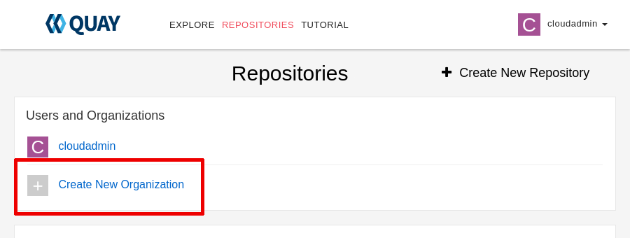

* 1. Type finance as the organization name, then click **Create Organization**.

1. Create the budget-app-dev repository in the finance organization.
   1. Click **Create New Repository**.

|  |
| --- |
|  |

* 1. Type budget-app-dev as the repository name, then click **Create Private Repository**.

1. Create the budget-app repository in the finance organization.
   1. Click **REPOSITORIES**, then click **finance** to navigate to the finance organization.
   2. Click **Create New Repository**, type budget-app as the repository name, and then click **Create Private Repository**.
2. Create the deployers team in the finance organization.

The deployers team has read permissions on the budget-app-dev repository and administrator permissions on the budget-app repository.

The deployers team replicates the IdM group with the distinguished name cn=deployers,cn=groups relative to cn=accounts,dc=ocp4,dc=example,dc=com.

* 1. Click **REPOSITORIES**, then click **finance** to navigate to the finance organization.
  2. Click **Teams and Membership**.

|  |
| --- |
|  |

* 1. Click **Create New Team**, type deployers as the team name, and then click **Create team**.
  2. Select the **Read** permission for the budget-app-dev repository. Select the **Admin** permission for the budget-app repository.

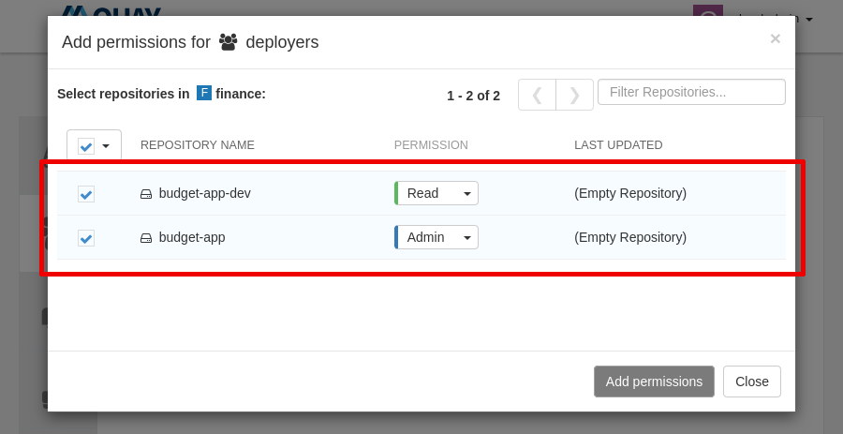

Figure 6.12: The permissions for the deployers team

Click **Add permissions**.

* 1. Click **deployers** in the team list to navigate to the team configuration page. Click **Enable Directory Synchronization**, then type cn=deployers,cn=groups as the distinguished name, then click **Enable Group Sync**.

1. Create the developers team in the finance organization.

The developers team has admin permissions on the budget-app-dev repository.

The developers team replicates the IdM group with the distinguished name cn=developers,cn=groups relative to cn=accounts,dc=ocp4,dc=example,dc=com.

* 1. Click **REPOSITORIES**, then click **finance** to navigate to the finance organization.
  2. Click **Teams and Membership**.
  3. Click **Create New Team**, then type developers as the team name, then click **Create team**.
  4. Select the **Admin** permission for the budget-app-dev repository.

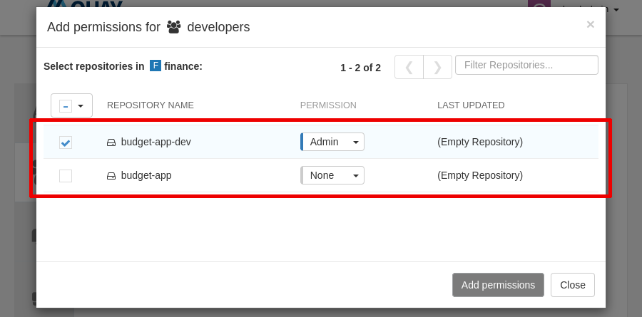

Figure 6.13: The permissions for the developers team

Click **Add permissions**.

* 1. Click **developers** in the team list to navigate to the team configuration page. Click **Enable Directory Synchronization**, type cn=developers,cn=groups as the distinguished name, and then click **Enable Group Sync**.

1. As the bob user, a member of the developers team, generate an encrypted password to use command-line tools.
   1. Sign out the cloudadmin user. Click **cloudadmin**, then click **Sign out all sessions**.

|  |
| --- |
|  |

* 1. Log in as the bob user with the redhat password.

If prompted, click **Confirm Username**.

* 1. Click **bob**, then **Account Settings**.

|  |
| --- |
|  |

* 1. Click **Generate Encrypted Password**.

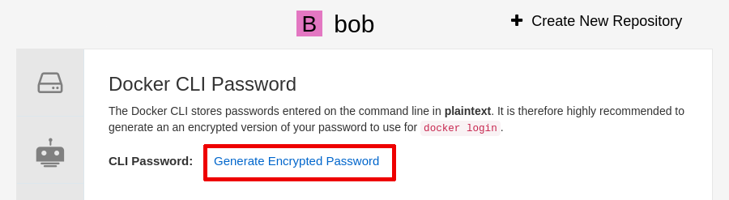

* 1. Type the redhat password and click **Verify**.
  2. Copy the password and store it in a temporary location to use in a later step. The password is a string of letters, numbers, and symbols.

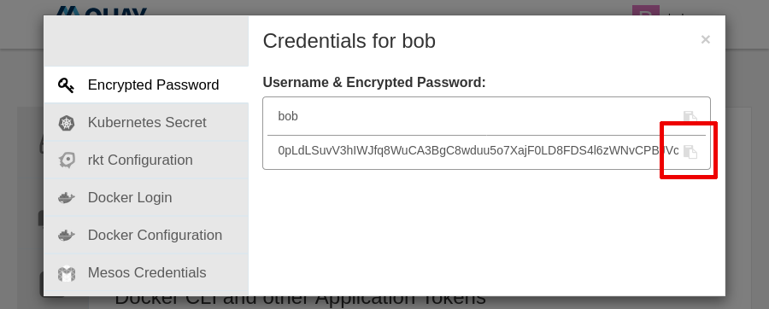

1. Create an image by using Podman.
   1. Create a Containerfile file containing a minimal image definition. The result should look like the following file.

[student@workstation ~]$ **vi Containerfile**

FROM quay.io/podman/hello

* 1. Build the image by using the podman build command.

[student@workstation ~]$ **podman build . -t budget-app:development**

...output omitted...

Successfully tagged localhost/budget-app:development

...output omitted...

1. Push the image to Quay.
   1. Log in as the bob user with the password from a previous step.

[student@workstation ~]$ **podman login -u=bob -p=*password* \**

**central-quay-registry.apps.ocp4.example.com**

Login Succeeded!

...output omitted...

* 1. Push the image to the budget-app-dev repository.

[student@workstation ~]$ **podman push localhost/budget-app:development \**

**central-quay-registry.apps.ocp4.example.com/finance/budget-app-dev**

...output omitted...

Storing signatures

* 1. Try pushing the image to the budget-app repository.

[student@workstation ~]$ **podman push localhost/budget-app:development \**

**central-quay-registry.apps.ocp4.example.com/finance/budget-app**

...output omitted...

Error: trying to reuse blob sha256:... at destination: checking whether a blob sha256:... exists in central-quay-registry.apps.ocp4.example.com/finance/budget-app: unauthorized: authentication required

Quay rejects the image because the bob user is not allowed to push to the budget-app repository.

1. As the alice user, promote the image to the budget-app repository by using the skopeo command.
   1. Log in as the alice user with the redhat password.

### Warning

This exercise uses a plain text password for brevity. Commands such as skopeo store passwords in the file system unencrypted. If a malicious actor obtains access to the file system, then the actor can impersonate your account.

In real-world situations, always use encrypted passwords as described in a previous step.

[student@workstation ~]$ **skopeo login -u=alice -p=redhat \**

**central-quay-registry.apps.ocp4.example.com**

Login Succeeded!

...output omitted...

* 1. Promote the image to the budget-app repository by using the skopeo command.

[student@workstation ~]$ **skopeo copy \**

**docker://central-quay-registry.apps.ocp4.example.com/finance/budget-app-dev \**

**docker://central-quay-registry.apps.ocp4.example.com/finance/budget-app**

...output omitted...

Storing signatures

1. Review the repositories.
   1. Navigate to the Quay web console at https://central-quay-registry.apps.ocp4.example.com. If you are not logged in as the bob user, then log in as the bob user with the redhat password.

Note that you can only see the budget-app-dev repository.

|  |
| --- |
|  |

Figure 6.18: Repositories visible to the bob user

* 1. Click **bob**, then click **Sign out all sessions**.
  2. Log in as the alice user with the redhat password.

If prompted, click **Confirm Username**.

* 1. Note that you can see both the budget-app-dev and budget-app repositories.

|  |
| --- |
|  |

* 1. Figure 6.19: Repositories visible to the alice user

**Finish**

On the workstation machine, change to the student user home directory and use the lab command to complete this exercise. This step is important to ensure that resources from previous exercises do not impact upcoming exercises.

[student@workstation ~]$ **lab finish quay-rbac**

This concludes the section

## **Lab: Installing and Configuring Red Hat Quay**

* Use the command line to install Red Quay and push a container image by using a robot account.

**Outcomes**

* Install Quay by using the command line.
* Use the Quay API.
* Use robot accounts.

As the student user on the workstation machine, use the lab command to prepare your system for this exercise.

This command ensures that Quay is not present in the hub cluster.

[student@workstation ~]$ **lab start quay-review**

1. Log in to the ocp4 cluster as the admin user with the redhat password. The API server address is https://api.ocp4.example.com:6443.
   1. Log in to the ocp4 cluster.

[student@workstation ~]$ **oc login -u admin -p redhat \**

**https://api.ocp4.example.com:6443**

Login successful.

...output omitted...

1. Install the Quay operator cluster-wide. Use the do480-catalog offline catalog. The lab script includes a DO480/solutions/quay-review/subscription.yaml solution file.
   1. Create a subscription.yaml file with the following content.

apiVersion: operators.coreos.com/v1alpha1

kind: Subscription

metadata:

name: quay-operator

namespace: openshift-operators

spec:

sourceNamespace: openshift-marketplace

source: do480-catalog

channel: stable-3.6

installPlanApproval: Automatic

name: quay-operator

* 1. Create the subscription by using the oc create command.

[student@workstation ~]$ **oc create -f subscription.yaml**

subscription.operators.coreos.com/quay-operator created

* 1. Use the watch command to verify that the quay-operator.v3.6.4 deployment is available.

[student@workstation ~]$ **watch oc get deployment -n openshift-operators**

NAME READY UP-TO-DATE AVAILABLE AGE

quay-operator.v3.6.4 1/1 1 1 22s

Press **Ctrl**+**C** to exit the watch command.

1. [Hide Solution](https://rol.redhat.com/rol/app/)
2. Create a registry namespace.
   1. Create the namespace by using the oc create command.

[student@workstation ~]$ **oc create namespace registry**

namespace/registry created

1. Create an init-config-bundle-secret object in the registry namespace with a config.yaml key containing the Quay configuration.

Use the suggested options for automation.

* 1. Enable the /api/v1/user/initialize Quay API endpoint to create the first user.
  2. Allow access to the Quay registry API without the use of an X-Requested-With header.
  3. Define a quayadmin super user.

The lab script includes a DO480/solutions/quay-review/config.yaml solution file.

* 1. Create a config.yaml file with the following content.

FEATURE_USER_INITIALIZE: true

BROWSER_API_CALLS_XHR_ONLY: false

SUPER_USERS:

- quayadmin

FEATURE_USER_CREATION: false

* 1. Create the secret by using the oc create command.

[student@workstation ~]$ **oc create secret generic \**

**--from-file config.yaml=./config.yaml init-config-bundle-secret -n registry**

secret/init-config-bundle-secret created

[Hide Solution](https://rol.redhat.com/rol/app/)

1. Create a QuayRegistry object named central in the registry namespace. The QuayRegistry object references the init-config-bundle-secret object containing the Quay configuration.

Do not include Clair, the horizontal pod autoscaler, or the mirror feature.

The lab script includes a DO480/solutions/quay-review/quay-registry.yaml solution file.

* 1. Create a quay-registry.yaml file with the following content.

apiVersion: quay.redhat.com/v1

kind: QuayRegistry

metadata:

name: central

namespace: registry

spec:

configBundleSecret: init-config-bundle-secret

components:

- kind: clair

managed: false

- kind: horizontalpodautoscaler

managed: false

- kind: mirror

managed: false

* 1. Create the registry by using the oc create command.

[student@workstation ~]$ **oc create -f quay-registry.yaml**

quayregistry.quay.redhat.com/central created

* 1. Use the watch command to verify that the registry deployments are available. The central-quay-app deployment can take a few minutes to become available.

[student@workstation ~]$ **watch oc get deployment -n registry**

NAME READY UP-TO-DATE AVAILABLE AGE

central-quay-app 2/2 2 2 4m26s

central-quay-config-editor 1/1 1 1 4m26s

central-quay-database 1/1 1 1 4m26s

central-quay-redis 1/1 1 1 4m26s

Press **Ctrl**+**C** to exit the watch command.

[Hide Solution](https://rol.redhat.com/rol/app/)

1. Create the quayadmin user and obtain an access token. The password must be at least 8 characters and contain no white space. The lab script includes a DO480/solutions/quay-review/quayadmin-user.json solution file.

Store the token in a /home/student/quayadmin_token file. This step is necessary so that the lab script can use the API to grade your work.

* 1. Create a quayadmin-user.json file with the quayadmin user definition.

{

"username": "quayadmin",

"password":"redhat123",

"email": "quayadmin@example.com",

"access_token": true

}

* 1. Use the curl command to post the user definition in JSON format to the initialize user endpoint. Note the returned access token for a later step.

[student@workstation ~]$ **curl -X POST -k \**

**https://central-quay-registry.apps.ocp4.example.com/api/v1/user/initialize \**

**--header "Content-Type: application/json" \**

**--data @quayadmin-user.json**

{"access_token":"**0ITUIV9KMVJ0RPMWV5PT3D8ETWE82GBIA0U8NA6X**",

"email":"quayadmin@example.com",

"encrypted_password":"YvOcxZBtrRkmkEhqcu3DhUTkXoTwWmA/Cdp4lr9W7ySiE99nQVI8VnECRmwoYItz",

"username":"quayadmin"}

* 1. Store the new token in a /home/student/quayadmin_token file. This step is necessary so that the lab script can use the API to grade your work.
  2. [student@workstation ~]$ **echo *0ITUIV9KMVJ0RPMWV5PT3D8ETWE82GBIA0U8NA6X* \**

**>quayadmin_token**

* 1. (Optional) Store the token in an environment variable. If you store the token, then you can use the QUAYADMIN_TOKEN variable in the following commands instead of copying and pasting the token.

[student@workstation ~]$ **QUAYADMIN_TOKEN=*0ITUIV9KMVJ0RPMWV5PT3D8ETWE82GBIA0U8NA6X***

[Hide Solution](https://rol.redhat.com/rol/app/)

1. Create the finance organization by using the API. The lab script includes a DO480/solutions/quay-review/finance-organization.json solution file.
   1. Create a finance-organization.json file with the finance organization definition.

{

"name": "finance",

"email": [finance@example.com](mailto:finance@example.com)

}

* 1. Use the curl command to post the organization definition in JSON format. Replace the token for the quayadmin user with the token that you obtained in a previous step.

[student@workstation ~]$ **curl -X POST -k \**

**https://central-quay-registry.apps.ocp4.example.com/api/v1/organization/ \**

**--header "Content-Type: application/json" \**

**--header "Authorization: Bearer *0ITUIV9KMVJ0RPMWV5PT3D8ETWE82GBIA0U8NA6X*" \**

**--data @finance-organization.json**

"Created"

1. Create the budget-app-dev image repository by using the API. The lab script includes a DO480/solutions/quay-review/budget-app-dev-repository.json solution file.
   1. Create a budget-app-dev-repository.json file with the finance organization definition.

{

"namespace": "finance",

"repository": "budget-app-dev",

"description": "development",

"visibility": "private"

}

* 1. Use the curl command to post the image repository definition in JSON format. Replace the token for the quayadmin user with the token that you obtained in a previous step.

[student@workstation ~]$ **curl -X POST -k \**

**https://central-quay-registry.apps.ocp4.example.com/api/v1/repository \**

**--header "Content-Type: application/json" \**

**--header "Authorization: Bearer *0ITUIV9KMVJ0RPMWV5PT3D8ETWE82GBIA0U8NA6X*" \**

**--data @budget-app-dev-repository.json**

{"namespace": "finance", "name": "budget-app-dev", "kind": "image"}

1. Create the deployer robot account by using the API. The lab script includes a DO480/solutions/quay-review/deployer-robot.json solution file.
2. Create a deployer-robot.json file with the finance organization definition.

{

"description": "deployer"

}

* 1. Use the curl command to post the robot account definition in JSON format. Replace the token for the quayadmin user with the token that you obtained in a previous step.

[student@workstation ~]$ **curl -X PUT -k \**

**https://central-quay-registry.apps.ocp4.example.com/api/v1/organization/finance/robots/deployer \**

**--header "Content-Type: application/json" \**

**--header "Authorization: Bearer *0ITUIV9KMVJ0RPMWV5PT3D8ETWE82GBIA0U8NA6X*" \**

**--data @deployer-robot.json**

{"name": "finance+deployer", "created": "Fri, 27 May 2022 17:21:48 -0000", "last_accessed": null, "description": "deployer", "token": "**OX829EO5TH48W8UXO8GUBPALKE3CXMUZY51GNTOYPFUSJRZMK3X5DSGFUYYD1B0R**", "unstructured_metadata": null}

### Note

* + - The https://central…​/robots/deployer \ fragment must be typed as a single line.

Note the new token. The previous token identified the quayadmin user. This token identifies the deployer robot account.

1. Grant permissions to the deployer robot account over the budget-app-dev image repository.
   1. Use the curl command to grant the deployer robot account the write role on the budget-app-dev repository in the finance organization. Replace the token for the quayadmin user with the token that you obtained in a previous step.

[student@workstation ~]$ **curl -X PUT -k \**

**https://central-quay-registry.apps.ocp4.example.com/api/v1/repository/finance/budget-app-dev/permissions/user/finance+deployer \**

**--header "Content-Type: application/json" \**

**--header "Authorization: Bearer *0ITUIV9KMVJ0RPMWV5PT3D8ETWE82GBIA0U8NA6X*" \**

**--data '{"role": "write"}'**

{"role": "write", "name": "finance+deployer", "is_robot": true, "avatar": {"name": "finance+deployer", "hash": "d55a13210f2c19148de2691ad3d9652140531e9b267d39ca468459a3c2e6961d", "color": "#5254a3", "kind": "robot"}, "is_org_member": true}

### Note

* + - The https://central…​/user/finance+deployer \ fragment must be typed as a single line.

1. Create a budget-app:development image by using the podman command. You can create an image based on the quay.io/podman/hello image.
   1. Create a Containerfile file containing a minimal image definition. Your file should match the following example.

FROM quay.io/podman/hello

* 1. Build the image by using the podman build command.

[student@workstation ~]$ **podman build . -t budget-app:development**

...output omitted...

Successfully tagged localhost/budget-app:development

...output omitted...

1. As the deployer robot account, push the image to the budget-app-dev image repository in the finance organization.
   1. Log in as the deployer robot account by using the token that you obtained in a previous step."

### Note

You must use the deployer robot account token, not the quayadmin user token.

[student@workstation ~]$ **podman login -u=finance+deployer \**

**-p=*OX829EO5TH48W8UXO8GUBPALKE3CXMUZY51GNTOYPFUSJRZMK3X5DSGFUYYD1B0R* \**

**central-quay-registry.apps.ocp4.example.com**

Login Succeeded!

...output omitted...

* 1. Push the image to the budget-app-dev repository.

[student@workstation ~]$ **podman push localhost/budget-app:development \**

**central-quay-registry.apps.ocp4.example.com/finance/budget-app-dev**

...output omitted...

Storing signatures

1. [Hide Solution](https://rol.redhat.com/rol/app/)

**Evaluation**

As the student user on the workstation machine, use the lab command to grade your work. Correct any reported failures and rerun the command until successful.

[student@workstation ~]$ **lab grade quay-review**

**Finish**

On the workstation machine, use the lab command to complete this exercise. This step is important to ensure that resources from previous exercises do not impact upcoming exercises.

[student@workstation ~]$ **lab finish quay-review**

This concludes the section

# **Chapter 7.  Integrating Red Hat Quay with Red Hat OpenShift and RHACM**

[Describe Red Hat Quay Use Cases in a Multicluster Architecture](https://rol.redhat.com/rol/app/courses/do480-2.4/pages/ch07)

[Quiz: Describe Red Hat Quay Use Cases in a Multicluster Architecture](https://rol.redhat.com/rol/app/courses/do480-2.4/pages/ch07s02)

[Restricting Image Registry Sources](https://rol.redhat.com/rol/app/courses/do480-2.4/pages/ch07s03)

[Guided Exercise: Restricting Image Registry Sources](https://rol.redhat.com/rol/app/courses/do480-2.4/pages/ch07s04)

[Deploying from Red Hat Quay to the Cluster Fleet](https://rol.redhat.com/rol/app/courses/do480-2.4/pages/ch07s05)

[Guided Exercise: Deploying from Red Hat Quay to the Cluster Fleet](https://rol.redhat.com/rol/app/courses/do480-2.4/pages/ch07s06)

[Lab: Integrating Red Hat Quay with OpenShift and RHACM](https://rol.redhat.com/rol/app/courses/do480-2.4/pages/ch07s07)

[Summary](https://rol.redhat.com/rol/app/courses/do480-2.4/pages/ch07s08)

**Abstract**

|  |  |
| --- | --- |
| **Goal** | Describe Red Hat Quay use cases in a multicluster environment, and use Red Hat Advanced Cluster Management for Kubernetes (RHACM) to deploy applications and control the image sources allowed in the cluster fleet. |
| **Objectives** | * Identify the different Red Hat Quay use cases and architectures in a multicluster environment, and the benefits of using a central registry. * Use Red Hat Advanced Cluster Management for Kubernetes (RHACM) to restrict container image source registries in your cluster fleet. * Use Red Hat Advanced Cluster Management for Kubernetes (RHACM) to deploy an application using a central Red Hat Quay registry. |
| **Sections** | * Describe Red Hat Quay Use Cases in a Multicluster Architecture (and Quiz) * Restricting Image Registry Sources (and Guided Exercise) * Deploying from Red Hat Quay to the Cluster Fleet (and Guided Exercise) |
| **Lab** | * Integrating Red Hat Quay with OpenShift and RHACM |

## **Describe Red Hat Quay Use Cases in a Multicluster Architecture**

### **Objectives**

* Identify the different Red Hat Quay use cases and architectures in a multicluster environment, and the benefits of using a central registry.

### **Quay Deployment Patterns on Multicloud Environments**

When the number of users and clusters interacting with the registry grows, you might face scaling challenges. Red Hat Quay has many deployment options that can help you scale your environment.

Red Hat Quay.io is a managed service that offers geo-replication and high availability without the operating costs of managing your own Quay instances. Quay.io does not cover all usage scenarios, such as disconnected operation. However, Quay.io can also be used in combination with other registries.

If Quay.io is not suitable for your environment, then you can deploy Quay on standalone hosts or on Red Hat OpenShift. Red Hat recommends installing Quay on an OpenShift cluster by using the Quay operator. There are some elements that you need to evaluate to chose the Quay deployment pattern and features to use in your environment.

* The geo-replication feature supports Quay users that are geographically distributed.
* High availability and autoscaling of front-end components is provided. To determine the requirements of back-end components, you must calculate the expected service level for each registry.
* The mirroring feature can mirror parts of some public registries to support disconnected Kubernetes or OpenShift clusters.
* The Quay bridge operator can adapt the Quay tenancy model to the OpenShift permissions model so that you can replace the OpenShift cluster's internal registry.

The Quay bridge operator is described elsewhere in this section.

#### **Calculating the Number of Registries**

One important deployment choice is deciding if your cluster fleet needs one central registry, multiple registries, or a mix of both.

In Quay, one registry is represented by the database, the shared storage, the collections of users, and the registry DNS.

A central Quay registry provides the following benefits in a multicloud and multicluster environment.

**Saves compute resources**

The more registries you have, the more instances of the Quay application you need.

**Saves operational costs**

The fewer Quay components that you must maintain, the less effort is needed.

**Centralizes access and security**

A primary Quay registry can centralize the security scanning and set control over the images used in your cluster fleet.

**Saves storage space**

A high number of container images can share common layers that compound the image, and a central registry stores these layers just once.

**Supports disconnected environments**

A registry simplifies the configuration of Kubernetes and OpenShift clusters to run in disconnected environments.

The following list reflects concerns that might lead you to create multiple registries and how a central Quay registry can address them.

**Separation between environments**

You can define clear separation of environments by using the Quay tenancy model with organizations and role-based access control.

**Stability in registry upgrades**

If you use Quay on OpenShift, the Quay operator upgrades the Quay base software.

**Need for multiple data center deployments and high availability**

You can deploy a central Quay registry across data centers by using the Quay geo-replication and repository mirroring features.

**Scalability of the registry platform**

Red Hat Quay code base is the same as the base in Quay.io. Thus, Quay can scale to serve big registries without losing quality of service. When Quay is installed on OpenShift, the Quay operator uses horizontal pod autoscaler components to automatically performs this scaling.

Although a centralized registry has many advantages, there are times when multiple registries might be necessary. The main reason to have more than one registry is to provide more than one configuration. For example, if you must modify the config.yaml file for an environment to change the authentication type, or activate the repository mirroring feature, then you need more than one registry.

The Quay architecture gives supports mixed configurations. The Quay operator can deploy and manage multiple registries by creating additional instances of the QuayRegistry custom resource definition.

For example, you can install a central primary registry across many data centers or clusters by using the geo-replication feature. Afterwards, you can add secondary registries that mirror only a subset of the images of the primary registry.

The following diagram shows an example of a central Quay primary registry with one or many secondary Quay registries.

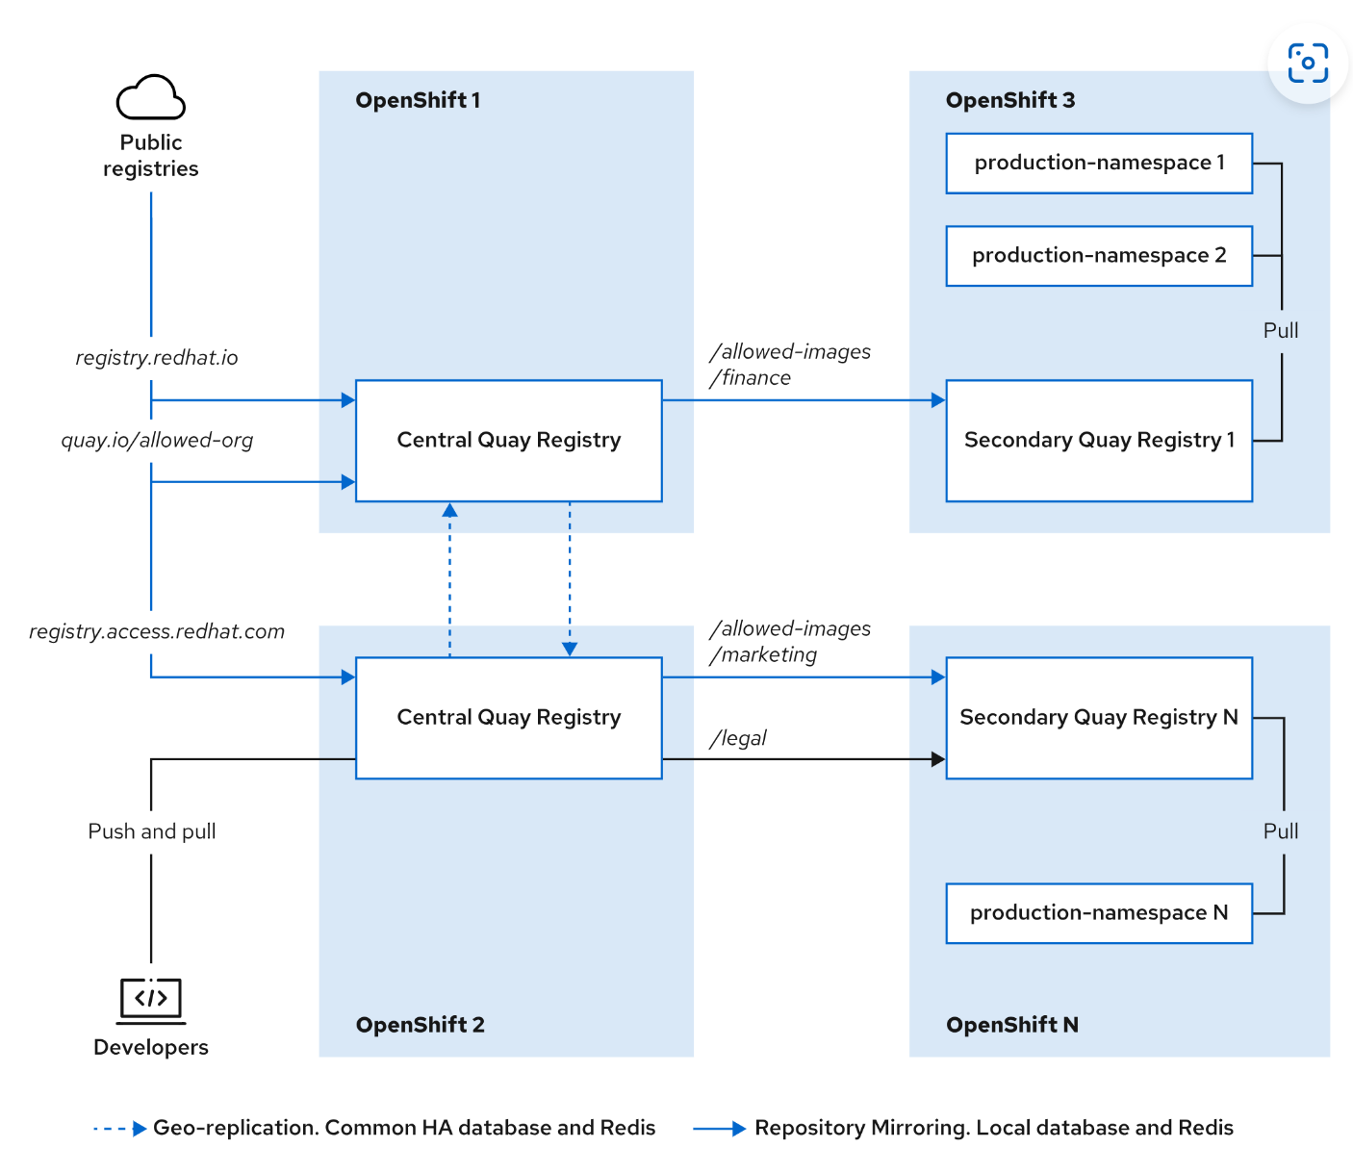

In the previous diagram, the Central Quay Registry is the primary registry, and becomes the single source of truth for your cluster fleet.

In this scenario, the clusters can pull images only from the secondary registries. The secondary registries are accessible only within the internal network and do not need to access to the Internet because they pull all the images from the primary registry. You can have different configurations on each of the different secondary registries because they are independent Quay instances, with their own database. However, you can also still control which images are allowed by controlling the central registry.

#### **Quay as a Registry for OpenShift**

A common deploy pattern for Quay is to replace the internal OpenShift registry for builds and workloads. However, the Quay tenancy model does not follow the OpenShift cluster permissions model. The Kubernetes and OpenShift image registry access is configured per namespace. You must add the robot account credentials for access to Quay organizations to each namespace.

### Note

To learn more about the Quay robot accounts, see [the section called “ Deploying from Red Hat Quay to the Cluster Fleet ”](https://rol.redhat.com/rol/app/courses/do480-2.4/pages/ch07s05).

You can also add the Quay robot accounts tokens to the global pull secret for OpenShift clusters. For more information about how to modify the OpenShift global pull secret, refer to the Updating the global cluster pull secret section of the official OpenShift documentation at <https://access.redhat.com/documentation/en-us/openshift_container_platform/4.10/html-single/images/managing-images#images-update-global-pull-secret_using-image-pull-secrets>.

Quay provides an operator that helps to integrate Quay with the namespaces and permission model of OpenShift, the Quay bridge operator. The Quay bridge operator must run on every OpenShift cluster where you need automatic integration with a Quay registry.

The operator automates the following operations.

* Creates an organization in Quay for every OpenShift namespace.
* Creates three robot accounts in the Quay organization corresponding to the three OpenShift service accounts in each namespace: builder, default, and deployer.
* Adds the secrets of the previous robot accounts to the service accounts in the namespaces to access to the repositories in the Quay organization.
* Creates a repository in Quay for every OpenShift ImageStream object.
* Deletes the repository, the organization, and the robot accounts in Quay when you delete a namespace on OpenShift.
* Triggers redeployments of applications that use ImageStreams when there is a push to the Quay repository.

The main operator custom resource definition is the QuayIntegration object. This object allows you to set an identifier on the cluster for the integration. Thus, you can use the Quay bridge operator with multiple clusters, avoiding names collision.

The following screen capture shows the Quay console with the organizations created by the Quay bridge operator. The organizations come from 2 different clusters.

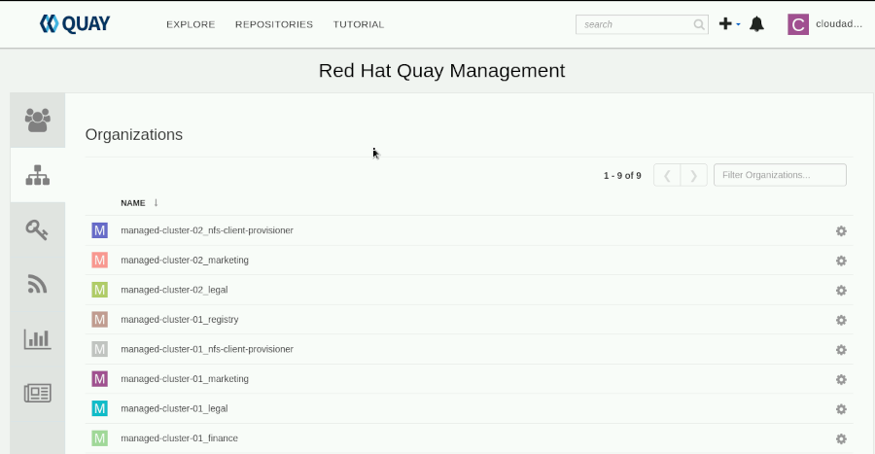

Figure 7.2: Organizations created by the Quay bridge operator

You must install the Quay bridge operator on every OpenShift cluster that requires integration with the Quay registries.

### Note

The Quay bridge operator cannot integrate with Red Hat Quay.io.

### References

For more information about the Quay operator, refer to the Deploy Red Hat Quay on OpenShift with the Quay Operator Guide at <https://access.redhat.com/documentation/en-us/red_hat_quay/3.6/html-single/deploy_red_hat_quay_on_openshift_with_the_quay_operator/index>

For more information about the Quay bridge operator, refer to the Integrate Red Hat Quay into OpenShift with the Bridge Operator chapter in the Manage Red Hat Quay Guide at <https://access.redhat.com/documentation/en-us/red_hat_quay/3.6/html-single/manage_red_hat_quay/index#quay-bridge-operator>

## **Restricting Image Registry Sources**

### **Objectives**

* Use Red Hat Advanced Cluster Management for Kubernetes (RHACM) to restrict container image source registries in your cluster fleet.

### **Restricting Image Sources on OpenShift Clusters**

Companies often need to control the origin of the software running their workloads. By restricting access to image container registries, companies can control the software that is used in a cluster.

Red Hat OpenShift Container Platform (RHOCP) has a mechanism to control the origin of images in use. Kubernetes does not provide any direct mechanism to control image sources. You could implement a custom a Kubernetes admission controller, which consults a service that allows or denies access to the registry when a workload pulls an image, but RHOCP offers an image controller that performs this function.

#### **The OpenShift Image Controller Object**

OpenShift 4 provides the config.openshift.io/v1/Image resource type. This resource type contains configuration fields related to image control, such as a list of allowed registries. Each cluster has a single config.openshift.io/v1/Image object. The name of this object is always cluster. This object describes the global image configuration of the OpenShift cluster.

The following YAML file shows an example of the cluster image controller object.

apiVersion: config.openshift.io/v1

kind: Image

metadata:

annotations:

release.openshift.io/create-only: "true"

creationTimestamp: "2022-05-17T13:44:26Z"

generation: 1

name: cluster

resourceVersion: "8302"

selfLink: /apis/config.openshift.io/v1/images/cluster

uid: e34555da-78a9-11e9-b92b-06d6c7da38dc

spec:

additionalTrustedCA:

name: myconfigmap

registrySources:

allowedRegistries:

- example.com

- quay.io

- registry.redhat.io

- image-registry.openshift-image-registry.svc:5000

- reg1.io/myrepo/myapp:latest

insecureRegistries:

- insecure.com

status:

internalRegistryHostname: image-registry.openshift-image-registry.svc:5000

|  |  |
| --- | --- |
|  | Object type and version. |
|  | The name of the object. It is a fixed value. |
|  | The config map that contains additional certificate authorities (CA) to trust on external registries. |
|  | Field that determines how the cluster manages individual registries for builds and workloads. |
|  | List of allowed registries. You can specify registries by domain and use the * wildcard for subdomains. Furthermore, you can allow specific repositories and tags. If you use the allowedRegistries field, then you cannot use its opposite, the blockedRegistries field. |
|  | List of registries that do not have valid TLS certificates. |

The machine config operator (MCO) searches for changes in the OpenShift image controller object. Whenever the object changes, the MCO drains all the workloads from each OpenShift node. Then, the MCO applies the changes by modifying the /host/etc/containers/policy.json file and returns each node to the Ready state. Changing the image controller object can be time-consuming on large clusters.

You can use the oc explain command to read the documentation of the OpenShift image controller resource definition and all its fields. For example, you can read which fields contain the registrySources field by using the following command.

[user@host ~]$ **oc explain images.config.openshift.io.spec.registrySources**

KIND: Image

VERSION: config.openshift.io/v1

RESOURCE: registrySources <Object>

DESCRIPTION:

registrySources contains configuration that determines how the container

runtime should treat individual registries when accessing images for

builds+pods. (e.g. whether or not to allow insecure access). It does not

contain configuration for the internal cluster registry.

FIELDS:

allowedRegistries <[]string>

allowedRegistries are the only registries permitted for image pull and push

actions. All other registries are denied. Only one of BlockedRegistries or

AllowedRegistries may be set.

blockedRegistries <[]string>

blockedRegistries cannot be used for image pull and push actions. All other

registries are permitted. Only one of BlockedRegistries or

AllowedRegistries may be set.

containerRuntimeSearchRegistries <[]string>

containerRuntimeSearchRegistries are registries that will be searched when

pulling images that do not have fully qualified domains in their pull

specs. Registries will be searched in the order provided in the list. Note:

this search list only works with the container runtime, i.e CRI-O. Will NOT

work with builds or imagestream imports.

insecureRegistries <[]string>

insecureRegistries are registries which do not have a valid TLS

certificates or only support HTTP connections.

Furthermore, you can view the status of the cluster OpenShift image controller object by using the following command.

[user@host ~]$ **oc get image.config.openshift.io/cluster -o yaml**

See the references section for more information about all the fields in the image.config.openshift.io/cluster object.

### **Creating a Governance Policy to Restrict Source Registries on OpenShift Clusters**

You can enforce the status of a Kubernetes object by using Red Hat Advanced Cluster Management for Kubernetes (RHACM) governance policies.

As stated elsewhere in the course, every RHACM policy requires one or more Policy, one PlacementRule, and one PlacementBinding object definitions. You can modify the status of an object across the cluster fleet by using the Policy object.

You can create an RHACM policy to manage the OpenShift image controller object across the cluster fleet. The following example shows a policy that restricts clusters to using a small set of registries.

apiVersion: policy.open-cluster-management.io/v1

kind: Policy

metadata:

name: image-policy

...omitted output...

spec:

remediationAction: enforce

disabled: false

policy-templates:

- objectDefinition:

apiVersion: policy.open-cluster-management.io/v1

kind: ConfigurationPolicy

metadata:

name: image-policy

spec:

remediationAction: enforce

severity: low

namespaceSelector:

exclude:

- kube-*

include:

- default

**object-templates:**

**- complianceType: musthave**

**objectDefinition:**

**apiVersion: config.openshift.io/v1**

**kind: Image**

**metadata:**

**name: cluster**

**spec:**

**registrySources:**

**allowedRegistries:**

**- image-registry.openshift-image-registry.svc:5000**

**- registry.redhat.io**

**- registry.access.redhat.com**

**- quay.io**

If your workloads try to pull an image from a different registry, then they fail with the following message.

Failed to pull image "external.unknownregistry.io/mysql:8.0": rpc error: code = Unknown desc = Source image rejected: Running image docker://external.unknownregistry.io/mysql:8.0 is rejected by policy.

### Warning

OpenShift blocks all registries that are not included in the allowedRegistries list. Except for disconnected clusters, all clusters require access to the following list of registries for correct operation.

* The OpenShift internal registry
* The registry.redhat.io registry
* The quay.io registry

When using the allowedRegistries field, ensure those registries are always included in the list.

Use a placement rule to define the clusters that receive the policy. The following example defines the target clusters for the policy by using the location label.

apiVersion: apps.open-cluster-management.io/v1

kind: PlacementRule

metadata:

name: placement-image-policy

spec:

clusterConditions:

- status: "True"

type: ManagedClusterConditionAvailable

**clusterSelector:**

**matchExpressions:**

**- {key: location, operator: In, values: ["APAC"]}**

### References

For more information about all the fields of the image.config.openshift.io/cluster object, refer to the Image configuration resources chapter of the Images Guide of the official OpenShift documentation at <https://access.redhat.com/documentation/en-us/openshift_container_platform/4.10/html-single/images/index#image-configuration>

For more information about the policy YAML structure, refer to the The Policy YAML Structure section in the Clusters guide in the Red Hat Advanced Cluster Management for Kubernetes documentation at <https://access.redhat.com/documentation/en-us/red_hat_advanced_cluster_management_for_kubernetes/2.4/html-single/governance/index#policy-yaml-structure>

## **Restricting Image Registry Sources**

### **Objectives**

* Use Red Hat Advanced Cluster Management for Kubernetes (RHACM) to restrict container image source registries in your cluster fleet.

### **Restricting Image Sources on OpenShift Clusters**

Companies often need to control the origin of the software running their workloads. By restricting access to image container registries, companies can control the software that is used in a cluster.

Red Hat OpenShift Container Platform (RHOCP) has a mechanism to control the origin of images in use. Kubernetes does not provide any direct mechanism to control image sources. You could implement a custom a Kubernetes admission controller, which consults a service that allows or denies access to the registry when a workload pulls an image, but RHOCP offers an image controller that performs this function.

#### **The OpenShift Image Controller Object**

OpenShift 4 provides the config.openshift.io/v1/Image resource type. This resource type contains configuration fields related to image control, such as a list of allowed registries. Each cluster has a single config.openshift.io/v1/Image object. The name of this object is always cluster. This object describes the global image configuration of the OpenShift cluster.

The following YAML file shows an example of the cluster image controller object.

apiVersion: config.openshift.io/v1

kind: Image

metadata:

annotations:

release.openshift.io/create-only: "true"

creationTimestamp: "2022-05-17T13:44:26Z"

generation: 1

name: cluster

resourceVersion: "8302"

selfLink: /apis/config.openshift.io/v1/images/cluster

uid: e34555da-78a9-11e9-b92b-06d6c7da38dc

spec:

additionalTrustedCA:

name: myconfigmap

registrySources:

allowedRegistries:

- example.com

- quay.io

- registry.redhat.io

- image-registry.openshift-image-registry.svc:5000

- reg1.io/myrepo/myapp:latest

insecureRegistries:

- insecure.com

status:

internalRegistryHostname: image-registry.openshift-image-registry.svc:5000

|  |  |
| --- | --- |
|  | Object type and version. |
|  | The name of the object. It is a fixed value. |
|  | The config map that contains additional certificate authorities (CA) to trust on external registries. |
|  | Field that determines how the cluster manages individual registries for builds and workloads. |
|  | List of allowed registries. You can specify registries by domain and use the * wildcard for subdomains. Furthermore, you can allow specific repositories and tags. If you use the allowedRegistries field, then you cannot use its opposite, the blockedRegistries field. |
|  | List of registries that do not have valid TLS certificates. |

The machine config operator (MCO) searches for changes in the OpenShift image controller object. Whenever the object changes, the MCO drains all the workloads from each OpenShift node. Then, the MCO applies the changes by modifying the /host/etc/containers/policy.json file and returns each node to the Ready state. Changing the image controller object can be time-consuming on large clusters.

You can use the oc explain command to read the documentation of the OpenShift image controller resource definition and all its fields. For example, you can read which fields contain the registrySources field by using the following command.

[user@host ~]$ **oc explain images.config.openshift.io.spec.registrySources**

KIND: Image

VERSION: config.openshift.io/v1

RESOURCE: registrySources <Object>

DESCRIPTION:

registrySources contains configuration that determines how the container

runtime should treat individual registries when accessing images for

builds+pods. (e.g. whether or not to allow insecure access). It does not

contain configuration for the internal cluster registry.

FIELDS:

allowedRegistries <[]string>

allowedRegistries are the only registries permitted for image pull and push

actions. All other registries are denied. Only one of BlockedRegistries or

AllowedRegistries may be set.

blockedRegistries <[]string>

blockedRegistries cannot be used for image pull and push actions. All other

registries are permitted. Only one of BlockedRegistries or

AllowedRegistries may be set.

containerRuntimeSearchRegistries <[]string>

containerRuntimeSearchRegistries are registries that will be searched when

pulling images that do not have fully qualified domains in their pull

specs. Registries will be searched in the order provided in the list. Note:

this search list only works with the container runtime, i.e CRI-O. Will NOT

work with builds or imagestream imports.

insecureRegistries <[]string>

insecureRegistries are registries which do not have a valid TLS

certificates or only support HTTP connections.

Furthermore, you can view the status of the cluster OpenShift image controller object by using the following command.

[user@host ~]$ **oc get image.config.openshift.io/cluster -o yaml**

See the references section for more information about all the fields in the image.config.openshift.io/cluster object.

### **Creating a Governance Policy to Restrict Source Registries on OpenShift Clusters**

You can enforce the status of a Kubernetes object by using Red Hat Advanced Cluster Management for Kubernetes (RHACM) governance policies.

As stated elsewhere in the course, every RHACM policy requires one or more Policy, one PlacementRule, and one PlacementBinding object definitions. You can modify the status of an object across the cluster fleet by using the Policy object.

You can create an RHACM policy to manage the OpenShift image controller object across the cluster fleet. The following example shows a policy that restricts clusters to using a small set of registries.

apiVersion: policy.open-cluster-management.io/v1

kind: Policy

metadata:

name: image-policy

...omitted output...

spec:

remediationAction: enforce

disabled: false

policy-templates:

- objectDefinition:

apiVersion: policy.open-cluster-management.io/v1

kind: ConfigurationPolicy

metadata:

name: image-policy

spec:

remediationAction: enforce

severity: low

namespaceSelector:

exclude:

- kube-*

include:

- default

**object-templates:**

**- complianceType: musthave**

**objectDefinition:**

**apiVersion: config.openshift.io/v1**

**kind: Image**

**metadata:**

**name: cluster**

**spec:**

**registrySources:**

**allowedRegistries:**

**- image-registry.openshift-image-registry.svc:5000**

**- registry.redhat.io**

**- registry.access.redhat.com**

**- quay.io**

If your workloads try to pull an image from a different registry, then they fail with the following message.

Failed to pull image "external.unknownregistry.io/mysql:8.0": rpc error: code = Unknown desc = Source image rejected: Running image docker://external.unknownregistry.io/mysql:8.0 is rejected by policy.

### Warning

OpenShift blocks all registries that are not included in the allowedRegistries list. Except for disconnected clusters, all clusters require access to the following list of registries for correct operation.

* The OpenShift internal registry
* The registry.redhat.io registry
* The quay.io registry

When using the allowedRegistries field, ensure those registries are always included in the list.

Use a placement rule to define the clusters that receive the policy. The following example defines the target clusters for the policy by using the location label.

apiVersion: apps.open-cluster-management.io/v1

kind: PlacementRule

metadata:

name: placement-image-policy

spec:

clusterConditions:

- status: "True"

type: ManagedClusterConditionAvailable

**clusterSelector:**

**matchExpressions:**

**- {key: location, operator: In, values: ["APAC"]}**

### References

For more information about all the fields of the image.config.openshift.io/cluster object, refer to the Image configuration resources chapter of the Images Guide of the official OpenShift documentation at <https://access.redhat.com/documentation/en-us/openshift_container_platform/4.10/html-single/images/index#image-configuration>

For more information about the policy YAML structure, refer to the The Policy YAML Structure section in the Clusters guide in the Red Hat Advanced Cluster Management for Kubernetes documentation at <https://access.redhat.com/documentation/en-us/red_hat_advanced_cluster_management_for_kubernetes/2.4/html-single/governance/index#policy-yaml-structure>

## **Guided Exercise: Restricting Image Registry Sources**

* Locate deployments that use container images from insecure registries across the cluster fleet. Then, you configure the cluster fleet to avoid untrusted image sources by using a Red Hat Advanced Cluster Management for Kubernetes (RHACM) governance policy.

**Outcomes**

* Locate specific images across the cluster fleet.
* Deploy a RHACM governance policy.
* Use the RHACM policy to manage the image.config.openshift.io/cluster OpenShift image object.

As the student user on the workstation machine, use the lab command to prepare your system for this exercise.

This command ensures that all the deployments are ready on the cluster fleet. The command also creates the following Quay resources:

* Two public image organizations in the internal Quay registry: the central-quay-registry.apps.ocp4.example.com/public organization and the central-quay-registry.apps.ocp4.example.com/finance organization.
* Two Quay repositories with an image: the central-quay-registry.apps.ocp4.example.com/public/mysql:8.0 image and the central-quay-registry.apps.ocp4.example.com/finance/approved-mysql:8.0 image.

[student@workstation ~]$ **lab start quayacm-restrict**

1. Use the RHACM web console search feature to identify any images in the internal Quay registry that are pulled from the public untrusted organization.
   1. From the workstation machine, navigate to the RHACM web console at https://multicloud-console.apps.ocp4.example.com. When prompted, click **htpasswd_provider** and log in as the admin user with the redhat password.
   2. Click the **Search** icon in the upper-right corner of the window to open the RHACM search page.
   3. In the search field, type image: and review the different image registries in use across the cluster fleet. Continue by typing public without pressing **Enter** to restrict the search.

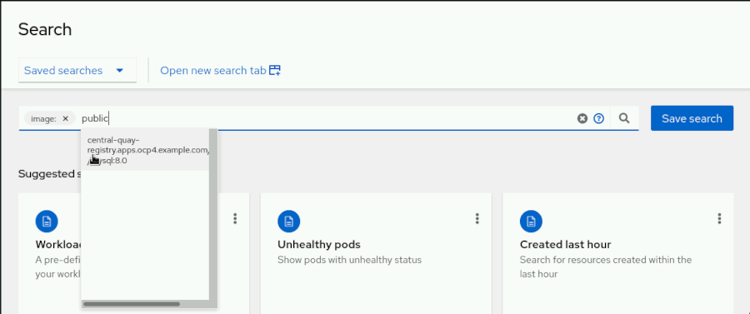

Click the name of the MySQL image showed in the searches suggestions.

* 1. Click **1 Related deployment** in the results page to find which deployments and clusters contain that image. There is one deployment that uses the central-quay-registry.apps.ocp4.example.com/public/mysql:8.0 image. The deployment is in the budget-app namespace in the local-cluster cluster.

The finance department only accepts images that are already tested and stored under the finance Quay organization.

1. Use a RHACM governance policy to allow pulling images only from trusted registries and repositories.
   1. From the terminal, log in to the ocp4 hub cluster as the admin user with the redhat password. The API server address is https://api.ocp4.example.com:6443.

[student@workstation ~]$ **oc login -u admin -p redhat \**

**https://api.ocp4.example.com:6443**

Login successful.

...output omitted...

* 1. Create the policies namespace to store the new policy.
  2. [student@workstation ~]$ **oc create namespace policies**

namespace/policies created

* 1. Change to the ~/DO480/labs/quayacm-restrict directory, and review the image-policy.yaml file.

[student@workstation ~]$ **cd DO480/labs/quayacm-restrict**

Edit the image-policy.yaml file to add the finance Quay URL organization to the list of allowed container registries.

apiVersion: policy.open-cluster-management.io/v1

kind: Policy

metadata:

name: image-policy

...output omitted...

spec:

remediationAction: enforce

disabled: false

policy-templates:

...output omitted...

object-templates:

- complianceType: musthave

objectDefinition:

apiVersion: config.openshift.io/v1

kind: Image

metadata:

name: cluster

spec:

registrySources:

allowedRegistries:

**- central-quay-registry.apps.ocp4.example.com/finance**

- registry.redhat.io

- registry.access.redhat.com

- quay.io

apiVersion: policy.open-cluster-management.io/v1

kind: PlacementBinding

...output omitted...

apiVersion: apps.open-cluster-management.io/v1

kind: PlacementRule

...output omitted...

clusterSelector:

matchExpressions: []

This policy uses the image.config.openshift.io/cluster image object to specify which container registries the OpenShift cluster can use.

This policy also uses an empty cluster selector to select all the clusters present in the fleet.

* 1. Create the policy in the policies namespace.

[student@workstation quayacm-restrict]$ **oc apply -f image-policy.yaml -n policies**

policy.policy.open-cluster-management.io/image-policy created

placementbinding.policy.open-cluster-management.io/binding-image-policy created

placementrule.apps.open-cluster-management.io/placement-image-policy created

This RHACM policy is in enforcing mode. Thus, it modifies the image.config.openshift.io/cluster image object in each cluster immediately. Then, the OpenShift Machine Config operator in each cluster updates all the nodes in the clusters to apply the list of allowed registries.

* 1. Navigate to the RHACM web console and click **Governance** on the left pane. Then, click **image-policy** to review that the image-policy policy is compliant in all the matched clusters.

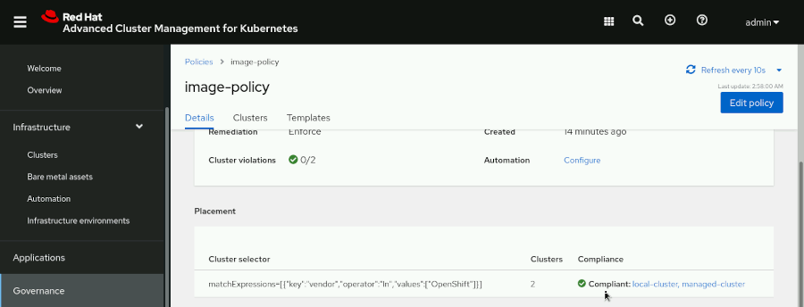

1. Deploy the invoices-app application to test that only trusted repositories are allowed.
   1. From the terminal, change to the ~/DO480/labs/quayacm-restrict directory and review the template-app-deployment.yaml OpenShift template file. Note the parameter with the image that the application uses.

...output omitted...

parameters:

- description: MySQL image

displayName: MySQL image

name: MYSQL_IMAGE

required: true

**value: central-quay-registry.apps.ocp4.example.com/public/mysql:8.0**

...output omitted...

* 1. Log in to a managed cluster.

[student@workstation quayacm-restrict]$ **oc login -u admin -p redhat \**

**https://api.ocp4-mng.example.com:6443**

Login successful.

...output omitted...

* 1. Create the invoices-app namespace.
  2. [student@workstation quayacm-restrict]$ **oc create namespace invoices-app**

namespace/invoices-app created

* 1. Deploy the application by processing the template.

[student@workstation quayacm-restrict]$ **oc process \**

**-f template-app-deployment.yaml \**

**-p "APPLICATION=invoices-app" \**

**| oc create -n invoices-app -f -**

deployment.apps/mysql-invoices-app created

service/mysql-invoices-app created

* 1. Inspect the status of the invoices-app application pods.
  2. [student@workstation quayacm-restrict]$ **oc get pods -n invoices-app**
  3. NAME READY STATUS RESTARTS AGE

mysql-invoices-app-5459f489d9-6gttv 0/1 ImagePullBackOff 0 2m20s

The pod cannot pull the image. To review the reason, get the events of the invoices-app namespace.

[student@workstation quayacm-restrict]$ **oc get events -n invoices-app | \**

**grep Failed**

10m Warning Failed pod/mysql-invoices-app-5459f489d9-6gttv Failed to pull image "central-quay-registry.apps.ocp4.example.com/public/mysql:8.0": rpc error: code = Unknown desc = Source image rejected: Running image docker://central-quay-registry.apps.ocp4.example.com/public/mysql:8.0 is rejected by policy.

10m Warning Failed pod/mysql-invoices-app-5459f489d9-6gttv Error: ErrImagePull

10m Warning Failed pod/mysql-invoices-app-5459f489d9-6gttv Error: ImagePullBackOff

1. Correct the invoices-app application deployment by using an approved image.
   1. Delete the invoices-app namespace in the managed cluster.

[student@workstation quayacm-restrict]$ **oc delete namespace invoices-app**

namespace "invoices-app" deleted

* 1. Recreate the namespace.

[student@workstation quayacm-restrict]$ **oc create namespace invoices-app**

namespace/invoices-app created

* 1. Process the deployment template with the MYSQL_IMAGE parameter pointing to the approved central-quay-registry.apps.ocp4.example.com/finance/approved-mysql:8.0 MySQL image.

[student@workstation quayacm-restrict]$ **oc process \**

**-f template-app-deployment.yaml \**

**-p "APPLICATION=invoices-app" \**

**-p "MYSQL_IMAGE=central-quay-registry.apps.ocp4.example.com/finance/approved-mysql:8.0" \**

**| oc create -n invoices-app -f -**

deployment.apps/mysql-invoices-app created

service/mysql-invoices-app created

### Note

* + - The -p "MYSQL_IMAGE=…​approved-mysql:8.0" \ fragment must be typed as a single line.
  1. Inspect the status of the invoices-app application pods.

[student@workstation quayacm-restrict]$ **oc get pods -n invoices-app**

NAME READY STATUS RESTARTS AGE

mysql-invoices-app-67b47884c8-7gtp6 1/1 Running 0 71s

**Finish**

On the workstation machine, change to the student user home directory and use the lab command to complete this exercise. This step is important to ensure that resources from previous exercises do not impact upcoming exercises.

[student@workstation quayacm-restrict]$ **cd ~**

[student@workstation ~]$ **lab finish quayacm-restrict**

This concludes the section.

## **Deploying from Red Hat Quay to the Cluster Fleet**

### **Objectives**

* Use Red Hat Advanced Cluster Management for Kubernetes (RHACM) to deploy an application using a central Red Hat Quay registry.

### **Introducing Robot Accounts**

Quay provides robot accounts for automated operations. Robot accounts are similar to user accounts, but the following key differences make them more suitable for automated processes.

* Robot accounts belong to a single organization.
* Robot accounts cannot use the web interface.
* Robot accounts access Quay by using tokens only instead of passwords.

Limiting the capabilities of robot accounts reduces security risks.

Robot accounts are also similar to Kubernetes service accounts. Kubernetes service accounts and robot accounts act as user accounts for automated processes.

#### **Managing Robot Accounts**

Manage team membership of robot accounts from the team page.

From the organization page, click **Robot Accounts** to manage robot accounts by using the web console.

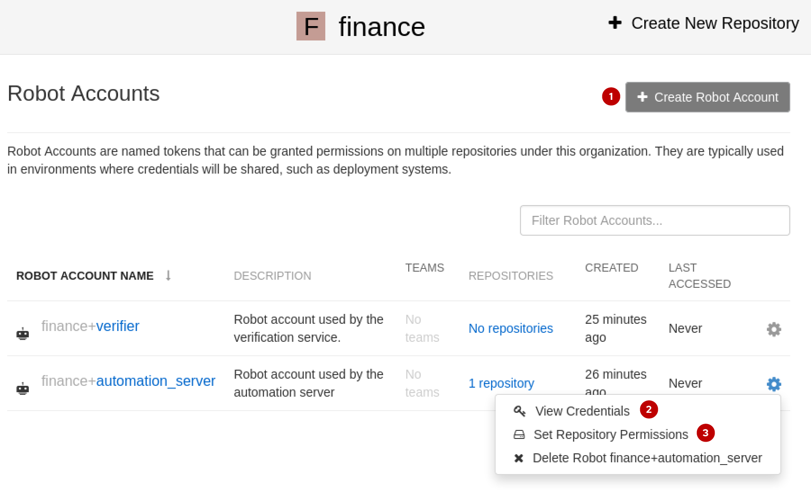

Managing robot accounts.

|  |  |
| --- | --- |
|  | Click **Create Robot Account** to create robot accounts. |
|  | Click **View Credentials** to get the robot account token and display usage instructions. |
|  | Click **Set Repository Permissions** to manage repository permissions. |

You can also manage robots by using the API. You need a token with the administer organization permission to manage robots.

To create a robot account, make an HTTP PUT request with a payload with the following structure to the https://quay.example.com/api/v1/organization/*organization*/robots/*name*/ endpoint.

{"description": "***description***"}

The response contains the robot account token.

{

"name": "finance+verifier",

"created": "Wed, 27 Apr 2022 10:34:33 -0000",

"last_accessed": null,

"description": "Robot account used by the verification service.",

"token": **"B2...Z9"**,

"unstructured_metadata": null

}

To grant robot accounts permissions over repositories, make an HTTP PUT request with a payload with the following structure to the https://quay.example.com/api/v1/repository/*organization*/*repository*/permissions/user/*organization*+*robot_account_name*/ endpoint.

{"role": "***role***"}

The role has a read, write, or admin value.

### Warning

If a malicious actor obtains access to the robot account token, then the actor can perform all the actions that the robot account can perform.

Only grant the minimum permissions that you require. Store the token as confidential information. Review usage logs to detect unusual activity.

To revoke a token, recreate the robot account. You can also recreate robot accounts periodically to reduce the period a leaked token is usable.

### **Using Robot Accounts for Deployments**

After creating a robot account, you can use the robot account credentials in deployments.

The Quay console displays robot account credentials and instructions to use robot accounts. Navigate to the **Robot Accounts** page for an organization to display existing robot accounts. Click a robot account name or the **Options** gear icon, then click **View Credentials**.

A window opens displaying instructions about using the robot account.

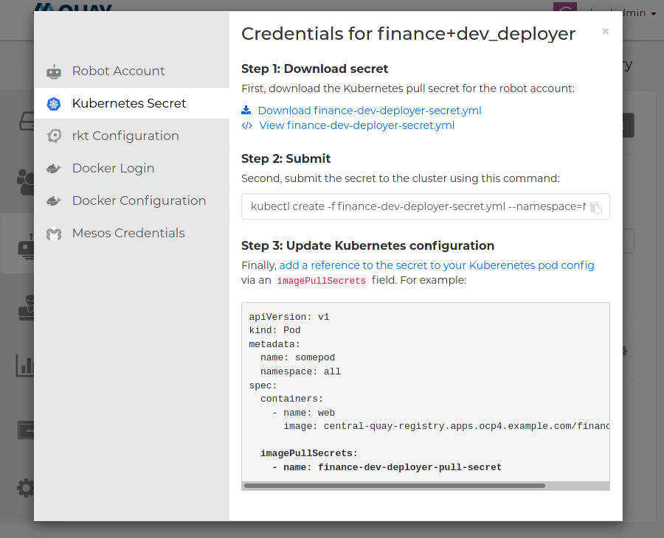

Figure 7.5: Robot account usage instructions

This window contains a secret definition that you can view or download. You can use the kubectl create command to create a secret in a cluster containing the robot account credentials. Finally, the window contains an example about how to use the secret in a pod definition.

After you create the secret, you can reference it as an image pull secret in workload definitions.

apiVersion: v1

kind: Pod

metadata:

name: somepod

namespace: all

spec:

containers:

- name: web

image: central-quay-registry.apps.ocp4.example.com/finance/somerepo

**imagePullSecrets:**

**- name: finance-deployer-pull-secret**

### **Deploying Workloads That Use Private Images Across a Cluster Fleet**

Using the imagePullSecrets key in workload definitions can be effective when only a low number of workloads require an image pull secret. If you are using Red Hat Advanced Cluster Management for Kubernetes (RHACM) applications to deploy workloads, then you can add the image pull secret to the RHACM application definitions. However, when many deployments require a secret, editing all workloads can be inconvenient and error prone.

The Quay bridge operator can synchronize OpenShift namespaces and Quay organizations, and configure the necessary image pull secrets. For more information about the Quay bridge operator, refer to [the section called “ Describe Red Hat Quay Use Cases in a Multicluster Architecture ”](https://rol.redhat.com/rol/app/courses/do480-2.4/pages/ch07). When using the Quay bridge operator, if a workload requires a private image, then you push the image to the Quay organization that matches the workload namespace. This way, workloads can access private images transparently.

When working on a cluster fleet, you can use RHACM policies to install the Quay bridge operator in all managed clusters automatically.

Alternatively, you can add pull secrets to the service accounts that interact with Quay or update the global pull secret.

By default, Kubernetes clusters have a default service account in each namespace. Kubernetes uses these service accounts to interact with registries. In addition to the default service account, OpenShift clusters also use builder and deployer service accounts. To use private registries, you can use the oc secrets link command to add secrets to service accounts.

You can use Red Hat Advanced Cluster Management for Kubernetes (RHACM) or other automation systems to perform those operations across a cluster fleet.

### References

For more information, refer to the Allowing robot access to a user repository section in the Managing access to repositories chapter in the Red Hat Quay 3.6 Use Red Hat Quay documentation at <https://access.redhat.com/documentation/en-us/red_hat_quay/3.6/html-single/use_red_hat_quay/index#allow-robot-access-user-repo>

For more information about image pull secrets, refer to the Using image pull secrets section in the Managing images chapter in the Images guide at <https://access.redhat.com/documentation/en-us/openshift_container_platform/4.10/html-single/images/index#using-image-pull-secrets>

For more information about default OpenShift service accounts, refer to the Default service accounts section in the Using service accounts in applications chapter in the Authentication and authorization guide at <https://access.redhat.com/documentation/en-us/openshift_container_platform/4.10/html-single/authentication_and_authorization/index#service-accounts-default_using-service-accounts>

## **Guided Exercise: Deploying from Red Hat Quay to the Cluster Fleet**

* Create an application container image in Red Hat Quay and deploy the application to the cluster fleet by using Red Hat Advanced Cluster Management (RHACM).

**Outcomes**

* Configure deployments to use a private container registry.

As the student user on the workstation machine, use the lab command to prepare your system for this exercise.

This command ensures that RHACM and Quay are available.

[student@workstation ~]$ **lab start quayacm-deploy**

1. Create a minimal application image.
   1. Create a file named Containerfile with the following content.

FROM registry.access.redhat.com/ubi8/httpd-24:1

RUN echo hello >/var/www/html/index.html

* 1. Use the podman build command to build the image.

[student@workstation ~]$ **podman build . -t hello:1**

...output omitted...

Successfully tagged localhost/hello:latest

...output omitted...

1. Create a budget-app-dev namespace.
   1. Log in to the ocp4 hub cluster as the admin user with the redhat password. The API server address is https://api.ocp4.example.com:6443.

[student@workstation ~]$ **oc login -u admin -p redhat \**

**https://api.ocp4.example.com:6443**

Login successful.

...output omitted...

* 1. Create the budget-app-dev namespace.

[student@workstation ~]$ **oc create namespace budget-app-dev**

namespace/budget-app-dev created

1. Create a finance organization and a budget-app-dev image repository in Quay.
   1. From the workstation machine, navigate to the Quay web console at https://central-quay-registry.apps.ocp4.example.com. Log in as the cloudadmin user with the redhat password.

If prompted, click **Confirm Username**.

* 1. Click **Create New Organization**.



* 1. Type finance as the organization name, then click **Create Organization**.
  2. Click **Create New Repository**.

|  |
| --- |
|  |

* 1. Type budget-app-dev as the repository name, then click **Create Private Repository**.

1. Create a dev_deployer robot account. Grant read permissions to the robot account over the budget-app-dev repository.
   1. Click **REPOSITORIES**, then click **finance** to go to the organization page.
   2. Click **Robot Accounts**, then click **Create Robot Account**.

|  |
| --- |
|  |

* 1. Type dev_deployer as the robot account name, leave the description blank, then click **Create robot account**.
  2. On the page that opens, select the **Read** permission over the budget-app-dev repository, then click **Add permissions**.

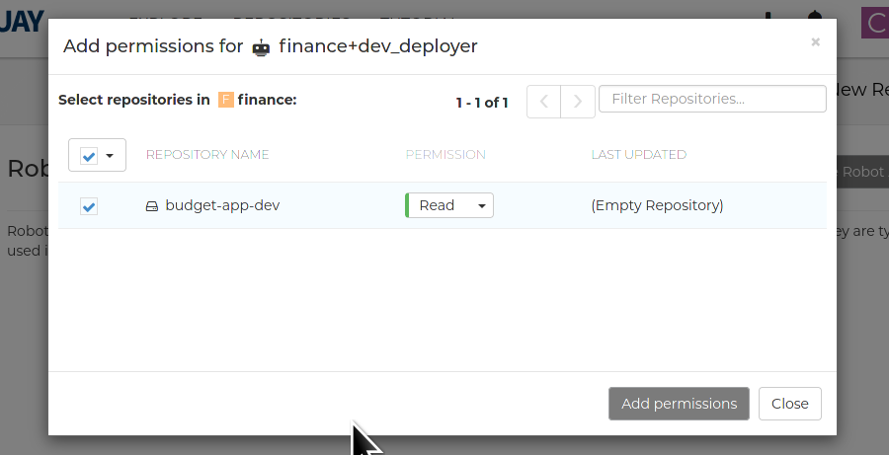

1. Obtain the robot account secret.
   1. Click **finance+dev_deployer** to view the credentials for the robot account, then click **Kubernetes Secret** to view instructions about using a robot account in Kubernetes.

The page describes how to create a Kubernetes secret for the robot account, and how to use the imagePullSecrets directive to refer to the secret for pulling images.



* 1. Click the download icon to download finance-dev-deployer-secret.yml. In the confirmation window, click **Save File** and then click **OK**. The browser downloads the file to the /home/students/Downloads directory.

1. Use the oc create command to create the secret in the budget-app-dev namespace.

[student@workstation ~]$ **oc create -f Downloads/finance-dev-deployer-secret.yml \**

**--namespace=budget-app-dev**

secret/finance-dev-deployer-pull-secret created

1. Push the image to Quay.
   1. Log in to Quay as the cloudadmin user with the redhat password.

### Warning

This exercise uses a plain text password for brevity. Commands such as podman store passwords in the file system unencrypted. If a malicious actor obtains access to the file system, then the actor can impersonate your account.

In real-world situations, always use encrypted passwords as described in a previous step.

[student@workstation ~]$ **podman login -u=cloudadmin -p=redhat \**

**central-quay-registry.apps.ocp4.example.com**

Login Succeeded!

...output omitted...

* 1. Push the image to Quay.

[student@workstation ~]$ **podman push localhost/hello:1 \**

**central-quay-registry.apps.ocp4.example.com/finance/budget-app-dev:1**

...output omitted...

Writing manifest to image destination

Storing signatures

1. Fork the do480-apps course GitHub repository at <https://github.com/redhattraining/do480-apps/>. This repository contains starter YAML files to build the application.
   1. From the workstation machine, navigate to the do480-apps repository at <https://github.com/redhattraining/do480-apps/>.
   2. In the upper-right corner of the GitHub repository page, click **Fork**, then click **Create fork** to create a fork for your repository.

### Note

If you have already performed this exercise or made other changes to the fork, then you must delete your fork to avoid problems during this exercise.

To delete the fork, navigate to https://github.com/your-fork-name/DO480-apps/. Click **Settings**. Click **Delete this repository** and enter the name of the repository to confirm the deletion.

* 1. In your GitHub fork, navigate to the deployment.. Click **quayacm-deployment** and then click **deployment.yaml** to access the file. Click the pencil icon to edit the YAML file.
  2. Edit the deployment that matches the following content.

...output omitted...

spec:

containers:

- image: **central-quay-registry.apps.ocp4.example.com/finance/budget-app-dev:1**

name: budget-app

ports:

- containerPort: 8080

name: budget-app

**imagePullSecrets:**

**- name: finance-dev-deployer-pull-secret**

### Note

The - image: central…​dev:1 statement must be a single line.

Scroll to the bottom of the page and click **Commit changes**.

1. Deploy the application by using RHACM.
   1. From the workstation machine, navigate to https://multicloud-console.apps.ocp4.example.com.
   2. Click **htpasswd_provider** and log in as the admin user with the redhat password.
   3. On the left navigation bar, navigate to **Applications**, click **Create application**, and then click **Subscription**.
   4. Fill the form with the following values.

| **Field** | **Value** |
| --- | --- |
| **Name** | budget-app-dev |
| **Namespace** | budget-app-dev |
| **Repository types** | **Git** |
| **URL** | https://github.com/*your_fork*/DO480-apps.git |
| **Branch** | **main** |
| **Path** | **quayacm-deployment** |

* 1. Scroll down and expand **Select clusters to deploy to** to configure a placement rule for the application. Select the **Deploy on local cluster** option to create a placement rule that deploys the application only on the local cluster.
  2. Click **Save**.

1. Access the application.
   1. On the **Topology** page, wait until all the application components have a green checkmark.
   2. Click the **Route** component. Click the link to http://budget.apps.ocp4.example.com/ that is displayed. A new tab opens and displays the **hello** text.

**Finish**

On the workstation machine, change to the student user home directory and use the lab command to complete this exercise. This step is important to ensure that resources from previous exercises do not impact upcoming exercises.

[student@workstation ~]$ **lab finish quayacm-deploy**

This concludes the section.

## **Lab: Integrating Red Hat Quay with OpenShift and RHACM**

* Use Red Hat Advanced Cluster Management for Kubernetes (RHACM) to restrict image sources in the production clusters. Then you configure a Quay robot account to manage images for production clusters. Finally, you deploy the budget-app application in the production clusters by adding a specific image to the list of allowed images.

**Outcomes**

* Use a RHACM policy to allow specific images by managing the image.config.openshift.io/cluster OpenShift object.
* Use robot accounts to manage Quay organizations.
* Deliver applications into multiple clusters by using RHACM GitOps.
* Configure deployments to use a Quay private container registry.

As the student user on the workstation machine, use the lab command to prepare your system for this exercise.

This command ensures that all Quay resources are present. The command also tags the production managed clusters for RHACM by using the env=production label.

[student@workstation ~]$ **lab start quayacm-review**

1. Log in to the RHACM OpenShift hub cluster as the admin user with the redhat password. The API server address is https://api.ocp4.example.com:6443.
   1. Log in to the RHACM hub cluster.
   2. [student@workstation ~]$ **oc login -u admin -p redhat \**
   3. **https://api.ocp4.example.com:6443**
   4. Login successful.

...output omitted...

1. [Hide Solution](https://rol.redhat.com/rol/app/)
2. Create an RHACM governance policy in the policies namespace, to allow only the following list of images and container registries:
   1. registry.redhat.io
   2. registry.access.redhat.com
   3. quay.io
   4. central-quay-registry.apps.ocp4.example.com/finance/budget-app:production

The policy uses the image.config.openshift.io/cluster OpenShift object. Apply the policy to the managed clusters with the env=production label. The lab script includes a DO480/labs/quayacm-review/image-policy.yaml solution file.

* 1. Create the policies namespace to store the new policy.
  2. [student@workstation ~]$ **oc create namespace policies**

namespace/policies created

* 1. Change to the ~/DO480/labs/quayacm-review directory.

[student@workstation ~]$ **cd DO480/labs/quayacm-review**

* 1. Review the image-policy.yaml file.
  2. apiVersion: policy.open-cluster-management.io/v1
  3. kind: Policy
  4. metadata:
  5. name: image-policy
  6. ...output omitted...
  7. spec:
  8. remediationAction: enforce
  9. disabled: false
  10. policy-templates:
  11. ...output omitted...
  12. object-templates:
  13. - complianceType: musthave
  14. objectDefinition:
  15. apiVersion: config.openshift.io/v1
  16. kind: Image
  17. metadata:
  18. name: cluster
  19. spec:
  20. registrySources:
  21. allowedRegistries:
  22. **- registry.redhat.io**
  23. **- registry.access.redhat.com**
  24. **- quay.io**
  25. **- central-quay-registry...budget-app:production**
  26. ---
  27. apiVersion: policy.open-cluster-management.io/v1
  28. kind: PlacementBinding
  29. ...output omitted...
  30. apiVersion: apps.open-cluster-management.io/v1
  31. kind: PlacementRule
  32. ...output omitted...
  33. clusterSelector:
  34. matchExpressions:

**- {key: env, operator: In, values: ["production"]}**

### Note

As stated in this chapter, the image.config.openshift.io/cluster object filters by using domain names, repository names, or specific image names and tags.

* 1. Create the policy in the policies namespace.
  2. [student@workstation quayacm-review]$ **oc apply -f image-policy.yaml -n policies**
  3. policy.policy.open-cluster-management.io/image-policy created
  4. placementbinding.policy.open-cluster-management.io/binding-image-policy created

placementrule.apps.open-cluster-management.io/placement-image-policy created

* 1. Read the image.config.openshift.io/cluster OpenShift object in the non-production cluster to verify that it does not contain the three allowed registries.
  2. [student@workstation quayacm-review]$ **oc get image.config.openshift.io/cluster \**
  3. **-o yaml**
  4. apiVersion: config.openshift.io/v1
  5. kind: Image
  6. metadata:
  7. annotations:
  8. include.release.openshift.io/ibm-cloud-managed: "true"
  9. include.release.openshift.io/self-managed-high-availability: "true"
  10. include.release.openshift.io/single-node-developer: "true"
  11. release.openshift.io/create-only: "true"
  12. creationTimestamp: "2022-05-13T15:58:17Z"
  13. generation: 1
  14. name: cluster
  15. ownerReferences:
  16. - apiVersion: config.openshift.io/v1
  17. kind: ClusterVersion
  18. name: version
  19. uid: 73cada64-5434-48af-8208-ec144ee8555d
  20. resourceVersion: "25816"
  21. uid: 214ff292-782c-4b92-b31b-0cc1b4af75a1
  22. **spec: {}**
  23. status:

internalRegistryHostname: image-registry.openshift-image-registry.svc:5000

* 1. Log in to the managed-cluster production cluster.
  2. [student@workstation quayacm-review]$ **oc login -u admin -p redhat \**
  3. **https://api.ocp4-mng.example.com:6443**
  4. Login successful.

...output omitted...

* 1. Review the image.config.openshift.io/cluster OpenShift object in the production cluster to verify that it contains the three allowed registries.
  2. [student@workstation quayacm-review]$ **oc get image.config.openshift.io/cluster \**
  3. **-o yaml**
  4. apiVersion: config.openshift.io/v1
  5. kind: Image
  6. metadata:
  7. annotations:
  8. include.release.openshift.io/ibm-cloud-managed: "true"
  9. include.release.openshift.io/self-managed-high-availability: "true"
  10. include.release.openshift.io/single-node-developer: "true"
  11. release.openshift.io/create-only: "true"
  12. creationTimestamp: "2022-05-13T16:42:21Z"
  13. generation: 3
  14. name: cluster
  15. ownerReferences:
  16. - apiVersion: config.openshift.io/v1
  17. kind: ClusterVersion
  18. name: version
  19. uid: 13a25437-a584-434b-a32f-2f3c6d08f87c
  20. resourceVersion: "175103"
  21. uid: b4070508-948f-4d43-a7eb-f876e7a72c9e
  22. **spec:**
  23. **registrySources:**
  24. **allowedRegistries:**
  25. **- quay.io**
  26. **- registry.access.redhat.com**
  27. **- registry.redhat.io**
  28. **- central-quay-registry.apps.ocp4.example.com/finance/budget-app:production**
  29. status:

internalRegistryHostname: image-registry.openshift-image-registry.svc:5000

[Hide Solution](https://rol.redhat.com/rol/app/)

1. Create a Quay robot account for the finance Quay organization.

Grant the account the read permission on the budget-app-dev repository, and the write permission on the budget-app repository. Log in to the Quay central registry at https://central-quay-registry.apps.ocp4.example.com as cloudadmin, using redhat123 as the password.

* 1. From the workstation machine, navigate to the Quay web console at https://central-quay-registry.apps.ocp4.example.com. Log in as cloudadmin using redhat123 as the password.

If prompted, click **Confirm Username**.

* 1. Click **REPOSITORIES**, then click **finance** to go to the organization page.

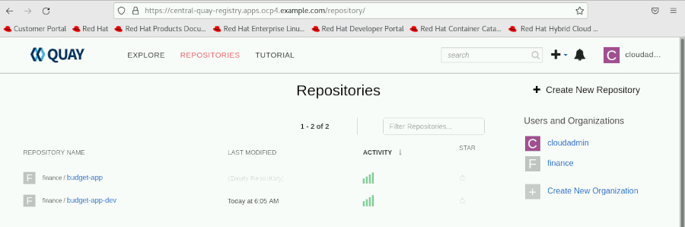

* 1. Click **Robot Accounts**, then click **Create Robot Account**.
  2. Type prod_deployer as the robot account name, leave the description blank, then click **Create robot account**.
  3. On the page that opens, select the **Read** permission over the **budget-app-dev** repository and the **Write** permission over the **budget-app** repository, and then click **Add permissions**.

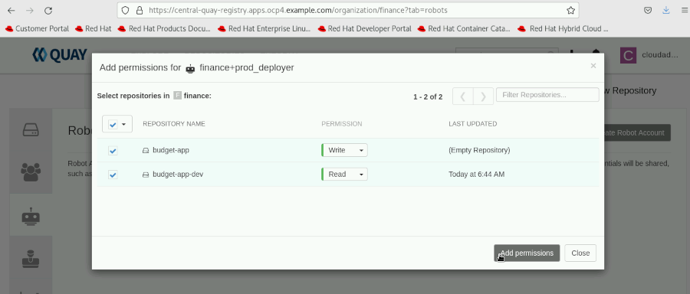

* 1. Click **finance+prod_deployer** to view the credentials for the robot account. Store the token in a /home/student/prod_deployer_token file. This step is necessary so the lab script can use the API to grade your work

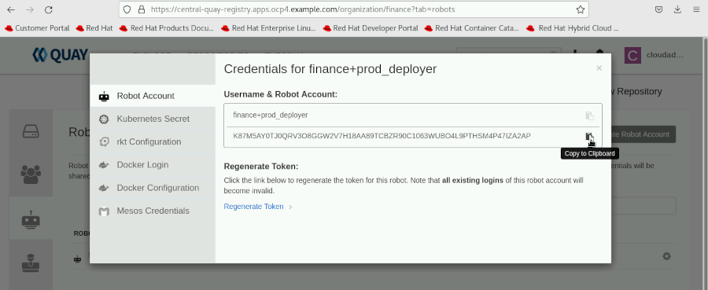

* 1. Click **Kubernetes Secret** to view instructions to use the robot account in Kubernetes.

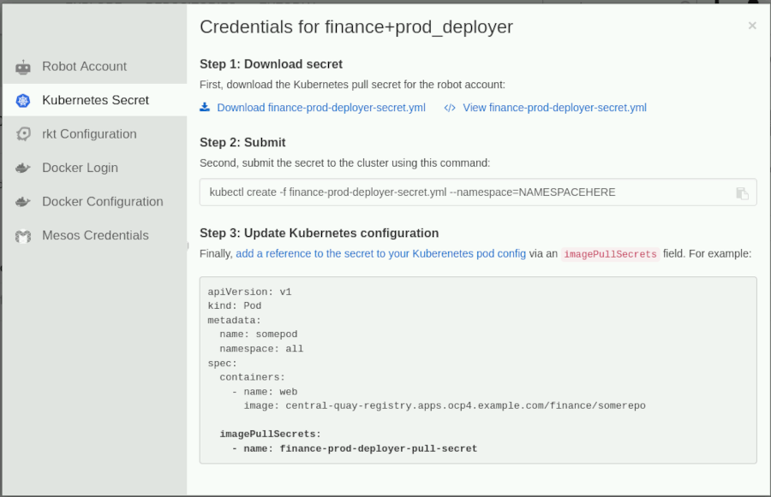

* 1. Click the download icon to download the finance-prod-deployer-secret.yml file.

In the confirmation window, click **Save File** and then click **OK**. The browser downloads the file to the /home/students/Downloads directory.

[Hide Solution](https://rol.redhat.com/rol/app/)

1. Prepare the managed clusters for access to the central Quay registry. Create the budget-app namespace, and the finance-prod-deployer-pull-secret pull secret from the robot account on the production and non-production clusters. The API server address of the non-production cluster is https://api.ocp4.example.com:6443. The API server address of the production cluster is https://api.ocp4-mng.example.com:6443.
   1. Log in to the local-cluster non-production cluster.
   2. [student@workstation quayacm-review]$ **oc login -u admin -p redhat \**
   3. **https://api.ocp4.example.com:6443**
   4. Login successful.

...output omitted...

* 1. Create the budget-app namespace.
  2. [student@workstation quayacm-review]$ **oc create namespace budget-app**

namespace/budget-app-dev created

* 1. Use the oc create command to create the secret in the budget-app namespace.
  2. [student@workstation quayacm-review]$ **oc create -f \**
  3. **~/Downloads/finance-prod-deployer-secret.yml \**
  4. **-n budget-app**

secret/finance-prod-deployer-pull-secret created

* 1. Create the same namespace and pull secret on the managed-cluster production cluster.
  2. [student@workstation quayacm-review]$ **oc login -u admin -p redhat \**
  3. **https://api.ocp4-mng.example.com:6443**
  4. Login successful.

...output omitted...

[student@workstation quayacm-review]$ **oc create namespace budget-app**

namespace/budget-app created

[student@workstation quayacm-review]$ **oc create -f \**

**~/Downloads/finance-prod-deployer-secret.yml \**

**-n budget-app**

secret/finance-prod-deployer-pull-secret created

1. [Hide Solution](https://rol.redhat.com/rol/app/)
2. Fork the do480-apps course GitHub repository at <https://github.com/redhattraining/do480-apps/>. This repository contains starter YAML files to build the application. Modify the deployment to use the central-quay-registry.apps.ocp4.example.com/finance/budget-app-dev:1.0 container image and the pull secret.
   1. From the workstation machine, navigate to the do480-apps repository at <https://github.com/redhattraining/do480-apps/>.
   2. In the upper-right corner of the GitHub repository page, click **Fork**, and then click **Create fork** to create a fork.

### Note

If you have already performed this exercise or made other changes to the fork, then you must delete your fork to avoid problems during this exercise.

To delete the fork, navigate to https://github.com/your-fork-name/DO480-apps/. Click **Settings**. Click **Delete this repository** and enter the name of the repository to confirm the deletion.

* 1. In your GitHub fork, navigate to the deployment. Click **quayacm-review** and then click **deployment.yaml** to access the file. Click the pencil icon to edit the YAML file.
  2. Edit the deployment to match the following content.
  3. ...output omitted...
  4. spec:
  5. containers:
  6. - image: **central-quay-registry.apps.ocp4.example.com/finance/budget-app-dev:1.0**
  7. name: budget-app
  8. ports:
  9. - containerPort: 8080
  10. name: budget-app
  11. **imagePullSecrets:**

**- name: finance-prod-deployer-pull-secret**

### Note

The - image: central…​dev:1.0 statement must be a single line.

Scroll to the bottom of the page and click **Commit changes**.

1. [Hide Solution](https://rol.redhat.com/rol/app/)
2. Deploy the budget-app application to all the OpenShift managed clusters using RHACM. The application fails on production clusters because it is using an image from a forbidden registry.
   1. From the workstation machine, navigate to the RHACM web console at https://multicloud-console.apps.ocp4.example.com.
   2. Click **htpasswd_provider** and log in as the admin user with the redhat password.
   3. On the left navigation bar, navigate to **Applications**, click **Create application**, and then click **Subscription**.
   4. Fill the form with the following values.

| **Field** | **Value** |
| --- | --- |
| **Name** | budget-app |
| **Namespace** | budget-app |
| **Repository types** | **Git** |
| **URL** | <https://github.com/>*your_fork*/DO480-apps.git |
| **Branch** | **main** |
| **Path** | **quayacm-review** |

* 1. Scroll down and expand **Select clusters to deploy to** to configure a placement rule for the application. Select the **Deploy to all online clusters and local cluster** option to create a placement rule that deploys the application to all clusters.
  2. Click **Save**. The application starts to deploy in the local-cluster and managed-cluster clusters.
  3. The console redirects you to the details of the new application. On the **Topology** page, wait about three or four minutes for the deployments to finish. Then, click the Deployment node in the application topology view.

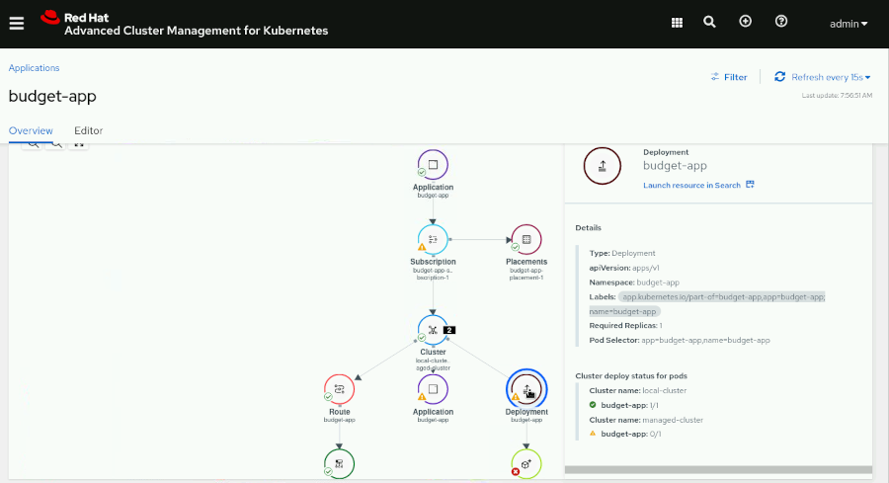

The **Cluster deploy status for pods** table indicates that there is one correct pod belonging to the budget-app deployment in the local-cluster cluster. There is another failing pod in the same deployment, but in the managed-cluster cluster.

* 1. Log in again to the managed-cluster cluster, which is tagged with the env=production label.
  2. [student@workstation quayacm-review]$ **oc login -u admin -p redhat \**
  3. **https://api.ocp4-mng.example.com:6443**
  4. Login successful.

...output omitted...

* 1. Locate the reason of the failing pod by searching the namespace events.
  2. [student@workstation quayacm-review]$ **oc get events -n budget-app | grep Failed**
  3. 10m Warning Failed pod/budget-app-85bbf4585c-sklss Failed to pull image "central-quay-registry.apps.ocp4.example.com/finance/budget-app-dev:1.0": rpc error: code = Unknown desc = Source image rejected: Running image docker://central-quay-registry.apps.ocp4.example.com/finance/budget-app-dev:1.0 is rejected by policy.

...output omitted...

The previous messages indicate that there is a policy that does not allow to use images from the requested source. Note that the message is referring to a policy from the image.config.openshift.io/cluster object, not to the RHACM policy.

1. [Hide Solution](https://rol.redhat.com/rol/app/)
2. Promote the budget-app-dev:1.0 image to the allowed budget-app repository with the production robot account by using the skopeo command. Use the password token you saved in the /home/student/prod_deployer_token file.
   1. Read the prod_deployer token from the /home/student/prod_deployer_token file.
   2. [student@workstation quayacm-review]$ **cat /home/student/prod_deployer_token**

8H711MZKS6LWU0467RXG5P8ZMCLBX1RODR4R1U78UQC662T9X2NOK5WFMRS2AKCQ

* 1. Log in to Quay by using the skopeo command. Use the token from the previous step.
  2. [student@workstation quayacm-review]$ **skopeo login \**
  3. **-u=finance+prod_deployer \**
  4. **-p=*8H711MZKS6LWU0467RXG5P8ZMCLBX1RODR4R1U78UQC662T9X2NOK5WFMRS2AKCQ* \**
  5. **central-quay-registry.apps.ocp4.example.com**
  6. Login Succeeded!

...output omitted...

* 1. Promote the image to the budget-app repository by using the skopeo command.
  2. [student@workstation quayacm-review]$ **skopeo copy \**
  3. **docker://central-quay-registry.apps.ocp4.example.com/finance/budget-app-dev:1.0 \**
  4. **docker://central-quay-registry.apps.ocp4.example.com/finance/budget-app:production**
  5. ...output omitted...

Storing signatures

### Note

The docker://…​dev:1.0 and docker://…​app:production statements must each be on a single line.

1. [Hide Solution](https://rol.redhat.com/rol/app/)
2. Modify the budget-app application in your GitHub account to use the central-quay-registry.apps.ocp4.example.com/finance/budget-app:production image.
   1. In your GitHub fork, navigate to the deployment. Click **quayacm-review** and then click **deployment.yaml** to access the file. Click the pencil icon to edit the YAML file.
   2. Edit the deployment to match the following content.
   3. ...output omitted...
   4. spec:
   5. containers:
   6. - image: **central-quay-registry.apps.ocp4.example.com/finance/budget-app:production**
   7. name: budget-app
   8. ports:
   9. - containerPort: 8080
   10. name: budget-app
   11. imagePullSecrets:

- name: finance-prod-deployer-pull-secret

### Note

The - image: central…​app:production statement must be a single line.

Scroll to the bottom of the page and then click **Commit changes**.

* 1. In the RHACM console, click **Applications**, and then click **budget-app**. Click **Sync** to update the application with the last commit in the repository.

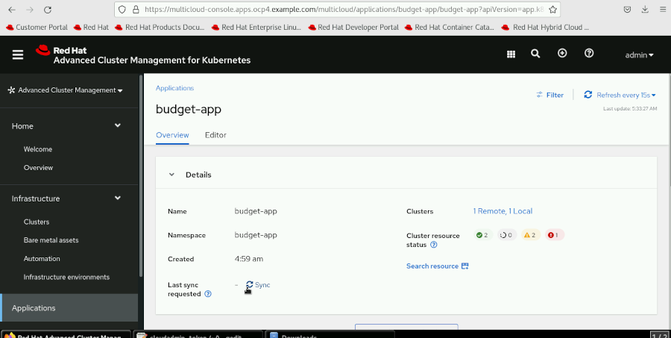

* 1. After three or four minutes, test that the deployment in the production cluster is ready.
  2. [student@workstation quayacm-review]$ **oc get pods -n budget-app**
  3. NAME READY STATUS RESTARTS AGE

budget-app-64b4f9d44c-lrgfj 1/1 Running 0 2m

* 1. Change to the /home/student directory.

[student@workstation quayacm-review]$ **cd ~**

1. [Hide Solution](https://rol.redhat.com/rol/app/)

**Evaluation**

As the student user on the workstation machine, use the lab command to grade your work. Correct any reported failures and rerun the command until successful.

[student@workstation ~]$ **lab grade quayacm-review**

**Finish**

On the workstation machine, change to the student user home directory and use the lab command to complete this exercise. This step is important to ensure that resources from previous exercises do not impact upcoming exercises.

[student@workstation ~]$ **lab finish quayacm-review**

This concludes the section

# **Chapter 8.  Installing and Configuring RHACS**

[Security Considerations in Kubernetes Multicluster Environments](https://rol.redhat.com/rol/app/courses/do480-2.4/pages/ch08)

[Quiz: Security Considerations in Kubernetes Multicluster Environments](https://rol.redhat.com/rol/app/courses/do480-2.4/pages/ch08s02)

[Installing and Configuring RHACS](https://rol.redhat.com/rol/app/courses/do480-2.4/pages/ch08s03)

[Guided Exercise: Installing and Configuring RHACS](https://rol.redhat.com/rol/app/courses/do480-2.4/pages/ch08s04)

[Importing Managed Clusters into RHACS](https://rol.redhat.com/rol/app/courses/do480-2.4/pages/ch08s05)

[Guided Exercise: Importing Managed Clusters into RHACS](https://rol.redhat.com/rol/app/courses/do480-2.4/pages/ch08s06)

[Quiz: Installing and Configuring RHACS](https://rol.redhat.com/rol/app/courses/do480-2.4/pages/ch08s07)

[Summary](https://rol.redhat.com/rol/app/courses/do480-2.4/pages/ch08s08)

**Abstract**

|  |  |
| --- | --- |
| **Goal** | Install and configure Red Hat Advanced Cluster Security for Kubernetes (RHACS) and learn how it can help organizations with security in multicluster environments. |
| **Objectives** | * Identify security concerns in Kubernetes multicluster environments and potential fixes offered by Red Hat Advanced Cluster Security for Kubernetes (RHACS). * Install and configure Red Hat Advanced Cluster Security for Kubernetes (RHACS) and become familiar with the RHACS architecture, installation methods, and available customizations. * Import managed clusters into Red Hat Advanced Cluster Security for Kubernetes (RHACS) and retrieve basic security information from the cluster fleet using the RHACS console. |
| **Sections** | * Security Considerations in Kubernetes Multicluster Environments (and Quiz) * Installing and Configuring RHACS (and Guided Exercise) * Importing Managed Clusters into RHACS (and Guided Exercise) (and Quiz) |

## **Security Considerations in Kubernetes Multicluster Environments**

### **Objectives**

* Identify security concerns in Kubernetes multicluster environments and potential fixes offered by Red Hat Advanced Cluster Security for Kubernetes (RHACS).

### **Security Considerations in Kubernetes**

As companies continue adopting cloud-native application models, more critical workloads run in Kubernetes.

Additionally, teams developing cloud-native applications can use a DevOps approach, where the development and operations teams work together following agile principles. By adopting this DevOps model, companies can release new versions of their applications more often.

The combination of using a DevOps approach and the use of containerized applications has security advantages due to the isolation of the processes, but requires a different approach. Development and operations teams who are not familiar with cloud-native application models might not be familiar with Kubernetes security and the security of the platform where the applications are deployed.

To improve aspects of security in a DevOps scenario, the DevSecOps model focuses on integrating the security from the early stages of the software development lifecycle.

A DevSecOps model must include software development security, such as the following considerations:

* Security in the design phase
* Static secure code analysis and best practices
* Container image vulnerability scanning before deploying to production
* Secure access to version control systems (VCS)
* Secure access to the continuous integration system (CI)
* Automatic build security testing
* Defensive security, or implementing a Blue Team approach

Additionally, the model must include operational security, such as the following considerations:

* Continuous container image vulnerability scanning for deployments in production
* Secure access to the continuous deployment system (CD)
* Automatic security testing of production deployments
* Offensive security by implementing a Red Team
* Dynamic security code analysis during run time
* Incident response planning

The previous security considerations apply to every software development company. However, there are some extra security challenges in Kubernetes environments:

* You need extra knowledge to set up users, groups, service accounts, and the role-based access control (RBAC) configuration.
* You must secure the VCS repositories containing the platform configuration.
* You must ensure that container image sources are reliable.
* You need expertise in software defined networks (SDN).
* You must secure many new attack vectors, such as container image vulnerabilities, application vulnerabilities, Kubernetes secrets management, and more.

Although IT professionals are increasingly familiar with Kubernetes, security remains one of the main challenges for adopting and running containerized applications in production Kubernetes clusters.

### **Addressing Security in Kubernetes with RHACS**

Red Hat Advanced Cluster Security for Kubernetes (RHACS) simplifies most of the challenges discussed in the preceding paragraphs.

RHACS features integrate with DevSecOps models to protect the application workloads and the Kubernetes infrastructure. RHACS has many available features, such as the following considerations:

* Vulnerability management
* Configuration management
* Risk profiling
* Threat detection
* Incident response
* Compliance analysis and reporting
* Network traffic segmentation
* Muliticluster status visibility

#### **Vulnerability Management with RHACS**

The RHACS vulnerability management scanner decomposes container images by layers and identifies the software components, whether installed by a package manager or as a programming software dependency.

The RHACS vulnerability scanner provides considerable vulnerability information, but it can be integrated with third-party scanners to take advantage of potential new features.

RHACS can use the vulnerability scanner results to control which images are used by enforcing policies based on the common vulnerability scoring system (CVSS) calculated score.

You can access the vulnerability management dashboard from the **Vulnerability Management** → **Dashboard** menu. The dashboard provides the following vulnerability information:

* Top risky deployments by CVE count and CVSS score
* Top riskiest images by CVEs
* Frequently violated policies
* Recently detected vulnerabilities
* Most common vulnerabilities
* Deployments with most severe policy violations
* Vulnerabilities by cluster, namespace, deployment, or component
* Vulnerabilities in the OS of the nodes
* Fixable and non-fixable CVEs
* Base OS image layer
* Inactive images vulnerabilities

The RHACS **Vulnerability Management** menu also includes the **Risk Acceptance** and **Reporting** pages.

You can review the alerts on the **Risk Acceptance** page. If the alert is a false positive, the security risk is low, or the vulnerability is not exploitable, then you can dismiss the alert.

On the **Reporting** page, you can create automated custom reports and send them to a list of recipients.

#### **Configuration Management with RHACS**

To build a secure Kubernetes deployment and avoid security breaches, administrators must know Kubernetes concepts such as secrets, service accounts, and RBAC.

RHACS automatically analyzes RBAC configurations to identify users, groups, and service accounts with elevated privileges. RHACS also monitors the RBAC settings for overly permissive access to secrets, access from deployments to the Kubernetes API server, and secrets passed in as environment variables.

RHACS protects against potentially insecure misconfigurations by creating policies that determine whether privileged containers are allowed to run. These policies limit the resources that can mount a path on the host and their file system permissions and monitor RBAC settings.

The RHACS **Configuration Management** page provides access to the following dashboards:

* Policy violations by severity
* Center for Internet Security (CIS) Docker and Kubernetes scan results
* Those users with the most cluster administrator roles
* Secrets most used across deployments

The RHACS dashboard provides a dedicated via to the following features:

* RHACS policies
* CIS controls
* Application and infrastructure elements such as clusters, namespaces, nodes, deployments, images, and secrets
* RBAC visibility and configuration, including users and groups, service accounts, and roles

#### **Risk Profiling with RHACS**

Risk profiling means determining if a risk is acceptable or not. To make this determination, you must correlate vulnerabilities, their severity, how easy it might be to exploit the vulnerability, whether the service is exposed, and others.

On the **Risk** page, RHACS scores and sorts all deployments across all clusters considering many factors. This risk profile helps you decide which deployments require immediate attention.

#### **Threat Detection with RHACS**

RHACS implements predictive and threat-based protection for running containers. With predictive protection, RHACS identifies abnormal process executions or network connections. With threat-based protection, RHACS detects suspicious processes such as netcat or nmap processes.

With RHACS, you can create policies to detect suspicious runtime behaviors. You can configure policies to trigger violations and alerts or perform enforcing actions automatically.

RHACS analyzes all the processes running in containers and creates process baselines for every container type in a deployment. New processes that differ from these baselines are considered a risk but do not produce violations automatically.

You can manage container process baselines from the **Risk** page. Click on a deployment, and then click the **Process Discovery** tab. Violations are displayed on the **Violations** page.

After confirming that the process baselines follow expected behavior, you can lock the process baseline so that RHACS triggers a violation event if it detects an abnormal process.

#### **Incident Response with RHACS**

Incident response is how administrators react to security events. In a containerized environment, incidents are typically resolved by removing the container with anomalous behavior as soon as the incident is detected.

RHACS provides details about malicious processes and network activity for post-mortem analysis. You can export these details to centralized Security Information and Event Management (SIEM) systems, such as Splunk or Sumo Logic, and notifier systems, such as Slack, email, Pagerduty, Jira, and others.

In addition to collecting and exporting this data, you can create policies to prevent risky deployments automatically and respond to runtime security incidents.

RHACS logs security incidents and displays them on the **Violations** page.

#### **Compliance Analysis and Report with RHACS**

Compliance standards are security guidelines for configuring systems. At the time of publication, RHACS offers compliance analysis using six different standards:

* [CIS Docker](https://www.cisecurity.org/benchmark/docker)
* [CIS Kubernetes](https://www.cisecurity.org/benchmark/kubernetes)
* [HIPAA](https://www.hhs.gov/hipaa/for-professionals/security/guidance/cybersecurity/index.html)
* [PCI DSS](https://www.pcisecuritystandards.org/)
* [NIST 800-190](https://csrc.nist.gov/publications/detail/sp/800-190/final)
* [NIST 800-53](https://csrc.nist.gov/publications/detail/sp/800-53/rev-5/final)

From the **Compliance** page, you can run compliance scans and export detailed compliance reports.

RHACS provides detailed information about each compliance report control and guidance about how to make the system compliant.

#### **Network Traffic Segmentation with RHACS**

In Kubernetes, network policies implement network traffic segmentation. Network traffic segmentation allows isolating applications from each other and limiting network traffic to known sources and destinations. This segmentation prevents incoming attacks, lateral movement between applications, and data breaches.

From the **Network Graph** page, access the **Network Policy Simulator**. In the network policy simulator, RHACS generates suggested policies based on the observed network flows. You can apply network policies and analyze the behavior of the network traffic before applying the changes to the network policies in a production environment. The network policy simulator also provides diagrams with live traffic flows to evaluate the implementation of network policies.

#### **Muliticluster Status Visibility with RHACS**

In a multicluster environment, security operators need visibility into the applications and configurations in the cluster fleet. RHACS provides visibility for security operators with the following centralized views:

* Risk prioritization
* Runtime activity and forensics
* Vulnerability threats
* Configuration risk
* Deployment and Kubernetes metadata
* Global search capabilities
* SIEM notifications
* SSO and scoped access controls

### References

For more information, refer to the Red Hat Advanced Cluster Security for Kubernetes Documentation at <https://docs.openshift.com/acs/3.69/welcome/index.html>

[Operationalize Red Hat Advanced Cluster Security for Kubernetes](https://redhat.highspot.com/items/6180359dc4121d1a49ae2e5f#1)

[Most common Kubernetes security issues and concerns to address](https://cloud.redhat.com/blog/most-common-kubernetes-security-issues-and-concerns-to-address)

[Kubernetes adoption, security, and market trends report 2021](https://www.redhat.com/en/resources/kubernetes-adoption-security-market-trends-2021-overview)

## **Installing and Configuring RHACS**

### **Objectives**

* Install and configure Red Hat Advanced Cluster Security for Kubernetes (RHACS) and become familiar with the RHACS architecture, installation methods, and available customizations.

### **RHACS Components**

Red Hat Advanced Cluster Security for Kubernetes (RHACS) is composed of centralized services and secured cluster services. Centralized services run on a specific cluster and receive data from multiple secured cluster services. Secured cluster services require a small amount of resources compared to centralized services. Because RHACS uses this distributed architecture model, it supports large scale deployments that minimize impacts to the underlying infrastructure.

#### **RHACS Centralized Services**

The RHACS centralized services run on a single cluster and include two main components, Central and Scanner.

**Central**

Central is the RHACS component that provides centralized services and the application management interface.

Central handles data persistence, API interactions, and user interface access. You can secure multiple Red Hat OpenShift or Kubernetes clusters with a single Central instance.

**Scanner**

Scanner is a Red Hat developed vulnerability scanner. This service analyzes all the layers of the container images to find known Common Vulnerabilities and Exposures (CVEs). Scanner also identifies vulnerabilities in packages installed by package managers, language-level dependencies, and application-level dependencies.

To create all the elements of the RHACS centralized services, you must create a Central Kubernetes custom resource (CR). The RHACS operator defines this resource.

By default, RHACS installs a lightweight version of Scanner on each secured cluster to analyze the images in the integrated container registry.

If you do not want to install the lightweight Scanner version on the secured clusters, then you can change this setting when you create the Central CR.

#### **RHACS Secured Cluster Services**

The RHACS secured cluster services run on each cluster secured by RHACS and include Sensor, Collector, Scanner, and Admission Controller.

**Sensor**

Sensor analyzes and monitors the cluster. This service interacts with the OpenShift or Kubernetes API server for policy detection and enforcement. Sensor coordinates with Collector.

**Collector**

Collector analyzes and monitors container activity on the nodes. This service collects information about network activity and the container runtime and sends the data to Sensor.

**Scanner**

Scanner, if installed, analyzes container images from the integrated container registry.

**Admission Controller**

This service prevents the creation of workloads that violate RHACS security policies.

To create all of the elements of the RHACS secured cluster services, you must create a SecuredCluster Kubernetes CR. The RHACS operator defines this resource.

### **RHACS Architecture**

The following example diagram shows a multicluster RHACS deployment and its components:

|  |
| --- |
|  |

The Central service only runs in the hub cluster.

The Scanner service runs in the hub cluster; optionally, Scanner can run in the secured clusters to enable scanning of images in the integrated container registry.

The Sensor, Collector, and Admission Controller services run on each cluster secured by RHACS.

In the preceding diagram, the hub cluster is also a secured cluster.

### **Installing RHACS**

To install RHACS, you must satisfy the following general prerequisites:

* Red Hat OpenShift version 4.5 or later
* Cluster nodes with a supported operating system, such as Amazon Linux, CentOS, Container-Optimized OS from Google, Red Hat Enterprise Linux CoreOS, Debian, Red Hat Enterprise Linux, or Ubuntu
* At least 4 CPU cores and at least 3 GiB of RAM for the node running the centralized services
* At least 2 CPU cores and at least 3 GiB of RAM for nodes running the secured cluster services
* Persistent block storage; Rados Block Device (RBD) storage is recommended
* Permissions to configure deployments in the OpenShift or Kubernetes clusters
* Access to the Red Hat Container Registry at registry.redhat.io

RHACS requires communication with external entities such as image registries, CI/CD pipelines, SIEM systems, and the stackrox.io servers. The following diagram represents the prerequisites for network communication between RHACS internal and external services:

|  |
| --- |
|  |

To run Central, you must satisfy the following specific prerequisites:

* Allow outbound network traffic to definitions.stackrox.io and collector-modules.stackrox.io
* At least 1.5 CPU cores
* At least 4 GiB of RAM
* At least 100 GiB of storage

To run Scanner, your cluster must have the following available resources:

* At least 1 CPU core
* At least 1.5 GiB of RAM
* At least 30 GiB of storage

### Note

The resource requirements above are per replica. Red Hat recommends running two replicas of Scanner.

To run the Scanner database, your cluster must have the following available resources:

* At least 0.2 CPU cores
* At least 200 MiB of RAM

### Note

The Scanner database requires variable amounts of available persistent storage.

To run Sensor, your cluster must have the following available resources:

* At least 1 CPU core
* At least 1 GiB of RAM

To run Admission Controller, your cluster must have the following available resources:

* At least 0.05 CPU cores
* At least 100 MiB of RAM

### Note

The resource requirements above are per replica. The Admission Controller runs three replicas.

You can install RHACS using the Advanced Cluster Security for Kubernetes operator, Helm charts, or the roxctl command. Red Hat recommends using the Advanced Cluster Security for Kubernetes operator if available in the supporting infrastructure.

Also, you can install RHACS using Red Hat Advanced Cluster Management for Kubernetes (RHACM) policies. The RHACM policy for installing RHACS uses the Advanced Cluster Security for Kubernetes operator.

See the references section for a list of installation methods for different platforms.

#### **Installing RHACS with the Advanced Cluster Security for Kubernetes Operator**

You can install the Advanced Cluster Security for Kubernetes operator from OperatorHub or by using the oc command. See the references section for instructions on how to install an operator using the oc command.

After you install the operator, install the centralized services in the hub cluster by creating the Central CR. You can create a Central CR from the **Installed Operators** page in the OpenShift web console, or using a YAML file.

Red Hat recommends installing the Central CR in the stackrox namespace for compatibility with pre-existing RHACS policies.

The following example shows a Central CR definition YAML file.

apiVersion: platform.stackrox.io/v1alpha1

kind: Central

metadata:

name: stackrox-central-services

namespace: stackrox

spec:

central:

exposure:

loadBalancer:

enabled: false

port: 443

nodePort:

enabled: false

route:

enabled: true

persistence:

persistentVolumeClaim:

claimName: stackrox-db

egress:

connectivityPolicy: Online

scanner:

analyzer:

scaling:

autoScaling: Enabled

maxReplicas: 5

minReplicas: 2

replicas: 3

scannerComponent: Enabled

You can configure settings for Central, Scanner, and other services when you create the Central CR. For a complete list of Central configuration options, refer to the following [link](https://docs.openshift.com/acs/3.69/installing/install-ocp-operator.html#central-configuration-options-operator_install-ocp-operator).

#### **Installing RHACS Using Helm Charts**

In platforms where the operator installation model is not available, Red Hat recommends installing RHACS by using Helm charts.

To install RHACS by using Helm charts, use the Helm CLI v3.2 or later. The Helm charts for installing RHACS are hosted at the following URL: <https://mirror.openshift.com/pub/rhacs/charts/>.

The RHACS Helm repository contains two charts. Use the central-services chart for installing the centralized components. Use the secured-cluster-services chart for installing the per-cluster components such as Sensor and Admission Controller, and the per-node components, such as Collector.

Before installing the secured cluster services, you must generate the init bundle and import the Central certificates in all the secured clusters.

You can generate the init bundle from the RHACS web console.

Alternatively, you can generate an API token from the RHACS web console and generate the bundle by using the roxctl command. This approach is useful for automating the addition of secured clusters from the command line.

For more information about generating API tokens from the RHACS web console, visit the following [link](https://docs.openshift.com/acs/3.69/cli/getting-started-cli.html#cli-authentication_cli-getting-started).

For more information about installing RHACS by using Helm charts, visit the following [link](https://docs.openshift.com/acs/3.69/installing/installing_helm/install-helm-quick.html)

#### **Installing RHACS Using the Command Line**

Red Hat recommends installing RHACS by using the roxctl command only if no other method is compatible with your environment.

For detailed steps to install RHACS by using the roxctl command, visit the following [link](https://docs.openshift.com/acs/3.69/installing/install-quick-roxctl.html).

#### **Installing RHACS Using RHACM Policies**

When RHACM is available, you can create RHACM policies to deploy RHACS in the cluster fleet. This approach ensures that every cluster in the fleet is secured by RHACS.

To deploy RHACS, you must create two policies in RHACM, one for the centralized services and another for the secured cluster services. The policy for installing the centralized services should apply to the hub cluster. The policy for installing the secured cluster services should apply to the clusters that you want RHACS to secure. You can achieve this separation by using a the clusterSelector parameter of the PlacementRule object. You can find more information about how to create policies with placement rules in [the section called “RHACM Policy Overview”](https://rol.redhat.com/rol/app/courses/do480-2.4/pages/ch03).

You can find example YAML files to create an RHACM policy to install the centralized services at the following [link](https://github.com/stolostron/policy-collection/blob/main/community/CM-Configuration-Management/policy-acs-operator-central.yaml).

You can find example YAML files to create an RHACM policy to install the secured cluster services at the following [link](https://github.com/stolostron/policy-collection/blob/main/community/CM-Configuration-Management/policy-acs-operator-secured-clusters.yaml).

Before installing the secured cluster services, you must generate the init bundle and import the Central certificates in all the secured clusters.

### **Uninstalling RHACS**

If you installed RHACS on Kubernetes, use the kubectl command instead of the oc command.

Security context constraints (SCCs) are an OpenShift feature, so the oc delete scc command does not apply to Kubernetes clusters.

The following steps uninstall RHACS:

1. Delete the rhacs-operator namespace
2. Delete the namespace where you installed the Central and SecuredCluster resources, if different from stackrox

If you installed RHACS on Red Hat OpenShift, run the following commands:

[user@demo ~]$ **oc get clusterrole,clusterrolebinding,role,rolebinding,psp \**

**-o name | grep stackrox | xargs oc delete --wait**

[user@demo ~]$ **oc delete scc -l "app.kubernetes.io/name=stackrox"**

[user@demo ~]$ **oc delete ValidatingWebhookConfiguration stackrox**

[user@demo ~]$ **for namespace in \**

**$(oc get ns | tail -n +2 | awk '{print $1}');\**

**do oc label namespace $namespace namespace.metadata.stackrox.io/id-; \**

**oc label namespace $namespace namespace.metadata.stackrox.io/name-; \**

**oc annotate namespace $namespace modified-by.stackrox.io/namespace-lab**

If you installed RHACS on Kubernetes, run the following commands:

[user@demo ~]$ **kubectl get clusterrole,clusterrolebinding,role,rolebinding,psp \**

**-o name | grep stackrox | xargs kubectl delete --wait**

[user@demo ~]$ **kubectl delete ValidatingWebhookConfiguration stackrox**

[user@demo ~]$ **for namespace in $(kubectl get ns | tail -n +2 | awk '{print $1}');\**

**do kubectl label namespace $namespace namespace.metadata.stackrox.io/id-; \**

**kubectl label namespace $namespace namespace.metadata.stackrox.io/name-; \**

**kubectl annotate namespace $namespace modified-by.stackrox.io/namespace-lab**

If you installed RHACS by using RHACM policies, remember that deleting the policy does not remove the Advanced Cluster Security for Kubernetes operator. You must follow the preceding steps in each cluster to uninstall RHACS.

### **RHACS Settings**

After installing RHACS, you can apply a number of configurations depending on your needs. These configurations are described in the following list.

**Add trusted Certificate Authorities (CAs)**

If you are using an enterprise CA or self-signed certificates, then you can add the root certificate of your trusted CA to RHACS. You can also add the root certificate of the CA of an image registry.

**Add custom TLS certificates**

If the TLS certificate is trusted by any of the CAs configured in RHACS, users and API clients connecting to Central do not have to bypass the untrusted certificate warnings. You can add a custom TLS certificate during the installation or on an existing RHACS deployment.

**Add security notices**

Security notices are messages that users see when they log in to RHACS. You can set up organization-wide security notices that appear on the RHACS web console.

**Enable offline mode**

You can enable the RHACS offline mode in disconnected clusters.

To install the Advanced Cluster Security for Kubernetes operator in disconnected environments, mirror the OperatorHub content into a local registry as explained in the [documentation](https://access.redhat.com/documentation/en-us/openshift_container_platform/4.10/html-single/operators/index#olm-restricted-networks).

If you are using the Helm installation method, then import the images into your corporate registry by downloading the individual images from the Red{nsbp}Hat registry.

In offline mode, you can download Scanner definitions and kernel support packages from the StackRox Community site and upload them to Central and Scanner by using the roxtcl command.

**Configure alert data retention**

To save storage costs, you con configure RHACS to automatically delete past alerts. When configured, RHACS deletes the alerts after a specified period of time.

**Expose the RHACS portal over HTTP**

You can configure the RHACS portal to be exposed through an unencrypted HTTP server. This is useful for compatibility with ingress controllers, layer 7 load balancers, Istio, and others.

**Configure automatic upgrades for secured clusters**

You can configure RHACS to automatically upgrade the secured clusters after updating the central services. This approach is useful for saving time upgrading RHACS in all the secured clusters and avoiding version mismatches. You can only use automatic upgrades if you installed RHACS by using the Advanced Cluster Security for Kubernetes operator.

**Configure a proxy for external access**

You can configure RHACS to use a proxy if your network configuration restricts outbound traffic through proxies. Traffic between Central and Scanner, or other internal components, does not go through the proxy.

**Configure endpoints**

You can create a configuration map to configure the RHACS exposed endpoints. With this configuration map, you can specify the protocols to use, change the default ports, specify the server certificates, configure a trusted CA, or specify if mutual TLS authentication is required.

**Enable Prometheus monitoring**

You can configure the Sensor and Central services to expose metrics to Prometheus. You must create a network policy to allow ingress traffic to the exposed services.

Additionally, you can perform the following administrative tasks:

**Reissue internal certificates**

Each component of RHACS uses an X.509 certificate to authenticate to other components. When the certificates are close to the expiration date, you must reissue them.

**Generate a diagnostic bundle**

Red Hat support might request a diagnostic bundle for investigating issues in your RHACS installation. The diagnostic bundle contains the Central heap memory profile, RHACS system logs, YAML definitions for your RHACS components, the events from the namespace where RHACS runs, API endpoint statistics, information about the nodes, and general information about the product versions in your environment.

For more information about the available RHACS configurations, visit the following [link](https://docs.openshift.com/acs/3.69/welcome/index.html#configuring-red-hat-advanced-cluster-security-for-kubernetes).

### References

For more information, refer to the Red Hat Advanced Cluster Security for Kubernetes Product Architecture Documentation at <https://docs.openshift.com/acs/3.69/architecture/acs-architecture.html>

For more information about the installation platforms and methods, visit <https://docs.openshift.com/acs/3.69/installing/acs-installation-platforms.html>

For more information about RHACS installation prerequisites, visit <https://docs.openshift.com/acs/3.69/installing/prerequisites.html>

For more information about installing operators using the command line, refer to the Installing from OperatorHub using the CLI section in the Administrator tasks chapter in the Operators guide at <https://access.redhat.com/documentation/en-us/openshift_container_platform/4.10/html-single/operators/index#olm-installing-operator-from-operatorhub-using-cli_olm-adding-operators-to-a-cluster>

For more information about installation methods for different platforms, refer to the Installation platforms and methods chapter in the Installing guide at <https://access.redhat.com/documentation/en-us/red_hat_advanced_cluster_security_for_kubernetes/3.69/html-single/installing/index#installation-platforms>

## **Guided Exercise: Installing and Configuring RHACS**

* Install Red Hat Advanced Cluster Security for Kubernetes (RHACS) using an Red Hat Advanced Cluster Management for Kubernetes (RHACM) policy. You also configure RHACS to use Red Hat OpenShift Container Platform (RHOCP) authentication, enable audit logging, and verify that the configuration is correct.

**Outcomes**

* Install the RHACS Operator using an RHACM policy.
* Install the RHACS Central using an RHACM policy.
* Configure the Rsyslog server using the RHACS Syslog integration.
* Configure the RHOCP Oauth server as an identity provider for RHACS.
* Verify that you can log in to RHACS using credentials from the Red Hat OpenShift ocp4 cluster.
* Verify that the audit logging configuration works as expected.

As the student user on the workstation machine, use the lab command to prepare your system for this exercise.

[student@workstation ~]$ **lab start rhacs-install**

1. Log in to the ocp4 cluster as the admin user and create a rhacs-install project.
   1. Open a terminal and log in to the ocp4 cluster as the admin user with the redhat password. The API server address is https://api.ocp4.example.com:6443.

[student@workstation ~]$ **oc login -u admin -p redhat \**

**https://api.ocp4.example.com:6443**

Login successful.

...output omitted...

* 1. Create the rhacs-install project.

[student@workstation ~]$ **oc new-project rhacs-install**

Now using project "rhacs-install" on server "https://api.ocp4.example.com:6443".

...output omitted...

1. Deploy an RHACM policy named policy-advanced-cluster-security-install in the rhacs-install namespace. This policy installs the RHACS operator in the rhacs-operator namespace in the ocp4 cluster. The ocp4 cluster is named local-cluster in RHACM.
   1. Change to the ~/DO480/labs/rhacs-install/ directory.

[student@workstation ~]$ **cd ~/DO480/labs/rhacs-install/**

[student@workstation rhacs-install]$

* 1. Review the file named policy-rhacs-operator-install.yaml that contains an RHACM policy definition to install RHACS.

[student@workstation rhacs-install]$ **cat policy-rhacs-operator-install.yaml**

...output omitted...

spec:

remediationAction: **enforce**

...output omitted...

object-templates:

- complianceType: musthave

objectDefinition:

apiVersion: v1

kind: **Namespace**

metadata:

name: **rhacs-operator**

- complianceType: musthave

objectDefinition:

apiVersion: v1

kind: **Namespace**

metadata:

name: **stackrox**

...output omitted...

object-templates:

- complianceType: musthave

objectDefinition:

apiVersion: operators.coreos.com/v1

kind: **OperatorGroup**

metadata:

name: rhacs-operator

namespace: rhacs-operator

...output omitted...

object-templates:

- complianceType: musthave

objectDefinition:

apiVersion: operators.coreos.com/v1alpha1

kind: **Subscription**

metadata:

name: **rhacs-operator**

namespace: rhacs-operator

spec:

channel: latest

installPlanApproval: Automatic

name: rhacs-operator

source: do480-catalog

sourceNamespace: openshift-marketplace

...output omitted...

clusterSelector:

matchExpressions:

- {key: **local-cluster**, operator: In, values: [**"true"**]}

The policy creates the rhacs-operator namespace to install the RHACS operator, the stackrox namespace to install the Central resource, and installs the RHACS operator in the local-cluster cluster.

* 1. Use the oc command to create the policy-advanced-cluster-security-install policy in the rhacs-install namespace.

[student@workstation rhacs-install]$ **oc create -f \**

**policy-rhacs-operator-install.yaml -n rhacs-install**

policy.policy.open-cluster-management.io/policy-advanced-cluster-security-install created

placementbinding.policy.open-cluster-management.io/binding-policy-advanced-cluster-security-install created

placementrule.apps.open-cluster-management.io/placement-policy-advanced-cluster-security-install created

* 1. From the workstation machine, open Firefox and navigate to the RHACM web console. The URL is https://multicloud-console.apps.ocp4.example.com.
  2. Click **htpasswd_provider** and log in as the admin user with the redhat password.
  3. In the left pane, click **Governance**. The dashboard shows the policy-advanced-cluster-security-install policy. Click **policy-advanced-cluster-security-install** and then click **Clusters** to check the status.
  4. Verify that the **Clusters** tab shows three templates: advanced-cluster-security-namespace, rhacs-operator-operator-group, and advanced-cluster-security-operator-subscription.

|  |
| --- |
|  |

### Note

* 1. It takes 2-3 minutes for all three templates to show the Compliant status.

1. As the admin user, verify the RHACS operator installation by using the RHACM web console.
   1. Click the search icon at the upper-right corner of the RHACM web console.
   2. Type the following parameters in the search bar to search for the rhacs-operator subscription.

| **Field name** | **Value** |
| --- | --- |
| kind | subscription |
| name | rhacs-operator |

* 1. The search result shows the rhacs-operator subscription present in the local-cluster.

|  |
| --- |
|  |

1. Deploy an RHACM policy named policy-rhacs-operator-central in the rhacs-install namespace. This policy installs the RHACS Central instance in the stackrox namespace in the ocp4. The ocp4 cluster is named local-cluster in RHACM.
   1. Review the file named policy-rhacs-operator-central.yaml with the definition of a RHACM policy to install RHACS Central.

[student@workstation rhacs-install]$ **cat policy-rhacs-operator-central.yaml**

...output omitted...

spec:

remediationAction: **enforce**

...output omitted...

object-templates:

- complianceType: musthave

objectDefinition:

apiVersion: v1

kind: **Namespace**

metadata:

name: **stackrox**

...output omitted...

object-templates:

- complianceType: musthave

objectDefinition:

apiVersion: platform.stackrox.io/v1alpha1

kind: **Central**

metadata:

namespace: stackrox

name: **stackrox-central-services**

spec:

...output omitted...

clusterSelector:

matchExpressions:

- {key: **local-cluster**, operator: In, values: [**"true"**]}

The policy ensures that the stackrox namespace exists in the local-cluster. It also creates the RHACS Central resource in the stackrox namespace.

* 1. Use the oc command to create the policy-advanced-cluster-security-central policy in the rhacs-install namespace.

[student@workstation rhacs-install]$ **oc create -f \**

**policy-rhacs-operator-central.yaml -n rhacs-install**

policy.policy.open-cluster-management.io/policy-advanced-cluster-security-central created

placementbinding.policy.open-cluster-management.io/binding-policy-advanced-cluster-security-central created

placementrule.apps.open-cluster-management.io/placement-policy-advanced-cluster-security-central created

* 1. In the left pane of the RHACM web console, click **Governance**. The dashboard shows the policy-advanced-cluster-security-central policy. Click **policy-advanced-cluster-security-central** and then click **Clusters** to check the status.
  2. Verify that the clusters tab shows the rhacs-central-namespace and advanced-cluster-security-central templates.

|  |
| --- |
|  |

### Note

* 1. It takes 2-3 minutes for templates to show the Compliant status.

1. As the admin user, log in to the RHACS central dashboard.
   1. From the workstation machine, open Firefox and access https://console-openshift-console.apps.ocp4.example.com.
   2. Click **htpasswd_provider** and log in as the admin user with the redhat password.
   3. Navigate to **Home** → **Projects** to display the **Projects** page, and then click **stackrox** to select the stackrox namespace.
   4. Navigate to **Operators** → **Installed Operators** to display installed operators, and then click **Central** to display the **Central** page.

|  |
| --- |
|  |

* 1. Click **stackrox-central-services** to display **stackrox-central-services** page. Copy the command from the **Admin Credentials Info** section to retrieve the default password for the admin user.

|  |
| --- |
|  |

* 1. Retrieve the default password for the admin user from the command line.

[student@workstation rhacs-install]$ **oc -n stackrox get secret central-htpasswd \**

**-o go-template='{{index .data "password" | base64decode}}'**

WcRPchXqaP6KAoLbyCSTr9v9d

* 1. Run the oc get route command to retrieve the URL of the RHACS web console.

[student@workstation rhacs-install]$ **oc get route -n stackrox**

NAME HOST/PORT PATH SERVICES PORT TERMINATION WILDCARD

central **central-stackrox.apps.ocp4.example.com** central https passthrough None

...output omitted...

* 1. Open Firefox and access https://central-stackrox.apps.ocp4.example.com.

### Note

If Firefox displays a warning message, then add exceptions to allow using the CENTRAL_SERVICE certificate.

* 1. From the **Select an auth provider** list, click **Login with username/password**. Then, log in as the admin user with the password retrieved in the preceding step.

1. Create and test an integration for RHACS Syslog.
   1. On the RHACS web console, navigate to **Platform Configuration** → **Integrations** to display the **Integration** page. Click **Syslog** in the **Notifier Integrations** section.

|  |
| --- |
|  |

* 1. On the **Integrations** page, click **New integration**.
  2. Complete the **Configure Syslog Integration** form with the following parameters.

| **Parameter** | **Value** |
| --- | --- |
| Integration name | Remotelog |
| Logging facility | local0 |
| Receiver host | workstation.lab.example.com |
| Receiver port | 514 |

### Note

* 1. The Rsyslog server is configured to use local0 facility for remote logging. The destination file of the audit logs is /var/log/remote/central.log.
  2. Click **Test** to verify that the integration works. If the integration works, the page displays a Success message.
  3. Click **Save**.

1. Configure the OpenShift Oauth authentication provider for RHACS with the None minimum access role. Assign the Admin role to the admin user and the Analyst role to the developer user.
   1. In the left pane of the RHACS web console, navigate to **Platform Configuration** → **Access Control** to display the **Access Control** page.
   2. Click **Add auth provider** and select **OpenShift Auth** to add a new auth provider.

|  |
| --- |
|  |

### Note

* 1. The order of the authentication providers might be different in your environment. Make sure to select **OpenShift Auth**.
  2. Add a new authentication provider named cluster with the None minimum access role. Fill the **Configuration** section with the following details. Do **not** click **Save** yet.

| **Field** | **Value** |
| --- | --- |
| **Name** | cluster |
| **Minimum access role** | **None** |
|  | |

* 1. Click **Add new rule** and complete the **Add new OpenShift Auth auth provider** form with the following rules. Click **Save**.

| **Key** | **Value** | **Role** |
| --- | --- | --- |
| **name** | admin | **Admin** |
| **name** | developer | **Analyst** |
|  | | |

1. Verify the new authentication configuration for the developer user.
   1. From the RHACS web console, click **ad** in the upper-right corner, and click **Logout**.
   2. Select the cluster auth provider. Click **htpasswd_provider** and log in as the developer user with the redhat password, and then click **Allow selected permissions**.

|  |
| --- |
|  |

### Note

* 1. If the auth provider selection is not available, then reload the web page.
  2. In the RHACS web console, navigate to **Platform Configuration** → **Integrations** to display the **Integration** page. Click **Syslog** in the **Notifier Integrations** section.

On the **Integrations** page, the **New integration** button is unavailable for the developer user. The developer user can only review the details of the existing Remotelog integration.

|  |
| --- |
|  |

* 1. From the RHACS web console, click **de** in the upper-right corner to see the user profile. The user profile displays the developer user name with the Analyst role. Click **Logout**.
  2. Select the cluster auth provider. Click **htpasswd_provider** and log in as the admin user with the redhat password. Click **Allow selected permissions**.
  3. In the RHACS web console, navigate to **Platform Configuration** → **Integrations** to display the **Integration** page. Click **Syslog** in the **Notifier Integrations** section.

On the **Integrations** page, the **New integration** is available for the admin user.

|  |
| --- |
|  |

* 1. From the RHACS web console, click **ad** in the upper-right corner to see the user profile. The user profile displays the admin user name and the Admin role.

1. Review the audit logs from the Rsyslog server running on the workstation machine. The audit logs recorded the authentication provider change.
   1. Verify that the test operation when configuring the OpenShift Oauth authentication provider is logged to the /var/log/remote/central.log log file.
   2. [student@workstation rhacs-install]$ **sudo grep Test /var/log/remote/central.log**
   3. ...output omitted...
   4. Apr 26 09:57:12 central stackRoxKubernetesSecurityPlatform[1] CEF:0|StackRox|Kubernetes Security Platform|3.69.0|**Test**|0|**Test**|stackroxKubernetesSecurityPlatform**Test**Message=test

...output omitted...

* 1. Verify that the action of configuring the OpenShift Oauth authentication provider is logged to the /var/log/remote/central log file. Search by using the authProviders keyword.

[student@workstation rhacs-install]$ **sudo grep authProviders /var/log/remote/central.log**

...output omitted...

Apr 26 09:59:06 central stackRoxKubernetesSecurityPlatform[1] CEF:0|StackRox|Kubernetes Security Platform|3.69.0|AuditLog|3|AuditLog|rt=1650967146973 spriv=Admin suser= request=/v1/**authProviders** requestMethod=POST outcome=REQUEST_SUCCEEDED

...output omitted...

* 1. Change to the home directory.
  2. [student@workstation rhacs-install]$ **cd ~**

[student@workstation ~]$

**Finish**

On the workstation machine, use the lab command to complete this exercise. This step is important to ensure that resources from previous exercises do not impact upcoming exercises.

[student@workstation ~]$ **lab finish rhacs-install**

### Important

Do not delete any resources created in this exercise. They are used in upcoming sections.

## **Importing Managed Clusters into RHACS**

### **Objectives**

* Import managed clusters into Red Hat Advanced Cluster Security for Kubernetes (RHACS) and retrieve basic security information from the cluster fleet using the RHACS console.

### **Importing Secured Clusters to RHACS**

When the Red Hat Advanced Cluster Security for Kubernetes (RHACS) Central instance is ready, you can import secured clusters into RHACS.

There are three methods for importing clusters into RHACS:

* Create a SecuredCluster resource that is provided by the Advanced Cluster Security for Kubernetes operator.
* Use the secured-cluster-services Helm chart, available at <https://mirror.openshift.com/pub/rhacs/charts/>.
* Use the roxctl command.

The method that you used to install the RHACS centralized services determines the correct method to import clusters. You can find more information about the different installation methods in [the section called “Installing RHACS”](https://rol.redhat.com/rol/app/courses/do480-2.4/pages/ch08s03).

When Red Hat Advanced Cluster Management for Kubernetes (RHACM) is available, you can create an RHACM policy to import RHACM managed clusters into RHACS automatically. This method is equivalent to creating a SecuredCluster resource provided by the Advanced Cluster Security for Kubernetes operator. You can review [the section called “Installing RHACS Using RHACM Policies”](https://rol.redhat.com/rol/app/courses/do480-2.4/pages/ch08s03) for more information about installing RHACS using RHACM policies.

Secured clusters require that the Central certificates communicate with the RHACS centralized services. A bundle named init bundle contains these certificates.

You can generate the bundle from the RHACS web console, as explained in [the section called “Generating an Init Bundle”](https://rol.redhat.com/rol/app/courses/do480-2.4/pages/ch08s05). Alternatively, you can generate an API token from the RHACS web console and generate the bundle using the roxctl command. This approach is useful if you want to automate adding secured clusters from the command line.

#### **Generating an Init Bundle**

The init bundle contains the Central server certificates. You must import these certificates to every secured cluster before creating the SecuredCluster resource. RHACS provides the Central certificates in the init bundle as a list of Kubernetes secrets in a YAML file.

You can find the route to the RHACS web console from the OpenShift web console or with the following command:

[user@demo ~]$ **oc -n stackrox get route central \**

**-o jsonpath="{.status.ingress[0].host}"**

central-stackrox.apps.ocp4.example.com

To log in to RHACS, use the admin user and the password obtained with the following command:

[user@demo ~]$ **oc -n stackrox get secret central-htpasswd \**

**-o go-template='{{index .data "password" | base64decode}}'**

...output omitted...

The OpenShift web console suggests using this command to obtain the default password from the Central custom resource page.

From the RHACS web console, follow the steps below to generate the init bundle YAML files:

1. Navigate to **Platform Configuration** → **Integrations**.
2. Click **Generate Bundle**.
3. Enter a name for the init bundle and click **Generate**.
4. Click **Download Kubernetes Secret File**.

The preceding steps generate and download a YAML file. Use that YAML file to create the secrets in the namespace where you plan to create the SecuredCluster resource. Import the same init bundle to every secured cluster in the namespace where the SecuredCluster resource resides.

#### **Creating Secured Clusters**

After importing the Central certificates by using the init bundle, you can import a cluster into RHACS.

You import secured clusters into RHACS by creating the SecuredCluster custom resource. Before creating the SecuredCluster custom resource, you must install the Advanced Cluster Security for Kubernetes operator in every secured cluster to create the SecuredCluster custom resource definition. When you install the operator, you can create a Secured Cluster from the **Installed Operators** page in the OpenShift web console or use a YAML file.

Red Hat recommends installing the SecuredCluster custom resource in the stackrox namespace for compatibility with pre-existing RHACS policies.

The following default YAML code creates a SecuredCluster custom resource provided by the operator.

apiVersion: platform.stackrox.io/v1alpha1

kind: SecuredCluster

metadata:

name: stackrox-secured-cluster-services

namespace: stackrox

spec:

auditLogs:

collection: Auto

admissionControl:

listenOnUpdates: true

bypass: BreakGlassAnnotation

contactImageScanners: DoNotScanInline

listenOnCreates: true

timeoutSeconds: 3

listenOnEvents: true

scanner:

analyzer:

scaling:

autoScaling: Enabled

maxReplicas: 5

minReplicas: 2

replicas: 3

scannerComponent: AutoSense

perNode:

collector:

collection: KernelModule

imageFlavor: Regular

taintToleration: TolerateTaints

clusterName: managed-cluster

centralEndpoint: 'central-stackrox.apps.ocp4.example.com:443'

Ensure that no other secure clusters in RHACS already use the value of the clusterName key.

The secured cluster communicates with Central using the URL defined in the centralEndpoint key.

You can find the Central endpoint address on the **Routes** page, displayed from the **Networking** menu of the cluster that is running Central.

Alternatively, run the following command in the cluster that is running Central to retrieve the Central endpoint:

[user@demo ~]$ **oc get route central -n stackrox**

NAME HOST/PORT ...

central **central-stackrox.apps.ocp4.example.com** ...

You can configure Admission Controller, Scanner, Sensor, and other service settings when creating the secured cluster instance. Visit the following [link](https://docs.openshift.com/acs/3.69/installing/install-ocp-operator.html#secured-cluster-configuration-options-operator_install-ocp-operator) for a complete list of Secured Cluster configuration options.

### **Exploring the RHACS Web Console**

You can access the RHACS web console from your preferred browser. If the Central instance runs in the stackrox namespace, the URL will be similar to https://central-stackrox.apps.ocp4.example.com.

Currently, the RHACS authentication does not integrate by default with the Red Hat OpenShift cluster where it runs. To log in, you must provide a username and password. The default credential is the admin user; retrieve the password by using the following command:

[user@demo ~]$ **oc -n stackrox get secret central-htpasswd \**

**-o go-template='{{index .data "password" | base64decode}}'**

The left panel of the RHACS web console contains the following menus:

**Dashboard**

On the **Dashboard** page, you can find aggregated information about policy violations, compliance reports, violations by cluster, top risky deployments, and active violations by time. The **Dashboard** page also provides a filter to look for resources across the secured clusters.

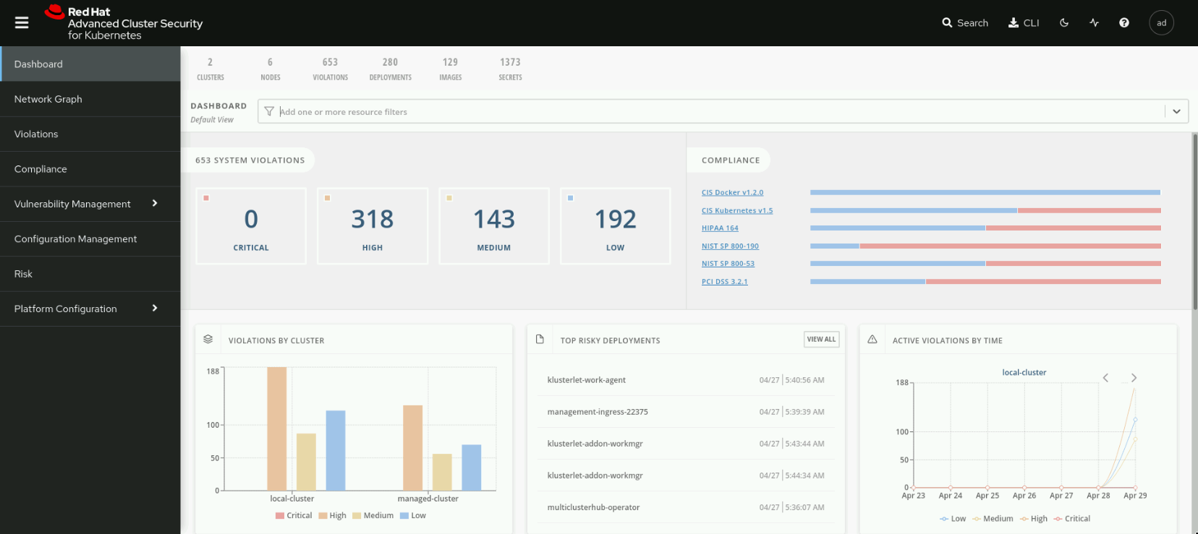

Figure 8.15: The Dashboard page

**Network Graph**

The **Network Graph** page provides a network graph view and a button to access the network policy simulator. From this page, you can visualize network flows on different clusters. You can also filter to locate resources across the cluster fleet.

**Violations**

RHACS reports policy violations on the **Violations** page. You can use this page to investigate the cause of violations and take corrective actions. The reported violations can be related to container images affected by CVEs, violations of DevOps recommended practices, high-risk deployments due to excessive permissions of the service accounts, and more.

**Compliance**

The **Compliance** page contains dashboards with information about the compliance status of the cluster fleet. From the **Compliance** page, you can click **SCAN ENVIRONMENT** to visualize compliance graphs.

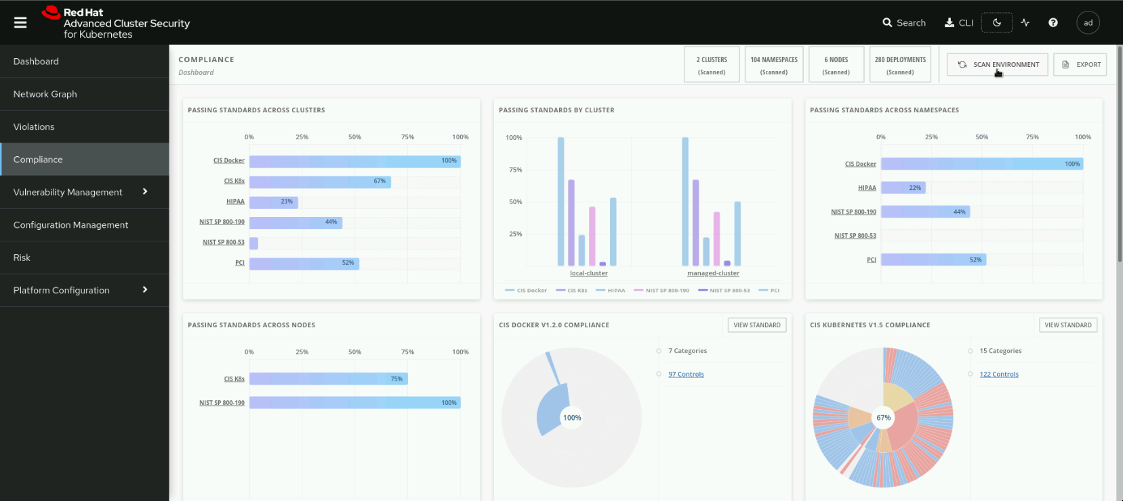

Figure 8.16: The Compliance dashboard

You can obtain more detailed information by clicking on the elements of each dashboard.

**Vulnerability Management**

The **Vulnerability Management** menu contains the **Dashboard**, **Risk Acceptance**, and **Reporting** pages.

The **Dashboard** page provides a centralized view of the most vulnerable images, frequently violated policies, and vulnerabilities affecting the cluster fleet.

From the **Risk Acceptance** page you can review the alerts generated by RHACS and decide which actions to take.

From the **Reporting** page, you can schedule vulnerability reports to run and send updates to a distribution list.

**Configuration Management**

The **Configuration Management** page provides reports about configuration-related policy violations, CIS Docker and CIS Kubernetes standards, users with elevated privileges, and Kubernetes secrets.

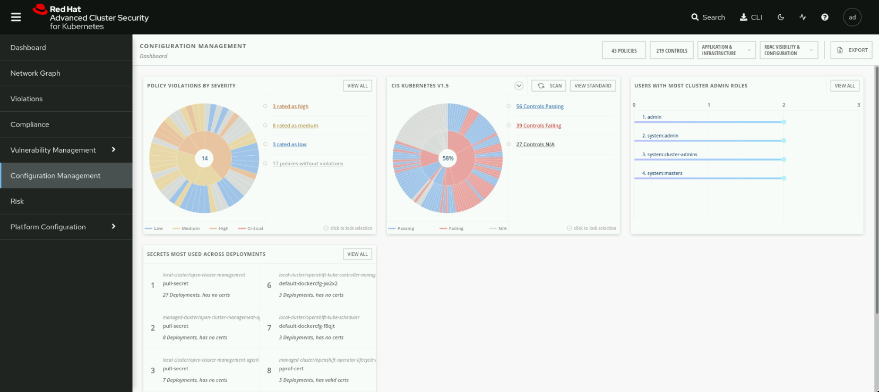

Figure 8.17: The Configuration Management dashboard

You can access more detailed information by clicking on each dashboard.

**Risk**

On the **Risk** page, RHACS creates a classification of issues using a calculated risk level. This view helps security professionals decide which elements require immediate attention.

**Platform Configuration**

The **Platform Configuration** menu contains the **Clusters**, **Policies**, **Integrations**, **Access Control**, **System Configuration**, and **System Health** pages.

The **Clusters** page shows the status of the secured clusters and allows you to configure automatic upgrades of the secured cluster services.

On the **Policies** page, you can review, create, and import RHACS policies using a JSON policy file.

On the **Integrations** page, you can configure integration with external services, such as image registries, notifiers, and backup systems. You can also manage authentication tokens, such as API tokens and init bundles.

On the **Access Control** page, you can add an authentication provider, manage roles and permission sets, and access scopes.

On the **System Configuration** page, you can manage the data retention configuration, create a header, a footer, or a login notice, and enable or disable the online telemetry data collection.

The **System Health** page provides an overview of the RHACS components running on the cluster fleet. You can view the status of the vulnerability definitions, image integrations, notifier integrations, and backup integrations. You can also generate a diagnostic bundle from this page.

### References

For more information about generating an init bundle, refer to the Generating an init bundle section of the Red Hat Advanced Cluster Security for Kubernetes Documentation at <https://docs.openshift.com/acs/3.69/installing/install-ocp-operator.html#generate-init-bundle-operator>

For more information about generating the API token from the RHACS web console, refer to the Authenticating using the roxctl CLI section of the Red Hat Advanced Cluster Security for Kubernetes Documentation at <https://docs.openshift.com/acs/3.69/cli/getting-started-cli.html#cli-authentication_cli-getting-started>

For more information about importing clusters into RHACS, refer to the Installing secured cluster services section of the Red Hat Advanced Cluster Security for Kubernetes Documentation at <https://docs.openshift.com/acs/3.69/installing/install-ocp-operator.html#install-secured-cluster-operator_install-ocp-operator>

## **Guided Exercise: Importing Managed Clusters into RHACS**

* Import all the clusters managed by Red Hat Advanced Cluster Management for Kubernetes (RHACM) into Red Hat Advanced Cluster Security for Kubernetes (RHACS) by using an RHACM policy. Then, you explore the RHACS console dashboard, run a compliance scan, and analyze the results.

**Outcomes**

* Install the RHACS operator in all the clusters using an RHACM policy.
* Generate a cluster init bundle using the RHACS dashboard.
* Create cluster init secrets in all the managed clusters.
* Create the RHACS SecuredCluster custom resource in all the clusters that use an RHACM policy.
* Verify the import of all the clusters from the RHACS web console.
* Run a compliance scan on all the clusters and analyze the result.

To perform this exercise, ensure you have completed [the section called “Guided Exercise: Installing and Configuring RHACS ”](https://rol.redhat.com/rol/app/courses/do480-2.4/pages/ch08s04).

As the student user on the workstation machine, use the lab command to prepare your system for this exercise.

[student@workstation ~]$ **lab start rhacs-import**

1. Edit the RHACM policy named policy-advanced-cluster-security-install to install RHACS in all the clusters. This policy installs the RHACS operator in the rhacs-operator namespace.
   1. From the workstation machine, open Firefox and navigate to the RHACM web console. The URL is https://multicloud-console.apps.ocp4.example.com.
   2. Click **htpasswd_provider** and log in as the admin user with the redhat password.
   3. In the left pane, click **Governance**. The dashboard shows the policy-advanced-cluster-security-install policy. Click **policy-advanced-cluster-security-install** and then click **Edit policy** to edit the policy.
   4. Remove the **local-cluster:"true"** value from the **Cluster selector** field to apply the policy to all the clusters.
   5. Click **Save**.
   6. Click **policy-advanced-cluster-security-install** and then click **Clusters** to verify the status. You should see that the local-cluster and the managed-cluster clusters show Compliant in the **Compliance** column.

|  |
| --- |
|  |

### Note

* 1. It takes 2-3 minutes for templates to show the Compliant status.

1. Create an integration for the cluster init bundle.
   1. From the workstation machine, open Firefox and access https://central-stackrox.apps.ocp4.example.com.
   2. Select the cluster auth provider. Click **htpasswd_provider** and log in as the admin user with the redhat password.
   3. On the RHACS web console, navigate to **Platform Configuration** → **Integrations** to display the **Integration** page. Click **Cluster Init Bundle** in the **Authentication Tokens** section.

|  |
| --- |
|  |

* 1. On the **Integrations** page, click **Generate bundle**.
  2. Enter rhacs-import in the **Cluster init bundle name** field and click **Generate**.
  3. On the **Configure Cluster Init Bundle Integration** page, click **Download Kubernetes secrets file** to download the secret file. In the confirmation window, select **Save File** and click **OK**.

|  |
| --- |
|  |

1. Create the rhacs-import cluster secrets on both ocp4-mng and ocp4 clusters.
   1. Open a terminal and log in to the ocp4-mng cluster as the admin user with the redhat password. The API server address is https://api.ocp4-mng.example.com:6443.

[student@workstation ~]$ **oc login -u admin -p redhat \**

**https://api.ocp4-mng.example.com:6443**

Login successful.

...output omitted...

* 1. Review the rhacs-import-cluster-init-secrets.yaml cluster init secrets file.

[student@workstation ~]$ **cat ~/Downloads/rhacs-import-cluster-init-secrets.yaml**

...output omitted...

apiVersion: v1

kind: **Secret**

metadata:

annotations:

init-bundle.stackrox.io/created-at: "2022-05-04T10:34:27.020155453Z"

init-bundle.stackrox.io/expires-at: "2023-05-04T10:34:00Z"

init-bundle.stackrox.io/id: e456829c-e586-4538-8732-cdceb7de2f40

init-bundle.stackrox.io/name: rhacs-import

creationTimestamp: null

name: **collector-tls**

stringData:

ca.pem: |

...output omitted...

apiVersion: v1

kind: **Secret**

metadata:

annotations:

init-bundle.stackrox.io/created-at: "2022-05-04T10:34:27.020155453Z"

init-bundle.stackrox.io/expires-at: "2023-05-04T10:34:00Z"

init-bundle.stackrox.io/id: e456829c-e586-4538-8732-cdceb7de2f40

init-bundle.stackrox.io/name: rhacs-import

creationTimestamp: null

name: **sensor-tls**

stringData:

ca.pem: |

...output omitted...

apiVersion: v1

kind: **Secret**

metadata:

annotations:

init-bundle.stackrox.io/created-at: "2022-05-04T10:34:27.020155453Z"

init-bundle.stackrox.io/expires-at: "2023-05-04T10:34:00Z"

init-bundle.stackrox.io/id: e456829c-e586-4538-8732-cdceb7de2f40

init-bundle.stackrox.io/name: rhacs-import

creationTimestamp: null

name: **admission-control-tls**

stringData:

admission-control-cert.pem: |

...output omitted...

The file contains three secrets: collector-tls, sensor-tls, and admission-control-tls.

* 1. Create the secrets in the stackrox namespace by using the rhacs-import-cluster-init-secrets.yaml file.

[student@workstation ~]$ **oc create -f \**

**~/Downloads/rhacs-import-cluster-init-secrets.yaml -n stackrox**

secret/collector-tls created

secret/sensor-tls created

secret/admission-control-tls created

* 1. Log in to the ocp4 cluster as the admin user with the redhat password. The API server address is https://api.ocp4.example.com:6443.

[student@workstation ~]$ **oc login -u admin -p redhat \**

**https://api.ocp4.example.com:6443**

Login successful.

...output omitted...

* 1. Create the secrets in the stackrox namespace by using the rhacs-import-cluster-init-secrets.yaml file.

[student@workstation ~]$ **oc create -f \**

**~/Downloads/rhacs-import-cluster-init-secrets.yaml -n stackrox**

secret/collector-tls created

secret/sensor-tls created

secret/admission-control-tls created

1. Create an RHACM policy named policy-advanced-managed-cluster-security in the rhacs-install namespace. This policy installs the RHACS SecuredCluster instance in the stackrox namespace on the ocp4 and ocp4-mng clusters. The ocp4 cluster is named local-cluster and the ocp4-mng cluster is named managed-cluster in RHACM.
   1. Change to the ~/DO480/labs/rhacs-import/ directory.

[student@workstation ~]$ **cd ~/DO480/labs/rhacs-import/**

[student@workstation rhacs-import]$

* 1. Review the policy-rhacs-operator-secured-clusters.yaml file with the definition of a RHACM policy to create the RHACS SecuredCluster instance.

[student@workstation rhacs-import]$ **cat \**

**policy-rhacs-operator-secured-clusters.yaml**

...output omitted...

object-templates:

- complianceType: musthave

objectDefinition:

apiVersion: v1

kind: **Namespace**

metadata:

name: **stackrox**

...output omitted...

object-templates:

- complianceType: musthave

objectDefinition:

apiVersion: platform.stackrox.io/v1alpha1

kind: **SecuredCluster**

metadata:

namespace: stackrox

name: **stackrox-secured-cluster-services**

spec:

clusterName: |

{{ fromSecret "open-cluster-management-agent" "hub-kubeconfig-secret" "cluster-name" | base64dec }}

auditLogs:

collection: Auto

centralEndpoint: |

**central-stackrox.apps.ocp4.example.com:443**

admissionControl:

listenOnCreates: false

listenOnEvents: true

listenOnUpdates: false

perNode:

collector:

collection: KernelModule

imageFlavor: Regular

taintToleration: TolerateTaints

...output omitted...

clusterSelector:

**matchExpressions: []**

The policy also ensures that the stackrox namespace exists in all the clusters. The policy also creates the RHACS SecuredCluster instance in the stackrox namespace.

* 1. Log in to the ocp4 cluster as the admin user with the redhat password. The API server address is https://api.ocp4.example.com:6443.

[student@workstation rhacs-import]$ **oc login -u admin -p redhat \**

**https://api.ocp4.example.com:6443**

Login successful.

...output omitted...

* 1. Use the oc command to create the policy-advanced-managed-cluster-security policy in the rhacs-install namespace.

[student@workstation rhacs-import]$ **oc create -f \**

**policy-rhacs-operator-secured-clusters.yaml -n rhacs-install**

policy.policy.open-cluster-management.io/policy-advanced-managed-cluster-security created

placementbinding.policy.open-cluster-management.io/binding-policy-advanced-managed-cluster-security created

placementrule.apps.open-cluster-management.io/placement-policy-advanced-managed-cluster-security created

* 1. From the workstation machine, open Firefox and navigate to the RHACM web console. The URL is https://multicloud-console.apps.ocp4.example.com.
  2. Click **htpasswd_provider** and log in as the admin user with the redhat password.
  3. In the left pane, click **Governance**. The dashboard shows the policy-advanced-managed-cluster-security policy. Click **policy-advanced-managed-cluster-security** and then click **Clusters** to inspect the status.
  4. Verify that the **Clusters** tab shows two templates for each cluster, the managed-cluster-security-ns and managed-cluster-security-endpoints templates.

|  |
| --- |
|  |

### Note

* 1. It takes 2-3 minutes for the templates to show the Compliant status.

1. Verify that the clusters local-cluster and managed-cluster are imported successfully in RHACS.
   1. On the RHACS web console, navigate to **Platform Configuration** → **Clusters** to display the **CLUSTERS** page. The **CLUSTERS** page displays both the local-cluster and managed-cluster clusters.

|  |
| --- |
|  |

### Note

* 1. It takes 5-10 minutes for clusters to import to RHACS successfully with Healthy status.

1. Run a compliance scan and review the result from RHACS dashboard.
   1. On the RHACS web console, navigate to **Compliance** to display the **COMPLIANCE** page.
   2. Click **SCAN ENVIRONMENT** to scan all the secured clusters. The **COMPLIANCE dashboard** shows results from the compliance report for both clusters.
   3. Click **2 CLUSTERS (Scanned)** to see the **Resource List**.

|  |
| --- |
|  |

* 1. Click **managed-cluster** to view more details for the managed-cluster compliance scan.

|  |
| --- |
|  |

* 1. You can click the different dashboards to obtain more details about the compliance scan results.
  2. Change to the home directory.
  3. [student@workstation rhacs-import]$ **cd ~**

[student@workstation ~]$

**Finish**

On the workstation machine, use the lab command to complete this exercise. This step is important to ensure that resources from previous exercises do not impact upcoming exercises.

[student@workstation ~]$ **lab finish rhacs-import**

### Important

Do not delete any resources created in this exercise. They are used in upcoming sections.

This concludes the section.

# **Chapter 9.  Multicluster Operational Security Using RHACS**

[Integrating RHACS with External Registries](https://rol.redhat.com/rol/app/courses/do480-2.4/pages/ch09)

[Guided Exercise: Integrating RHACS with External Registries](https://rol.redhat.com/rol/app/courses/do480-2.4/pages/ch09s02)

[Perform Multicluster Vulnerability Management with RHACS](https://rol.redhat.com/rol/app/courses/do480-2.4/pages/ch09s03)

[Guided Exercise: Perform Multicluster Vulnerability Management with RHACS](https://rol.redhat.com/rol/app/courses/do480-2.4/pages/ch09s04)

[Multicluster Configuration Management with RHACS](https://rol.redhat.com/rol/app/courses/do480-2.4/pages/ch09s05)

[Guided Exercise: Multicluster Configuration Management with RHACS](https://rol.redhat.com/rol/app/courses/do480-2.4/pages/ch09s06)

[Lab: Multicluster Operational Security Using RHACS](https://rol.redhat.com/rol/app/courses/do480-2.4/pages/ch09s07)

[Summary](https://rol.redhat.com/rol/app/courses/do480-2.4/pages/ch09s08)

**Abstract**

|  |  |
| --- | --- |
| **Goal** | Manage the operational security of a Kubernetes cluster fleet using Red Hat Advanced Cluster Security for Kubernetes (RHACS), and integrate RHACS with external services. |
| **Objectives** | * Integrate Red Hat Advanced Cluster Security for Kubernetes (RHACS) with Red Hat Quay and list the benefits of integrating RHACS with other tools. * Analyze the vulnerabilities affecting the cluster fleet using the Red Hat Advanced Cluster Security for Kubernetes (RHACS) vulnerability dashboard and reporting, and create a policy to prevent the deployment of vulnerable images. * Detect security policy violations and application or infrastructure misconfigurations by using the Red Hat Advanced Cluster Security for Kubernetes (RHACS) Configuration Management view. |
| **Sections** | * Integrating RHACS with External Registries (and Guided Exercise) * Perform Multicluster Vulnerability Management with RHACS (and Guided Exercise) * Multicluster Configuration Management with RHACS (and Guided Exercise) |
| **Lab** | * Multicluster Operational Security Using RHACS |

## **Integrating RHACS with External Registries**

### **Objectives**

* Integrate Red Hat Advanced Cluster Security for Kubernetes (RHACS) with Red Hat Quay and list the benefits of integrating RHACS with other tools.

### **Introducing Red Hat Advanced Cluster Security for Kubernetes Integrations**

Red Hat Advanced Cluster Security for Kubernetes (RHACS) integrates with many external systems. The following list describes some of the integrations supported by RHACS.

* Sending notifications by using logging systems, such as Syslog, or communication systems like email
* Making backups and storing them in object storage systems
* Configuring continuous integration systems to scan images built during continuous integration processes
* Obtaining additional vulnerability information from other image scanners

This module describes how RHACS integrates with container image registries.

### **Integrating RHACS with Container Image Registries**

RHACS uses the Docker Registry HTTP API to obtain vulnerability information about images, such as the container definition, the content of each image layer, and the image creation date.

RHACS integrates by default with many public registries. You can view the default integrations by navigating to **Platform Configuration** → **Integrations** in the RHACS web console. The **Image Integrations** section shows a list of container image registries with which RHACS can integrate.

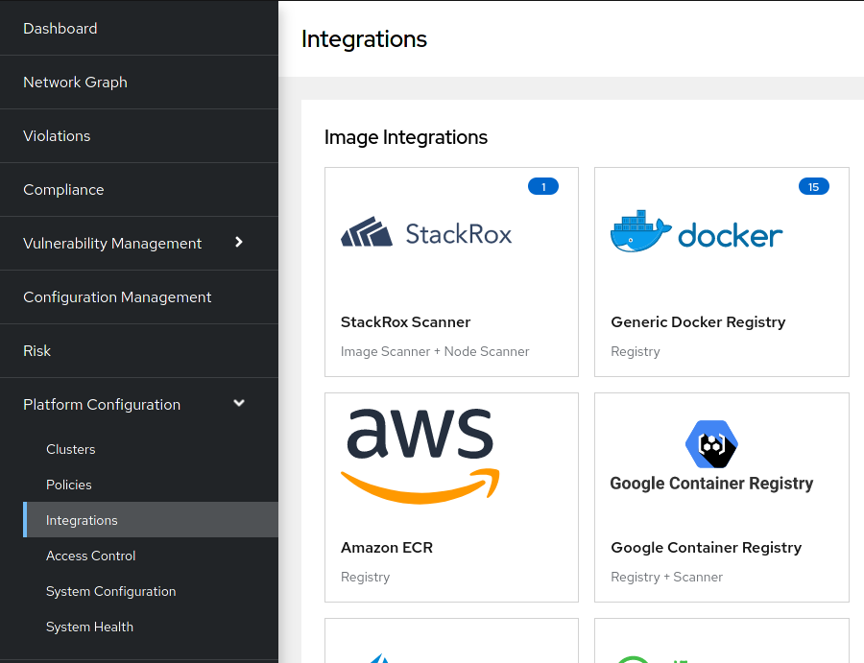

Figure 9.1: The list of image integrations

Click **Generic Docker Registry** to display a list of integrations. By default, RHACS lists **Public DockerHub** with the registry-1.docker.io endpoint. This means that RHACS can obtain information for the images stored in the public Docker Hub registry.

Other image integrations contain further preconfigured registries. Most of those registries are public registries that require no authentication. However, RHACS automatically integrates private registries by searching the cluster for image pull secrets.

Some image registries use other authentication methods. For example, Amazon Elastic Kubernetes Service (EKS) can use node Identity and Access Management (IAM) to allow nodes to authenticate to Amazon Elastic Container Registry (ECR). Because the cluster does not contain image pull secrets for the ECR registry, automatic integration does not work. You must configure integrations for this type of cluster manually.

### **Analyzing Images**

RHACS scans all clusters periodically and analyzes the images used in workloads.

RHACS can also scan specific images. For example, you can scan images used as a base to build other images, even if they do not run in any workload.

To configure scanning of specific images, navigate to **Vulnerability Management** → **Dashboard**, then click **Images**.

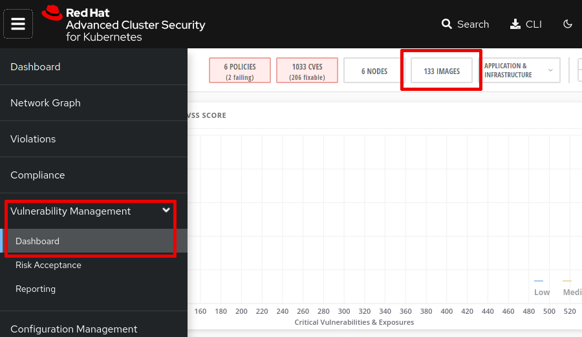

Figure 9.2: Accessing the images list

Click **MANAGE WATCHES** to manage container image watches.

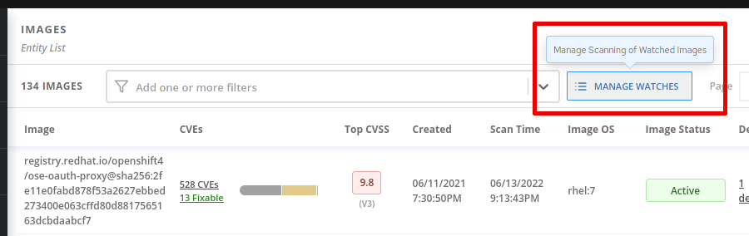

Figure 9.3: Accessing the watched images dialog

In the dialog that opens, you can add or remove watches.

|  |
| --- |
|  |

Figure 9.4: Adding or removing image watches

Additionally, the roxctl image check command scans images on demand. For example, you can configure a continuous integration pipeline to run the roxctl command to scan an image as part of a build process.

Note that RHACS does not scan entire repositories, only specific images.

### References

For more information, refer to the Integrating guide in the Red Hat Advanced Cluster Management for Kubernetes documentation at <https://access.redhat.com/documentation/en-us/red_hat_advanced_cluster_security_for_kubernetes/3.69/html-single/integrating/index>

## **Guided Exercise: Integrating RHACS with External Registries**

* Deploy an application by using an image hosted in the private Red Hat Quay registry and verify that Red Hat Advanced Cluster Security for Kubernetes (RHACS) automatically detects the deployed image. Then, you add a watch to an inactive image hosted on the private Quay registry and verify that it is listed.

**Outcomes**

* Add secret to service account to pull images from the private Red Hat Quay registry.
* Verify that RHACS detects a deployed image.
* Review images hosted in the private Red Hat Quay registry by using RHACS.
* Add an inactive image to the RHACS watched images.

To perform this exercise, ensure you have completed [the section called “Guided Exercise: Installing and Configuring RHACS ”](https://rol.redhat.com/rol/app/courses/do480-2.4/pages/ch08s04) and [the section called “Guided Exercise: Importing Managed Clusters into RHACS ”](https://rol.redhat.com/rol/app/courses/do480-2.4/pages/ch08s06).

As the student user on the workstation machine, use the lab command to prepare your system for this exercise.

[student@workstation ~]$ **lab start operate-integrate**

1. Log in to the Quay web console.
   1. From the workstation machine, open Firefox and navigate to the Quay web console at https://central-quay-registry.apps.ocp4.example.com. Log in as the cloudadmin user with the redhat password.

If prompted, click **Confirm Username**.

1. Create the finance organization and push the quay.io/redhattraining/do480-hello-app image to the central registry.
   1. Click **Create New Organization**.
   2. Type finance as the organization name, then click **Create Organization**.
   3. Open a terminal and log in as the cloudadmin user with the redhat password.

[student@workstation ~]$ **podman login -u=cloudadmin -p=redhat \**

**central-quay-registry.apps.ocp4.example.com**

Login Succeeded!

* 1. Push the quay.io/redhattraining/do480-hello-app image to the central registry by using the skopeo command.

[student@workstation ~]$ **skopeo copy \**

**docker://quay.io/redhattraining/do480-hello-app \**

**docker://central-quay-registry.apps.ocp4.example.com/finance/do480-hello-app**

Getting image source signatures

...output omitted...

1. Push a hello-quay image to the central registry.
   1. Create a Containerfile file containing a minimal image definition. The resulting file should look as follows.

FROM quay.io/podman/hello

* 1. Build the image by using the podman build command.

[student@workstation ~]$ **podman build . -t hello-quay**

...output omitted...

Successfully tagged localhost/hello-quay

...output omitted...

* 1. Push the image to the central registry.

[student@workstation ~]$ **podman push localhost/hello-quay \**

**central-quay-registry.apps.ocp4.example.com/finance/hello-quay**

...output omitted...

Storing signatures

1. Create a secret for central Quay registry authentication. Add the secret to the default service account to pull the image from the Quay registry.
   1. Log in to the ocp4 cluster as the admin user with the redhat password. The API server address is https://api.ocp4.example.com:6443.

[student@workstation ~]$ **oc login -u admin -p redhat \**

**https://api.ocp4.example.com:6443**

Login successful.

...output omitted...

* 1. Create the operate-integrate project.
  2. [student@workstation ~]$ **oc new-project operate-integrate**
  3. Now using project "operate-integrate" on server "https://api.ocp4.example.com:6443".

...output omitted...

* 1. Review the /run/user/1000/containers/auth.json file. The JSON file contains authentication details for central-quay-registry.apps.ocp4.example.com registry.

{

"auths": {

"central-quay-registry.apps.ocp4.example.com": {

"auth": "Y2xvdWRhZG1pbjpyZWRoYXQ="

}

}

}

### Note

If authentication details are unavailable in the /run/user/1000/containers/auth.json file, then run podman login.

[student@workstation ~]$ **podman login -u=cloudadmin -p=redhat \**

**central-quay-registry.apps.ocp4.example.com**

* 1. Create the quaysecret secret for central Quay registry authentication.

[student@workstation ~]$ **oc create secret generic quaysecret \**

**--from-file=.dockerconfigjson=/run/user/1000/containers/auth.json \**

**--type=kubernetes.io/dockerconfigjson -n operate-integrate**

secret/quaysecret created

* 1. Add the quaysecret secret to the default service account named default.

[student@workstation ~]$ **oc secrets link default quaysecret \**

**--for=pull -n operate-integrate**

1. Create the hello-app application in the ocp4 cluster.
   1. Change to the ~/DO480/labs/operate-integrate/ directory.

[student@workstation ~]$ **cd ~/DO480/labs/operate-integrate/**

[student@workstation operate-integrate]$

* 1. Review the hello-app.yaml file. The hello-app file is using the central-quay-registry.apps.ocp4.example.com/finance/do480-hello-app image.

...output omitted...

spec:

containers:

- name: hello-app

image: **central-quay-registry.apps.ocp4.example.com/finance/do480-hello-app**

...output omitted...

* 1. Create the hello-app application.

[student@workstation operate-integrate]$ **oc create -f hello-app.yaml**

deployment.apps/hello-app created

service/hello-app created

route.route.openshift.io/hello-app created

1. Verify that RHACS detects images from the central Quay registry.
   1. From the workstation machine, navigate to the RHACS web console at https://central-stackrox.apps.ocp4.example.com.
   2. Select the cluster authentication provider and click **Log in**.
   3. Click **htpasswd_provider** and log in as the admin user with the redhat password. If prompted to authorize access, click **Allow selected permissions**.
   4. In the RHACS web console, navigate to **Vulnerability Management** → **Dashboard**, then click **IMAGES**.

|  |
| --- |
|  |

* 1. On the **Image** page, type Image Registry:central-quay-registry.apps.ocp4.example.com in the search field to search images in the central Quay registry.
  2. The search result shows the do480-hello-app:latest image with the Active image status. You can click the do480-hello-app:latest image to obtain more details about the image.

|  |
| --- |
|  |

1. Add the hello-quay image to the watched images in RHACS.
   1. Click **Manage Scanning of Watched Images** to add the image to the watched images.

|  |
| --- |
|  |

* 1. Enter central-quay-registry.apps.ocp4.example.com/finance/hello-quay:latest in the **Image Name** field. Click **ADD IMAGE**. The page displays a confirmation message that the image is successfully added to the watched images.

|  |
| --- |
|  |

* 1. Click **RETURN TO IMAGE LIST**.
  2. On the **Image** page, type Image Registry:central-quay-registry.apps.ocp4.example.com in the search field to search images in the central Quay registry.
  3. The **Image Status** for the hello-quay image shows **Inactive** and **Scanning via watch tag** status.

|  |
| --- |
|  |

* 1. Change to the home directory.
  2. [student@workstation operate-integrate]$ **cd ~**

[student@workstation ~]$

**Finish**

On the workstation machine, use the lab command to complete this exercise. This step is important to ensure that resources from previous exercises do not impact upcoming exercises.

[student@workstation ~]$ **lab finish operate-integrate**

### Important

Do not delete any resources created in this exercise. They are used in upcoming sections.

## **Perform Multicluster Vulnerability Management with RHACS**

### **Objectives**

* Analyze the vulnerabilities affecting the cluster fleet using the Red Hat Advanced Cluster Security for Kubernetes (RHACS) vulnerability dashboard and reporting, and create a policy to prevent the deployment of vulnerable images.

### **Introducing Vulnerability Management**

Workloads that run on the cluster fleet use container images that contain all the software required for the workload. This software might have bugs that can cause security vulnerabilities. For example, a bug can cause a process to terminate on malformed input. A malicious attacker can feed malformed input to a service that is running an image affected by this bug and make the service unavailable.

Many different bugs can cause vulnerabilities. Usually, software maintainers document vulnerabilities that are detected in their software, including which versions contain the issue and which versions contain a fix. Organizations collect this information to create public databases of vulnerabilities. These databases often contain further information, such as the severity of the issue and mitigation options. For example, Red Hat Errata publishes security advisories that describe security fixes included in software updates.

Red Hat Advanced Cluster Security for Kubernetes (RHACS) analyzes workloads running on secured clusters for vulnerabilities. RHACS examines container images, enumerates versions of the software contained in the image, and correlates this information with vulnerability databases.

By using this information, you can identify vulnerabilities in workloads and take actions to maintain an adequate security level. You can update, replace, or remove the affected workloads, or mitigate vulnerabilities by other means, such as limiting access.

Additionally, in version 3.0.55.0 and later, RHACS enables an admission control webhook by default that can prevent the deployment of vulnerable images.

In addition to RHACS, you can also apply further strategies that reduce the risk of vulnerabilities.

* Favor the use of container images with clear update policies that are aligned with the organization's needs. Choose base images and applications that receive updates to address vulnerabilities.
* Streamline or automate deployments and implement automated testing. This helps keep workloads running the latest available versions of software that contain the latest patches for vulnerabilities.

Performing frequent updates might require a significant effort. However, streamlined deployments can yield further benefits, such as faster time-to-market.

### **Using the Vulnerability Dashboard**

RHACS presents information about vulnerabilities in the **Vulnerability Management** section of the web console.

The **Dashboard** page shows an overview of this information with several different classifications.

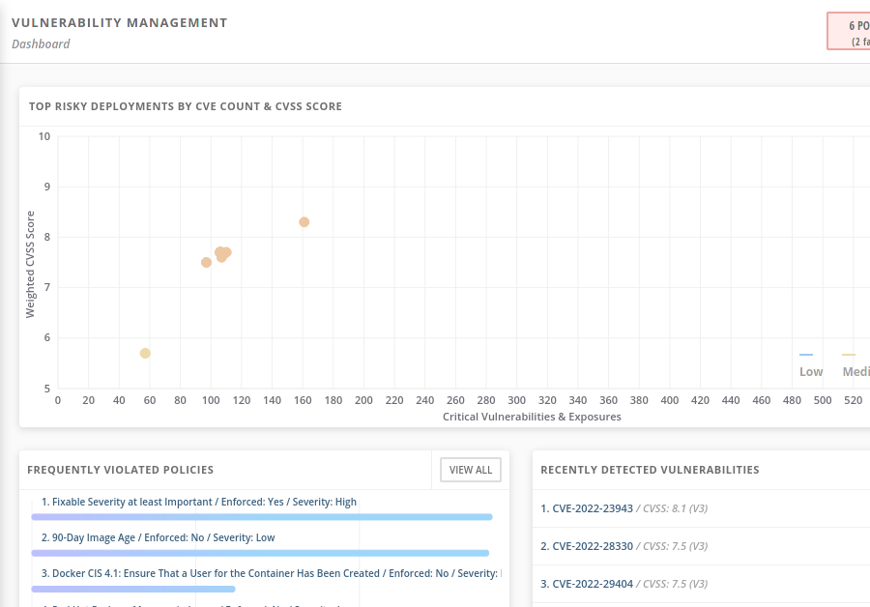

Figure 9.10: The vulnerability management dashboard

For example, you can review the **RECENTLY DETECTED VULNERABILITIES** panel periodically to identify new vulnerabilities in the cluster. Using this panel, you can react to new threats quickly.

If you want to identify the workloads that present the biggest risks, then you can use the **DEPLOYMENTS WITH MOST SEVERE POLICY VIOLATONS**. Using this panel, you can identify workloads to update, replace, or remove.

RHACS describes vulnerabilities by using the following concepts.

**Components**

A component is a piece of software. RHACS can identify components that are installed in images as RPM packages or installed by using software, such as the npm package manager.

**Images**

Images contain specific versions of components.

**Vulnerabilities**

A vulnerability is an identified issue in specific versions of a component.

The RHACS console sometimes refers to vulnerabilities as CVEs. CVE stands for Common Vulnerabilities and Exposures, a popular vulnerability database. Vulnerabilities receive a CVE identifier such as CVE-2022-23943, to help reference vulnerabilities. CVE is also a common way to refer to a CVE identifier. However, CVE lists in RHACM can contain items such as RHSA-2021:4033, pertaining to Red Hat Errata.

When examining RHACM vulnerability information, you can navigate to identify components, images, and vulnerabilities. Then, you can navigate from images to deployments to act on the vulnerabilities.

Alternatively, you can schedule periodic reports about vulnerabilities. These reports can help you communicate with teams that are responsible for vulnerable deployments.

### **Creating Policies**

A different approach to managing vulnerabilities is to prevent deployments with vulnerable images.

You can define policies to prevent users from creating workloads that match specific criteria. RHACS uses an admission control webhook to enforce policies. Kubernetes uses admission control webhooks before creating any workload. If the webhook rejects the workload, then Kubernetes does not create the workload.

To create a policy, navigate to **Platform Configuration** → **Policies** and click **Create policy**. You can define the new policy in the wizard that opens.

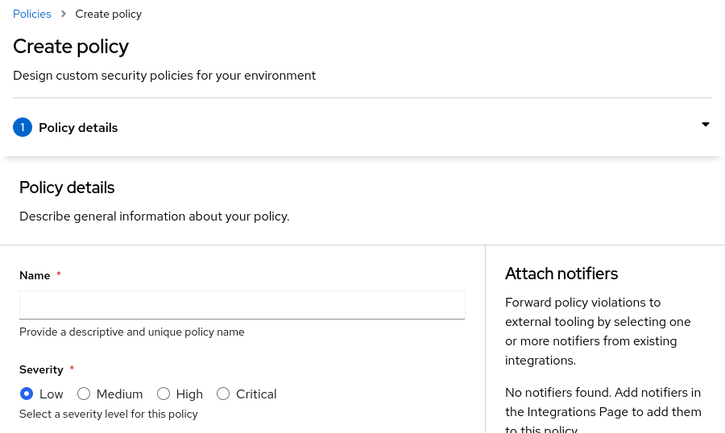

Figure 9.11: The first step creating a policy

On the **Create policy** page, you define the policy name and add categorization details, such as severity. You can also define notifications for the policy by using a configured notifier integration.

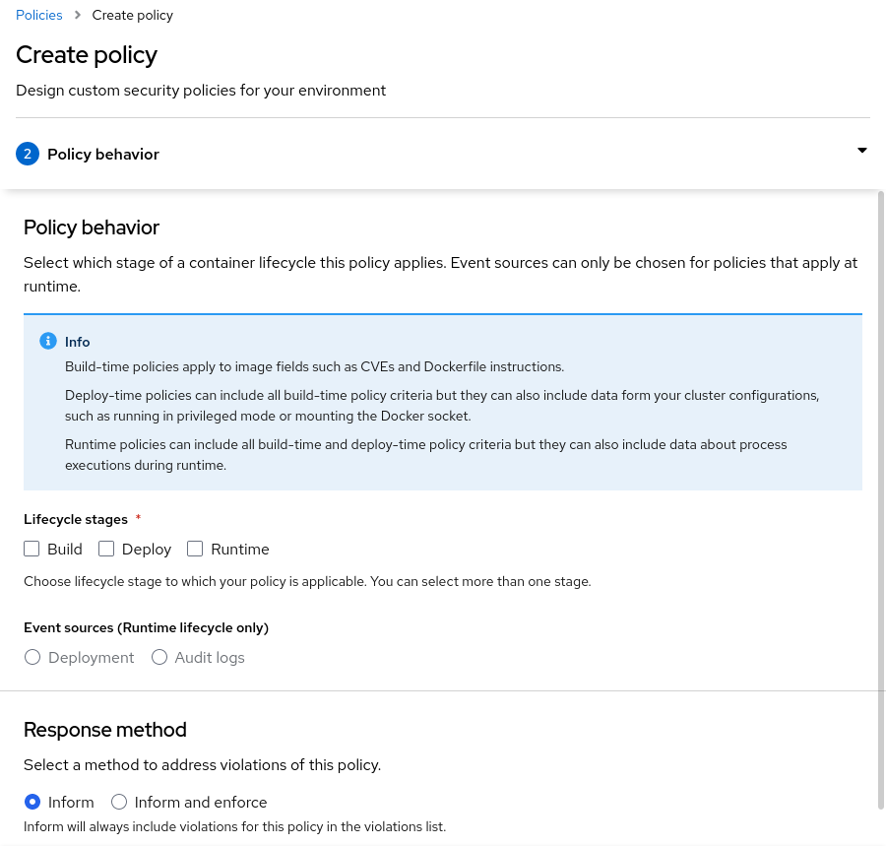

Figure 9.12: The second step creating a policy

On the **Policy behavior** page, you define when the policy activates and whether the policy prevents creating the workload or only informs. You can also choose the applicable lifecycle stage to which the policy applies. Depending on the stage, you can use different criteria for the policy. Runtime stage policies can respond to Kubernetes events by using audit logs as the event source. Other policies use criteria related to the properties of the workload.

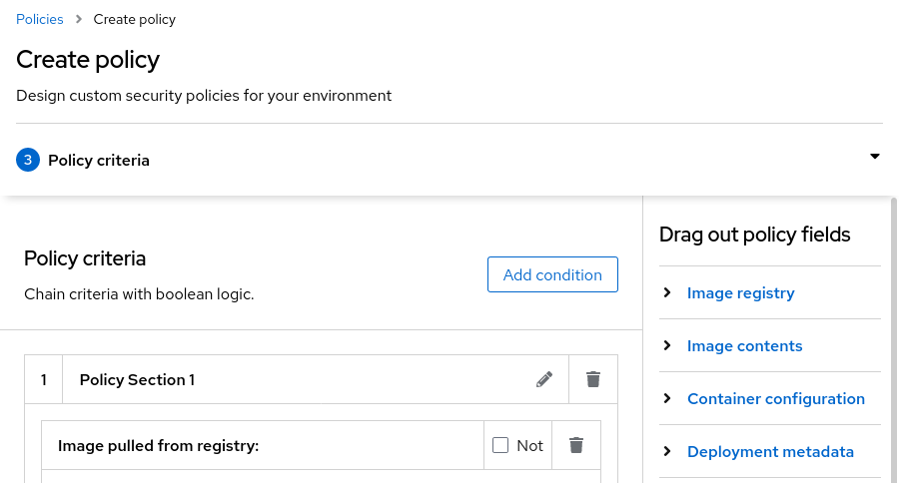

Figure 9.13: The third step creating a policy

On the **Policy criteria** page, you create the set of conditions that the policy uses. You can combine different conditions by dragging and dropping fields and adding conditions based on those fields.

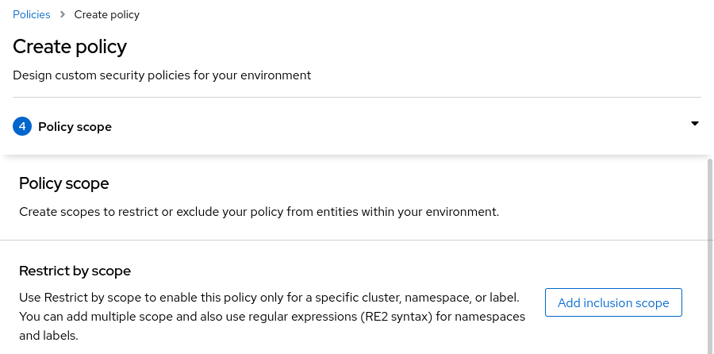

Figure 9.14: The fourth step creating a policy

On the **Policy scope** page, you can restrict a policy scope by adding an inclusion scope. If you define an inclusion scope, then the policy only affects workloads matching the scope. Scopes can filter on clusters, namespaces, and labels and can use regular expressions.

You can also use an exclusion scope. If you define an exclusion scope, then the policy affects all workloads except those matching the scope.

You can also exclude container images from the policy when creating a build stage.

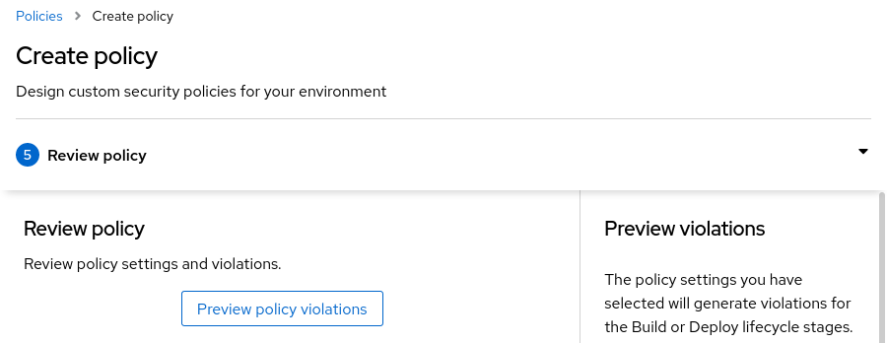

Figure 9.15: The final step creating a policy

The **Review policy** page displays all the details in the policy. Click **Preview policy violations** to display affected workloads.

After creating a policy, RHACS applies the policy. Navigate to the **Violations** page to view policy violations. To enforce policies, Kubernetes creates events when the policy affects a workload.

### References

For more information about admission controllers, refer to the Using admission controller enforcement chapter of the RHACS Operating Guide at <https://access.redhat.com/documentation/en-us/red_hat_advanced_cluster_security_for_kubernetes/3.69/html-single/operating/index#use-admission-controller-enforcement>

For more information about admission controllers, refer to the Managing vulnerabilities chapter of the RHACS Operating Guide at <https://access.redhat.com/documentation/en-us/red_hat_advanced_cluster_security_for_kubernetes/3.69/html-single/operating/index#managing-vulnerabilities>

For more information about security policies, refer to the Managing security policies chapter of the RHACS Operating Guide at <https://access.redhat.com/documentation/en-us/red_hat_advanced_cluster_security_for_kubernetes/3.69/html-single/operating/index#manage-security-policies>

[Explaining Red Hat Errata (RHSA, RHBA, and RHEA)](https://access.redhat.com/articles/2130961)

## **Guided Exercise: Perform Multicluster Vulnerability Management with RHACS**

* Analyze the vulnerabilities affecting the cluster fleet by using the Red Hat Advanced Cluster Security for Kubernetes (RHACS) vulnerability dashboard and reporting, and you create a policy to prevent the deployment of vulnerable images.

**Outcomes**

* Explore the RHACS vulnerability dashboard to locate risky images.
* Create an RHACS policy to prevent the deployment of vulnerable images.
* Verify that RHACS blocks the deployment of vulnerable images.

To perform this exercise, ensure that you have completed [the section called “Guided Exercise: Installing and Configuring RHACS ”](https://rol.redhat.com/rol/app/courses/do480-2.4/pages/ch08s04) and [the section called “Guided Exercise: Importing Managed Clusters into RHACS ”](https://rol.redhat.com/rol/app/courses/do480-2.4/pages/ch08s06).

As the student user on the workstation machine, use the lab command to prepare your system for this exercise.

[student@workstation ~]$ **lab start operate-vulnerability**

1. Log in to the RHACS web console.
   1. From the workstation machine, navigate to the RHACS web console at https://central-stackrox.apps.ocp4.example.com.
   2. Select the cluster authentication provider and click **Log in**.
   3. Click **htpasswd_provider** and log in as the admin user with the redhat password. If prompted to authorize access, click **Allow selected permissions**.
2. Locate the Common Vulnerabilities and Exposures (CVE) with the highest score for the top riskiest image.
   1. In the left pane, click **Vulnerability Management** → **Dashboard**.
   2. In the **TOP RISKIEST IMAGES** dashboard, click **VIEW ALL**. The images are sorted by **Risk Priority**, which is calculated by RHACS.
   3. Click the image in the first row. In this example, the image is registry.redhat.io/openshift4/ose-oauth-proxy@sha256:2fe11e0fabd878f53a2627ebbed273400e063cffd80d8817565163dcbdaabcf7. A detailed view of the CVEs affecting the image opens.

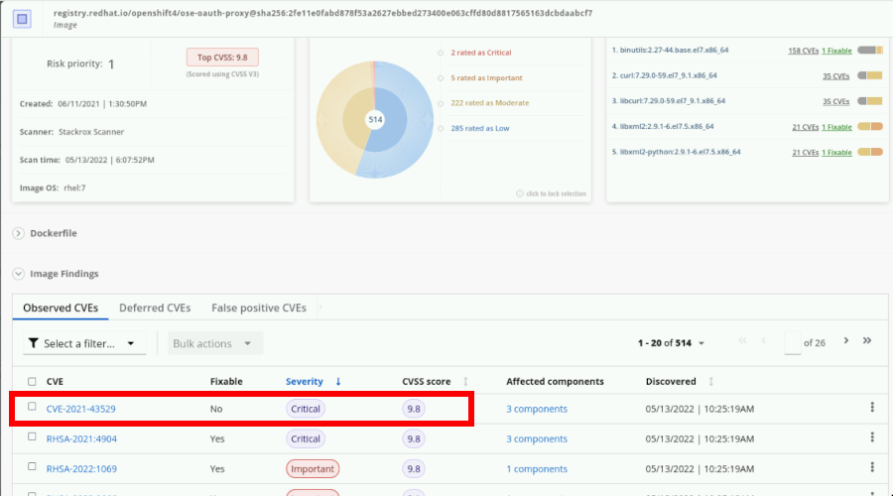

In this example, the CVE with the highest score is CVE-2021-43529.

### Note

The CVE with the highest score is subject to change. Use the CVE with the highest score in your lab environment to complete the next steps.

* 1. Click **CVE-2021-43529**. Review the description and details of this CVE.

1. Create a highly-vulnerable deployment.
   1. Open a terminal and log in to the ocp4 cluster as the admin user with the redhat password. The API server address is https://api.ocp4.example.com:6443.

[student@workstation ~]$ **oc login -u admin -p redhat \**

**https://api.ocp4.example.com:6443**

Login successful.

...output omitted...

* 1. Change to the ~/DO480/labs/operate-vulnerability/ directory.

[student@workstation ~]$ **cd ~/DO480/labs/operate-vulnerability/**

[student@workstation operate-vulnerability]$

* 1. Review the etherpad-deployment.yaml file with the deployment definition that uses a highly-vulnerable image.

...output omitted...

apiVersion: apps/v1

kind: Deployment

...output omitted...

containers:

- env:

- name: TITLE

value: OpenShift 4 Etherpad

- name: DEFAULT_PAD_TEXT

value: OpenShift 4 Etherpad

name: etherpad

securityContext:

{}

image: **"quay.io/redhattraining/etherpad:latest"**

...output omitted...

The YAML file also contains instructions to create the etherpad namespace, service, route, and persistent volume claim. The deployment uses the quay.io/redhattraining/etherpad:latest image.

* 1. Use the oc command to create the elements described in the etherpad-deployment YAML file.

[student@workstation operate-vulnerability]$ **oc create -f etherpad-deployment.yaml**

namespace/etherpad created

service/etherpad created

route.route.openshift.io/etherpad created

persistentvolumeclaim/etherpad created

deployment.apps/etherpad created

[student@workstation operate-vulnerability]$

1. Analyze the details of the highly-vulnerable deployment from the RHACS web console.
   1. From Firefox, open the RHACS web console.
   2. In the left pane, click **Vulnerability Management** → **Dashboard**.
   3. Locate the quay.io/redhattraining/etherpad:latest image in the **TOP RISKIEST IMAGES** dashboard.

|  |
| --- |
|  |

### Note

* 1. If the dashboard does not list the quay.io/redhattraining/etherpad:latest image, reload the page from the web browser.
  2. In the **TOP RISKIEST IMAGES** dashboard, click **quay.io/redhattraining/etherpad:latest**.
  3. Review the details of the vulnerabilities affecting this image.

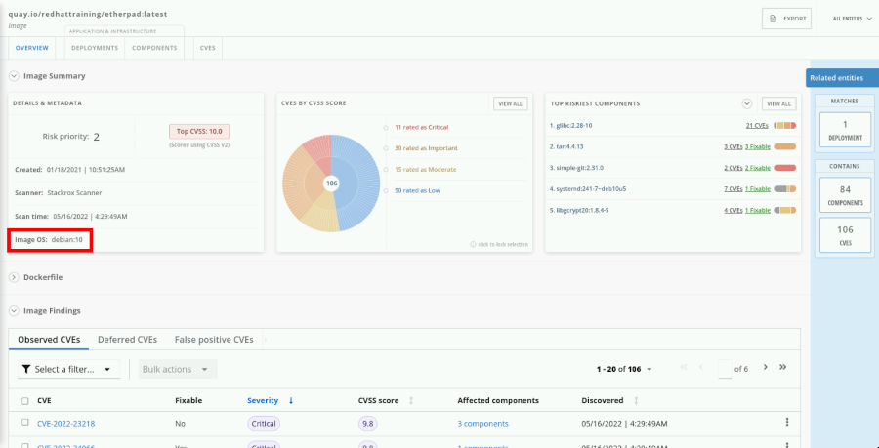

The image contains several high risk vulnerabilities. Among other issues, the image uses an old operating system, debian:10. At this point, nothing prevents the vulnerable image from being deployed in the secured cluster.

1. Create an RHACS policy to prevent the deployment of images that use the debian:10 operating system.
   1. From the RHACS web console, navigate to **Platform Configuration** → **Policies**.
   2. Click **Create policy**.
   3. In the **Policy details** page, add the following parameters:

| **Field name** | **Value** |
| --- | --- |
| Name | debian10-policy |
| Severity | **High** |
| Categories | **Vulnerability Management** |

* 1. Click **Next**.
  2. On the **Policy behavior** page, add the following parameters:

| **Field name** | **Value** |
| --- | --- |
| Lifecycle stages | **Deploy** |
| Response method | **Inform and enforce** |
| Configure enforcement behavior | **Enforce on Deploy** |

* 1. 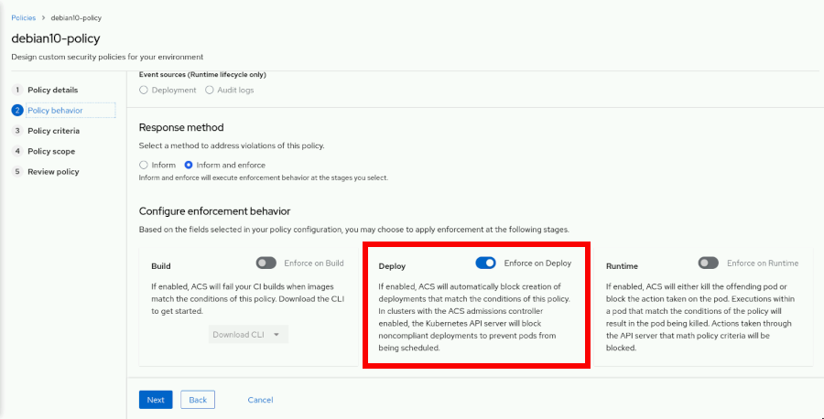
  2. Click **Next**.
  3. In the **Policy criteria** page, locate the **Image OS** drag out policy field in the right pane. You can find it under **Image contents**. Drag the **Image OS** policy field in to the **Policy Section 1** box and type debian:10 in the **Image operating system:** text field.

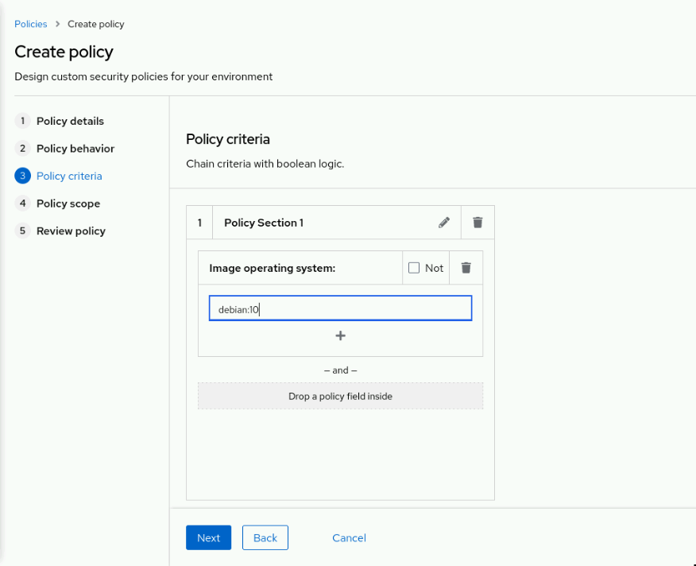

Click **Next**.

* 1. On the **Policy scope** page, click **Next**.
  2. On the **Review policy** page, verify that the etherpad image shows in the **Preview violations** right pane.

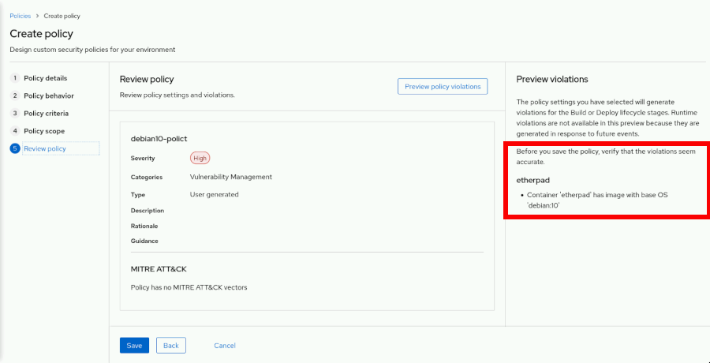

Click **Save** to create the policy.

1. Attempt to create a new etherpad deployment and verify that the policy blocks it.
   1. From the terminal, use the oc command to delete all elements in the etherpad-deployment.yaml file.

[student@workstation operate-vulnerability]$ **oc delete -f etherpad-deployment.yaml**

namespace "etherpad" deleted

service "etherpad" deleted

route.route.openshift.io "etherpad" deleted

persistentvolumeclaim "etherpad" deleted

deployment.apps "etherpad" deleted

[student@workstation operate-vulnerability]$

* 1. Use the oc command to recreate the elements described in the etherpad-deployment YAML file.

[student@workstation operate-vulnerability]$ **oc create -f etherpad-deployment.yaml**

namespace/etherpad created

service/etherpad created

route.route.openshift.io/etherpad created

persistentvolumeclaim/etherpad created

deployment.apps/etherpad created

[student@workstation operate-vulnerability]$

* 1. Verify that the debian10-policy scales down the deployment to zero replicas.

[student@workstation ~]$ **oc get events -n etherpad | grep debian10-policy**

2m27s Warning StackRox enforcement deployment/etherpad Deployment violated StackRox policy "debian10-policy" and was scaled down

* 1. Change to the home directory.

[student@workstation operate-vulnerability]$ **cd ~**

[student@workstation ~]$

* 1. In the left pane of the RHACS web console, click **Violations**.
  2. In the search field, type debian10-policy in the **Policy** field.
  3. Click **debian10-policy** and go to the **Enforcement** tab.

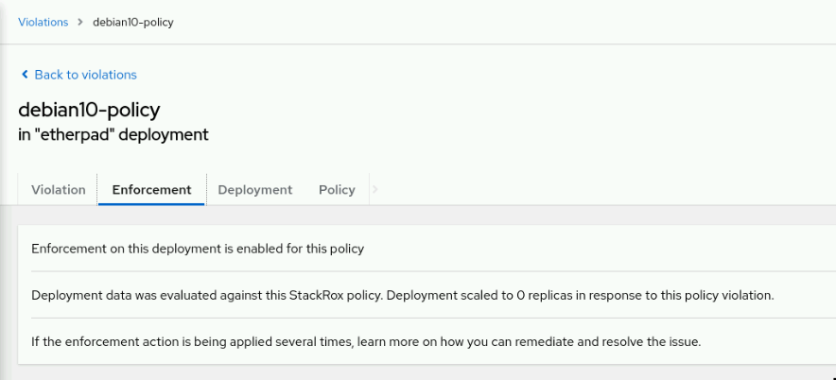

The RHACS web console provides information about the policy violation and the actions taken.

1. Delete the debian10-policy.
   1. From the RHACS web console, navigate to **Platform Configuration** → **Policies**.
   2. In the **Filter policies** text field, type Policy, press **Tab**, type debian10-policy and press **Tab**.

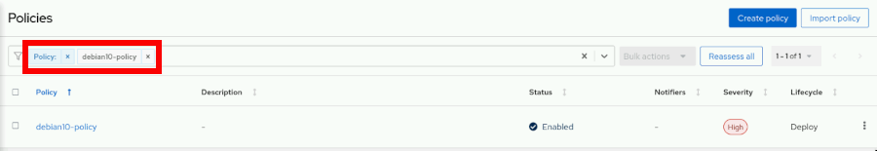

* 1. Click the vertical ellipsis (**⋮**) menu to the right of the policy field, and then click **Delete policy**.

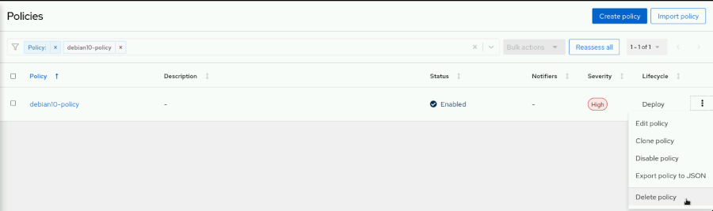

* 1. When prompted, click **Delete** to confirm.

The page displays the **Successfully deleted policy** message.

**Finish**

On the workstation machine, use the lab command to complete this exercise. This step is important to ensure that resources from previous exercises do not impact upcoming exercises.

[student@workstation ~]$ **lab finish operate-vulnerability**

### Important

Do not delete any resources created in this exercise. They are used in upcoming sections.

## **Multicluster Configuration Management with RHACS**

### **Objectives**

* Detect security policy violations and application or infrastructure misconfigurations by using the Red Hat Advanced Cluster Security for Kubernetes (RHACS) Configuration Management view.

### **Introducing Configuration Management Policies**

Kubernetes provides a uniform model for configuration and workloads on clusters. Pods, deployments, nodes, and other objects are all representable as YAML or JSON files. These objects have fields, for example, the kind, metadata, or spec fields. Furthermore, depending on the type of object, the spec field must follow a certain structure.

The Kubernetes API prevents creating objects without the correct structure.

Although Kubernetes prevents you from creating malformed objects, you can still create undesirable objects. For example, defining requests and limits for CPU and memory is a best practice, but nothing prevents you from creating a deployment without such limits.

Given the uniformity of Kubernetes resources, a single rules system can detect undesirable objects of all kinds.

Red Hat Advanced Cluster Security for Kubernetes (RHACS) includes a system to define rules to identify undesirable configurations. Optionally, this system can prevent creation of these configurations altogether.

RHACS uses the term configuration management to describe this system. Configuration management commonly refers to any process that helps keep a system correctly configured. The previous example about ensuring all deployments have resource limits represents the role of configuration management, because a deployment without resource limits is an incorrect configuration.

### **RHACS Built-in Policies**

RHACS comes preconfigured with many default configuration management rules. Navigate to **Platform Configuration** → **Policies** to list the preconfigured rules, called policies.

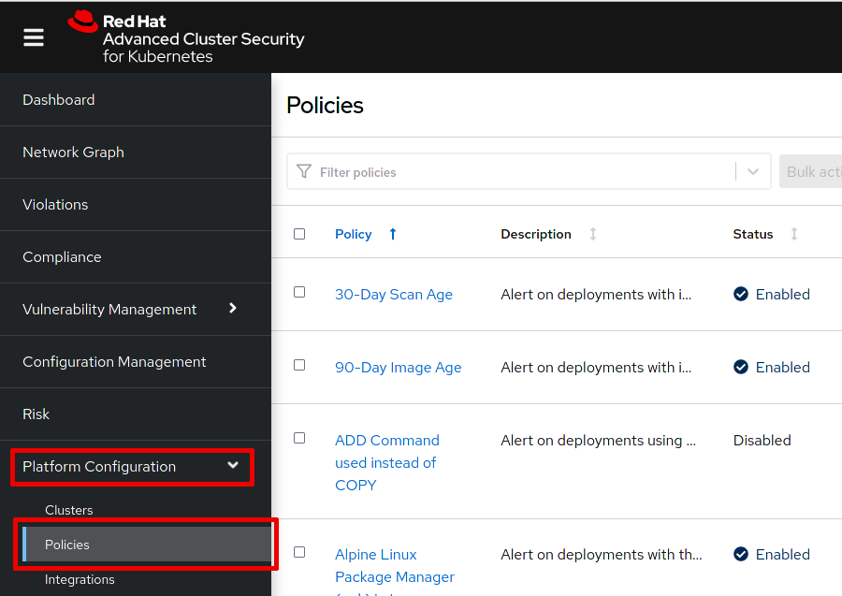

Figure 9.25: RHACS policies

RHACS categorizes policies around topics, such as privileges, security best practices, and DevOps best practices.

You can examine the policy described previously by searching for the No resource requests or limits specified policy. This policy has medium severity, a description and rationale to describe the policy, and guidance to help address violations.

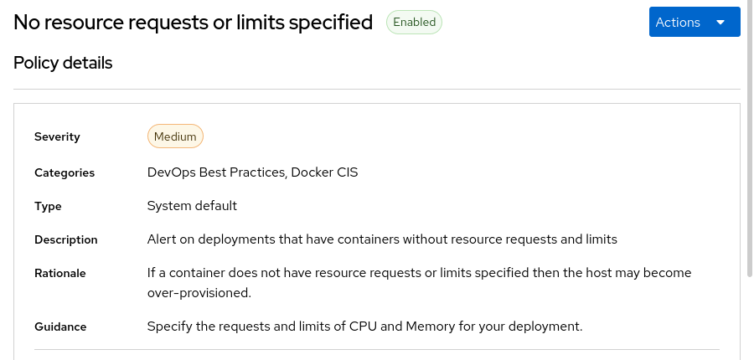

Figure 9.26: The no resource requests or limits specified policy details

You can also review the criteria that define the policy. This policy examines container configuration fields and verifies that resource limit fields are set.

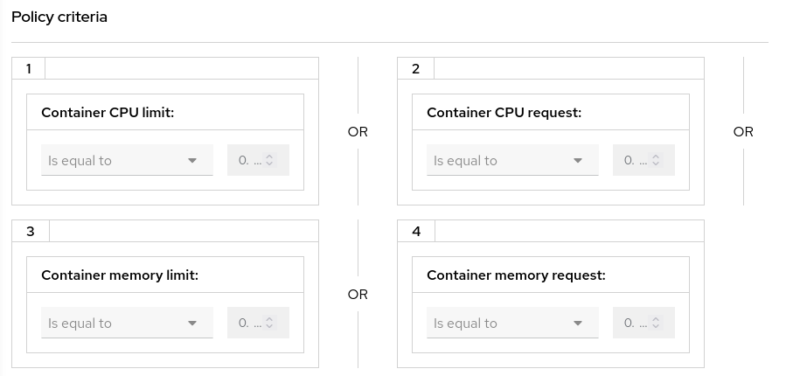

Figure 9.27: The no resource requests or limits specified policy criteria

Furthermore, this policy excludes some system namespaces from the scope to prevent alerts on system deployments that you do not manage.

RHACS policies are the same mechanism that you used to prevent creating deployments based on images with known vulnerabilities, as described in [the section called “ Perform Multicluster Vulnerability Management with RHACS ”](https://rol.redhat.com/rol/app/courses/do480-2.4/pages/ch09s03).

### **Reviewing Configuration Policies Status**

RHACS presents information about policy status in the **Configuration Management** section of the web console.

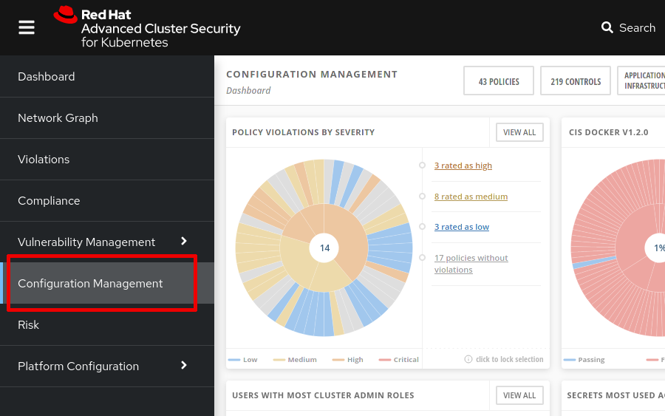

Figure 9.28: The configuration management dashboard

You can view this information from different perspectives.

For example, the **POLICY VIOLATIONS BY SEVERITY** panel in the dashboard shows all policies and their status. The items in the **APPLICATION & INFRASTRUCTURE** menu display information about clusters, namespaces, nodes, deployments, images, and secrets. If you want to find the most severe policy violations in the secured clusters, then the **POLICY VIOLATIONS BY SEVERITY** panel helps you locate them. To examine policy violations in a deployment, navigate to **APPLICATION & INFRASTRUCTURE** → **Deployments**.

### **Additional Configuration Management Information**

The **Configuration Management** section of the web console contains further information that can help you detect misconfigurations.

Controls are rules, similar to policies, that implement standards established by the Center for Internet Security (CIS). RHACS 3.69 provides controls for CIS Docker v1.2.0 and CIS Kubernetes v1.5.

The items in the **APPLICATION & INFRASTRUCTURE** menu list clusters, namespaces, nodes, deployments, images, and secrets in the secured clusters. Besides policy status for each of these objects, the subsequent pages display additional configuration management details. For example, the deployment list displays information about images and secrets used in the deployment and the associated service account.

The menu items in the **RBAC VISIBILITY & CONFIGURATION** menu list users and groups, service accounts, and roles in the secured clusters. In addition to each object's policy status, the subsequent pages display additional configuration management details. You can filter these objects with different criteria, such as the cluster, namespace, or role.

### **Adding New Policies**

As described in [the section called “ Perform Multicluster Vulnerability Management with RHACS ”](https://rol.redhat.com/rol/app/courses/do480-2.4/pages/ch09s03), you can configure new policies to identify and prevent misconfigurations.

The following list enumerates the kinds of validations that you can perform in policies, in addition to those related to image vulnerabilities.

* Container configuration, such as privileged containers, environment variables, or memory and CPU requests
* Deployment configuration, such as labels or annotations
* Storage, such as volume type, writable host mounts or volumes, or mount propagation
* Networking, such as exposed ports
* Process activity, such as process names or arguments
* Kubernetes access, such as service account or minimum RBAC permissions
* Kubernetes events, such as user, group, or action

Note that many default policies in RHACS are disabled by default. Some of these policies, such as the Wget in Image policy, are not useful in all environments, but you can activate those policies easily if you consider them valuable. Some others, such as the Required Image Label policy, are templates that you can clone to provide a starter point for creating your own custom policies.

### References

For more information about security policies, refer to the Managing security policies chapter of the RHACS Operating Guide at <https://access.redhat.com/documentation/en-us/red_hat_advanced_cluster_security_for_kubernetes/3.69/html-single/operating/index#manage-security-policies>

## **Lab: Multicluster Operational Security Using RHACS**

* Configure Red Hat Advanced Cluster Security for Kubernetes (RHACS), generate an init bundle, and import a managed cluster. Then, you create a policy to prevent the deployment of vulnerable images. Finally, you deploy an application by using an image hosted in the private Red Hat Quay registry.

**Outcomes**

* Generate a cluster init bundle by using the RHACS dashboard.
* Create cluster init secrets in all the managed clusters.
* Verify the import of all the clusters from the RHACS web console.
* Add a secret to the service account to pull images from the private Red Hat Quay registry.
* Create an RHACS policy to prevent the deployment of vulnerable images.
* Verify that RHACS blocks the deployment of vulnerable images.

As the student user on the workstation machine, use the lab command to prepare your system for this exercise.

This command ensures that RHACS and Quay are available.

[student@workstation ~]$ **lab start operate-review**

1. As the cloudadmin user with the redhat password, push the quay.io/redhattraining/do480-hello-app image to the hello-app private repository of the cloudadmin user.

Push the image quay.io/redhattraining/do480-hello-app for both the v1.0 and latest tags. The central quay registry URL is central-quay-registry.apps.ocp4.example.com.

* 1. From the workstation machine, open a terminal and log in as the cloudadmin user with the redhat password.

[student@workstation ~]$ **podman login -u=cloudadmin -p=redhat \**

**central-quay-registry.apps.ocp4.example.com**

Login Succeeded!

* 1. Push the quay.io/redhattraining/do480-hello-app:v1.0 image to the private repository of the cloudadmin user by using the skopeo command.

[student@workstation ~]$ **skopeo copy \**

**docker://quay.io/redhattraining/do480-hello-app:v1.0 \**

**docker://central-quay-registry.apps.ocp4.example.com/cloudadmin/hello-app:v1.0**

Getting image source signatures

...output omitted...

* 1. Push the quay.io/redhattraining/do480-hello-app:latest image to the private repository of the cloudadmin user by using the skopeo command.

[student@workstation ~]$ **skopeo copy \**

**docker://quay.io/redhattraining/do480-hello-app:latest \**

**docker://central-quay-registry.apps.ocp4.example.com/cloudadmin/hello-app:latest**

Getting image source signatures

...output omitted...

[Hide Solution](https://rol.redhat.com/rol/app/)

1. Create a secret named quaysecret in the operate-review namespace for the central Quay registry authentication. Add the secret to the default service account to pull the image from the Quay registry.
   1. Log in to the ocp4 cluster as the admin user with the redhat password. The API server address is https://api.ocp4.example.com:6443.

[student@workstation ~]$ **oc login -u admin -p redhat \**

**https://api.ocp4.example.com:6443**

Login successful.

...output omitted...

* 1. Create the operate-review project.

[student@workstation ~]$ **oc new-project operate-review**

Now using project "operate-review" on server "https://api.ocp4.example.com:6443".

...output omitted...

* 1. Review the /run/user/1000/containers/auth.json file. The JSON file contains authentication details for the central-quay-registry.apps.ocp4.example.com registry.

[student@workstation ~]$ **cat /run/user/1000/containers/auth.json**

{

"auths": {

"central-quay-registry.apps.ocp4.example.com": {

"auth": "Y2xvdWRhZG1pbjpyZWRoYXQ="

}

}

}

### Note

If authentication details are unavailable in the /run/user/1000/containers/auth.json file, then run the podman login command.

[student@workstation ~]$ podman login -u=cloudadmin -p=redhat \

central-quay-registry.apps.ocp4.example.com

* 1. Create the quaysecret secret for the central Quay registry authentication.

[student@workstation ~]$ **oc create secret generic quaysecret \**

**--from-file=.dockerconfigjson=/run/user/1000/containers/auth.json \**

**--type=kubernetes.io/dockerconfigjson -n operate-review**

secret/quaysecret created

* 1. Add the quaysecret secret to the default service account named default.

[student@workstation ~]$ **oc secrets link default quaysecret \**

**--for=pull -n operate-review**

1. [Hide Solution](https://rol.redhat.com/rol/app/)
2. Using the **htpasswd_provider** option, log in to the OpenShift web console as the admin user with the redhat password. Retrieve the default admin password for the RHACS central dashboard by using the OpenShift web console. As the admin user, log in to the RHACS central dashboard.

The OpenShift console URL is https://console-openshift-console.apps.ocp4.example.com

* 1. From the workstation machine, open Firefox and access https://console-openshift-console.apps.ocp4.example.com.
  2. Click **htpasswd_provider** and log in as the admin user with the redhat password.
  3. Navigate to **Home** → **Projects** to display the **Projects** page, and then click **stackrox** to select the stackrox namespace.
  4. Navigate to **Operators** → **Installed Operators** to display installed operators, and then click **Central** to display the **Centrals** page.

|  |
| --- |
|  |

* 1. Click **stackrox-central-services** to display **stackrox-central-services** page. Copy the command from the **Admin Credentials Info** section to retrieve the default password for the admin user.

|  |
| --- |
|  |

* 1. Retrieve the default password for the admin user from the command line.
  2. [student@workstation ~]$ **oc -n stackrox get secret central-htpasswd \**
  3. **-o go-template='{{index .data "password" | base64decode}}'**

WcRPchXqaP6KAoLbyCSTr9v9d

* 1. Run the oc get route command to retrieve the URL of the RHACS web interface.

[student@workstation ~]$ **oc get route -n stackrox**

NAME HOST/PORT PATH SERVICES PORT TERMINATION WILDCARD

central **central-stackrox.apps.ocp4.example.com** central https passthrough None

...output omitted...

* 1. Open Firefox and access https://central-stackrox.apps.ocp4.example.com.

### Note

If Firefox displays a warning message, then add exceptions to permit the CENTRAL_SERVICE certificate.

* 1. From the list of authentication providers, select **Login with username/password**. Log in as the admin user with the password retrieved in the preceding step.

[Hide Solution](https://rol.redhat.com/rol/app/)

1. Create an integration for the Cluster Init Bundle bundle.
   1. On the RHACS web console, navigate to **Platform Configuration** → **Integrations** to display the **Integration** page. Click **Cluster Init Bundle** in the **Authentication Tokens** section.

|  |
| --- |
|  |

* 1. On the **Integrations** page, click **Generate bundle**.
  2. Enter the operate-import value in the **Cluster init bundle name** field and click **Generate**.
  3. On the **Configure Cluster Init Bundle Integration** page, click **Download Kubernetes secrets file** to download the secrets file. In the confirmation window, select **Save File** and click **OK**.

|  |
| --- |
|  |

1. [Hide Solution](https://rol.redhat.com/rol/app/)
2. Create the operate-import cluster secrets on both the ocp4-mng and ocp4 clusters.
   1. Return to the terminal and log in to the ocp4-mng cluster as the admin user with the redhat password. The API server address is https://api.ocp4-mng.example.com:6443.

[student@workstation ~]$ **oc login -u admin -p redhat \**

**https://api.ocp4-mng.example.com:6443**

Login successful.

...output omitted...

* 1. Review the operate-import-cluster-init-secrets.yaml cluster init secrets file.

[student@workstation ~]$ **cat ~/Downloads/operate-import-cluster-init-secrets.yaml**

...output omitted...

apiVersion: v1

kind: **Secret**

metadata:

annotations:

init-bundle.stackrox.io/created-at: "2022-05-04T10:34:27.020155453Z"

init-bundle.stackrox.io/expires-at: "2023-05-04T10:34:00Z"

init-bundle.stackrox.io/id: e456829c-e586-4538-8732-cdceb7de2f40

init-bundle.stackrox.io/name: operate-import

creationTimestamp: null

name: **collector-tls**

stringData:

ca.pem: |

...output omitted...

apiVersion: v1

kind: **Secret**

metadata:

annotations:

init-bundle.stackrox.io/created-at: "2022-05-04T10:34:27.020155453Z"

init-bundle.stackrox.io/expires-at: "2023-05-04T10:34:00Z"

init-bundle.stackrox.io/id: e456829c-e586-4538-8732-cdceb7de2f40

init-bundle.stackrox.io/name: operate-import

creationTimestamp: null

name: **sensor-tls**

stringData:

ca.pem: |

...output omitted...

apiVersion: v1

kind: **Secret**

metadata:

annotations:

init-bundle.stackrox.io/created-at: "2022-05-04T10:34:27.020155453Z"

init-bundle.stackrox.io/expires-at: "2023-05-04T10:34:00Z"

init-bundle.stackrox.io/id: e456829c-e586-4538-8732-cdceb7de2f40

init-bundle.stackrox.io/name: operate-import

creationTimestamp: null

name: **admission-control-tls**

stringData:

admission-control-cert.pem: |

...output omitted...

The file contains three secrets: collector-tls, sensor-tls, and admission-control-tls.

* 1. Create the secrets in the stackrox namespace by using the operate-import-cluster-init-secrets.yaml file.

[student@workstation ~]$ **oc create -f \**

**~/Downloads/operate-import-cluster-init-secrets.yaml -n stackrox**

secret/collector-tls created

secret/sensor-tls created

secret/admission-control-tls created

* 1. Log in to the ocp4 cluster as the admin user with the redhat password. The API server address is https://api.ocp4.example.com:6443.

[student@workstation ~]$ **oc login -u admin -p redhat \**

**https://api.ocp4.example.com:6443**

Login successful.

...output omitted...

* 1. Create the secrets in the stackrox namespace by using the operate-import-cluster-init-secrets.yaml file.

[student@workstation ~]$ **oc create -f \**

**~/Downloads/operate-import-cluster-init-secrets.yaml -n stackrox**

secret/collector-tls created

secret/sensor-tls created

secret/admission-control-tls created

1. [Hide Solution](https://rol.redhat.com/rol/app/)
2. Verify that the local-cluster and managed-cluster clusters are imported successfully in RHACS.
   1. From the RHACS web console, navigate to **Platform Configuration** → **Clusters** to display the **CLUSTERS** page. The **CLUSTERS** page displays both the local-cluster and managed-cluster clusters.

|  |
| --- |
|  |

### Note

* 1. It takes 15-20 minutes for clusters to import to RHACS successfully and show a Healthy status.

1. [Hide Solution](https://rol.redhat.com/rol/app/)
2. Create an RHACS policy to prevent the deployment of images by using the latest tag from the central registry.
   1. From the RHACS web console, navigate to **Platform Configuration** → **Policies**.
   2. Click **Create policy**.
   3. On the **Policy details** page, add the following parameters:

| **Field name** | **Value** |
| --- | --- |
| Name | latest-tag-policy |
| Severity | **High** |
| Categories | **Vulnerability Management** |

* 1. And click **Next**.
  2. On the **Policy behavior** page, add the following parameters:

| **Field name** | **Value** |
| --- | --- |
| Lifecycle stages | **Deploy** |
| Response method | **Inform and enforce** |
| Configure enforcement behavior | **Enforce on Deploy** |

* 1. Click **Next**.
  2. In the **Drag out policy field** pane, expand the **Image registry** list. Drag the **Image tag** tile to the **Policy Section 1** list and type latest in the **Image tag** text field.
  3. Drag the **Image registry** tile to the **Policy Section 1** list and type central-quay-registry.apps.ocp4.example.com in the **Image pulled from registry** text field.

|  |
| --- |
|  |

* 1. Click **Next**.
  2. On the **Policy scope** page, click **Next**.
  3. On the **Review policy** page, click **Save** to create the policy.

[Hide Solution](https://rol.redhat.com/rol/app/)

1. Deploy the hello-quay application to the production environment by using the ~/DO480/labs/operate-review/hello-quay.yaml file.

The hello-quay application is using the quay.io/redhattraining/do480-hello-app image with the latest tag. Verify that the application is deployed and the application URL, hello-quay.apps.ocp4.example.com, is working.

* 1. Log in to the ocp4 cluster as the admin user with the redhat password. The API server address is https://api.ocp4.example.com:6443.

[student@workstation ~]$ **oc login -u admin -p redhat \**

**https://api.ocp4.example.com:6443**

Login successful.

...output omitted...

* 1. Change to the ~/DO480/labs/operate-review/ directory.

[student@workstation ~]$ **cd ~/DO480/labs/operate-review/**

[student@workstation operate-review]$

* 1. Review the hello-quay.yaml file. The YAML file uses an image from the quay.io registry with the latest tag.

[student@workstation operate-review]$ **cat hello-quay.yaml**

...output omitted...

spec:

containers:

- name: hello-quay

image: **quay.io/redhattraining/do480-hello-app:latest**

...output omitted...

* 1. Use the oc command to create the elements described in the hello-quay YAML file.

[student@workstation operate-review]$ **oc create -f hello-quay.yaml**

deployment.apps/hello-quay created

service/hello-quay created

route.route.openshift.io/hello-quay created

* 1. Verify the status of the hello-quay application.

[student@workstation operate-review]$ **oc get deployment \**

**hello-quay -n operate-review**

NAME READY UP-TO-DATE AVAILABLE AGE

hello-quay 1/1 1 1 53s

* 1. Test the hello-quay application deployment.

[student@workstation operate-review]$ **curl hello-quay.apps.ocp4.example.com**

Hello Application!

Image version : latest

[Hide Solution](https://rol.redhat.com/rol/app/)

1. Deploy the hello-central application by using the ~/DO480/labs/operate-review/hello-central.yaml file.

The hello-central application is using central-quay-registry.apps.ocp4.example.com/cloudadmin/hello-app image with the latest tag. Verify that the latest-tag-policy RHACS policy scaled down the deployment.

* 1. Review the hello-central.yaml file. The YAML file uses an image from central-quay-registry.apps.ocp4.example.com registry with the latest tag.

[student@workstation operate-review]$ **cat hello-central.yaml**

...output omitted...

spec:

containers:

- name: hello-central

image: **central-quay-registry.apps.ocp4.example.com/cloudadmin/hello-app:latest**

...output omitted...

* 1. Use the oc command to create the elements described in the hello-central YAML file.

[student@workstation operate-review]$ **oc create -f hello-central.yaml**

deployment.apps/hello-central created

service/hello-central created

route.route.openshift.io/hello-central created

* 1. Verify that the latest-tag-policy scales down the deployment to zero replicas.

[student@workstation ~]$ **oc get events -n operate-review | grep latest-tag-policy**

11s Warning StackRox enforcement deployment/hello-central Deployment violated StackRox policy "latest-tag-policy" and was scaled down

[Hide Solution](https://rol.redhat.com/rol/app/)

1. Remove the elements described in the hello-central YAML file. Update the hello-central.yaml file to use the v1.0 tag. Verify that the application is deployed and the application URL, hello-central.apps.ocp4.example.com, is working.
   1. Use the oc command to delete all elements in the hello-central.yaml file.

[student@workstation operate-review]$ **oc delete -f hello-central.yaml**

deployment.apps "hello-central" deleted

service "hello-central" deleted

route.route.openshift.io "hello-central" deleted

* 1. Change the image tag from latest to v1.0 in the hello-central.yaml file.

[student@workstation operate-review]$ **vim hello-central.yaml**

...output omitted...

spec:

containers:

- image: **central-quay-registry.apps.ocp4.example.com/cloudadmin/hello-app:v1.0**

imagePullPolicy: Always

name: hello-central

...output omitted...

* 1. Use the oc command to create the elements described in the hello-central YAML file.

[student@workstation operate-review]$ **oc create -f hello-central.yaml**

deployment.apps/hello-central created

service/hello-central created

route.route.openshift.io/hello-central created

* 1. Verify the status of the hello-central application.

[student@workstation operate-review]$ **oc get deployment \**

**hello-central -n operate-review**

NAME READY UP-TO-DATE AVAILABLE AGE

hello-central 1/1 1 1 10m

* 1. Test the hello-central application deployment.

[student@workstation operate-review]$ **curl hello-central.apps.ocp4.example.com**

Hello Application!

Image version : 1.0

1. [Hide Solution](https://rol.redhat.com/rol/app/)

**Evaluation**

As the student user on the workstation machine, use the lab command to grade your work. Correct any reported failures and rerun the command until successful.

[student@workstation ~]$ **lab grade operate-review**

**Finish**

On the workstation machine, change to the student user home directory and use the lab command to complete this exercise. This step is important to ensure that resources from previous exercises do not impact upcoming exercises.

[student@workstation ~]$ **lab finish operate-review**